INFORMATION SHEET

UN No. 1956

Hazard No. 2(S)E

Classification: As 4882-2003: SG-ACO-16/2

# Argon 16

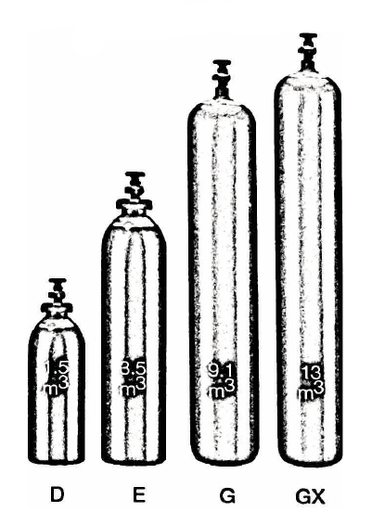

Container sizes may vary from state to state

|  |  |  |  |
| --- | --- | --- | --- |
| SPECIFICATION | | E Cyl. | **G** Cyl. |
| Cylinder contents (m3) (101.325 kPa at 150C) | | 4.3 | 10.0 |
| Water Capacity per cylinder (L) | | 23 | 50 |
| Cylinder Pressure (kPa) | | 18,500 | 17,000 |
| Cylinder Colour | | Peacock Blue/ Pewter Shoulder/Black Neck | |
| Outlet Connection | | Type 10 | |
| Dimensions (mm) | Height  Diameter | 780  230 | 1510  230 |

Cylinder dimensions are approximate – variations may occur due to manufacturing tolerances

Height includes the valve

### Typical Analysis

|  |  |  |  |
| --- | --- | --- | --- |
| PRODUCT NAME | Ar | O2 | CO2 |
| Argon 16 | 82% | 2% | 16% |

### Description

A smooth running general purpose shielding gas mixture suitable for both the short arc and spray transfer models. Suitable for use with solid wires on mild steels.

### Typical Uses

* MIG welding of Mild Steel (carbon steel)

### Main hazards

* Compressed high pressure gas in cylinders
* Asphyxiant in high concentrations.

### Storage and handling

Ensure adequate ventilation for all cylinders and packs. Secure single cylinders in upright position and protect valves and manifolds from accidental damage.

* Keep cylinders and packs in a cool area away from all sources of heat.
* Close all valves when not in use.
* Ensure all regulators and other devices attached to the cylinder outlets are free from oil and grease, and able to withstand contents pressures. Check for leaks regularly.
* Do not store cylinders in an area where in an area where any leaking gas could accumulate.
* If valve is damaged, do not attempt to operate.
* If valve does not operate by hand, return the cylinder to the supplier (attach a “faulty” tag).

N.B. Only regulators, manifolds and ancillary equipment, rated for the appropriate pressure and compatible with the relevant gas, shall be connected to or downstream of these cylinders.

### In case of leaks

* If cylinder or pack is suspected of leaking, evacuate personnel from the direction in which the gas is likely to flow. Stop leak if possible.
* Major leaks should only be approached with breathing apparatus.
* If possible and if safe to do so, remove leaking cylinder or pack to a safe area outdoors and allow contents to empty into atmosphere.
* Return empty cylinders and pack to supplier with a note to confirm the leak occurred
* Notify emergency services if required