INFORMATION SHEET

UN No. 1066

Hazard No. 2(T)E

Classification: As 4882-2003: SG-AHe-25

# Argon 25/75

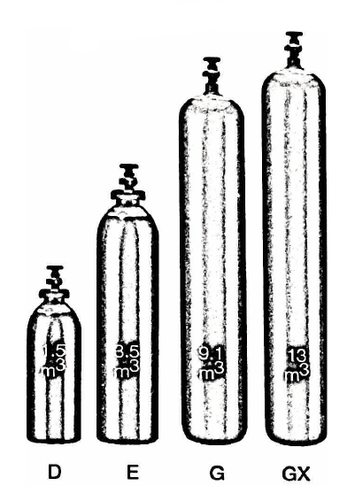

|  |  |  |  |
| --- | --- | --- | --- |
| SPECIFICATION | | Argon 25 Cylinder | Argon 75 Cylinder |
| Cylinder contents (m3) (101.325 kPa at 150C) | | 7.8 | 7.3 |
| Water Capacity per cylinder (L) | | 50 | |
| Cylinder Pressure (kPa) | | 17,000 | |
| Cylinder Colour | | Peacock Blue Body/  Brown Shoulder | Brown Body/  Peacock Blue Shoulder |
| Outlet Connection | | Type 10 | |
| Dimensions (mm) | Height  Diameter | 1510  230 | |

Cylinder dimensions are approximate – variations may occur due to manufacturing tolerances

Height includes the valve

### Typical Analysis

|  |  |  |  |  |
| --- | --- | --- | --- | --- |
| PRODUCT NAME | He | Ar | O2 | Moisture |
| Argon 25 | 25% | 75% | < 50 ppm | < 10 ppm |
| Argon 75 | 75% | 25% | < 50 ppm | < 10 ppm |

### Description

Argon 25 and 75 are argon/helium based mixtures and are inert, non-toxic, colourless and odourless. Supplied in high pressure metal cylinders.

Argon 25 and 75 used in GMAW and GTAW for aluminium and aluminium alloys (Argon 25 up to 6mm, Argon 75 above 6mm).

Argon 25 is faster than argon, producing flatter, smoother, broader weld beads with greater penetration, fewer defects and improved productivity. It does not produce as fierce an arc as Argon 75 and gives less chance of burn through in thin sections.

Argon 75 produces a hotter arc, giving the best penetration, defect free weld beads with low porosity at high production levels.

### Physical Characteristics

* Appearance / Odour: Colourless and Odourless
* Relative density (Air = 1): 1.3
* Molecular weight: 30.2
* Density of gas @ 15°C, 101.325kPa: 1.28Kg/m³

### Typical Uses

* MIG and TIG welding of Aluminium

### Main hazards

* Only used approved pressure rated equipment.
* Asphyxiant in high concentrations.
* Compressed high pressure gas in cylinders.

### Storage and handling

Ensure adequate ventilation for all cylinders and packs. Secure single cylinders in upright position and protect valves and manifolds from accidental damage.

* Keep cylinders and packs in a cool area away from all sources of heat.
* Close all valves when not in use.
* Ensure all regulators and other devices attached to the cylinder outlets are free from oil and grease, and able to withstand contents pressures. Check for leaks regularly.
* Do not store cylinders in an area where in an area where any leaking gas could accumulate.
* If valve is damaged, do not attempt to operate.
* If valve does not operate by hand, return the cylinder to the supplier (attach a “faulty” tag).

N.B. Only regulators, manifolds and ancillary equipment, rated for the appropriate pressure and compatible with the relevant gas, shall be connected to or downstream of these cylinders.

### In case of leaks

* If cylinder or pack is suspected of leaking, evacuate personnel from the direction in which the gas is likely to flow. Stop leak if possible.
* Major leaks should only be approached with breathing apparatus.
* If possible and if safe to do so, remove leaking cylinder or pack to a safe area outdoors and allow contents to empty into atmosphere.
* Return empty cylinders and pack to supplier with a note to confirm the leak occurred
* Notify emergency services if required