INFORMATION SHEET

UN No. 1066

Hazard No. 2TE

Classification: As 4882-2003: SG-CO-5/2

# Argon 52

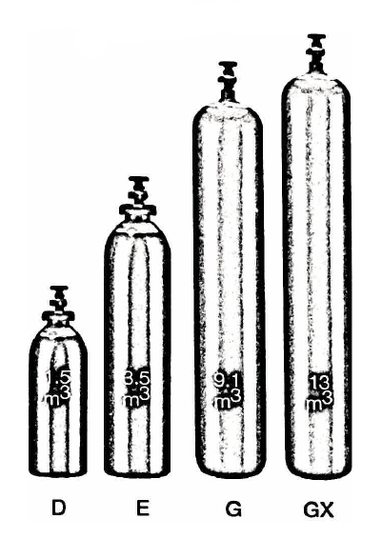

Container sizes may vary from state to state

|  |  |  |  |
| --- | --- | --- | --- |
| SPECIFICATION | | E Cyl. | **G** Cyl. |
| Cylinder contents (m3) (101.325 kPa at 150C) | | 4.3 | 8.9 |
| Water Capacity per cylinder (L) | | 23 | 50 |
| Cylinder Pressure (kPa) | | 17,000 | |
| Cylinder Colour | | Peacock Blue/ Pewter Shoulder/Black Neck | |
| Outlet Connection | | Type 10 | |
| Dimensions (mm) | Height  Diameter | 780  230 | 1510  230 |

Cylinder dimensions are approximate – variations may occur due to manufacturing tolerances

Height includes the valve

### Typical Analysis

|  |  |  |  |  |
| --- | --- | --- | --- | --- |
| PRODUCT NAME | Ar | O2 | CO2 | Moisture |
| Argon 52 | Balance | 2%±0.5% | 5%±0.5% | < 20 ppm |

### Description

Argon 52 is inert, non-toxic, colourless and odourless. Supplied in high pressure metal cylinders and packs where available.

Argon 52 is offered to customers using the GMAW process on carbon steel less than 4mm think for fabricating automotive components and cabinets, performing duct and sheet metal work and repairing vehicles.

Argon 52 for these applications is easy to use, provides a quality weld and and minimises overall cost.

Argon 52 offers the ability to spray transfer, which improves productivity.

### Typical Uses

* Mix with medium gas content
* Any welding application which requires spatter free process using spray transfer

### Main hazards

* Only used approved pressure rated equipment.
* Asphyxiant in high concentrations.
* Compressed high pressure gas in cylinders.

### Storage and handling

Ensure adequate ventilation for all cylinders and packs. Secure single cylinders in upright position and protect valves and manifolds from accidental damage.

* Keep cylinders and packs in a cool area away from all sources of heat.
* Close all valves when not in use.
* Ensure all regulators and other devices attached to the cylinder outlets are free from oil and grease, and able to withstand contents pressures. Check for leaks regularly.
* Do not store cylinders in an area where in an area where any leaking gas could accumulate.
* If valve is damaged, do not attempt to operate.
* If valve does not operate by hand, return the cylinder to the supplier (attach a “faulty” tag).

N.B. Only regulators, manifolds and ancillary equipment, rated for the appropriate pressure and compatible with the relevant gas, shall be connected to or downstream of these cylinders.

### In case of leaks

* If cylinder or pack is suspected of leaking, evacuate personnel from the direction in which the gas is likely to flow. Stop leak if possible.
* Major leaks should only be approached with breathing apparatus.
* If possible and if safe to do so, remove leaking cylinder or pack to a safe area outdoors and allow contents to empty into atmosphere.
* Return empty cylinders and pack to supplier with a note to confirm the leak occurred
* Notify emergency services if required