INFORMATION SHEET

UN No. 1956

Hazard No. 2(R)E

# CO2 and Nitrogen

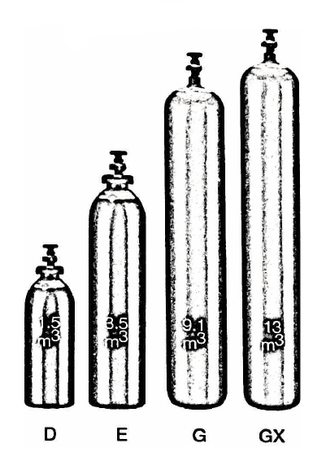

# Mixes

Container sizes may vary from state to state

|  |  |  |  |  |  |  |  |
| --- | --- | --- | --- | --- | --- | --- | --- |
| SPECIFICATION | | Mix 30 | | Mix 40 | | Mix 55 | |
| Cylinder contents (m3) (101.325 kPa at 150C) | | 2.0 | 5.2 | 2.0 | 4.9 | 2.0 | 6.0 |
| Water Capacity per cylinder (L) | | 15.4 | 34 | 15.4 | 34 | 15.4 | 34 |
| Cylinder Pressure (kPa) | | 13,400 | | 11,000 | 12,000 | 11,000 | 12,000 |
| Cylinder Colour | | Pewter Body/Green Grey Shoulder | | Pewter Body/Green Grey Shoulder | | Green Grey Body/Pewter Shoulder | |
| Outlet Connection | | Type 50 | | Type 30 | | | |
| Dimensions (mm) | Height  Diameter | 705  215 | 1335  215 | 705  215 | 1335  215 | 705  215 | 1335  215 |

Cylinder dimensions are approximate – variations may occur due to manufacturing tolerances

Height includes the valve

### Typical Analysis

|  |  |  |
| --- | --- | --- |
| PRODUCT NAME | CO2 | N2 |
| Mix 30 | 30% | 70% |
| Mix 40 | 40% | 60% |
| Mix 55 | 55% | 45% |

### Physical Characteristics

Appearance/Odour: Colourless and Odourless

### Typical Uses

Mix and CO₂ gases have been developed to meet the needs of hotels and clubs for:

* Dispensing beer and stout
* Soft drink
* Wine
* Juices

### Main hazards

Inhalation of Mix in high concentration is dangerous to respiration. At very high concentrations, leads to loss of consciousness and eventually death.

### Storage and handling

* Store cylinders upright in a cool, well ventilated area away from sources of heat and combustible materials.
* Protect cylinders, particularly the valve, against physical damage whether full or empty.
* Do not allow any part of the cylinder to be exposed to temperatures above 45°C.
* Check that cylinders are clearly labelled.
* Keep outlet seals in place on full cylinders.
* Close valves on empty cylinders.

N.B. Only regulators, manifolds and ancillary equipment, rated for the appropriate pressure and compatible with the relevant gas, shall be connected to or downstream of these cylinders.

### In case of leaks

* Remove to well ventilated area
* Stop leak if possible to do so
* Evacuate area away from direction of movement of gas.
* If leak cannot be stopped, move cylinder to a safe area and allow to empty.
* Return empty cylinders and pack to supplier with a note to confirm the leak occurred
* Notify emergency services if required