INFORMATION SHEET

UN No. 1013

Hazard No. 2(T)E

# Carbon Dioxide

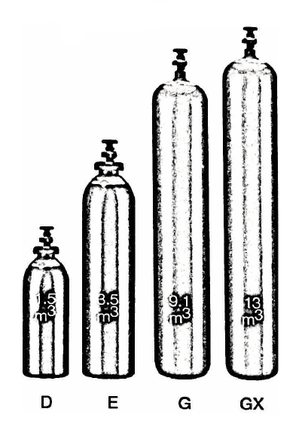

# Compressed

Container sizes may vary from state to state

|  |  |  |  |
| --- | --- | --- | --- |
| SPECIFICATION | | VT Cylinder | F Cylinder |
| Cylinder contents (m3) (101.325 kPa at 150C) | | 10 | 22 |
| Water Capacity per cylinder (L) | | 15 | 34 |
| Cylinder Pressure (kPa) | | 5,000 | |
| Cylinder Colour | | Green Grey | |
| Outlet Connection | | Type 30 | |
| Dimensions (mm) | Height  Diameter | 705  215 | 1335  215 |

Cylinder dimensions are approximate – variations may occur due to manufacturing tolerances

Height includes the valve

### Typical Analysis

|  |  |  |  |
| --- | --- | --- | --- |
| PRODUCT NAME | CO2 | O2 | Moisture |
| CO2 | 99.5% | < 30 ppm | < 20 ppm |

### Description

Carbon dioxide is a non-flammable gas which is odourless, colourless and non-toxic.

### Typical Uses

The food industries consume most of the carbon dioxide produced It is employed for:

* Carbonation of soft drinks, lemonade, soda, fruit juices etc.
* Recharging of natural mineral waters with carbon dioxide
* Conservation of wine, unfermented grape juice and various fruit juices
* Tapping of beer and prevention of oxidation through contact with the air.
* Accelerating the growth of farm produce as an atmosphere additive.

It is employed in the chemical industry in the following applications:

* Preparation of sodium carbonate, alkaline bicarbonates, lead carbonate and various organic substances (eg. salicylic acid).
* Neutralisation of sedentary alkalis
* Manufacture of foam rubbers
* Precipitation of lime after clarification of juices in the sugar industry
* Dehydration of penicillin
* Tanning of hides
* Production of paints and varnishes

### Main hazards

Inhalation of carbon dioxide in high concentration is dangerous to respiration. At very high concentrations, leads to less of consciousness and eventually death.

### Storage and handling

* Store cylinders upright in a cool, well ventilated area away from sources of heat and combustible materials.
* Protect cylinders, particularly the valve, against physical damage whether full or empty.
* Do not allow any part of the cylinder to be exposed to temperatures above 45°C.
* Check that cylinders are clearly labelled.
* Keep outlet seals in place on full cylinders.
* Close valves on empty cylinders.

### In case of leaks

* Remove to well ventilated area
* Stop leak if possible to do so
* Evacuate area away from direction of movement of gas.
* If leak cannot be stopped, move cylinder to a safe area and allow to empty.
* Notify emergency services if required