INFORMATION SHEET

UN No. 1046

Hazard No. 2(T)

# Helium

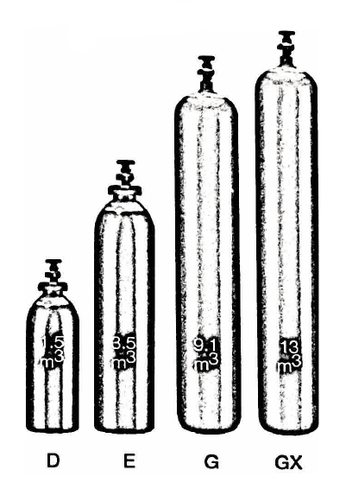

Container sizes may vary from state to state.

|  |  |  |  |  |  |
| --- | --- | --- | --- | --- | --- |
| SPECIFICATION | | CL Cyl. | D Cyl. | E Cyl. | **G** Cyl. |
| Cylinder contents (m3) (101.325 kPa at 150C) | | 0.6 | 1.2 | 3.5 | 9.1 |
| Water Capacity per cylinder (L) | | 4.6 | 10 | 23 | 50 |
| Cylinder Pressure (kPa) | | 16,500 | 14,000 | 16,500 | 20,000 |
| Cylinder Colour | | Brown | | | |
| Outlet Connection | | Type 10 | | | |
| Dimensions (mm) | Height  Diameter | 640  117 | 645  180 | 1000  220 | 1580  230 |

Cylinder dimensions are approximate – variations may occur due to manufacturing tolerances

Height includes the valve

### Typical Analysis

|  |  |  |  |  |  |
| --- | --- | --- | --- | --- | --- |
| PRODUCT NAME | He | N2 | O2 | Moisture | CxHy |
| UHP Heliun | >99.999% | < 5 ppm | < 2 ppm | < 3 ppm | < 0.5 ppm |
| HP Helium | >99.999% | < 10 ppm | < 5 ppm | < 20 ppm | - |
| Industrial Helium | >99% | - | < 1% |  | - |

### Description

Helium is a light, non-flammable gas which is colourless, odourless and tasteless. It is non-toxic and is almost a totally inert gas. Significantly is is lighter than air.

### Typical Uses

* Balloon inflation
* Welding gas mixtures
* Gas chromatography
* Glass production
* Leak detection
* Heat transfer
* Gas lasers
* Breathing gas mixtures
* Medical gas mixtures
* Scientific research
* Purging gas for metallurgical processes

### Main hazards

Helium is non-flammable. Although considered non-toxic, its presence in large quantities increases breathing rates and ultimately leads to paralysis of the respiratory system. Helium should never be allowed to escape in large quantities into confined spaces. Always ensure the cylinders are kept cool below 45°C . Store upright in a cool well ventilated area. Keep free from mechanical shock.

### Storage and handling

* Keep cylinders upright and protect the valves form physical damage. Secure cylinders when standing.
* Ensure storage area is well ventilated. Check regularly for leaks. Close all valves when not in use.
* Do not attempt to transfer contents from one cylinder to another without checking with Speed Gas for correct procedure.
* Close valves when not in use and when empty, check regularly for leaks.
* If valve is damaged, do not attempt to operate.
* If valve does not operate by hand, return the cylinder to the supplier (attach a “faulty” tag).

N.B. Only regulators, manifolds and ancillary equipment, rated for the appropriate pressure and compatible with the relevant gas, shall be connected to or downstream of these cylinders.

### In case of leaks

* If cylinder or pack is suspected of leaking, evacuate personnel from the direction in which the gas is likely to flow. Stop leak if possible.
* Major leaks should only be approached with breathing apparatus.
* If possible and if safe to do so, remove leaking cylinder or pack to a safe area outdoors and allow contents to empty into atmosphere.
* Return empty cylinders and pack to supplier with a note to confirm the leak occurred
* Notify emergency services if required