INFORMATION SHEET

UN No. 1072

Hazard No. 2(S)

# Oxygen

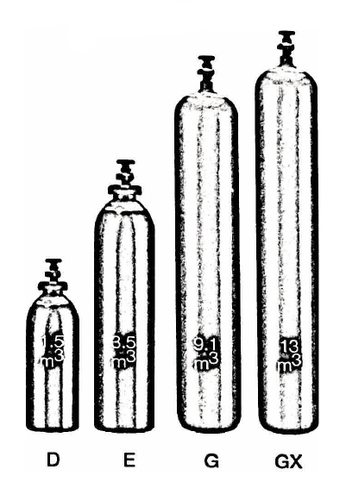

Container sizes may vary from state to state

|  |  |  |  |  |  |
| --- | --- | --- | --- | --- | --- |
| SPECIFICATION | | **D** Cyl. | **E** Cyl. | **G** Cyl. | |
| Cylinder contents (m3) (101.325 kPa at 150C) | | 1.5 | 4 | 8.9 | 10.3 |
| Water Capacity per cylinder (L) | | 10 | 23 | 50 | 50 |
| Cylinder Pressure (kPa) | | 14,300 | 16,500 | 17,900 | 20,000 |
| Cylinder Colour | | Black | | | |
| Outlet Connection | | Type 10 | | | |
| Dimensions (mm) | Height  Diameter | 645  180 | 880  204 | 1510  230 | |

Cylinder dimensions are approximate – variations may occur due to manufacturing tolerances

Height includes the valve

### Typical Analysis

|  |  |  |  |
| --- | --- | --- | --- |
| PRODUCT NAME | O2 | Moisture | CxHy |
| UHP Oxygen | >99.999% | < 3 ppm | < 0.5 ppm |
| HP Oxygen | >99.9995% | < 20 ppm | - |
| Industrial Oxygen | >99.5% | - | < 0.5 ppm |

### Description

Ovygen supplied in high pressure cylinders.

Oxygen is a colourless, odourless and tasteless gas.

### Typical Uses

* Oxy-Acetylene welding
* Flame cleaning
* Oxy cutting
* Flame heating
* Flame hardening
* Water treatment
* Chemical reactions requiring increased oxidation rates

### Main hazards

Oxygen is not flammable but supports combustion. Oxygen enrichment of the atmosphere, even by a few per cent, considerably increases the risk of fire. Materials not normally combustible in air may burn vigorously or even ignite without any apparent reason in enriched air.

### Storage and handling

* Store oxygen cylinders away from combustible materials.
* Ensure all cylinders are correctly labelled in accordance with Australian Dangerous Goods Code (Transport)
* Protect cylinders and particularly the valve from physical damage whether cylinder is full or empty.
* Store cylinders in a cool, well ventilated, spark free area below 45°C.
* External storage is preferred.
* Cylinders should never be carried or stored in unventilated areas, vans, cars, garages etc.
* Close valves when not in use and when empty, check regularly for leaks.
* If valve is damaged, do not attempt to operate.
* If valve does not operate by hand, return cylinder to supplier (attach a faulty cylinder tag).

N.B. Only regulators, manifolds and ancillary equipment, rated for the appropriate pressure and compatible with the relevant gas, shall be connected to or downstream of these cylinders.

### In case of leaks

* Shut off all engines, electrical equipment and other sources of ignition.
* No smoking or naked lights.
* If possible, use emergency equipment stops.
* Stops leaks if possible, especially in enclosed or inadequately ventilated rooms. Move people from area.
* Check all lines and equipment for leaks, with periodic rechecks. All fittings and connections should be properly fitted.
* If leak continues, move cylinder to a safe area and allow to empty.
* Return empty cylinders and pack to supplier with a note to confirm the leak occurred
* Notify emergency services if required