INFORMATION SHEET

UN No. 1006

Hazard No. 2(T)

Classification: As 4882-2003: SG-A-100

# Pure Argon

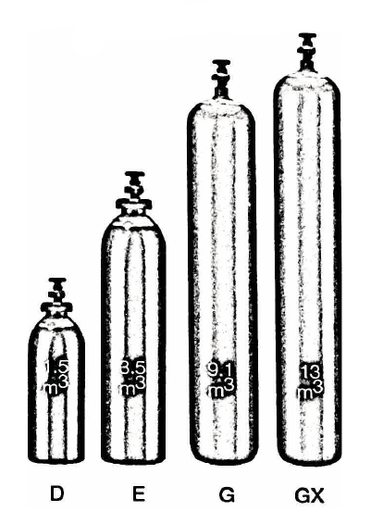

Container sizes may vary from state to state

|  |  |  |  |  |
| --- | --- | --- | --- | --- |
| SPECIFICATION | | **D** Cyl. | **E** Cyl. | **G** Cyl. |
| Cylinder contents (m3) (101.325 kPa at 150C) | | 1.5 | 6.8 | 10.5 |
| Water Capacity per cylinder (L) | | 10 | 23 | 50 |
| Cylinder Pressure (kPa) | | 14,100 | 30,000 | 19.800 |
| Cylinder Colour | | Peacock Blue | | |
| Outlet Connection | | Type 10 | | |
| Dimensions (mm) | Height  Diameter | 645  180 | 780  180 | 1510  230 |

Cylinder dimensions are approximate – variations may occur due to manufacturing tolerances

Height includes the valve

### Typical Analysis

|  |  |  |  |
| --- | --- | --- | --- |
| PRODUCT NAME | Ar | O2 | Moisture |
| UHP Argon | 99.999% | < 5 ppm | < 5 ppm |
| HP Argon | 99.995% | < 10 ppm | < 5 ppm |
| Industrial Argon | 99.99% | < 25 ppm | < 5 ppm |

### Description

Argon is a non-toxic, colourless, tasteless and odourless. Argon is the most profuse of the atmosphere’s rare gases. It is supplied in high pressure cylinders.

### Typical Uses

* G.M.A and G.T.A welding materials
* Inert atmospheres
* Filler gas in incandescent and neon lamps
* Plasma cutting (mixed with hydrogen)
* Gas chromatography
* Spectrometry

### Main hazards

Argon is non-flammable. Although non-toxic, its presence in large quantities can replace the amount of oxygen necessary to support life.

It should never be allowed to escape into confined spaces. Always ensure the cylinders are kept cool and below 45°C.

Store upright in cool, well ventilated area. Keep free from mechanical shock.

### Storage and handling

* Keep cylinders upright and protect the valves from physical damage. Secure cylinders when standing.
* Ensure storage area is well ventilated. Check regularly for leaks. Close all valves when not in use.
* Do not attempt to transfer contents from one cylinder to the other. Use regulators.
* Never apply lubricants to valves and regulators.
* If valve is damaged, do not attempt to operate.
* If valve does not operate by hand, notify the supplier and return the cylinder with “faulty” tag attached.

N.B. Only regulators, manifolds and ancillary equipment, rated for the appropriate pressure and compatible with the relevant gas, shall be connected to or downstream of these cylinders.

### In case of leaks

* Evacuate people from the direction of the gas flow.
* Stop leak if safe to do so.
* Do not approach a major leak without breathing equipment.
* If leak cannot be stopped and only if safe to do so, move cylinder to outdoor area and allow to empty.
* Return empty cylinders and pack to supplier with a note to confirm the leak occurred
* Notify emergency services if required