COMPUTER SCIENCE LEVEL 6
Perform Website Design

PRACTICAL ASSESSMENT Time: 3 HOURS

INSTRUCTIONS TO CANDIDATE

- In this practical assessment, you are required to perform the following task:
  - TASK 1: Design an Exam application Portal

  - TASK 2 : Develop a website

- You are provided with the following resources:

  - Computer installed with website development tools. (i.e. Notepad ++,Sublime text, Visual studio) and Local Host Servers( i.e. XAMPP, Wamp server)
  - Printer
  - Printing papers
- Create a Folder “CDACC NOV 2024” and save all your work

TASK 1: DESIGN AN EXAM APPLICATION PORTAL (30 MARKS)
You are required to design a website with a heading “Exam Application Portal” on the landing page similar to the output given below.
- Create HTML files;

  - index.html

  - Register.html

- Create a form named exam with a POST method in the index.html file.

- Add a fieldset whose width=40px to include all form controls as they appear on the output.
- Add restriction to ensure the Name filed input is mandatory.
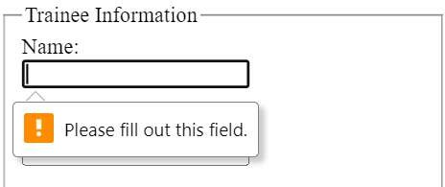
- Add the following options for selection in the department section.

  - ICT
  - Electrical
  - Computer Science
  - Health Science

- Add the following options for selection in the course section.

  - ICT Level 6
  - ICT Level 5
  - Computer Science Level 6
  - Health Science Level 6
- Add the following options for selection in the Exam Series section.
  - MARCH 2025

  - JULY 2025

  - NOVEMBER 2024

- Add another fieldset to implement the other form controls.

- Run the POST command onClick() method on the “SUBMIT” button.

- Ensure that the applicant gets a notification after successful application.

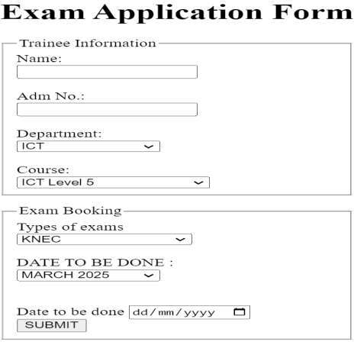
EXPECTED OUTPUT

TASK 2: DEVELOP A WEBSITE (20 MARKS)
You are required to design a website with a heading “Nyote Technical” on the landing page similar to the output given below.
- Create a website with the following page.

  - Home

  - Product

  - About

  - Contact

- Add contents on each web pages of at least 100 words.

- Blend the background colour of your choice to enhance formatting.

- Link all pages.

- Add a photo in the home page of your choice.

- Add email address, location and phone number on the contact page

- Screenshot the final output and print.

