## portfolio 1. part 2. Social Engagement experiment

[https://github.com/kurmie/Portfolio-1-Eye-tracking/blob/master/DataAnalysis.Rmd]

*Introduction*

The goal of this experiment was to demonstrate how the social engagement setting can affect the emotional response of a perceiver. The aspects of gender, ostentation and directedness/non-directedness were manipulated in the stimuli to achieve the goal of the experiment. The experiment participants were exposed to 8 video stimuli with different variations of these aspects: 4 videos demonstrating a male actor, 4 videos demonstrating a female actor. Moreover, the videos of each actor were further subdivided according to the ostentation, meaning elaborate acting, and directedness of the actors’ gaze.

The hypotheses were proposed at two levels, assuming that ostentation and directedness are adequate measures of the social engagement event, and dilation of pupils reflects emotional response:

Conceptual: Ostentation and directedness influence emotional responses of participants of the social engagement.

Operational: The participant’s pupil size will differ depending on ostentation and directedness of the actor

1. *Methods*

Data collection

The experiment took place in a lab room placed in a basement, so the lighting is assumed to be non-dependent on daylight and consistent across the participants. Every participant was seated approximately 30 cm in front of a 20-inch flat panel monitor. An Eye Link 1000 head mounted eye tracker was used to record monocular eye positions and pupil size data at 1000 Hz sampling frequency. Prior to exposing the participants to the experimental design, the eye-tracker was calibrated for every participant using the in-built nine-point automated calibration procedure, that was repeated if necessary. The validation procedure needed to report average errors below 1 and maximal error below 1.5 to successfully end the calibration procedure. Further the experimental paradigm was run as a PsychoPy implementation and time stamps for the initiation of stimulus exposure were recorded.

Participants

Participants of the experiment were looked at to evaluate if there are potential issues that might affect the quality of data, such as eyeglasses and lenses or presence of mascara. However, neither of factors performed as exclusion criteria. In total, there were six participants of the experiment, four of which were female. One of the participants wore glasses. All of the participants were Cognitive Science students in age range between 20 to 30 years old. The validation procedure reported that calibration process was finished with average errors below 1 for every participant (on average 0.87).

Data pre-processing

The recorded eye-tracking data (velocities, pupil size, and x and y coordinates) were automatically pre-processed using the in-built DataViewer software. Artifacts were removed. Eye-blinks, saccades and fixations were identified. The validation data were used to model measurement error and assess if any participants should be excluded. The data was high-pass filtered at a 100 s cut off to counter calibration drift. Systematic bias in fixation estimates on fixation crosses was estimated and positions were accordingly adjusted at every trial.

Data analysis

To test the operational hypothesis, the following measures were included in the data analysis:

|  |  |  |
| --- | --- | --- |
| Measure | Role | Reasoning |
| Pupil size | Outcome/dependent variable | It was selected as one of the main characteristics of emotional response to the social interaction |
| Ostentation | Predictor variable | Manipulation of this variable will show what effect an attitude of the actor towards a viewer has on the outcome variable |
| Directedness | Predictor variable | Manipulation of this variable will show what effect eye contact/gaze direction has on emotional engagement in the social event |
| Number of the trial | Predictor variable | It was used to control for the effect of familiarity and/or fatigue based on amount of time participants spent in the experimental setting |
| Gender of the participant | Predictor variable | It was used to control for the effect of gender on the measure of emotional arousal |
| Gender of the actor | Predictor variable | It was used to control for the effect of gender of the actor on the measure of emotional arousal of participants |
| Participant ID | Random effect | It was used to control for random effects of individual variation across participants |

Different combinations of predictor measures were considered in the number of models. The models for the first outcome variable, duration of fixations, are listed in the table below:

|  |  |
| --- | --- |
| № of a model | Formula |
| 1 | Pupil size = β0i + β1i Ostentation + β2i Directedness+ (1+Ostentation + Directedness| Participant ID) +ε |
| 2 | Pupil size = β0i + β1i Ostentation + β2i Directedness+ β3i Number of the trial + (1+Ostentation+Directedness+ Number of the trial | Participant ID) +ε |
| 3 | Pupil size = β0i + β1i Ostentation + β2i Directedness+ β3i Gender of the participant * Gender of the actor + (1+Ostentation+Directedness+ Gender of the participant * Gender of the actor | Participant ID) +ε |

The mixed effects models were selected as the most appropriate type of a model due to the presence of repeated measures per participant in the data and in order to control for random effects. The structure of the random effects was consistent in all models, allowing random intercepts for participants and random slopes for the predictors included in the model. An interaction model (3) was created. In the interaction model it was assumed that the effects of predictors influence each other: the effect of the gender of the participant has an influence on the effect of gender of the actor.

A 4-fold cross-validation model selection procedure was employed to identify which combination of parameters produces the best model. Cross-validation was stratified at the participant level and balanced across conditions. Out-of-sample error operationalized as root mean square error was used as the selection criterion. The model with the least root mean square error on the test data was selected as the best model and was ran on the full dataset to optimize parameter estimation.

The data analysis was performed using the statistical software of R studio (RStudio Team, 2015) on R (R Core Team, 2017). The data from the eye-tracker was cleaned up using packages readr version 1.1.1 (Wickham, Hester &amp;amp; Francois; 2017), and data.table version 1.10.4-3 (Dowle, Srinivasan &amp;amp; 2017). The generalized linear mixed effect models were designed by using packages lme4 (Bates, Maechler, Bolker &amp;amp; Walker, 2015), lmerTest (Kuznetsova, Brockhoff &amp;amp; Christensen, 2016). The cross-validation procedure was performed by using the package caret version 6.0-79 (Kuhn, 2018), and root mean square error was calculated by using the package Metrics version 0.1.3 (Hamner, Frasco, LeDell; 2017).

1. *Results*

The 4-fold cross-validation selection process yielded the following model performance results:

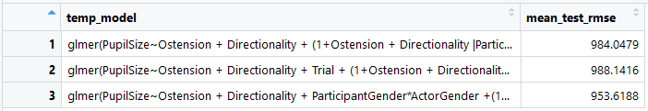

As can be seen in the results, the model 3 showed the lowest out-of-sample error. The parameters of the best model included ostension, directionality, and the participant’s and actor’s gender interaction, with an average root mean square error of 953.618 when performed on the test data.

The formula of the selected model is presented below.

*Pupil size = β0i + β1i Ostentation + β2i Directedness+ β3i Gender of the participant * Gender of the actor + (1+Ostentation+Directedness+ Gender of the participant * Gender of the actor | Participant ID) +ε*

Ostensive acting had a non-significant negative effect on the size of pupils of the participant (β = -0.0189, se = 0.0312, t-value = -0.608, p>0.05). Directedness towards 3rd person, and not towards the participant, had a non-significant negative effect on pupil size (β = -0.0383, se = 0.0381, t-value = -1.005, p>0.05). This means that the ostensive acting and directedness of the actor did not affect emotional response of the participant. However, the interaction effect of the participant’s and actor’s genders had a significant effect on pupil size (β = -0.0591, se = 0.0170, t-value = -3.468, p<0.05). This can be interpreted as pupil sizes were reduced in male participants when the male actor was presented.

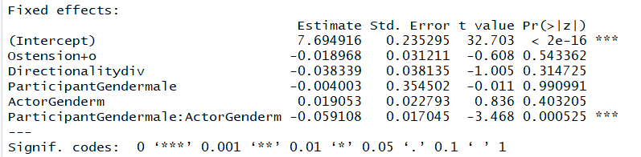

Plots

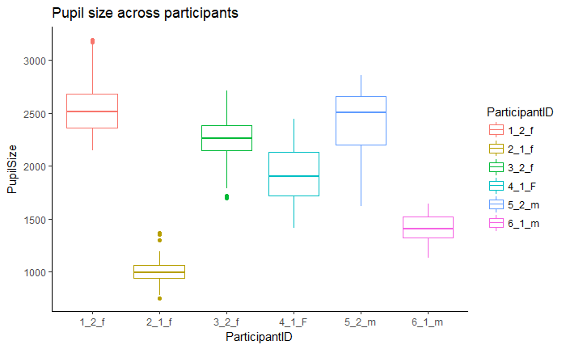

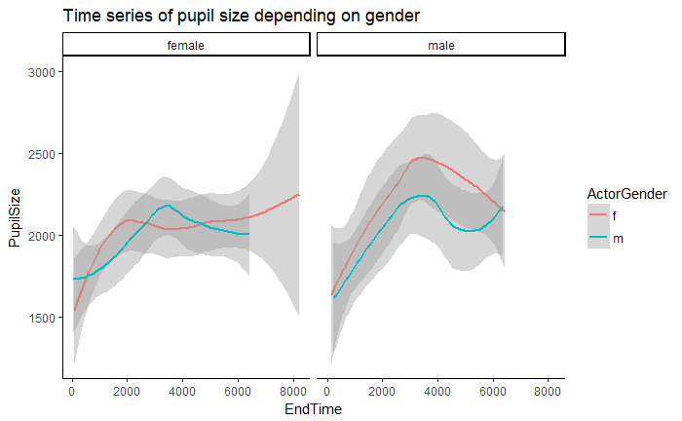

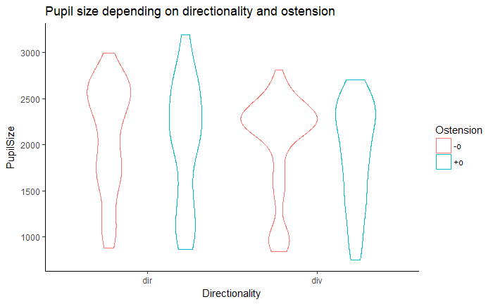

1. *Discussion*

The goal of the experiment was to analyze the differences in emotional response depending on aspects of a social engagement setting. Two variables were chosen to describe setting of social engagement event: ostension and directedness. One variable was chosen to describe emotional response: pupil size, i.e. dilation and contraction of the pupil. I.e. the differences in pupil size depending on the engagement aspects, if found, would confirm dependence of emotional response on these aspects.

The results revealed the effect of gender interaction between the actor and the participant, i.e. in males pupils dilated more in response to the actor of the opposite gender, and contracted in response to the actor of the same gender. However, the operational hypothesis was not confirmed by the results. Therefore, the conceptual hypothesis that emotional response can be altered by named aspects of the social engagement setting did not find support in the collected data.

The validity of the findings should be questioned due to serious limitations in terms of quantity of participants, or the power of the study, and possible methodological issues in model evaluation.