List of Practicals Using Open Office

For class - X

Assignment 5

Objective: Creating template in OO Writer and using it for creating certificates.
Task: Create the template as shown below in OO Writer using the instructions given below:

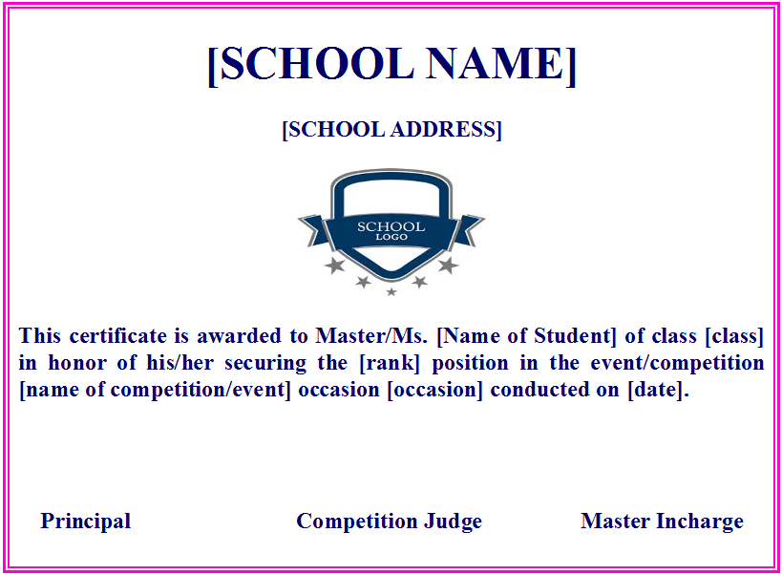
Instructions:
- Apply page borders as displayed in the screenshot. Apply border colour as per your choice.
- Page orientation must be landscape.
- Give your desired formatting for school name, school address, and text written in the certificate.
- Save your file as a template and give the name as certificate template.

Assignment 6

Objective: Data Consolidation.
Task: . Open OO Calc and do data consolidation as per instructions given below:

In Sheet 1, enter the data as shown below:
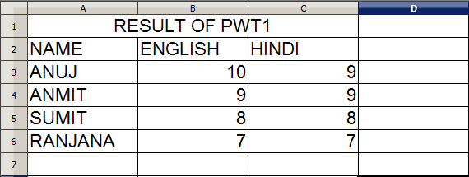
In Sheet 2, enter the data as shown below:
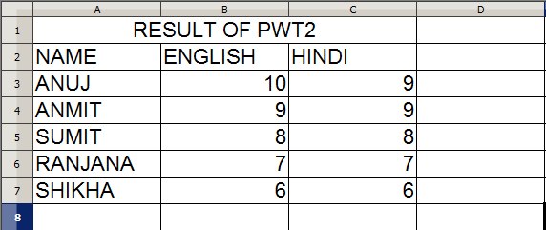
After creating these two worksheets perform data consolidation and create the consolidated worksheet as shown below.
Consolidated worksheet

