List of Practicals Using Open Office

For class - X

Assignment 7

Objective: Subtotals.
Task: Create a file SUBTOTALS in OO Calc and follow the instructions given below:
Enter the data in spreadsheet SUBTOTALS as shown below:
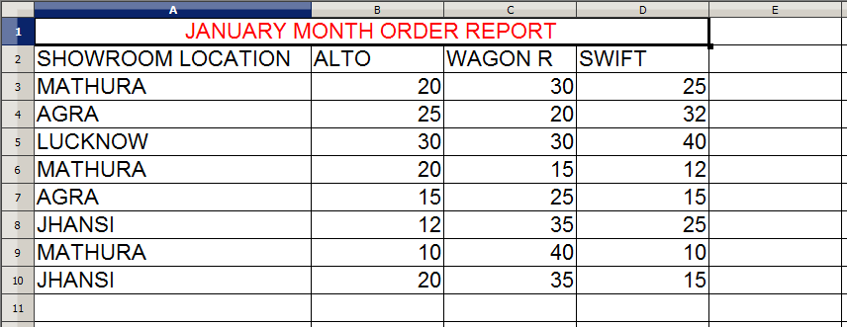
Display the sum of the Districts and the Grand Total using Subtotals feature of OO Calc.Your output should be as shown below:
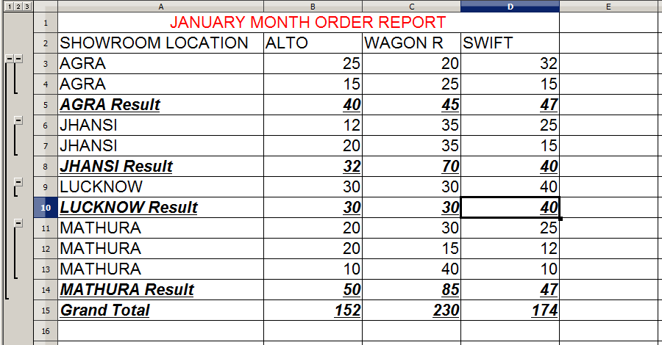

Assignment 8

Objective: Goal Seek.
Task: Create a file GOALSEEK in OO Calc and follow the instructions given below:

A student is planning her goals about the marks she should score in the upcoming 4th semester exams in order to achieve a distinction (75%). Assuming that examination of each subject is for 100 marks. Her result of previous semesters is given as under:
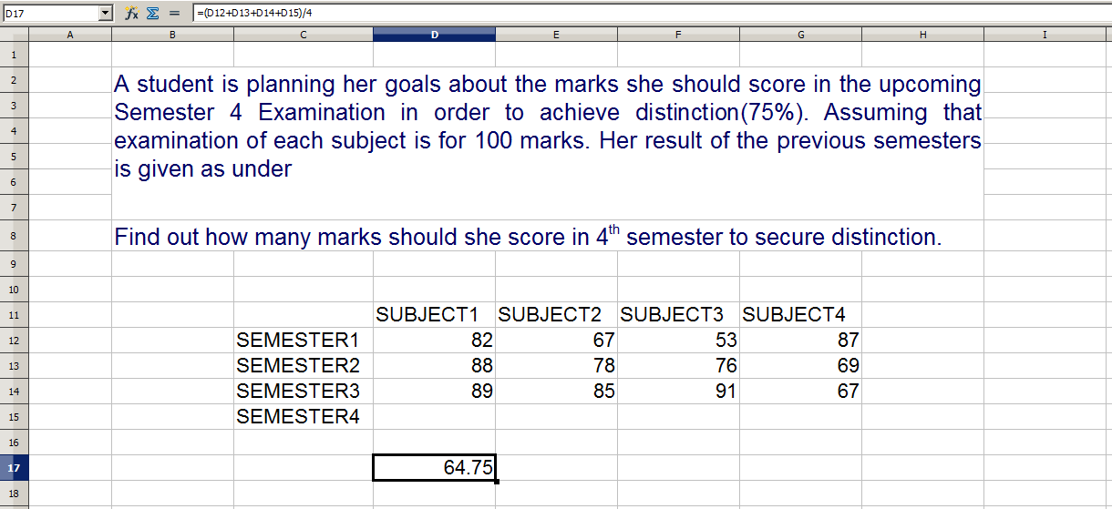
Find out how many marks should she score in 4th semester to secure distinction
The output should be:
