List of Practicals Using Open Office

For class - X

Assignment 9

Objective: Solver Tool.
- Task: Create a file SOLVER in OO Calc as shown below and follow the instructions given below:

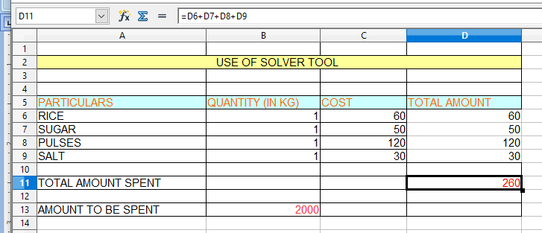
Using Solver Tool Change the Quantity of the items so that Total Amount should be 2000 instead of 260.
The Output should be:
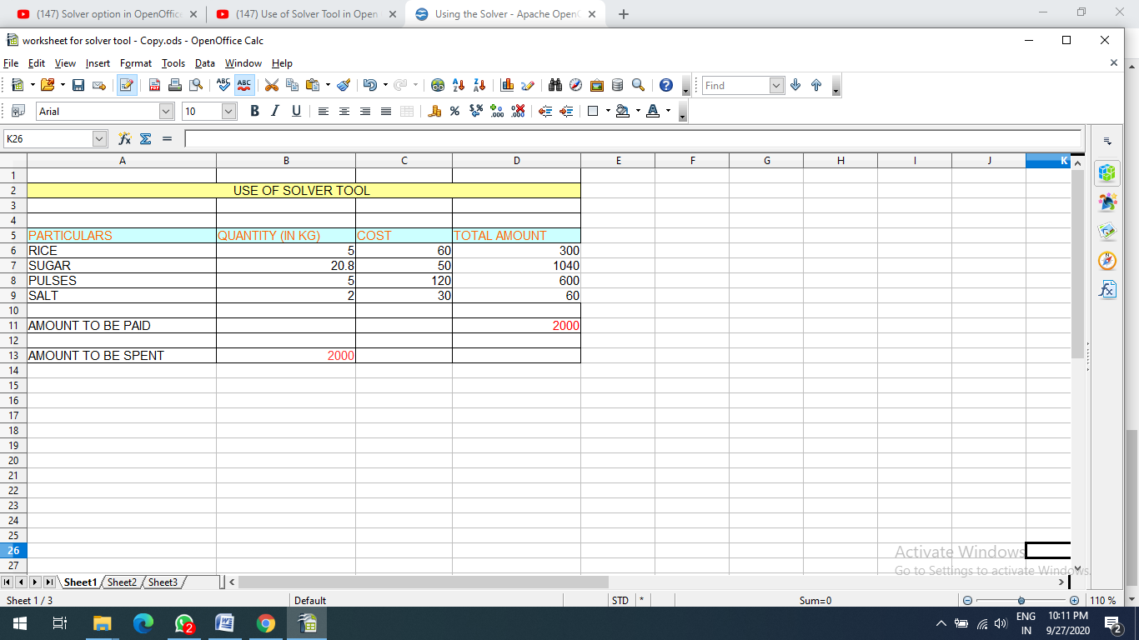

Assignment 10

Objective: What if Scenario
Task: Create a file Whatifscenario in OO Calc as shown below and follow the instructions given below:

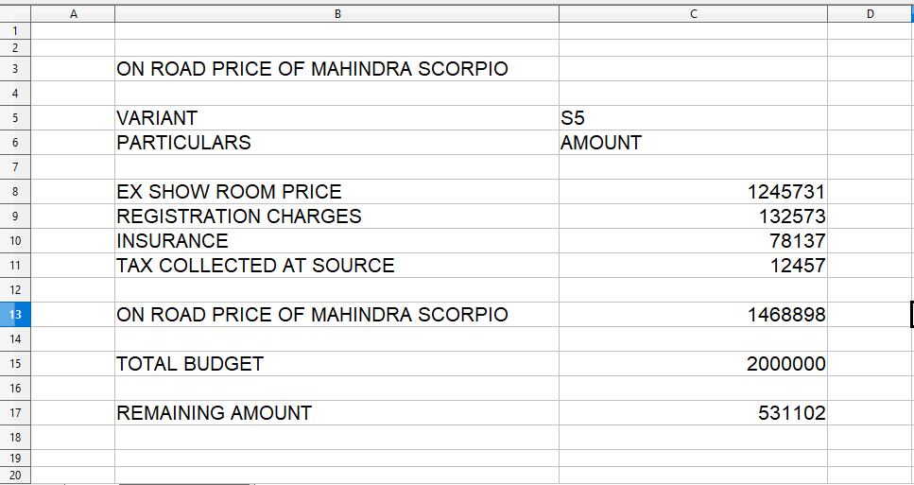
Create 3 variants of the car. According to the variant we will come to know what will be the On road price of the car and if my budget is Rs. 20 lakh, how much money will I be left with after making the payment for the car.
The Output will be: