List of Practicals Using Open Office

For class – X

Assignment 13

Objective: Table Creation in BASE

Task: Create a new database SCHOOL, create a table TEACHER in it using Design View with the following field names and their data types:

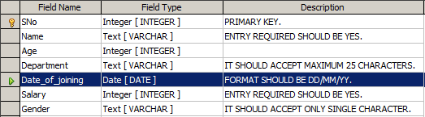
Enter the following data in the TEACHER table as shown below:

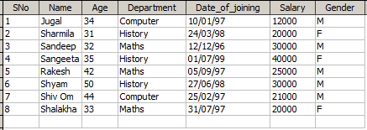

Assignment 14

Objective: To create queries using SQL commands.

Task: Using the Teacher Table created in assignment 13 perform the SQL Queries to extract the data from the table:

  - Write SQL commands for the following queries based on the table Teacher given below:

  - To show all information about the teacher of History department.

  - To list the names of female teachers who are in Maths department.

  - To list the names of all teachers with their date of joining in descending order.

  - To display teacher’s name, salary, age for male teachers only.

