List of Practicals Using Open Office

For class - X

Assignment 3:

Objective: Position the image with text
Task: Write the following paragraph and insert relevant image in a file and place it as displayed in the following screenshot.

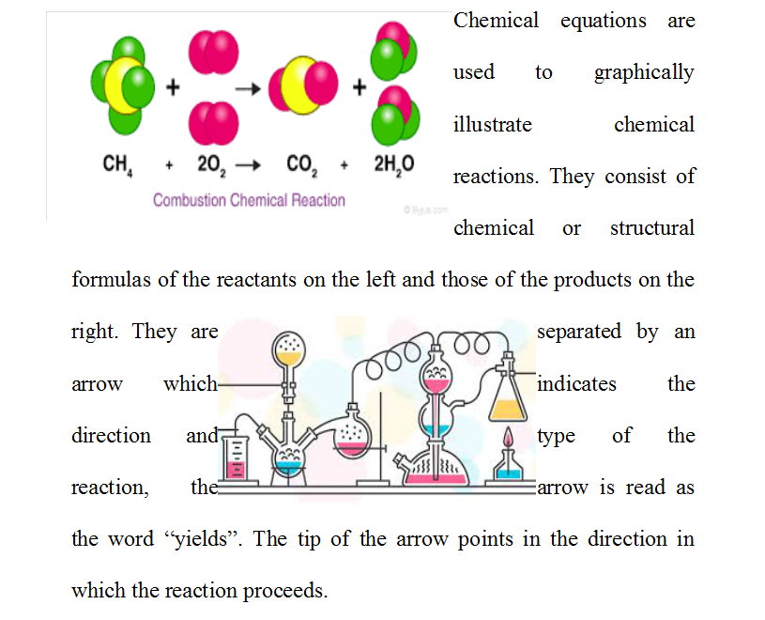

Assignment 4:

Objective: Use of styles and fill format to apply different styles in OO Writer document.

Task: Start OO Writer, type the following text and apply different inbuilt styles as marked in front of contents.

