**UNIT 3 - RELATIONAL DATABASE MANAGEMENT SYSTEMS (BASIC)**

**PAGE NO. 114-115**

Fill in the blanks:

1. A **TABLE** is an organized collection of data.

2. A **DBMS** is a software package that can be used for creating and managing databases.

3. A **RDBMS** is a database management system that is based on the relational model.

4.Three popular DBMS software are **OPENOFFICE BASE, MS-ACCESS & SQL.**

5. A **PRIMARY KEY** is a unique value that identifies a row in a table.

6. Composite Key is a combination of **MORE THAN ONE**  columns.

Short Answer Questions

1. What does DBMS stands for?

Ans. **DATA BASE MANAGEMENT SYSTEM**

2. What does RDBMS stands for?

**Ans. RELATIONAL DATABASE MANAGEMENT SYSTEM**

3. How is data organized in a RDBMS?

Ans. Data is organized in the form of tables which can be linked if required.

4.State the relationship and difference between a primary and foreign key?

Ans. A **primary key** acts as a unique identifier for each record meaning it uniquely identifies each row/record **in a** table. "A **foreign key**" is a field in one table that relates the tables together. The **primary key** attributes cannot have NULL values however; a **foreign key** can have a NULL value.

**PAGE NO. 129-130**

Fill in the blanks:

1. A table is a set of data elements that is organized using a model of vertical **COLUMNS** and horizontal **ROWS**.

2. A **COLUMN** is a set of data values of a particular type, one for each row of the table.

3. A **ROW or RECORD or TUPLE** represents a single, data item in a table.

4. **DATA TYPES** are used to identify which type of data we are going to store in the database.

5. There are **THREE** ways to create a table.

6. Field properties can be set in both the **DESIGN VIEW** and **in WIZARD**.

Short Answer Questions:

1. In how many ways tables can be created in Base?

Ans. In BASE, we can create tables in the following ways:

(i) using Design view.

(ii) using Wizard.

(iii) using SQL commands.

2. Why are data types used in DBMS /RDBMS?

Ans. Datatypes are used to identify which type of data (value) we are going to store in the database.

3. List datatypes available in Numeric Datatype?

Ans. 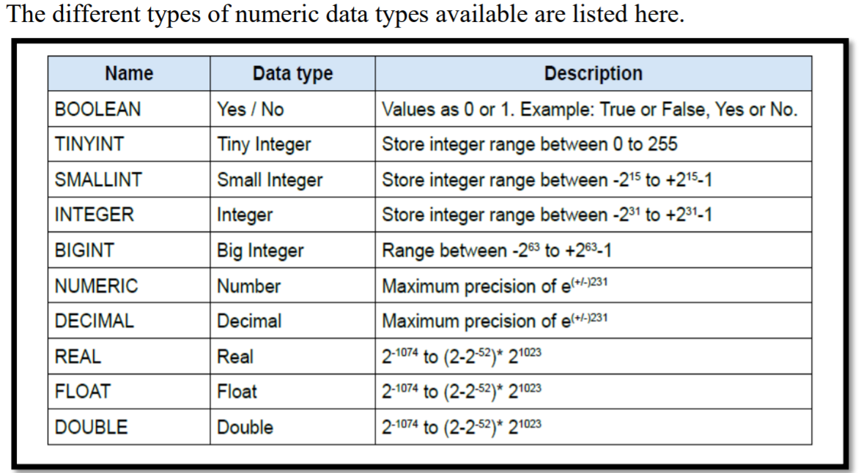

4. Define the structure of a table.

Ans. A table is a set of data elements (values) that is organized using a model of vertical columns(which are identified by their name) and horizontal rows. A table has a defined number of columns, but can have any number of rows. Each row is identified by the values appearing in a particular column identified as a unique key index or the key field.

5. Differentiate between Tuples and Attributes of a table.

Ans. Tuple represents one complete unit of information about an entity, one record(one row) in a table. Each row in a table represents a set of related data, and every row in the table has the same structure.

Attributes or Columns or Fields: An attribute is a set of data values of a particular type, one for each row of the table. For example, cFirstName, or cLastName are fields in a row.

6. List datatypes available in Alphanumeric Datatype?

Ans. 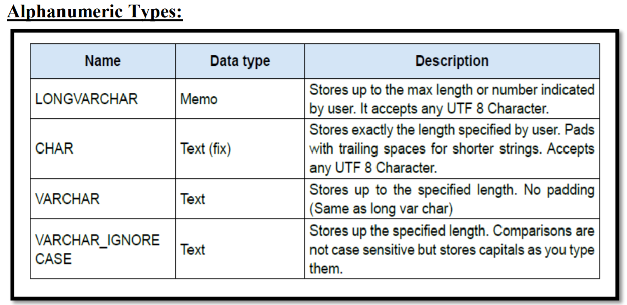

7. Name different Binary data types.

Ans. Different types of Binary data types are as follows:

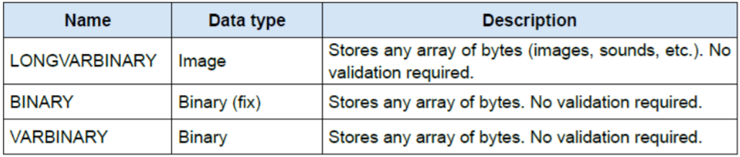

**PAGE NO. 139-140**

Fill in the blanks:

1. The types of languages used for creating and manipulating the data in the Database are **DDL** & **DML**.

2. A **Data Definition Language (DDL)** is a standard for commands that defineS the different structures in a database.

3. A **Data Manipulation Language (DML)** is a language that enables users to access and manipulate data in a database.

4. A **SELECT** is a part of DML involving information retrieval only.

5. A popular data manipulation language is **SQL**

6. **TABLES** are the basic building blocks of a database.

7. There are **THREE** types of Relationships in a table.

Short Answer Questions:

1. What is the file extension for databases created using OpenOffice.Org Base?

Ans .odb

2. List any three file formats that can be managed using OpenOffice.Org Base?

Ans. Three file formats that can be managed using OpenOffice.org base are:

\***.odt** – This file format is used by OpenOffice.org Writer application for creating documents. This is the counterpart of .doc extension of MS Word.

\***.ods** – This file format is used by OpenOffice.org Calc application for creating spreadsheets. This is the counterpart of .xls extension of MS Excel.

\***.odp** – This file format is used by OpenOffice.org Presentation application for creating presentations. This is the counterpart of .ppt extension of MS Powerpoint.

3.How many types of relationships can be created in Base? Explain each of the them.

Ans. There are three types of relationships which can be created in tables:

1. ONE to ONE

2. ONE to MANY OR MANY to ONE

3. MANY to MANY

**(i) One-to-one relationships :** In a one-to-one relationship, one record in a table is associated with one and only one record in another table. For example, in a school database, each student has only one student ID, and each student ID is assigned to only one person.

A one-to-one relationship looks like this in the relationships graph:

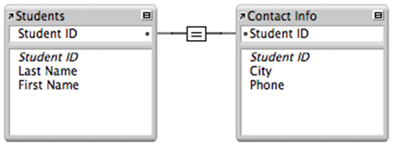

In this example, the key field in each table, Student ID, is designed to contain unique values. In the Students table, the Student ID field is the primary key; in the Contact Info table, the Student ID field is a foreign key.

This relationship returns related records when the value in the Student ID field in the Contact Info table is the same as the Student ID field in the Students table.

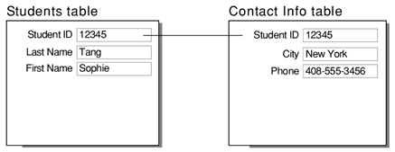

**One-to-many relationships**

In a one-to-many relationship, one record in a table can be associated with one or more records in another table. For example, each customer can have many sales orders.

A one-to-many relationship looks like this in the relationships graph:

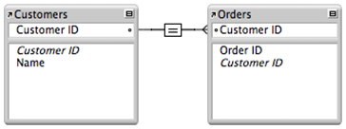

In this example the primary key field in the Customers table, Customer ID, is designed to contain unique values. The foreign key field in the Orders table, Customer ID, is designed to allow multiple instances of the same value.

This relationship returns related records when the value in the Customer ID field in the Orders table is the same as the value in the Customer ID field in the Customers table.

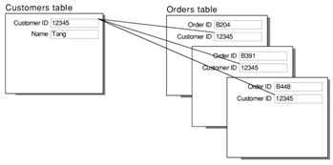

Because relationships work both ways, there are also many-to-one relationships.

**Many to Many Relationships**

A many-to-many relationship occurs when multiple records in a table are associated with multiple records in another table. For example, a many-to-many relationship exists between employees and projects: employees can work on various projects, and a project can have many employees working on it. Another example is the relationship between orders and product: you can order various products when placing an order, and each product is contained in zero or more orders.

Many-to many relationship between Employee and Project.



*Many-to many relationship between Employee and Project.*

Relational databases don't allow you to implement a direct many-to-many relationship between two tables because it is not possible to store the data efficient. For efficient processing, you can convert the many-to-many relationship tables into two one-to-many relationships by connecting these two tables with an intersection table that contains the keys of both tables.

4.What do you mean by Sorting? In how many ways it can be done?

Ans. Sorting means to arrange the data in either ascending order or descending order. Sorting can be done in two ways:

(i) Ascending order

(ii) Descending order

5.Explain Referential Integrity with the help of an example.

Ans. **Referential integrity** is a property of data stating that all its references are valid. In the context of [relational databases](https://en.wikipedia.org/wiki/Relational_database), it requires that if a value of one attribute (column) of a [relation](https://en.wikipedia.org/wiki/Relation_(database)) (table) references a value of another attribute (either in the same or a different relation), then the referenced value must exist.[[1]](https://en.wikipedia.org/wiki/Referential_integrity#cite_note-1)

For referential integrity to hold in a relational database, when a foreign key value is used it must reference a valid, existing primary key in the parent table. For instance, deleting a record that contains a value referred to by a foreign key in another table would break referential integrity.

In simple terms, 'referential integrity' guarantees that the target 'referred' to will be found. A lack of referential integrity in a database can lead relational databases to return incomplete data, usually with no indication of an error.

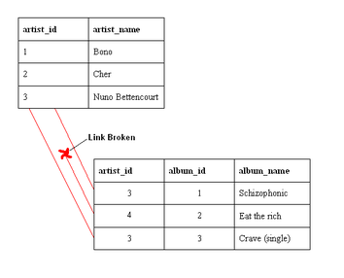

An example of a database that has not enforced **referential integrity**. In this example, there is a foreign key (artist_id) value in the album table that references a non-existent artist — in other words there is a [foreign key](https://en.wikipedia.org/wiki/Foreign_key) value with no corresponding [primary key](https://en.wikipedia.org/wiki/Primary_key) value in the referenced table. What happened here was that there was an artist called "[Aerosmith](https://en.wikipedia.org/wiki/Aerosmith)", with an artist_id of 4, which was deleted from the artist table. However, the album "[Eat the Rich](https://en.wikipedia.org/wiki/Eat_the_Rich_(Aerosmith_song))" referred to this artist. With referential integrity enforced, this would not have been possible.

**PAGE NO. 148**

Fill in the blanks:

1. A **TABLE** helps the user to systematically store information in the database. 2. A **DML command** enables users to view, enter, and change data directly in database objects such as tables.

3. **SELECT** statement retrieves zero or more rows from one or more database tables or database views.

4. By default, data is arranged in **ASCENDING** order using ORDER BY clause.

5. **UPDATE** statement is used for modifying records in a database.

6. **DELETE** statement is used to remove one or more records in a Database. Short Answer Questions:

1. (a) Name DML commands.

Ans. SELECT, INSERT, UPDATE, DELETE.

(b) Name DDL commands.

Ans. CREATE, ALTER, DROP(eg. DROP TABLE table_name)

2. What is the purpose of using queries?

Ans. A query can either be a request for data results from the database or for action on the data, or for both. A query can give us filtered data depending on the given conditions, can perform calculations, combine data from different **tables**, add, change, or delete data from a database.

3. Which clause of Select statement helps to display specific data?

Ans. WHERE clause.

4. Differentiate between Where and Orderby clause of SQL statements.

Ans. The SELECT statement has many optional clauses:

• WHERE specifies which rows to retrieve.

• ORDER BY specifies an order in which to return the rows.

5. State the purpose of Update Command with the help of an example.

Ans. Update statement is used for modifying records in a database.

The general syntax of the update statement is as follows:

UPDATE <table_name>

SET <column_name>= value [, column_name = value ...]

[WHERE <condition>];

Example : Change the price of mobile to 30000 and quantity to 6.

Ans. UPDATE ITEM SET Price=30000, Quantity=6

WHERE Itemname='MOBILE';

**PAGE NO. 161**

Fill in the blanks:

1. To create a form you need to select **FORMS** option available under Database section.

2. A **QUERY** helps to collect specific information from the pool of data in the database.

3. **REPORT** is used to display the display the summary of data.

4. **FORMS** are the interfaces with which the user interacts.

5. Data from multiple tables can be stored in **FORMS**.

Short Answer Questions:

1. Why there is a need to create Forms?

Ans. FORM is an interface in a user specified layout that lets users to view, enter, and change data directly in database objects such as tables or query. Data collected in forms can be passed to one or more than one Tables.

2. What is the purpose of creating Reports?

Ans. A report helps to display the data in a summarized manner. It is used to generate the overall work outcome in a clear format

3. What are the prerequisites to create a Form and Reports?

Ans. Tables or Queries are the prerequisites to create a Form and Reports.

4. Differentiate between Forms and Reports.

Ans. **Forms** allow both add data to tables and view data that already exists. Whereas **Reports** only helps to display the existing data from tables or queries in summarized manner.

5. Can a form displays data from queries?

Ans. Yes, forms can display the data from queries.

6. In how many ways Forms and Reports can be created in a database?

Ans. There are two ways to create a form in a database:

(i) Use wizard to create a form.

(ii) Create form in design view.

Report can be created by a single way i.e. Use wizard to create Report.