**Index**

This will be the initial page of our website.

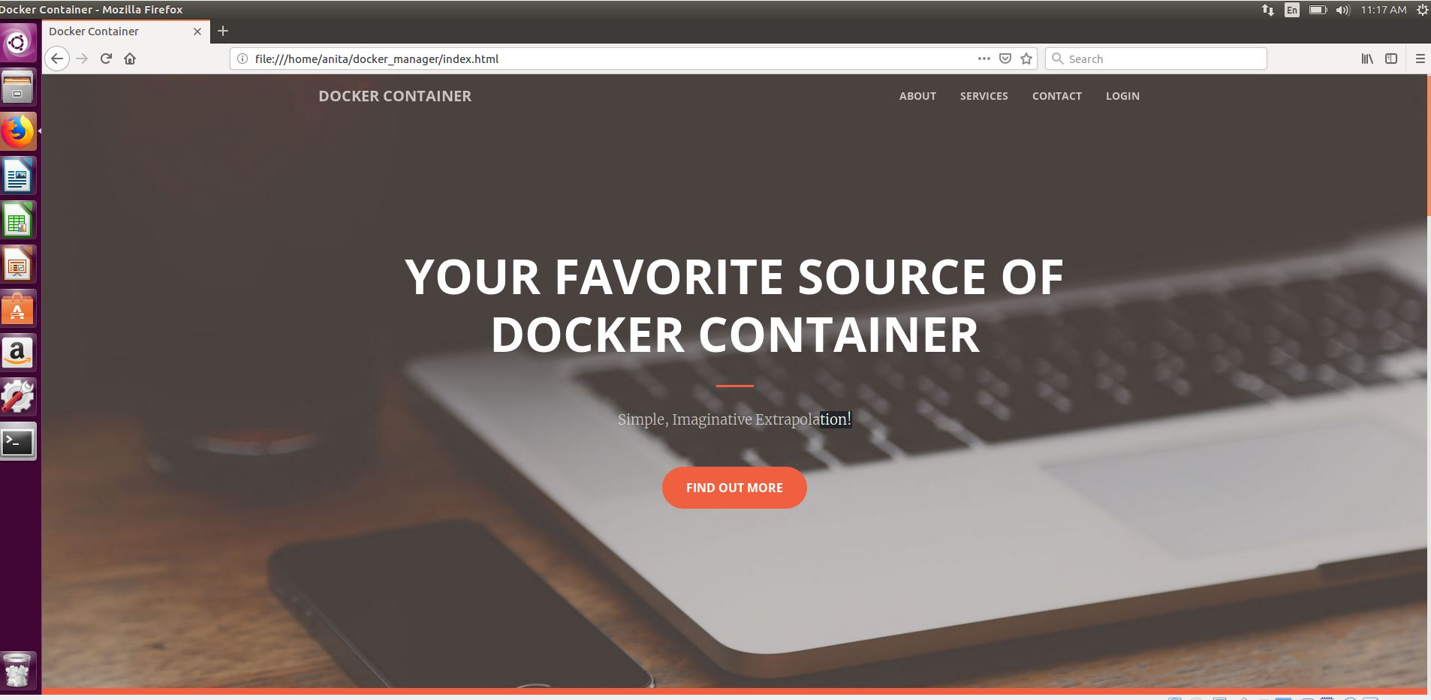

**About**

This will contain some information about the company providing containers

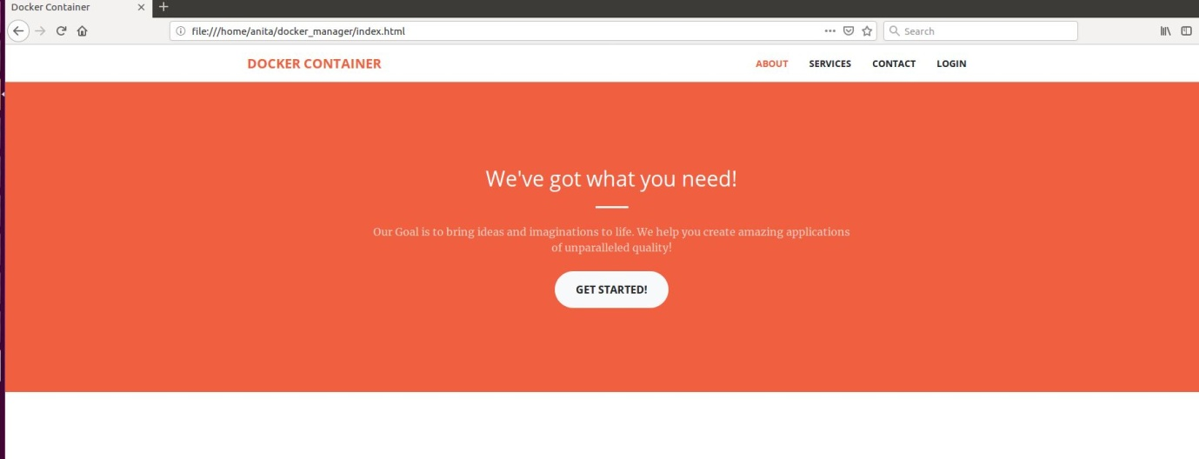

**Service**

This area will contain the services provided by the company. 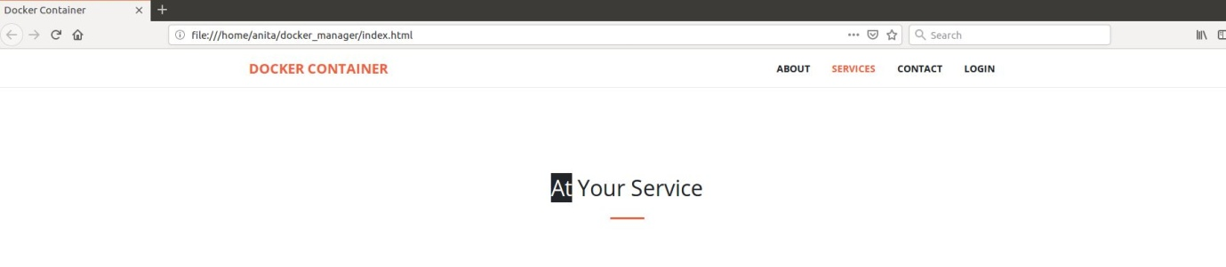

**Login**

Login page will help to log in and request their needs.

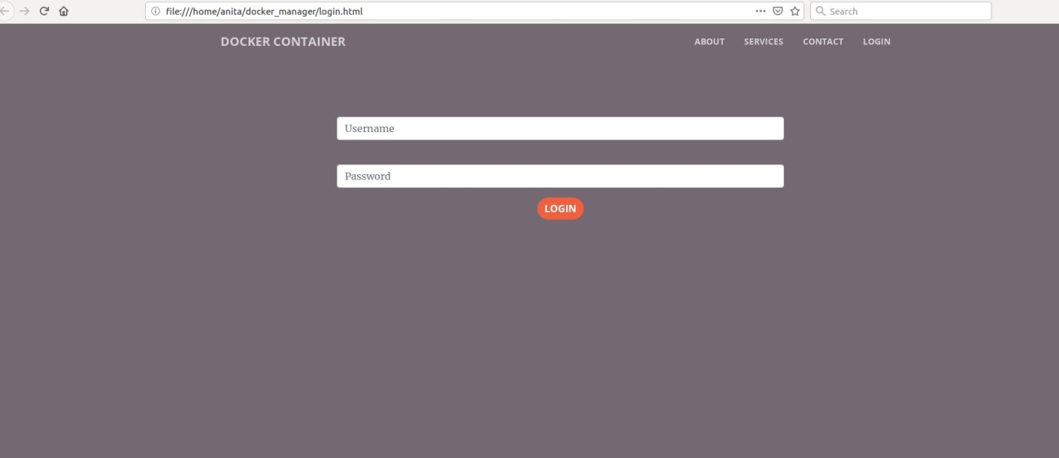

**Contact**

Contact details of the company.

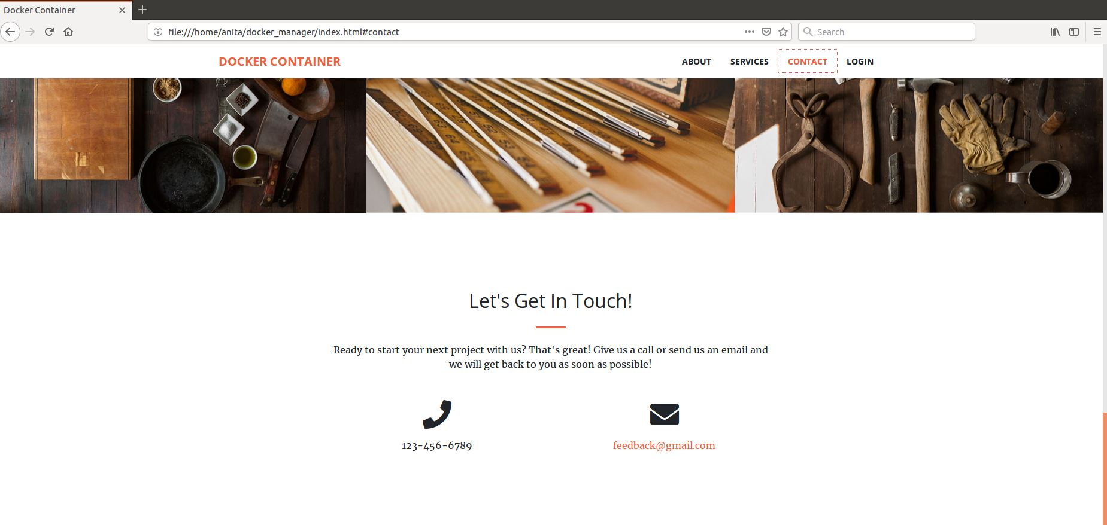

**Configuration**

After the customer login he will be asked for his requirements in this page

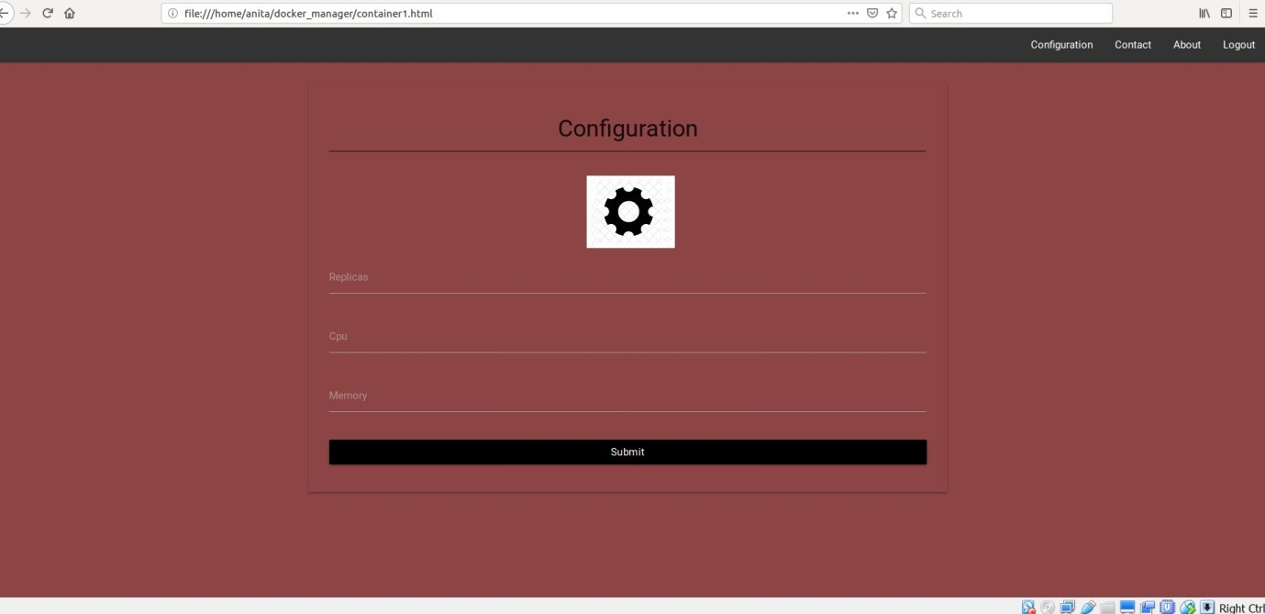

**Saved data**

The data submitted by the customers about their container requirements will be saved in this file.

