HTML Table Of Contents

1.HTML Introduction

**Introduction**

HTML5 is a cooperation between the World Wide Web Consortium

(W3C) and the WebHypertext Application Technology Working Group (WHATWG).

The new standard incorporates features like video playback and drag

And drop that have been previously dependent on third party browser plugins such as Adobe Flash, MicrosoftSilverlight, and Google Gears.

**Browser Support**

The latest versions of Apple Safari, Google Chrome, Mozilla Firefox, and Opera all support many HTML5 features and Internet Explorer 9.0 will also have support for some HTML5 functionality.

The mobile web browsers that come pre installed on iPhones, iPads, and Android phones all have excellent support for HTML5.

**New Features**

HTML5 introduces a number of new elements and attributes that can help you in building modern websites. Here is a set of some of the most prominent

features introduced in HTML5.

**New Semantic Elements:**

These are like <header>, <footer>, and <section>.

**Forms 2.0:**

Improvements to HTML web forms where new attributes have been introduced for <input> tag.

**Persistent Local Storage:**

To achieve without resorting to third party plugins.

**WebSocket :**

A next generation bidirectional communication technology for web applications.Server

**Sent Events:**

HTML5 introduces events which flow from web server to the web browsers and they are called Server Sent Events (SSE).

**Canvas:**

This supports a two-dimensional drawing surface that you can program with JavaScript.

**Audio & Video:**

You can embed audio or video on your web pages without resorting to third

party plugins.

**Geolocation:**

Now visitors can choose to share their physical location with your web application.

**Microdata:**

This lets you create your own vocabularies beyond HTML5 and extend your web pages with custom semantics.

**Drag and drop:**

Drag and drop the items from one location to another location on the same webpage

HTML5 comes with a lot of flexibility and it supports the following features

* Uppercase tag names.
* Quotes are optional for attributes.
* Attribute values are optional.
* Closing empty elements are optional.

**Structure of html5 document**

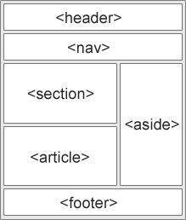

2.Tools & Editors

**HTML Editor**

HTML Editor - is the program you use to create and save your HTML documents.

Web Browser - is the program you use to view and test your HTML documents.

Editors

Text or Code-based Editors - which allow you to see the code as you are creating documents e.g. Notepad, WordPad etc., .

WYSIWYG Editors - show the results of the code, similar to the way it will appear in the browser e.g.., Netscape Composer, Microsoft FrontPage.

3.HTML Elements (Tags)

**Tags**

HTML Elements, also referred to as HTML tags, are enclosed by the less than (<) and greater than (>) brackets and may be written in capital or lowercase letters.

There are two types of tags :

• Container Tags

• Empty Tags.

Container Tags - are tags that contain both an on and an off tag.

<tagname>Content goes here...</tagname>

<p>My first paragraph.</p>

The **<p>** element defines a **paragraph**.

It has a **start** tag <p> and an **end** tag </p>.

The element **content** is: My first paragraph.

Empty Tags - are tags that have only an on tag and no off tag.

<br> is an empty element without a closing tag (the <br> tag defines a line break).

Empty elements can be "closed" in the opening tag like this: <br />.

## 4.HTML Attributes

**Attributes**

* All HTML elements can have **attributes**
* Attributes provide **additional information** about an element
* Attributes are always specified in **the start tag**
* Attributes usually come in name/value pairs like: **name="value"**

## **The lang Attribute**

The language of the document can be declared in the **<html>** tag.

The language is declared with the **lang** attribute.

Declaring a language is important for accessibility applications (screen readers) and search engines:

For e.g.

<!DOCTYPE html>

<html lang="en-US">

<body>

</body>

</html>

## **Use Lowercase Attributes**

The HTML5 standard does not require lowercase attribute names.

The title attribute can be written with uppercase or lowercase like **title** or **TITLE**.

## **Quote Attribute Values**

The HTML5 standard does not require quotes around attribute values.

Example

<p title="My First Page">

This is a paragraph.

</p>

5.HTML Editing Commands

Editing: Headlines

<H> – Actually represents a group of six different tags, each one stands for a different headline size. H1 is the largest size, while the fonts gradually decrease in size as one moves to the smallest size - H6.

For example: <HTML>

<BODY>

This is normal size text.

<H1>This is the largest headline. </H1>

<H3>This is the size of headline H3</H3>

<H5>While this is H5</H5>

</BODY>

</HTML>

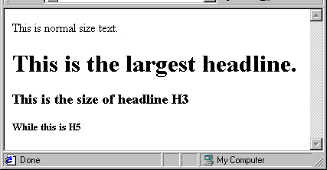

Editing: Text Flow

* Line breaks in HTML code are interpreted by browsers as spaces.Tags such as <P> <DIV> and <BR> enable us to force new lines.
* <P> and <DIV> also allow us to control paragraph alignment.
* <P> – Begins a new paragraph.
* Main attributes:
  + ID - Labels the element with a unique identifier.
  + ALIGN - Aligns the paragraph content to the left, right or center. The default is left alignment.

Example:

<P ID="LangArticle"> Language is not only made up of words!

<P align=center> As surprising as it may sound, expressions, accent, culture and even manners are of no less importance than words…

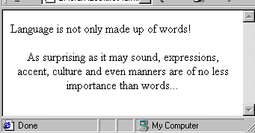

* <DIV> tag is used *to group the large section of HTML elements together*.

The div tag is generally used by web developers to group HTML elements together and apply CSS styles to many elements at once.

Example:-

<div style="border:1px solid pink;padding:20px;font-size:20px">

<p>Welcome to Amber Academy, Here you get Information on latest technologies.</p>

<p>This is second paragraph</p>

</div>

O/P



* <BR> – Breaks the current line of text.

For example:

By merging both the fantastic and the realistic, Gabriel Garcia Marquez <BR> is able to turn his books into a fascinating experience.

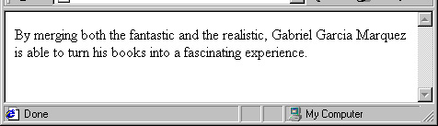

* <PRE> – Forces text to be displayed exactly as set by the page author, which means that line breaks occur whenever they appear broken in the code, etc.

The following slide presents an example:

<PRE>

This is first line

This is second line

</PRE>

O/P



6.HTML Formatting

* <B> - Designates text that should be displayed in boldface.

For example: What does <B>that</B> have to do with <B>this</B>?.

What does **that** have to do with **this**?.

The <B> tag does not force spaces:

For example: <B>you</B>-niversity.com

**you**-niversity.com

* <I> - Designates italicized text .
* <U> - Underlines the text enclosed within the start and end tags.

For example: This is <I>italicized</I>, while this is <U>underlined</U>.

This is *italicized*, while this is underlined.

* <FONT> - Changes the font of the text. Main attributes:
  + SIZE – Value may be fixed(1,2, ... 7)

<FONT SIZE=“2">text size is 2</FONT>

* + COLOR – Value may be one of a set of predefined color names (red, blue...), or a string with the hash sign (#) and a 6 digit hexadecimal RGB (#FF0000, #0000FF).

<FONT COLOR="BLUE">blue colored text</FONT>

* + FACE - Indicates font type such as: Times New Roman, Monospace, serif, Courier, Ariel, etc.

<FONT FACE="MONOSPACE">This text is monospace</FONT>

For example:

<FONT FACE="monospace">This font is

monospace.</FONT><BR>

<FONT SIZE="+1">This is the default font, its size is 4</FONT><BR>

<FONT SIZE="4" FACE="monospace">This is monospace size4!

</FONT><BR>

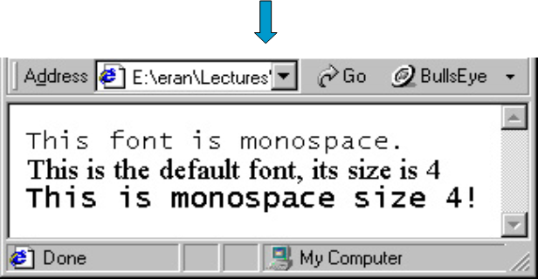

* <strong> - Important text
  + The HTML **<strong>** element defines **strong** text, with added semantic "strong" importance.
* <em> - Emphasized text
  + The HTML **<em>** element defines *emphasized* text, with added semantic importance.
* <mark> - Marked text
  + The HTML **<mark>** element defines marked or highlighted text:
* <small> - Small text
  + The HTML **<small>** element defines smaller text:
* <del> - Deleted text
  + The HTML **<del>** element defines deleted (removed) text.
* <ins> - Inserted text
  + The HTML **<ins>** element defines inserted (added) text.
* <sub> - Subscript text
  + The HTML **<sub>** element defines subscripted text.
* <sup> - Superscript text
  + The HTML **<sup>** element defines superscripted text.

**Note:** Browsers display <strong> as <b>, and <em> as <i>. However, there is a difference in the meaning of these tags: <b> and <i> defines bold and italic text, but <strong> and <em> means that the text is "important".

7.HTML Comments

You can add comments to your HTML source by using the following syntax:

<!-- Write your comments here -->

### **Example**

<!-- This is a comment -->

<p>This is a paragraph.</p>

<!-- Remember to add more information here -->

8.HTML Links

* <A> – It is used to create a hyperlink – which is used to link from one page to another.
* Example:-

Let’s go <A HREF="http//www.yahoo.com”>to YAHOO</A>.

Will result in: Let's go to YAHOO.

When the "to YAHOO" is clicked, the current page will be replaced with the home page of Yahoo!'s Web site

* Another <A> tag attribute is TARGET:

TARGET – Determines where the destination document will be displayed. The options are:

<a target="_blank|_self|_parent|_top|*framename*">

Within the current window or frame - this is the default (_self).

In another window - (_blank) Opens the linked document in a new window or tab

(_parent) - Opens the linked document in the parent frame

(_top) - Opens the linked document in the full body of the window

* <A> – It is used to create a Bookmark
  + HTML bookmarks are used to allow readers to jump to specific parts of a Web page.
  + Bookmarks can be useful if your webpage is very long.
  + To make a bookmark, you must first create the bookmark, and then add a link to it.
  + When the link is clicked, the page will scroll to the location with the bookmark.

## **Example**

First, create a bookmark with the id attribute:

<h2 id="C4">Chapter 4</h2>

Then, add a link to the bookmark ("Jump to Chapter 4"), from within the same page:

<a href="#C4">Jump to Chapter 4</a>

Or, add a link to the bookmark ("Jump to Chapter 4"), from another page:

<a href="html_demo.html#C4">Jump to Chapter 4</a>

* HTML Image Links

It's simple to use an image as hyperlink. We just need to use an image inside hyperlink at the place of text as shown below:

Example

<!DOCTYPE html>  
<html>  
<head>  
<title>Image Hyperlink Example</title>  
</head>  
<body>  
<p>Click following link</p>  
<a href="https://www.AmberAcademy.com" target="_self">   
 <img src="/images/logo.png" alt="Amber Academy" border="0"/>   
</a>  
</body>  
</html>

* HTML Email Links

HTML <a> tag provides you option to specifiy an email address to send an email. While using <a> tag as an email tag, you will use **mailto:email address** along with *href* attribute. Following is the syntax of using **mailto** instead of using http.

<a href= "mailto:abc@example.com">Send Email</a>

Now if a user clicks this link, it launches one Email Client ( like Lotus Notes, Outlook Express etc. ) installed on your user's computer.

9.HTML Images

Inserts a graphic image into an HTML document.

The <img> tag is empty, it contains attributes only, and does not have a closing tag.

* src - attribute specifies the URL (web address) of the image:
* WIDTH / HEIGHT – Indicates width and height. Given in:

Number of pixels – for a fixed result or,Percentage – for a dynamic fit.

* alt -The alt attribute provides an alternate text for an image, if the user for some reason cannot view it. If a browser cannot find an image, it will display the value of the alt attribute:

<img src="*url*" alt="*some_text*" width="128" height="128">

Image Maps

* An image map is defined in two parts:
* The <MAP> tag is used to define the division into different areas.
* The USEMAP attribute is added to the <IMG> tag to connect the image to the map.

The <MAP> tag:

* Is used to enclose the area of the map.

Requires the NAME attribute, which assigns a name to the map and links it to the image

The <AREA> tag:

* Defines an area within the map, as well as an action to be taken when the area is clicked.

Main attributes:

ALT – The label or “Tooltip”, which will appear when the mouse passes over the area.

SHAPE – Defines the area’s shape.

Possible values: circ/circle, poly/polygon, rect/rectangle.

COORDS - Defines the coordinates according to the area’s shape:

circ/circle - X, Y (for the circle’s center) and R (the radius in pixels).

poly/polygon - “X1,Y1,X2,Y2...Xn,Yn.” (n>=3).

Each pair of X & Y coordinates defines one vertex of the polygon.

The polygon is automatically closed (by the definition of the first and last points).

rect/rectangle – “X1,Y1,X2,Y2”. Each pair of coordinates defines one end of the rectangle’s diagonal.

HREF – Defines the URL of the target to be retrieved when

the area’s region is clicked.

In addition, event handlers such as OnMouseOver, OnMOuseOut, etc., can be used.

It is also possible to create the map through the use of a graphic tool that calculates the area’s coordinates.

The USEMAP attribute is added to the <IMG> tag to associate the image with the correct map.

The value of USEMAP is a map name preceded by the hash sign (#).

### **Example**

<img src="planets.gif" alt="Planets" usemap="#planetmap" style="width:145px;height:126px;">

<map name="planetmap">

<area shape="rect" coords="0,0,82,126" alt="Sun" href="sun.htm">

<area shape="circle" coords="90,58,3" alt="Mercury" href="mercur.htm">

<area shape="circle" coords="124,58,8" alt="Venus" href="venus.htm">

</map>

10.HTML Lists

* <UL> - Introduces an unordered (bulleted) list. A list is made up of list Items, each defined by an <LI> tag.

Example - a list of ice cream flavors:

<H4>My Flavors</H4>

<UL>

<LI> Vanilla

<LI> Banana

<LI> Strawberry

<LI> Chocolate

<LI> Lemon

</UL>

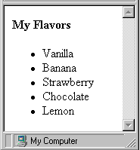

Example – A more complex list, made up of the ingredients of concrete:

<UL>

<LI>Dry Mixture:

<UL>

<LI>Cement.

<LI>Aggregates:

<UL>

<LI>Gravel.

<LI>Sand.

</UL>

</UL>

<LI>Water </UL>

TYPE – Through the use of this attribute, the bullet type of an unordered list can easily be changed to one of the three following options:

Circle (default)

Disc

Square

Example:

<UL type=square>

<LI> This is a square bullet.

</UL>

* <OL> - Introduces an ordered (i.e., a numbered) list, which also consists of a list of items defined by using the <LI> tag.
  + The type of numbering for an ordered list can be defined using

the TYPE attribute.

* + Possible values are:
    - A – Upper case letters (A,B,C,D…).
    - a – Lower case letters (a,b,c,d...).
    - I – Capital Roman numerals(I,II,III,IV…).
    - i – Lower case Roman numerals(i,ii,iii,iv …).
    - 1 – Numerals (1,2,3,4…).
  + The TYPE attribute may be used with:
    - An <OL> tag to set the numbering type for the list, or
    - An <LI> tag to set the numbering type from that item onwards.

<OL TYPE = I>

<LI><B>Canada:</B>

<OL TYPE = A >

<LI><B>Area(sq km):</B>9,975,000.

<LI><B>Languages:</B>

<OL>

<LI>English.

<LI>French.</LI>

</OL>

<LI><B>Currency:</B> Canadian Dollar.</LI>

</OL>

<LI><B>France</B>

<OL Type = A>

<LI><B>Area(sq km):</B> 551,000.

<LI><B>Languages:</B> French.

<LI><B>Currency:</B>French Franc.</LI>

</OL>

</OL>

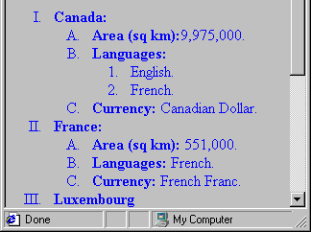

* <dl>- provides a layout that is similar to dictionary format.
  + <DL> – Brackets the definition list.
  + <DT> – Marks an item or term in the definition list.
  + <DD> – Marks the definition of previous DT terms.

<H3>Bridge Terms Definitions:</H3>

<DL>

<DT>Bid

<DD>Initial declaration of all players

based on their cards.

<DT>Pass

<DD>Must be your declaration in the event that you do not have at least 12 points.

<DT>Trump

<DD>Your strongest card type (it could be spade,

diamond, heart or club). You may declare

trump only if you have at least 4 cards of

this type.

</DL>

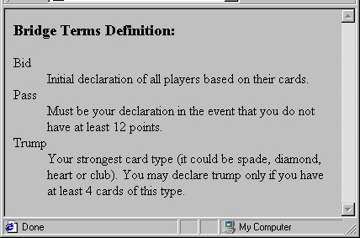

An example of a bulleted list with an image:

<H5>My Hobbies:</H5>

<DL>

<DT><IMG SRC="Bullet_d.Gif" > Swimming.

<DT><IMG SRC="Bullet_d.Gif" > Reading books.

<DT><IMG SRC="Bullet_d.Gif" > Dancing.

</DL>

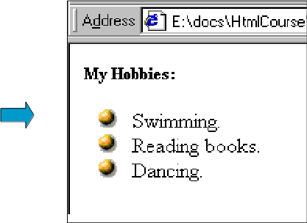

11.HTML Tables11.HTML Tables

<TABLE> Tag – Displays a table in an HTML page.

Main attributes:

BORDER – the size of the line that surrounds the table and its cells. Measured in pixels.

BORDERCOLOR – the color of the table’s border.

CELLPADDING – the size of the space between the cell’s edge and its content.

CELLSPACING – the size of the space between the cells.

BGCOLOR - the color of the background.

The <TABLE> tag defines a table, but HTML provides additional tags for setting the table’s label, rows and columns:

<CAPTION> - Sets the table’s caption. It must be bracketed between the <TABLE>, </TABLE> tags.

<CAPTION ALIGN=center VALIGN=bottom>Sample1</CAPTION>

<TR> – Establishes a new row in the table.

Main attributes for <TH> and <TD> tags:

BGCOLOR - Indicates a cell’s background color.

COLSPAN – Indicates the number of columns across which the cell extends. (See advanced table sample.)

ROWSPAN – Indicates the number of rows through which the cell extends. (See advanced table sample.)

ALIGN - Indicates how the text within the cell will be aligned.

Example:

<TABLE BORDER=2 BORDERCOLOR=BLACK CELLSPACING=0>

<CAPTION VALIGN=BOTTOM>first table sample</CAPTION>

<TR>

<TH>Name</TH>

<TH>Age</TH>

<TH>League</TH>

<TH>Category</TH>

</TR>

<TR>

<TD>Tamar Amnon</TD>

<TD>27</TD>

<TD>Hapoel TA</TD>

<TD>Advanced</TD>

</TR>

</TABLE>

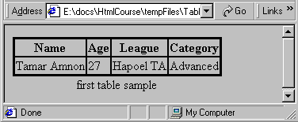

Illustrates the COLSPAN attribute.

The following code creates the third row of the table in the advanced table sample:

…<TR>

<TH>Languages</TH>

<TD>English, French</TD>

<TD COLSPAN=2 ALIGN=CENTER>French</TD>

<TD>French, German, Italian, Romansch</TD >

</TR> …

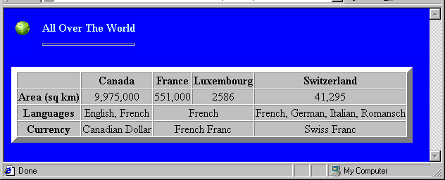

* An important reason for using tables is to order items on a page.
* HTML’s default sorting places items one after the other. Arranging them in a table allows you to sort them in additional ways.

## Table Header, Body, and Footer

## Tables can be divided into three portions: a header, a body, and a foot. The head and foot are rather similar to headers and footers in a word-processed document that remain the same for every page, while the body is the main content holder of the table.

## The three elements for separating the head, body, and foot of a table are:

## <thead> - to create a separate table header.

## <tbody> - to indicate the main body of the table.

## <tfoot> - to create a separate table footer.

## A table may contain several <tbody> elements to indicate different pages or groups of data. But it is notable that <thead> and <tfoot> tags should appear before <tbody>

<!DOCTYPE html>  
<html>  
<head>  
<title>HTML Table</title>  
</head>  
<body>  
<table border="1" width="100%">  
<thead>  
<tr>  
<td colspan="4">This is the head of the table</td>  
</tr>  
</thead>  
<tfoot>  
<tr>  
<td colspan="4">This is the foot of the table</td>  
</tr>  
</tfoot>  
<tbody>  
<tr>  
<td>Cell 1</td>  
<td>Cell 2</td>  
<td>Cell 3</td>  
<td>Cell 4</td>  
</tr>  
</tbody>  
</table>  
</body>  
</html>

The <thead>, <tbody>, and <tfoot> elements will not affect the layout of the table by default. However, you can use CSS to style these elements.

12.HTML Forms

* Forms were designed to allow the viewer of HTML pages to send information to server applications.
* A form defines a collection of input items that can be user-defined values. The form includes a means of submission (usually a submit button), which submits the entire set of values when activated by the user.
* Forms are currently used for three major purposes:
  + Sending information to server applications.
  + Sending information by mail to a predefined recipient.
  + Allowing the containing page to communicate with the user, through the use of event handling and JavaScript. This option will be discussed in the chapter on Dynamic HTML.
* Forms in HTML are created using <FORM> and </FORM>.
  + The ACTION attribute has the URL of a page to which the control has to

Reach.

* + We use METHOD attribute to specify the way we are sending the information to the web server.

This attribute takes two values:

• Get.

• Post.

* Input tag
  + <INPUT TYPE=“TEXT”>

Attributes : NAME,MAXLENGTH,SIZE,VALUE.

* + <INPUT TYPE=“PASSWORD”>

Attributes : NAME,MAXLENGTH,SIZE,VALUE.

* + <INPUT TYPE=“CHECKBOX”>

Attributes : NAME.

* + <INPUT TYPE=“RADIO”>

Attributes : NAME.

* Types of buttons
  + Submit Button:

For submitting the inputted data to the server we use this tag.

<INPUT TYPE=”SUBMIT” VALUE=”SUBMIT”>

This will generate a button with the text given to ‘value’ attribute displayed on it.

* + Reset Button:

If user wants to clear all the changes he made to the form, he can choose

reset option which clears all the fields.

<INPUT TYPE=”RESET” VALUE=”CLEAR”>

This will generate a button, with the text given to value attribute.

* Select Tag

A select box, also called drop down box which provides option to list down various options in the form of drop down list, from where a user can select one or more options.

* + <SELECT> tag : NAME,SIZE.
    - Example

<select name="dropdown">  
<option value="Maths" selected>Maths</option>  
<option value="Physics">Physics</option>  
</select>

* TEXT AREA

The <TEXTAREA> tag, creates a two-dimensional text field on the form.

* + <TEXTAREA NAME=”address” ROWS=”10” COLS=”100” MAXLENGTH=”2000” WRAP>

The above syntax creates a 10-row, 100-column area into which the user can

enter data of maximum length “2000”. The WRAP attribute makes the text

wrap, if the user does not hit the return key

Example

13.HTML Iframes

An iframe is used to display a web page within a web page.

An HTML ifra

me is defined with the **<iframe>** tag:

<iframe src="*URL*"></iframe>

The src attribute specifies the URL (web address) of the inline frame page.

Use the **height** and **width** attributes to specify the size of the iframe.

The attribute values are specified in pixels by default, but they can also be in percent (like "80%").

An iframe can be used as the target frame for a link.

The **target** attribute of the link must refer to the **name** attribute of the iframe:

<iframe src="demo_iframe.htm" name="iframe_a"></iframe>

<p><a href="https://www.amberacademy.com" target="iframe_a">AmberAcademy.com</a></p>

14.CSS

* Introduction to CSS
  + Cascading Style Sheets (CSS) is a simple mechanism for adding style (e.g.fonts, colors, spacing) to web documents. CSS allows you to change the appearance of hundreds of web pages by changing just one file.
  + Cascading Style Sheets are powerful mechanism for adding styles to web

documents. They enforce standards and uniformity throughout a website and provides numerous attributes to create dynamic effects.

* + CSS is a collection of rules, which contain a set of instructions, that tell the

browser how to present a particular HTML element.

* + CSS can be used to determine an element size, color, position and no. of

other features.

* + CSS separates the structure of the document from its presentation.
* Advantages
  + More formatting features are available.
  + Easier to edit content and its presentation.
  + They are re-usable.
  + Porting the content to different devices is very easy.
  + Ability to make global changes to all documents from a single location.

Types of Cascading Style Sheets

1) INLINE cascading style sheet.

2) INTERNAL cascading style sheet.

3) EXTERNAL cascading style sheet.

1)INLINE CSS

It is the way to provide a style exactly where the style needs to be applied.

How to use:

Using <style> attribute in any element that can be used with in the <body> tag.

Syntax:

<body>

<b style=“attribute: value; attribute: value; ------------;”>

Your text goes here

</b>

</body>

Example

<h1 style="color:blue;">This is a Blue Heading</h1>

Advantages :

* We can be able to control the style to a single character instance.
* It overwrites any external or document styles.

Disadvantages :

* Again and again, we have to redefine.

2)INTERNAL CSS

* In this type, the style is embedded as a document wide style in the head region of an HTML page.
* It is also called as document wide style sheet.
* How to use:
* Using <style> element with in the <head> tag of the document.
* Syntax:

<head>

<style type=“text/css”>

Element1{attribute:value; attribute:value----};

Element2{attribute:value; attribute:value----};

Example

<!DOCTYPE html>

<html>

<head>

<style>

body {background-color: powderblue;}

h1 {color: blue;}

p {color: red;}

</style>

</head>

<body>

<h1>This is a heading</h1>

<p>This is a paragraph.</p>

</body>

</html>

3)EXTERNAL CSS

* This is an external file, that provides an access to many no. of HTML documents either by importing or by linking.
* Note: These files are to be saved with extension “.CSS”.
* How to Use:
* Using <Link> attribute to print to an external style sheet.

<link rel=“style sheet” href=“styles.css”> </link>

* We can also use “@ import” to import other external style sheet.

<style type=“text/css”> @import “styles.css” </style>

Advantages:

* We can set the styles for many documents with only one style sheet.

Disadvantages:

* It requires extra download time for CSS, which may delay page submission on to the browser.

Example

Here is how the "styles.css" looks:

body {

background-color: powderblue;

}

h1 {

color: blue;

}

p {

color: red;

}

Demo.html

<!DOCTYPE html>

<html>

<head>

<link rel="stylesheet" href="styles.css">

</head>

<body>

<h1>This is a heading</h1>

<p>This is a paragraph.</p>

</body>

</html>

HTML5

HTML5 Intro

HTML5 Support

HTML5 Elements

HTML5 Semantics

HTML5 Migration

HTML5 Style Guide

HTML Graphics

HTML Canvas

HTML SVG

HTML Google Maps

HTML Media

HTML Media

HTML Video

HTML Audio

HTML Plug-ins

HTML YouTube

HTML APIs

HTML Geolocation

HTML Drag/Drop

HTML Local Storage

HTML App Cache

HTML Web Workers

HTML SSE