# **Requirement analysis**

**company:** The Digital Hub

**Type of company:**  Retailer

**Short description of the company:**

Nearly 50 years ago The Digital Hub opened in Canada. Since then, we've grown into the largest, and proudest, Canadian tech company.

Our Tech Experts are here to personalize your experience and to simplify the complex world of ever-evolving technology. Whether you're looking for tech essentials or the latest top brands, we'll help you find the best solution for you. We specialize in laptops, mobile phones and tablets.

The digital hub provides high end latest gadgets to the customers. Products can be availed at competing market prices. The company even offers price match policy. We provide our customers a **special facility** of delivering their orders and services within the **5 days** of time.

**Products Are-**

**Dell Inspiral:** Attributes:

**Id:** 101

**Storage:** 256GB

**Description:** Our thinnest, lightest notebook, completely transformed by the M1 chip. CPU speeds up to 3.5x faster, GPU speeds up to 5x faster than the previous models. Our most advanced Neural Engine for up to 9x faster machine learning. A silent, fanless design. This much power has never been this ready to go.

**Size:** 15 inch

**Color:**  Space Grey

**Price:**  $1499

**IPhone 7:** Attributes:

**Id:** 102

**Storage:** 64GB

**Description:** The new series was launched on October 13, 2020. The smartphone features an immersive 6.10-inch touchscreen display that has a resolution of 1170x2532 pixels at a pixel density of 460 pixels per inch (ppi). Further, this model features an IP68 rating for dust and water resistance.

**Size:** 6.1 inch

**Color:** Black

**Price:** $1400

**Samsung Galaxy Tab 7:** Attributes:

**Id:** 103

**Storage:** 128GB

**Description:** Introducing a faster A12Z Bionic processor, dual rear cameras, a new LiDAR scanner for improved augmented reality capabilities, improved audio, and an optional Magic Keyboard accessory that adds a trackpad to the iPad for the first time.

**Size:** 11.2 inch

**Color:** Gold

**Price:** $799

**Samsung Galaxy S:** Attributes:

**Id:** 104

**Storage:** 64GB

**Description:** The Samsung Galaxy S is the first smartphone in the S-series. It was released in March/June 2010. Later in July 2011, the S+ came.

**Size:** 6 inch

**Color:** Black

**Price:** $899

**Samsung Galaxy S4:** Attributes:

**Id:** 105

**Storage:** 16GB

**Description:** Samsung's main focus for the S4 was on the software rather than the hardware. The phone does contain hardware meant to compete with other high end phones, but the software is what is intended to help it win the competition

**Size:** 6 inch

**Color:** Dark Blue

**Price:** $800

**Samsung Galaxy S5:** Attributes:

**Id:** 106

**Storage:** 64GB

**Description:** The Samsung Galaxy S5 is Samsung's latest flagship smartphone. It was announced at MWC on February 24, 2014, It runs Android 4.4 KitKat, and features a similar design to its predecessor, the Galaxy S4.

**Size:** 6.2 inch

**Color:** Blue

**Price:** $1000

**Iphone 3G:** Attributes:

**Id:** 107

**Storage:** 16GB

**Description:** This is the iPhone 3GS. It was released on June 19, 2009 with a price tag of $199 for the 16GB model and $299 for the 32GB model, in the U.S., Canada and major European countries.

**Size:** 5.9 inch

**Color:** Space Gray

**Price:** $750

**Iphone 4S:** Attributes:

**Id:** 108

**Storage:** 16GB

**Description:** This is the iPhone 4S introduced by Tim Cook at Apple's 'Let's talk iPhone' event on October 4th 2011. It is very similar to the iPhone 4 (iPhone3,3). Compared to the iPhone 4 (iPhone3,3), the iPhone 4S contains an updated GOBI GSM/CDMA chip, a SIM slot, and a similar (but redesigned) antenna.

**Size:** 5.3 inch

**Color:** Rose Gold

**Price:** $800

**Apple MacBook Pro:** Attributes:

**Id:** 109

**Storage:** 256GB

**Description:** Apple MacBook Pro 13-inch 2020 is a macOS laptop with a 13.30-inch display that has a resolution of 1600x2560 pixels. It is powered by a Core i5 processor and it comes with 8GB of RAM. The Apple MacBook Pro 13-inch 2020 packs 256GB of SSD storage.

**Size:** 13 inch

**Color:** Silver

**Price:** $1900

**Samsung Galaxy Tab A:** Attributes:

**Id:** 110

**Storage:** 128GB

**Description:** Samsung Galaxy Tab A tablet was launched in June 2015. The tablet comes with a 8.00-inch display with a resolution of 1024x768 pixels. Samsung Galaxy Tab A is powered by a 1.2GHz quad-core processor. It comes with 2GB of RAM. The Samsung Galaxy Tab A runs Android 5.0 and is powered by a 4200mAh non-removable battery.

**Size:** 10 inch

**Color:** Gray

**Price:** $900

# **Conceptual Design**

1. **Logical Model**

**Modified ER after normalization**

**Relational schema**

**Physical Model**

**Implementation of Physical Model**

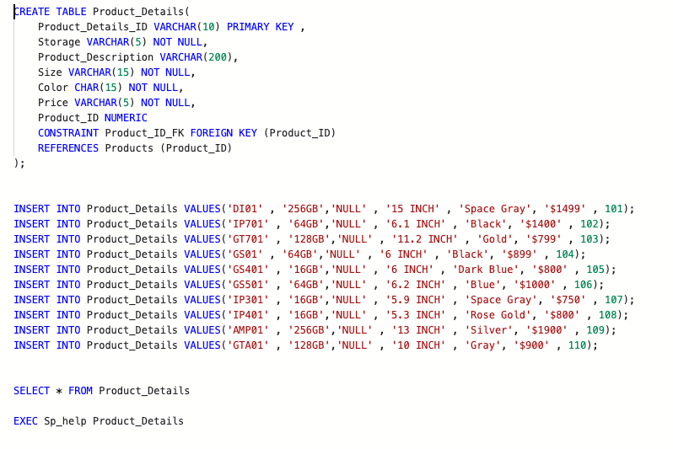

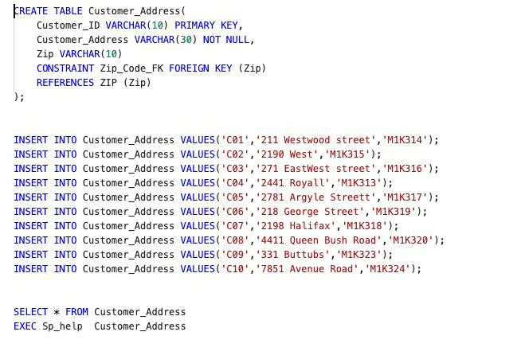

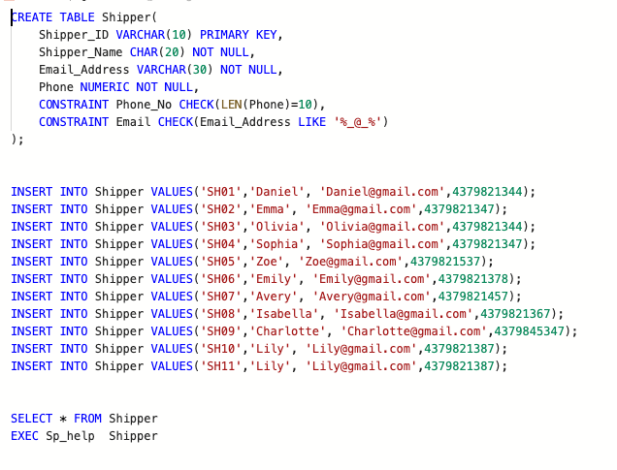

**Views and Indexes**

**Complex view:**

**Simple view:**

**Indexes:**

**Final ERD:**

**Report queries:**

**Exported Tables:**

