MINI PROJECT SYNOPSIS
(TITLE OF THE PROJECT)

(KCA-353)
Session: 2024-2025

Department of Master of Computer Applications (MCA)



Submitted By:
Name: Jahnvi Singh Roll No:2312000140076
Class :3rd sem(MCA)
Section: B-2

GL Bajaj College of Technology & Management
Plot No 2, APJ Abdul Kalam Rd, Knowledge Park III,
Greater Noida, Uttar Pradesh

Introduction and Objective of the Project
The e-commerce industry has revolutionized the way people shop, making products available at their fingertips. This project aims to develop a user-friendly e-commerce platform specifically for medicines. With the increasing demand for online pharmaceutical services, this website allows users to order medicines conveniently from their homes, with the added functionality of prescription upload and real-time order tracking.
The platform targets customers who seek easy access to medicines, healthcare products, and supplements, especially during emergencies or for those with mobility challenges. The website ensures secure transactions, proper medication information, and compliance with pharmaceutical regulations.
Key Features and Technologies in Medicine E-commerce
  - AI and Personalization: Platforms like 1mg and Netmeds use AI to offer personalized recommendations based on browsing and purchase history (Kumar et al., 2021).
  - Blockchain for Security: Blockchain technology is used to ensure transparency in transactions and prevent counterfeit drugs (Mukherjee et al., 2020).
  - Telemedicine Integration: Many platforms offer integrated telemedicine services for online consultations and e-prescriptions (Gururaj et al., 2022).
Regulatory Challenges and Compliance
  - United States: The FDA and DEA regulate the online sale of medicines, ensuring compliance with strict healthcare laws.
  - India: The Drug and Cosmetics Act governs online pharmacies, imposing strict rules for prescription and non-prescription drug sales.
  - Desai et al. (2019) highlighted that varying regulations across regions pose challenges for global operations of e-pharmacies.
Customer Trust and Counterfeit Medicines
  - Counterfeit drugs are a significant threat in the online medicine market. WHO estimates that about 10% of medicines in low and middle-income countries are substandard.
  - E-commerce platforms like PharmEasy and Medlife have rigorous verification systems in place to ensure medicine authenticity (Verma et al., 2021).
  - Customer reviews, ratings, and real-time feedback systems help build trust and transparency.
Objective-
The Objectives of E Commerce revolve around leveraging digital platforms to achieve various business goals. Here are some key objectives:

- Global Reach: The objective is to overcome geographical limitations and reach a global audience. E-commerce allows businesses to transcend borders and cater to customers worldwide.

- Cost Efficiency: E-commerce seeks to reduce operational costs associated with traditional brick-and-mortar stores, such as rent, utilities, and staffing. It aims for efficient and streamlined processes.

- 24/7 Availability: E-commerce platforms are designed to operate 24/7, providing customers with the flexibility to shop at any time. The goal is to eliminate time constraints and cater to diverse time zones.

- Enhance Customer Experience: E-commerce focuses on providing a seamless and user-friendly experience. This includes easy navigation, secure transactions, and personalized recommendations to improve overall customer satisfaction.

- Data-driven Decision Making: E-commerce businesses aim to gather and analyze data from customer interactions to make informed decisions. Understanding customer behavior helps in tailoring marketing strategies and improving products or services.

- Expand Customer Base: E-commerce seeks to attract new customers and retain existing ones. Marketing efforts, such as targeted promotions and social media engagement, contribute to expanding the customer base.

The technical challenges of designing and developing an e-Business web page are only one aspect of this project. Major part of the project is to acquire the desired knowledge, skills and experience to build an e-business website, based on the examination and analysis of user requirements and market needs. The main idea is to create a dedicated website that would provide employment services to IT students and graduates as well as to potential employers from the IT sector, which assumes a basic seeker provider model. This website will allow IT students/graduates and potential employers to have access to a dedicated website, consisting of students/graduates seeking jobs and employers who provide them. The site will hold details of job vacancies in a database and will allow searches to match seekers with providers. The website will be controlled by an organization (the Business) intended to be separate from both students and employers. Students and employers will only access their parts of the website and can only communicate with the e-Business.

Project Overview, along with a detailed report of the methodology that will be applied. However, there are some vital objectives, which should be accomplished, in order to allow the completion of the project.
These are:
• Conduct thorough problem investigation, which involves literature review, stakeholder analysis and evaluation and comparison of similar websites. This is the only way to understand the wider context of the problem, identify the target audience of the website, find out how other IT employment websites work, and discover possible gaps in the IT employment market. This will lead to a preliminary e-Business proposal.

• Come up with an innovative proposal that aims to fill the identified gaps of the market. This will be the basis for a dedicated website tailored to the needs of the stakeholders.

• Investigate and understand market research methods. Compare their advantages and disadvantages in order to choose the right one for testing the feasibility of the initial e-Business proposal with various stakeholders.

• Compare various e-Business models in order to choose the most suitable to use as the basis to make the business case for the proposal.

• Understand the strong and weak points of several website development methods and pick the methodology that will be the guideline of the project.
Project Category (RDBMS / OOPS / Networking / AI / ML / Data Science / Image Processing etc.)
For an e-commerce project in the medical field, you could consider several categories depending on your specific goals and requirements. Here are some relevant project categories:
- RDBMS (Relational Database Management System): Managing and organizing large volumes of patient data, medical records, and inventory.
- OOPS (Object-Oriented Programming): Developing modular and scalable software for various e-commerce functionalities like user management, product listings, and order processing.
- Networking: Ensuring secure and reliable communication between different systems, such as between the e-commerce platform and payment gateways or between the platform and healthcare providers.
- AI (Artificial Intelligence): Implementing AI for personalized recommendations, chatbots for customer support, and predictive analytics for inventory management.
- ML (Machine Learning): Using machine learning algorithms to analyze customer behavior, predict trends, and optimize marketing strategies.
- Data Science: Analyzing large datasets to gain insights into customer preferences, sales patterns, and operational efficiency.

Requirement Specifications (Detailed Functional Requirements and Technical Specifications)
- User Registration and Login – Secure authentication and personalized dashboards.
- Product Listings – Display a wide range of medicines and healthcare products with descriptions, prices, and availability.
- Search and Filter Functionality – A user-friendly search bar with filters like category, brand, price, and prescription requirement.
- Prescription Upload – Users can upload a valid prescription for prescription-based drugs.
- Secure Payment Gateway – Integration with payment methods like credit/debit cards, digital wallets, and UPI.
- Order Tracking – Real-time order tracking from placement to delivery.
- Customer Support – A chat system and FAQ section for users to get support on queries.
- Reviews and Ratings – Allow users to rate and review products based on their experience.
- Admin Panel – An admin interface to manage product listings, orders, customer data, and other administrative tasks.

Technologies Used:
- Front-End: HTML, CSS, JavaScript (React for enhanced user experience)
- Back-End: Node.js or PHP
- Database: MySQL or MongoDB
- Payment Integration: Stripe, PayPal, or Razorpay
- Server: Apache or Nginx
- Version Control: Git, GitHub
- APIs: Google Maps API (for tracking), Payment Gateway API, Prescription Verification API

Analysis (DFD, ER Diagram)
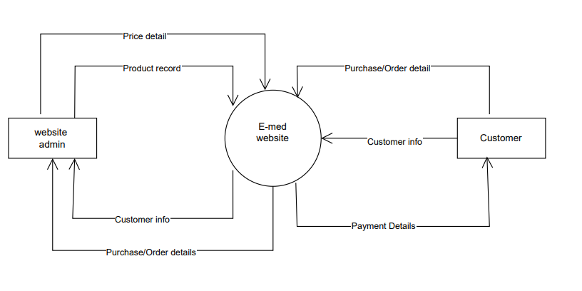
0-level DFD
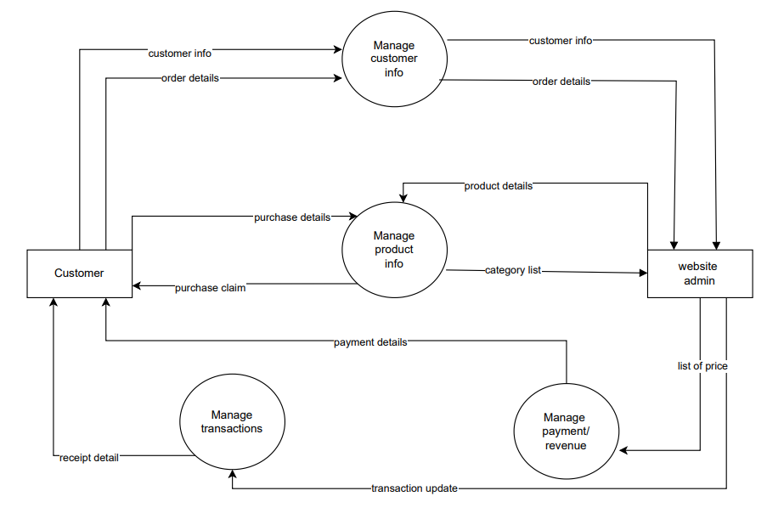
1-level DFD

ER-diagram:
- Customer-first_name, last_name, address, email_id, password, username.
- Product-p_id, p_price, p_name, p_model.
- Cart item-quantity, total_coostt, cart_id.
- Category-category_id, category_name.
- Payment-payment_id, amount, payment_type.
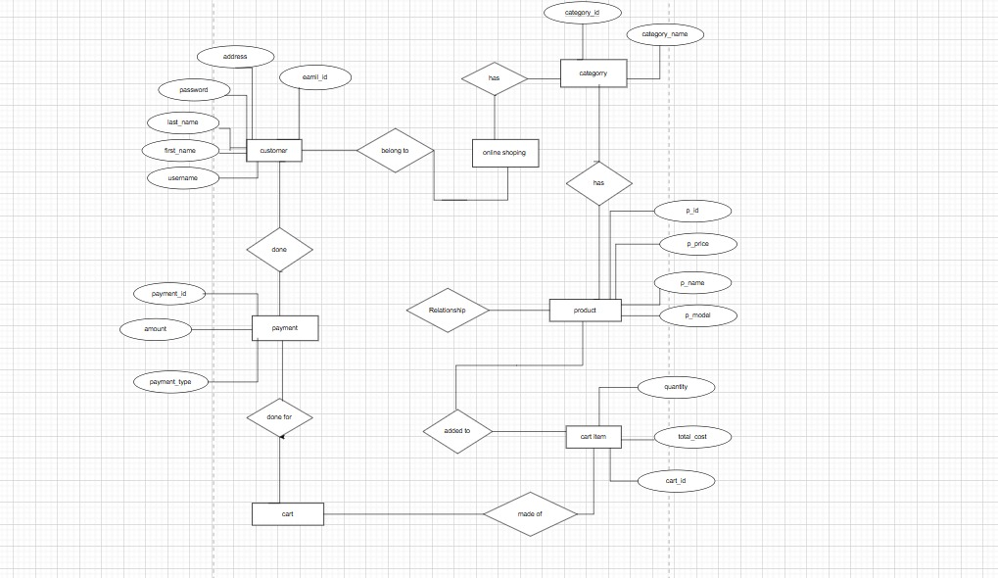

Project Modules (Project logic of each module)
A project module in an e-commerce website typically refers to a specific component or section of the website that handles a particular function or set of functions.
- User Management: Handles user registration, login, profile management, and authentication.
- Product Management: Manages product listings, categories, inventory, and product details.
- Shopping Cart: Allows users to add, remove, and manage items they intend to purchase.
- Order Management: Processes orders, tracks order status, and manages order history.
- Payment Gateway Integration: Facilitates payment processing through various payment methods (credit/debit cards, PayPal, etc.).
- Shipping and Delivery: Manages shipping options, calculates shipping costs, and tracks deliveries.
- Customer Support: Provides tools for customer inquiries, support tickets, and feedback.
- Marketing and SEO: Includes features for promotions, discounts, and search engine optimization.
- Analytics and Reporting: Collects and analyzes data on user behavior, sales, and website performance.
Each of these modules plays a crucial role in ensuring the smooth operation of an e-commerce website.
Technologies to be used
Software specification:
- Front-End Development: HTML5, CSS3, and JavaScript (or React) are used to create an intuitive user interface.
- Back-End Development: Node.js or PHP serves as the back-end framework for handling user requests, authentication, and managing databases.
- Database: MySQL or MongoDB is used for storing user data, product details, orders, and transaction history.
- APIs: Integration of third-party APIs for payment gateways, prescription verification, and map services for delivery tracking.
Security: SSL encryption is implemented for secure transactions and sensitive data protection
Future Scope and further enhancement of the Project
The future scope and further enhancements for an e-commerce project in the medical field can be quite extensive. Here are some possibilities to consider:
- Telemedicine Integration: Allowing customers to book virtual consultations with doctors or healthcare professionals directly through the e-commerce platform.
- Augmented Reality (AR) and Virtual Reality (VR): Implementing AR and VR to provide virtual product trials for medical devices or equipment, enhancing the shopping experience.
- Advanced AI and Machine Learning: Using AI for advanced customer service bots, predictive analytics for inventory management, and personalized health advice based on purchase history and user data.
- Blockchain Technology: Leveraging blockchain for secure and transparent transactions, ensuring the authenticity of medical products, and maintaining tamper-proof records of purchases.
- Wearable Device Integration: Connecting with wearable health devices to track user health data and recommend products based on real-time health information.
- Enhanced Mobile Experience: Developing a more robust mobile application with features like voice search, mobile payments, and push notifications for promotions and updates.
- Global Expansion: Expanding the platform to cater to international markets, including multi-currency support, international shipping options, and localized content.
- Subscription Services: Offering subscription-based services for regular delivery of essential medical supplies or medications, ensuring users never run out of critical items.
- Community and Social Features: Creating a community platform where users can share experiences, reviews, and recommendations about medical products and services.
- Regulatory Compliance and Data Privacy: Continuously updating the platform to comply with evolving healthcare regulations and ensuring the highest standards of data privacy and security.
These enhancements can help keep your e-commerce platform at the forefront of innovation, improve customer satisfaction, and drive business growth.
References
www.youtube.com
itsourcecode.com
www.google.com
elogic.co

