Chapter 3
Material Editor (MEDITOR.EXE)
version 2.01ae

This chapter explains all the functions supported by the material editor.

Outline
The material editor is a tool used to edit material for three-dimensional models.
The material means the following surface attributes that can be set for each polygon:
Color
Texture
Transparency
Shading method (Flat/smooth)
Availability of light source calculation
Note
For installing the material editor, see part 1, Installation.
Note
The material editor does not support a function for creating texture.
Applying texture requires that the texture have been created using a sprite editor, etc.
Note
This manual covers material editor version 1.7. An older version should be replaced by the latest one.

Operating Environment
As operating a three-dimensional model displayed on the video monitor, the user edits material. The artist board is used to render a three-dimensional model. This requires that the artist board have been installed in the host computer to be used.
The keyboard for the host computer is used to operate models. Materials are to be selected on Windows.

History

Version 2.00ae

Version 2.00ae (New features)
Meditor layouts the TIM data in VRAM automatically. You don’t have to specfiy VRAM address any more.
You can record the VRAM address used in Meditor into TIM file.
You can select one or more polygons at once inside a rectangle region.
You can inverse polygon selection status
You can select 4 different speed for the object movement and rotation
You can set semi-transparency rate (ABR)
You can select rectangle region in a texture and automatically adjust the region against some polygons.
Tool bar is enabled.
You can load an RSD file from most recently used file list (MRU) shown in the file menu
Polygon deletion
Light source calculation attribute is set for the selected polygons only.
Material attenuation attribute is supporeted.

Version 2.00ae (Bug fixes)
You can edit object with more than 10,000 polygons.
Texture polygon’s brightness was wrong.

Fundamental Use
The following gives the basic method of operating the material editor.
1. Start up the material editor.
2. Select "Open" in the file menu. The dialog box used to select a file is displayed.
3. Select the file to be read in, and click the OK button. With the texture model set, the texture arrangement dialog boxes corresponding to the number of textures used are displayed. Enter an appropriate value into the dialog box.
4. If needed, operate the three-dimensional model displayed on the video monitor for movement to the desired location and direction. The keyboard and the spin button on the moving dialog box can be used to move the model.
5. Select the material dialog box for the material menu.
6. Click the polygon selection button. The pointer is moved onto the video monitor, with the model for polygon selection set up.
7. Select the polygon for setting the material.
8. Click the right button on the mouse to return the pointer onto Windows.
9. Click the radio button in the dialog box to set the material.
10. Repeat above steps 6. to 9. to set materials for desired polygons.
11. Select "Storage" or "Storage under another name" to save the file.

File Format

RSD format
The material editor loads/saves 3D model data described in the RSD format. The RSD format is the standard format for the PlayStation 3D graphics tool group, allowing the description of 3D model shapes and materials. The RSD format is such that four kinds of files are used to describe a model. Specifications of the RSD format are covered in the appendix of this manual.
Table 3-4-1 RSD File
RSD file Describes relationships between the
PLY/MAT/GRP file and the texture file.
PLY file Describes the shape of a model.
MAT file Describes material information of a polygon.
GRP file Describes grouping information of a polygon.
The use of the material editor requires that the RSD file have been created. The 3D graphics tool includes a converter for converting the DXF format (format, for describing 3D shapes, supported by many commercially available modelers) into the RSD format. Thus, the DXF file created by a commercially available modeler can be used for 3D model data. For details, see 3D model creation in chapter for tutorial.
trueSpace for PlayStation (DTL-S280) supplied by Caligari Inc. supports the RSD format. Thus, the RSD file can be handled directly.

TIM format
The material editor uses 2D image data described in the TIM format for texture mapping. The TIM format can be created/edited by our sprite editor. Converters for the BMP, PICT and RGB formats are included in the 3D graphics tool.

Directory Structure
RSD and TIM data to be used by the material editor must be stored into the directory in accordance with the following rules.
Only a file name must be described for PLY/MAT/GRP in the *.RSD file. No absolute path can be used.
Correct example 1)
@RSD940102
PLY=HELI.PLY
MAT=HELI.MAT
GRP=HELI.GRP
Correct example 2)
@RSD940102
PLY=HELI01.PLY
MAT=HELI02.MAT
GRP=HELI03.GRP
* File names for RSD/PLY/MAT/GRP can be different.
Incorrect example
@RSD940102
PLY=C:\TEST01\RSD\HELI.PLY
MAT=C:\TEST01\RSD\HELI.MAT
GRP=C:\TEST01\RSD\HELI.GRP
* The absolute path is invalid.
The PLY/MAT/GRP files referenced in the *.RSD file must exist in the same path and their directory name must be RSD.
Correct example
D:\GAME1\TEST1\HELI01.RSD (See HELI01.PLY, HELI01.MAT, HELI01.MAT.)
D:\GAME1\TEST1\RSD\HELI01.PLY
D:\GAME1\TEST1\RASD\HELKI01.MAT
D:\GAME1\TEST1\RSD\HELI01.GRP
Incorrect example 1)
D:\GAME1\TEST1\HELI01.RSD (See HELI01.PLY, HELI01.MAT, HELI01.MAT.)
D:\GAME1\TEST1\HELI01.PLY
D:\GAME1\TEST1\HELI01.MAT
D:\GAME1\TEST1\HELI01.GRP
* The parent directory name is not RSD.

Incorrect example 2)
D:\GAME1\TEST1\RSD\HELI01.RSD
D:\GAME1\TEST1\RSD\HELI01.MAT
D:\GAME1\TEST1\RSD\HELI01.GRP
* No PLY file exists.
The texture file must be associated brotherly with the RSD data storage directory having a name of TIM.
Correct example
D:\GAME1\TEST1\RSD\HELI01.RSD (See BODY1.TIM, BODY2.TIM.)
…
D:\GAME1\TEST1\TIM\BODY1.TIM
D:\GAME1\TEST1\TIM\BODY2.TIM
Incorrect example
D:\GAME1\TEST1\RSD\HELI01.RSD (See BODY1.TIM, BODY2.TIM.)
…
D:\GAME1\TEST1\RSD\BODT1.TIM
D:\GAME1\TEST1\RSD\BODT2.TIM
* The TIM file does not exist in the TIM director associated brotherly with the RSD directory.

Following the above three rules, store the RSD and TIM file groups in advance. Creating a directory for each game tile and scene to store related RSD and TIM data under the directory will allow data to be processed readily.
Example
C:\GAME01\SCN00\RSD
C:\GAME01\SCN00\TIM
C:\GAME01\SCN01\RSD
C:\GAME01\SCN01\TIM
C:\GAME02\SCN00\RSD
C:\GAME02\SCN00\TIM
…

Location of Texture Data on VRAM
Texture mapping under the PlayStation architecture requires that texture data have been located on the VRAM.
How various image data should be located on the limited-size VRAM affects the design of a whole game program. Thus, in the initial phase of authoring, it is difficult to completely fix texture location,
The RSD format provides only for the use of a TIM file as texture data. (VRAM address information is not covered in the RSD file.) The address is can be relocated. Modifying the VRAM address of applied texture never affects RSD data. For locating texture data, see part 2, chapter 3, Creation of Texture Data.
“Auto layout TIM” function enables Meditor to allocate all the TIM data in VRAM automatically. So in general, user does not have to care about the location of TIM data while using the Meditor.

Ports and Addresses on Artist Board
The material editor uses a value written in the following file as the port address of the artist board.
C:\WINDOWS\ABOARD.INI
For example, if
addr=0x1340
is written in this file, the material editor uses a port address of 0x1340 to communicate with the artist board. If the port address of an actual board is not set at 0x1340 by the dip switch, the material editor cannot communicate correctly with the artist board.
If not set at 0x1340, use the ABOARD.EXE tool to modify file ABOARD.INI, or change the address of the board to set up the same address value.
For the ABOARD.EXE tool, see part 3, reference 5.1, ABOARD.EXE. For changing the port address of the artist board, refer to the manual for the artist board.

File Menu

Open
Reads in a new 3D model.

[Operation]
Select "Open".
In the displayed dialog box, select the RSD file to be invoked, and click the OK button.
On the material editor, the model is adjusted automatically for an appropriate size for easy operation.
With a texture applied on the invoked 3D model, the dialog box for setting the address of texture data is displayed. (Thus, data can be located on the VRAM.)

Dialog box for texture location
Figure 3-8-1 Dialog Box for Texture Location

Texture (X, Y):
Enter X and Y coordinates on the VRAM where image data is to be located. The initial value is X and Y coordinates of the image section set in the TIM file.
CLUT (X, Y):
Enter X and Y coordinates on the VRAM where the pallet is to be located. The initial value is X and Y coordinates of the pallet section set in the TIM file.
File:
Name of the invoked TIM file
Size
Lateral and longitudinal pixel sizes of the image data section
Mode
Indicates the number of colors.
4 (bits): 16 colors
8 (bits): 256 colors
16 (bits): 32768 colors
OK button
Loads a texture to the VRAM address specified in the dialog box for texture location.
Cancel button
Cancels the loaded texture.
Loaded RSD data is also canceled.
As the VRAM address of texture data is relocated, the set value is merely a tentative address.
The material editor uses the top left area of the VRAM for rendering and display. Locating texture data on the area for rendering and display results in the destruction of the data.
The area for rendering and display depends on the screen resolution.
Screen resolution Area for rendering and display
Lateral x longitudinal Top left - Bottom right

256 x 240 (0, 0) - (244, 479)
320 x 240 (0, 0) - (319, 479)
512 x 240 (0, 0) - (511, 479)
640 x 240 (0, 0) - (639, 479)
For resolution of 640 x 240, locating image data in the VRAM address (640, 0) causes no problem. But locating image data in (639, 0) results in the destruction of one left edge line of image data.
For know-how on other texture location, see part 2, chapter 3, Creation of Texture Data.

Reading in vertex
With the RSD file read in, reads in only vertex information from another model to modify only the model shape.

[Operation]
Select "reading in vertex".
In the displayed dialog box, select the PLY file to be invoked, and click the OK button.

[Application]
If there are two or more models arranged so as not to damage the number of vertices and the status of connection, material is set for only one of the models.
Reading in vertices from the other models to be saved under other names allows the application of the same material to more than one derivative model. The requirement is that the material be set only once.

Saving
Overwrites opened RSD data.

Saving under another name
Saves currently opened RSD data under another name. An existing file with the name is overwritten. If there is no file with the name, a new file is created.

[Operation]
Select "saving under another name". In the dialog box, enter a file name and clock the OK button.
[Note]
Saving texture-mapped RSD data into another RSD directory makes it impossible to look into the TIM file. Therefore, copy the TIM file referenced into to the TIM directory.

Reload TIM file
Reloads the VRAM with all the TIM files currently used as textures for the loaded model.
Use this function if another tool that uses the artist board has destroyed texture data on the VRAM.

Auto layout TIM
When this feature is enabled, Meditor automatically decide the address of the TIM data in VRAM.. This feature is effective for the following two cases:
- When an opened RSD file contained texture mapped polygons.
- When you mapped a new texture for the object.
When Meditor successfully allocates TIM data, “Auto layout Texture dialog” will pop-up. This dialog resembles “Allocate Texture dialog”, but it contains auto allocated texture address (coordinates) and clut address. You can change those values if you like.
Click OK button to load the TIM data into VRAM.
[Auto layout algorithms]
Each texture is placed in VRAM from up to down, left to right, under following constraints.
- Do not overlap with drawing/display area.
- Do not overlap with other texture.
- Do not cross VRAM page boundary.

Save TIM layout

Saves the TIM coordinate

Snap shot
Saves the image currently displayed on the video monitor into a file in the TIM format.
The image file can be edited by the sprite editor for use as texture. This function enables texture data to be created.

[Operation]
Select "Snap shot".
In the dialog box, enter a TIM file name.

End
Terminates the material editor.

Material Menu
The material dialog box pops up. The dialog box is used to set all materials.
Figure 3-9-1 Material Setting Dialog Box

RSD file: Name of file serving model being edited
Number of polygons: Total number of polygons in the model being edited
Polygon ID: ID of the last selected polygon

[Operation]
Select a polygon and use the radio button in the material dialog box to specify attributes of the polygon.

Shading
Sets a polygon shading method.
"Flat": Flat shading. Clears a polygon boundary.
"Smooth": Smooth shading. Smoothes a polygon boundary.
In the following Figure, the left model is subjected to flat shading, while the left model is subjected to smooth shading.
Figure 3-9-2 Shading effects
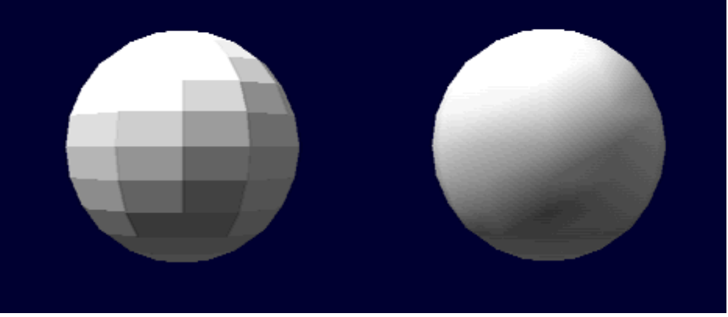
Note
Smooth shading can be applied more effectively to polygons which are adjacent to each other with a larger angle. To the contrary, a smaller angle results in a darker edge, See the left model in Figure 3.9.3.
Figure 3-9-3 Angles between Polygons and Smooth Shading
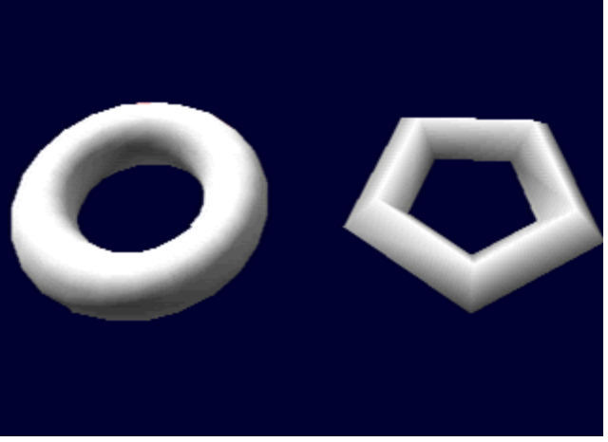

Semi-transparency
Sets the degrees of semi-transparency for a polygon.

- 50(B)+ 50(F) : BG(50%) + Texture(50%)
- 100(B)+100(F): BG(100%) + Texture(100%)
- 100(B)-100(F): BG(100%) - Texture(100%)
- 100(B)+ 25(F): BG(100%) + Texture(25%)
- 0(B)+100(F): BG(0%) + Texture(100%) : opaque
In Figure 3.9.4, the left cube is displayed semi-transparently, while the right polygon is displayed opaquely.
Figure 3-9-4 Semi-transparency
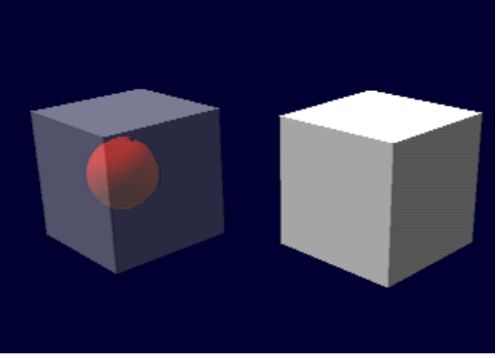
Note
Making a texture polygon (provided with applied texture) semitransparent requires that the TIM utility have been used to set the texture semi-transparency control (STP) bit at 1.

Material attenuation
Set the material attenuation parameter for all the polygons. The attribute specify the relationship between the normal gradient and brightness attenuation when light source calculation is performed. This attribute can be used to display an object’s material quality. Notice that this attribute is currently not supported by graphics libraries (libgs, libgte)., nor RSD file format. However you can use the attributes to record the effect color.
You should also note that the higher the material attenuation value, calculation takes longer and the processing requires a lot of resources.
- 0 : no material attenuation
- 1: brightness = pow(brightness, 2)
- 2: brightness = pow(brightness, 4)
- 3: brightness = pow(brightness,8)
- 4: brightness = pow(brightness, 16)

Texture mapping
Sets the color or texture map of a polygon.
"Texture": Applies texture. The procedure of texture mapping is explained in detail in the next section.
"Color": Applies color. The dialog box for setting color pops up. Select the color to be applied. In the polygon
selection mode, filling and brushing functions can be used.
Filling function: Shift + Ctrl + right button click
Stores the polygon color as the current brush color.
Brushing function: Shift + right button click
Applies the brush color to a polygon.

Light source calculation
Specifies whether to carry out light source calculation for the selected polygons.
"On": Carries out light source calculation.
"Off": Does not carry out light source calculation.
For example, light source calculation provides three-dimensional appearance. Without light source calculation, the same color is applied to the whole polygon, providing no three-dimensional appearance.
Figure 3-9-5 Light Source Calculation
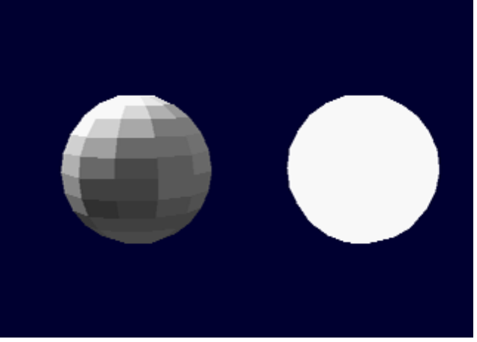

Application
With a partial model polygon colored brightly, no light source calculation is applied only the polygon. Damping light for the model brightens only the part subjected to no light source calculation. The part provides lighting effects.

Display
Specifies whether to display the selected polygon.
"On": Displays the polygon.
"Off": Does not display the polygon.
The display of an off polygon is suppressed until the specification of on. Further, such a polygon cannot be selected by clicking the mouse.
Selecting a polygon whose display is suppressed requires the selection of all polygons by the F3 key or of a cataloged group. Releasing display suppression allows the polygon to be displayed.
This function can be used validly to mask the polygons other than the target polygon when it is difficult to select the target polygon because of the other obstacle polygons or when the target polygon is covered by the other polygons.

"Copy" button
Copies the selected polygon.
A new created polygon shares the vertices with the old polygon.
Both the polygons have the same normal and material attributes. But these values can be changed independent of one another.
The copying function is applicable to sealing and the creation of double-faced polygons.

a) Sealing function
The surface of a plastic model can be sealed with texture.
Applying texture with a transparent part onto the upper polygon combined with the lower polygon leads to the observation of the lower polygon through the transparent texture part. The effective use of the sealing function allows the significant reduction of the number of textures on the VRAM.
In the following example, two kinds of seals are applied onto the same-quality texture.
Figure 3-9-6 Example 1) of Sealing Function

The sealing function can bridge over difficulties of differently colored texture polygons. In the following example, the left polygon is provided with typical texture, while the right polygon is provided with a seal.
Figure 3-9-7 Example 2) of Sealing Function
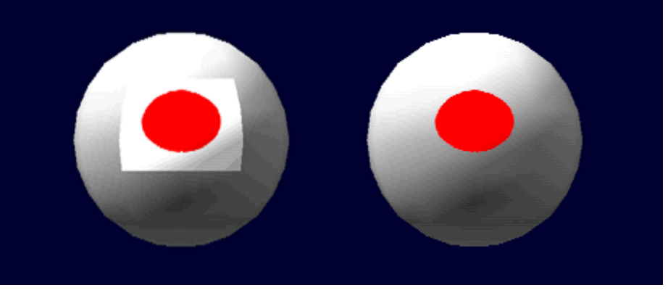

b) Creation of double-faced polygon
Reversing a copied polygon enables the creation of a double-faced polygon. The following reversing button is used to reverse a polygon.
In the following example, the right box provides the double-faced polygons corresponding to the polygons in the left box.
Figure 3-9-8 Double-faced Polygon
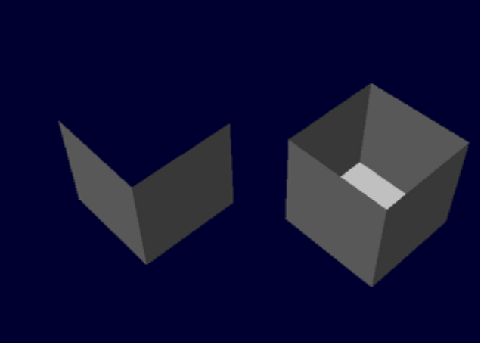

Delete button
Deletes the selected polygon. Notice that there is no way to undo this operation.

Isolated vertexes caused by the delete operation is removed from the RSD data

Reversing button
Reverses the selected polygon.
This function is applied to reversed model data polygons and the creation of double-faced polygons (see paragraph for the copying function).

Rendering color cataloging button
The current rendering color is cataloged as the selected polygon material, with polygon light source calculation turned off. For example, if a white polygon subjected to red light appears pink, the pink is cataloged as the polygon color.
This function allows the three-dimensional appearance of the model, even though it is not subjected to light source calculation on the program. The rendering color writing of a polygon through smooth shading after the appropriate setting of the light source leads to the creation of a model with very effective gradation color.
The material of a polygon where a rendering color has been written is changed as follows:
Before writing After writing
Flat color Flat color
Smooth color
Gradation color
Flat texture Color texture
Smooth texture Gradation texture

Rendering color clear button
Resets the material to the status before writing the rendering color.
With a rendering color written, this function cannot be used.

Polygon selection button
Clicking this button sets up the polygon selection mode.
The polygon selection mode can be left by clicking the right button.
The mouse cursor is displayed on the video monitor.
Smooth shading makes it difficult to select a polygon. In the polygon selection mode, however, all polygons are rendered by flat shading.
To set up the previous shading method, leave the polygon selection mode and click the polygon selection release button.

[Mouse operation in the polygon selection mode]
Move the mouse cursor inside the polygon to be selected and click the left button. The selected polygon becomes red.
By dragging the mouse rectangle region will be displayed in broken line. When you release the left mouse button, all the polygons (facing front ) inside the region will be selected. Dragging the mouse while holding down the Ctrl key will deselect all the polygons inside the region. Dragging the mouse while holding down the Shift key will select all the polygons (facing front or back) inside the region .
Clicking the selected polygon as pressing the Ctrl key releases the selected polygon.
Pressing the F3 key causes all polygons to be selected.
Pressing the F3 key again causes the selected polygons to be released. (This also applies to other than the polygon selection mode.)
Pressing the F3 key and the Shift key at once, will reverse the selection status. All the selected polygons will be deselected, and the all the non selected polygons will be selected.
With polygons superposed on one another, polygons below are selected in order by successively clicking the left button without moving the mouse cursor.
Mouse/key operation Result
Clicking the left button Polygon selection
Clicking the right button Termination of the polygon selection mode
Ctrl + clicking the right button Release of polygon selection
Shift + clicking the right button Brushing
Ctrl + Shift + clicking the right Filling button
Mouse operation in the polygon selection mode

Selected polygon release button
Releases the selected polygons.
The F3 key provides the same function.

Close button
Closes the material dialog box.

Procedure for Texture Mapping
Texture can be mapped by parallel projection.
1. After having selected a polygon to be provided with texture, click the "texture" radio button in the material setting dialog box.
2. The file dialog box pops up. Select the TIM file for texture application.
3. The "texture location" dialog box pops up. Enter the texture image position on the VRAM, and the pallet position.
4. The "texture mapping" dialog box pops up. The selected texture is displayed semi-transparently at the top left on the video monitor.
Adjust the positions of the selected polygon and the texture by model movement, texture movement, or texture extension or reduction.
The selected polygons that falls in the valid range of texture mapping are displayed in yellow. Checking the valid range as moving the texture by pixel allows the texture and the polygon to be adjusted by pixel.

Texture mapping dialog box
The dialog box is used for the parallel displacement, and the expansion and reduction of texture.
Figure 3-10-1 Dialog Box for Texture Mapping

"→" "←" "↓" and "" buttons
These buttons are used for the parallel displacement of the texture by pixel. Clicking the button with the shift key pressed causes texture to be moved by ten pixels.

"Longitudinal extension" and "lateral reduction" button
The button is used for the lateral extension and reduction of texture by pixel. Clicking the button with the shift key pressed allows the extension or reduction of texture by 10 pixels.
These operations can also be carried out by the arrow keys on the keyboard.
Figure 3-5-2 Texture Operation by Keyboard
← Left movement → Right movement
Upper movement ↓ Lower movement
Ctrl-← Lateral reduction Ctrl-→ Lateral extension
Ctrl- Lateral reduction Ctrl-↓ Longitudinal extension

"Automatic" button
This button is used to automatically adjust the position and size of texture according to the selected polygon.

"Inversion" check box
The check box allows mapping with texture inverted laterally.

"Continuous" button
To apply the current texture onto another polygon, click this key instead of the OK key. The semitransparent target texture is left on the video monitor for continuous texture mapping.

“Region” button
Enters the “region specify mode”. In this mode, mouse cursor is displayed on the video monitor, and user can specify a rectangle region by dragging a mouse. The region is shown in broken line. By specifying a region in a texture user can specify a sub-region in the texture.

Click right mouse button to exit from the region specify mode. System will ask you “Select the region?” . Answer “yes” to select a sub-region of the texture. Thereafter only the texture sub-region will be used as texture maps.
Select region and then click “Automatic button”, then the texture sub-region will be adjusted according to the selected polygon.
For instance, if the texture contains number of alphabetic characters, and you have selected a character A as the sub-region. You can map the character A to the polygon using automatic button.

"OK" button
Clicking this button leads to texture application, followed by the closing of the texture mapping dialog box.

[Application]
Multi-pallet texture
Assigning one TIM image two or more different pallets enables the same images to be colored variously. This means allows images in TIM data to be shared. Thus, the VRAM can be used effectively. TIM can describe more than one pallet (multi-pallet). But the RSD format can index only the start address in two or more pallets. Thus, each polygon cannot be assigned a pallet.
Possible actions are to create two or more TIM files with different pallet addresses from a TIM file for a multi-pallet, and read in such TIM files through the material editor. The TIM data is stored in different files. As image addresses and data contents are the same, however, the TIM data provides the same effects as a multi-pallet on the VRAM.
The following example describes such actions.
1. Use the sprite editor to create a multi-pallet TIM file (FOO.TIM).
2. Us the TIMULTIL.EXE pallet writing function to save pallets into different TIM files.
Example) Pallet Pallet address File
0 (480, 0) FOO0.TIM
1 (481, 0) FOO1.TIM
2 (482, 0) FOO2.TIM
… … …
N (480+N, 0) FOON.TIM
3. Read in FOO0.TIM.FOO1.TIM,... as texture from the material editor.

Light Source Menu
The light source setting dialog box pops up.
Set a light source, an ambient color, and a background color.
Figure 3-11-1 Light Source Setting Dialog Box

"Lighting" check box
This check box allows the light source to be turned on and off.

RGB
Sets the color of the light source.

Bearing and elevation
Sets the direction of the light source.

Ambient
Sets an ambient color.

Background
Sets the color of the background.

Move Menu
The "visual point/model movement" dialog box pops up.
Set methods of model movement, visual point movement and rendering.
Figure 3-12-1 Visual Point/Model Movement Dialog Box

"Movement of visual point"
Clicking the button allows the parallel displacement and rotation of the visual point.
The model and the visual point can also be moved by keyboard operation.
Model rotation
A: Left S: CW distortion
D: Right C. CCW distortion
W: Upper
X: Lower
Parallel displacement of visual point
Shift-A: Left Shift-S: Away from yourself
Shift-D: Right Shift-C: Toward yourself
Shift-W: Upper
Shift-X: Lower
Model rotation (Units of 90 degrees)
Ctrl-A: Left Ctrl-S: CW distortion
Ctrl-D: Right Ctrl-C: CCW distortion
Ctrl-W: Upper
Ctrl-X: Lower
You can control the rotation and displacement speed as follows.
Shift-1: Displacement speed 1
Shift-2: Displacement speed 4
Shift-3: Displacement speed 32
Shift-4: Displacement speed 100 (default)
Ctrl-1: Rotation speed 1
Ctrl-2: Rotation speed 4
Ctrl-3: Rotation speed 8
Ctrl-4: Rotation speed 16 (default)

Note
Shortening "period until automatic repetition start" and "repetition interval" on the keyboard provides smooth model movement.
The keyboard command on the Windows control panel can be used for this setting.

"Distance between visual point and screen"
Sets the distance between the visual point and the screen. The picture angle is changed according to this value.

"Zoom"
Extends the screen display without moving the visual point.

"Rendering"
Sets a method for rendering a model. The set rendering method is not reflected in material data.

Wire frame
Displayed in a wire frame.

Texture mask
Displayed with no texture applied.

Light source calculation not carried out
Displayed with light source calculation not carried out.

Default
Displayed according to the model material.

Vertex Edit Menu
The "vertex edit" dialog box pops up. The dialog box is used to move the vertices of a model. It can also be used to specify a vertex color for gradation color polygon creation.

"Vertex ID"
The ID of the selected vertex is displayed.

"Vertex selection" button
Clicking this button sets up the "vertex edit mode", with the mouse cursor appearing on the video monitor.
Clicking the left button with the mouse cursor located near a vertex causes the vertex to be selected. The selected vertex is displayed by a blue triangle.
To leave the vertex selection mode, click the right button
Mouse operation in the vertex selection mode
Drag and move a vertex by the mouse. Moving the mouse to the right causes the vertex to be moved along the screen.
With the Ctrl key pressed, the vertex is moved only vertically.
With the Shift key pressed, the vertex is moved only horizontally.
With the Ctrl and Shift keys pressed, the vertex is moved only toward or away from yourself.

[Application]
The use of the vertex edit function along with the vertex read function enables the UV value to be adjusted finely during texture mapping. The following example maps a square texture onto a trapezoid area.
1. Use the vertex edit function to make the trapezoid area rectangular.
2. Map the texture correctly in accordance with the rectangular area.
3. The model remains rectangular. Use the vertex read function to load the PLY file for the original model to make the rectangular area trapezoid.
Now, the square texture is mapped correctly onto the trapezoid area.
Creating gradation color polygon
Setting different colors for the vertices of a polygon allows the creation of the polygon with gradation color.
1. Select a polygon to be provided with gradation color.
2. Select vertices for which colors are to be set.
3. Use the "color" radio button in the material dialog box to select vertex colors.

Group Menu
The "group" management dialog box pops up.
The dialog box allows a polygon group to be managed.
Only group selection enables the selection of all the polygons belonging to the group at a time. Thus, materials can be edited rapidly.

"Polygon count"
Number of polygons selected

"Cataloging" button
Clicking this button causes the "group name" dialog box to be displayed. Clicking the OK button with a group name specified in the dialog box allows the currently selected polygon to be cataloged as a group.

"Group list"
Lists the names of cataloged groups and the number of polygons.
Clicking a group allows the selection of all the polygons belonging to the group.

"Delete" button
Deletes the selected group.

"Automatic creation" button
Automatically creates a group for each model material.

"Rename" button
Renames the selected group.

OT Menu
The "ordering table" dialog box pops up.
The dialog box is used to set the bit length of the ordering table (1 to 14 bits).
Larger bit length provides high accuracy of polygon depth judgment. But the rendering speed is lowered.
Figure 3.15-1 odtlg.pict OT Dialog Box

Resolution Menu
Sets the resolution of the video monitor.
When setting screen resolution, take texture location on the VRAM fully into account. Replacing screen resolution of 320 x 240 for the current texture location by resolution of 640 x 240 may result in the destruction of part of the texture on the VRAM.
Figure 3.16.1 resoluti.pict Resolution Dialog Box

Help Menu
Displays methods of binding keys, and operating the keyboard and the mouse.
Displays how to use the help menu.
Displays version information and the version of the program currently used.

