Mkvab.exe

Outline
Builds a sound source bank format VAB originating with the wave pattern data group VAG format created on aiff2vag.exe and the definition file which creates the attributes table.

Use
mkvab [option] vag-files...

Options
-f def_file
Specifies definition file def_file for creating attribute table .
-r vab_file
Analyzes the VAB file and outputs attribute definition file.
-o out_file
Specifies output file.
Limitation
This version has the following limitation:
Since the VAB file size and each VAG size are automatically calculated, the specified numerical value will be ignored.

Attribute Definition File
VabHdr (Attribute definitions throughout VAB)

Label Value Explanation
form ‘VABp’ Format identifier
ver 7 Format version number
id 0 VAB ID (Always 0)
fsize 0 File Size (mkvab automatically calculates)
ps 0~128 Total number of programs included in VAB
ts 0~2048 Total number of tones included in VAB
vs 0~254 Total number of VAG included in VAB

ProgAtr (Program (equivalent to musical instrument) level attribute definitions)

Label Value Explanation
tones 4 Number of tones included in program
mvol 0~127 Volume value of program
mpan 0~127 Panning value of program

VagAtr (Tone Level Attribute Definitions)
Label Value Explanation
prior 0~127 Tone priority. Larger values have priority.
mode 0,4 If set to 4, reverb effect is obtained. **
vol 0~127 Volume value of tone
pan 0~127 Panning value of tone
center 0~127 Center note (half tone unit)
shift 0~127 Fine tuning of center note
min 0~127 Minimum value of note remit
max 0~127 Maximum value of note remit
pbmin 0~127 Maximum value of downward-direction pitch bend
(half tone unit)
pbmax 0~127 Maximum value of upward-direction pitch bend
(half tone unit)
ar 0~127 Attack rate
dr 0~15 Decay rate
sr 0~127 Sustain rate
rr 0~31 Release rate
sl 0~15 Sustain level
prog 0~127 Program number belonging to tone
vag 0~254 VAG being used

** In order to obtain reverb effect, a reverb setting on a special sound function is necessary.

Supplement
ADSR (envelope), i.e. rates for attack, decay, sustain and release can be set singly and in the time change, a linear and exponentially functional curve can be set. Also, with sustain, it is also possible to set the level.

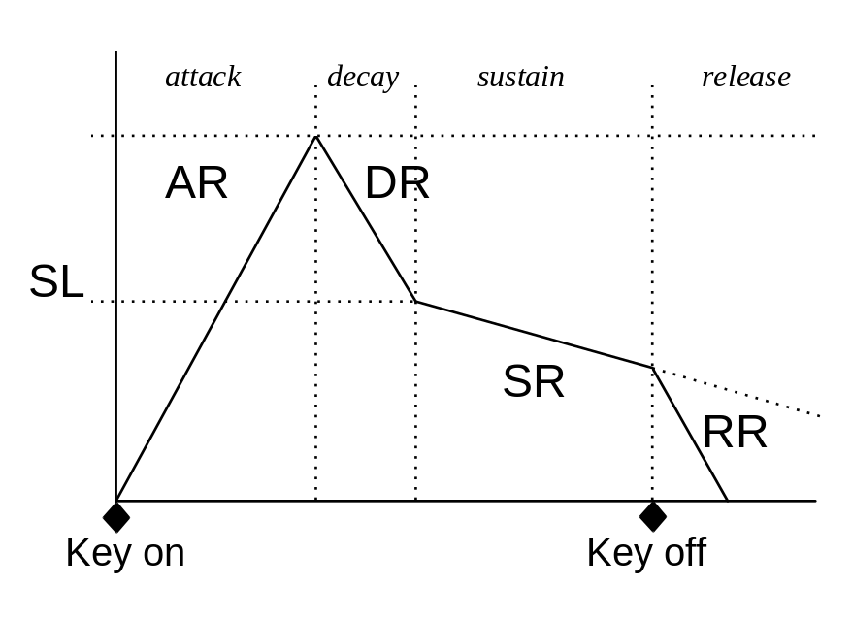
Figure: ADSR Concept Drawing

