Regression Models Course Project

Anit Bhandari

August 23, 2016

# Executive Summary

This analysis seeks to determine if the automatic or manual transmission is better for MPG and to quantify the difference. Using an ordinary least squares regression model on the mtcars dataset we can conclude:

* After adjusting for vehicle weight and quarter mile time, the manual transmissions provides a statistically significant 2.9 MPG advantage over the automatic transmission.

## About the Data[1]

This analysis was preformed using data extracted from the 1974 Motor Trend US magazine. It comprises fuel consumption for 32 1973–74 model automobiles and ten aspects of automobile design and performance:

* Number of cylinders
* Displacement (cu.in.)
* Gross horsepower
* Rear axle ratio
* Weight (lb/1000)
* 1/4 mile time
* V/S
* Transmission
* Number of forward gears
* Number of carburetors

# Data Processing

The only adjustment made to the data was relabeling the transmission type variable (am) to make it easier to interpret throughout the analysis.

data(mtcars)  
mtcars$am <- as.factor(mtcars$am)  
levels(mtcars$am) <- c("Automatic", "Manual")

# Exploratory Data Analysis

Mean MPG for this dataset is **20.09** with a standard deviation of **6.03**. There are 19 cars with an automatic transmission and 13 cars with a manual transmission.

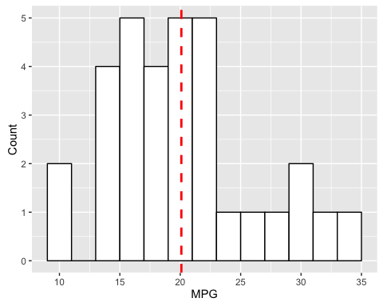

# Regression Analysis

## Single Variable Analysis

In order to tease out the effect of the type of transmission we first modeled MPG as a function of the type of transmission. Our null hypothesis is that there is no difference between the two types and the alternate is that there is a difference. In this model, the intercept represents cars with an automatic transmission:

fit <- lm(mpg ~ am, data = mtcars)

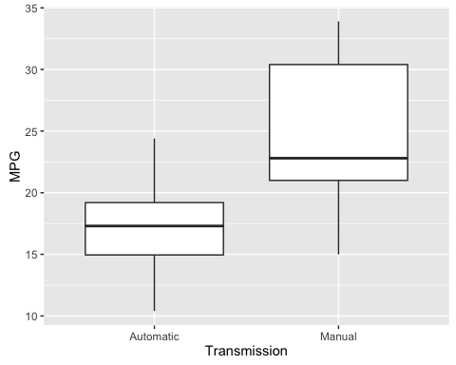

|  |  |  |  |  |
| --- | --- | --- | --- | --- |
|  | Estimate | Std. Error | t value | Pr(>|t|) |
| **amManual** | 7.245 | 1.764 | 4.106 | 0.000285 |
| **(Intercept)** | 17.15 | 1.125 | 15.25 | 1.134e-15 |

Fitting linear model: mpg ~ am

With a P-value of about 0.0003 we reject the null hypothsis. So at first blush it would appear that there is a statistically significant difference and that cars with a manual transmission have 7.2 MPG advantage than those with automatic transmissions.

This model has an adjusted R squared of about 0.34 which suggests there are other factors we are not taking into consideration. For example the figure 3 illustrates that the vehicle weight has a negative relationship with fuel efficiency. What happens to the transmission effect when we control for other variables?

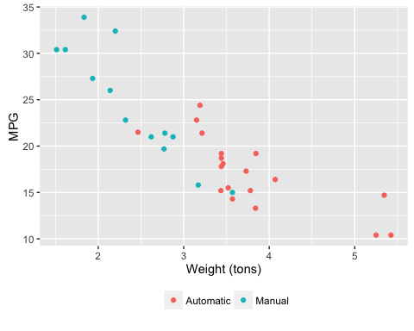

## Multi-Variable Analysis

R's step function was employed to determine which variables should be included in the model. This function uses a stepwise algorithm to select variables based on the Akaike information criterion (AIC).

best.fit <- step(lm(mpg ~ ., data=mtcars), direction=c("both"), trace=0)

|  |  |  |  |  |
| --- | --- | --- | --- | --- |
|  | Estimate | Std. Error | t value | Pr(>|t|) |
| **wt** | -3.917 | 0.7112 | -5.507 | 6.953e-06 |
| **qsec** | 1.226 | 0.2887 | 4.247 | 0.0002162 |
| **amManual** | 2.936 | 1.411 | 2.081 | 0.04672 |
| **(Intercept)** | 9.618 | 6.96 | 1.382 | 0.1779 |

Fitting linear model: mpg ~ wt + qsec + am

Once again our null hypothesis is that there is no difference between the two types of transmission and the alternate is that there is a difference. With a P-value of about 0.047 we would reject the null hypothsis. This model has an adjusted R squared of about 0.83 which is a significant improvement relative to the single variable model[2]. The manual transmission gives about a 2.9 miles per gallon gain in fuel economy relative to the automatic transmission.

# Appendix 1: Sample Data

|  |  |  |  |  |  |  |  |  |  |  |  |
| --- | --- | --- | --- | --- | --- | --- | --- | --- | --- | --- | --- |
|  | mpg | cyl | disp | hp | drat | wt | qsec | vs | am | gear | carb |
| **Mazda RX4** | 21 | 6 | 160 | 110 | 3.9 | 2.62 | 16.46 | 0 | Manual | 4 | 4 |
| **Mazda RX4 Wag** | 21 | 6 | 160 | 110 | 3.9 | 2.875 | 17.02 | 0 | Manual | 4 | 4 |
| **Datsun 710** | 22.8 | 4 | 108 | 93 | 3.85 | 2.32 | 18.61 | 1 | Manual | 4 | 1 |
| **Hornet 4 Drive** | 21.4 | 6 | 258 | 110 | 3.08 | 3.215 | 19.44 | 1 | Automatic | 3 | 1 |
| **Hornet Sportabout** | 18.7 | 8 | 360 | 175 | 3.15 | 3.44 | 17.02 | 0 | Automatic | 3 | 2 |
| **Valiant** | 18.1 | 6 | 225 | 105 | 2.76 | 3.46 | 20.22 | 1 | Automatic | 3 | 1 |
| **Duster 360** | 14.3 | 8 | 360 | 245 | 3.21 | 3.57 | 15.84 | 0 | Automatic | 3 | 4 |
| **Merc 240D** | 24.4 | 4 | 146.7 | 62 | 3.69 | 3.19 | 20 | 1 | Automatic | 4 | 2 |
| **Merc 230** | 22.8 | 4 | 140.8 | 95 | 3.92 | 3.15 | 22.9 | 1 | Automatic | 4 | 2 |
| **Merc 280** | 19.2 | 6 | 167.6 | 123 | 3.92 | 3.44 | 18.3 | 1 | Automatic | 4 | 4 |
| **Merc 280C** | 17.8 | 6 | 167.6 | 123 | 3.92 | 3.44 | 18.9 | 1 | Automatic | 4 | 4 |
| **Merc 450SE** | 16.4 | 8 | 275.8 | 180 | 3.07 | 4.07 | 17.4 | 0 | Automatic | 3 | 3 |
| **Merc 450SL** | 17.3 | 8 | 275.8 | 180 | 3.07 | 3.73 | 17.6 | 0 | Automatic | 3 | 3 |
| **Merc 450SLC** | 15.2 | 8 | 275.8 | 180 | 3.07 | 3.78 | 18 | 0 | Automatic | 3 | 3 |
| **Cadillac Fleetwood** | 10.4 | 8 | 472 | 205 | 2.93 | 5.25 | 17.98 | 0 | Automatic | 3 | 4 |
| **Lincoln Continental** | 10.4 | 8 | 460 | 215 | 3 | 5.424 | 17.82 | 0 | Automatic | 3 | 4 |
| **Chrysler Imperial** | 14.7 | 8 | 440 | 230 | 3.23 | 5.345 | 17.42 | 0 | Automatic | 3 | 4 |
| **Fiat 128** | 32.4 | 4 | 78.7 | 66 | 4.08 | 2.2 | 19.47 | 1 | Manual | 4 | 1 |
| **Honda Civic** | 30.4 | 4 | 75.7 | 52 | 4.93 | 1.615 | 18.52 | 1 | Manual | 4 | 2 |
| **Toyota Corolla** | 33.9 | 4 | 71.1 | 65 | 4.22 | 1.835 | 19.9 | 1 | Manual | 4 | 1 |
| **Toyota Corona** | 21.5 | 4 | 120.1 | 97 | 3.7 | 2.465 | 20.01 | 1 | Automatic | 3 | 1 |
| **Dodge Challenger** | 15.5 | 8 | 318 | 150 | 2.76 | 3.52 | 16.87 | 0 | Automatic | 3 | 2 |
| **AMC Javelin** | 15.2 | 8 | 304 | 150 | 3.15 | 3.435 | 17.3 | 0 | Automatic | 3 | 2 |
| **Camaro Z28** | 13.3 | 8 | 350 | 245 | 3.73 | 3.84 | 15.41 | 0 | Automatic | 3 | 4 |
| **Pontiac Firebird** | 19.2 | 8 | 400 | 175 | 3.08 | 3.845 | 17.05 | 0 | Automatic | 3 | 2 |
| **Fiat X1-9** | 27.3 | 4 | 79 | 66 | 4.08 | 1.935 | 18.9 | 1 | Manual | 4 | 1 |
| **Porsche 914-2** | 26 | 4 | 120.3 | 91 | 4.43 | 2.14 | 16.7 | 0 | Manual | 5 | 2 |
| **Lotus Europa** | 30.4 | 4 | 95.1 | 113 | 3.77 | 1.513 | 16.9 | 1 | Manual | 5 | 2 |
| **Ford Pantera L** | 15.8 | 8 | 351 | 264 | 4.22 | 3.17 | 14.5 | 0 | Manual | 5 | 4 |

# Appendix 2: Residual Plots

## Single Variable Model

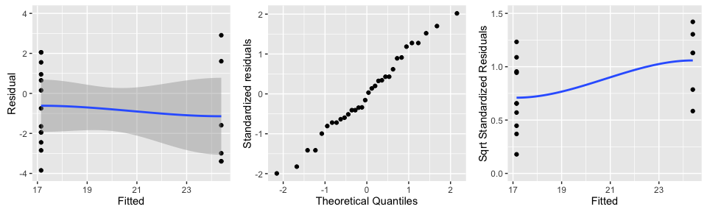

## Multi-Variable Model

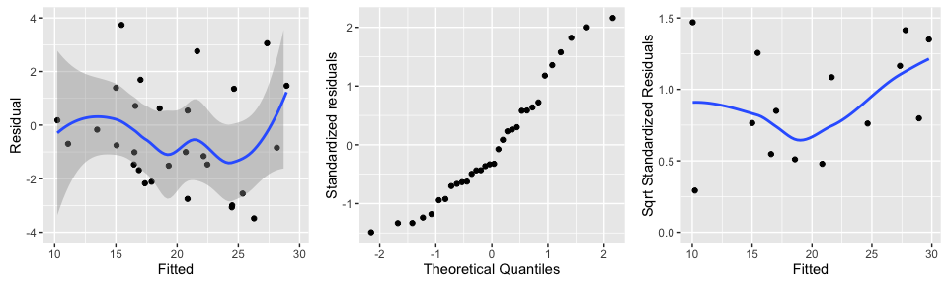

1. A sample of the data is found in Appendix 1
2. See Appendix 2 for a residual plots of the models