LAB RECORD- DBMS (FIRST 5 PROGRAMS)

Anitej Prasad

1BM19CS194

4-D

**LAB 1 QUERIES:**

create database insurance;

use insurance;

create table person(

driver_id varchar(10),

name varchar(20),

address varchar(30),

primary key(driver_id)

);

desc person;

create table car(

reg_num varchar(10),

model varchar(10),

year int,

primary key(reg_num)

);

desc car;

create table accident(

report_num int,

accident_date date,

location varchar(20),

primary key(report_num)

);

create table owns(

driver_id varchar(10),

reg_num varchar(10),

primary key(driver_id,reg_num),

foreign key(driver_id) references person(driver_id),

foreign key(reg_num) references car(reg_num)

);

desc owns;

create table participated(

driver_id varchar(10),

reg_num varchar(10),

report_num int,

damage_amount int,

primary key(driver_id,reg_num,report_num),

foreign key(driver_id) references person(driver_id),

foreign key(reg_num) references car(reg_num),

foreign key(report_num) references accident(report_num)

);

desc participated;

insert into person values('A01','Raghu','Electronic City');

insert into person values('A02','Rishab','Orange County');

insert into person values('A03','Rufus','NR Colony');

insert into person values('A04','Jamal','Lawrence Park');

insert into person values('A05','Kevin','Rosedale');

commit;

select * from person;

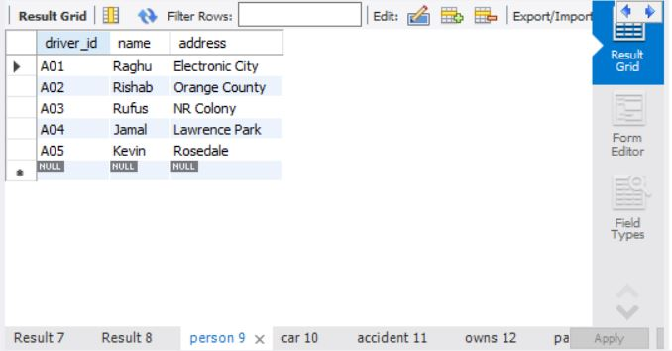

insert into car values('KA031111','Accord',2005);

insert into car values('KA041122','MX-5',2019);

insert into car values('KA051133','Indica',2010);

insert into car values('KA061144','Prius',2015);

insert into car values('KA071155','Camry',2020);

commit;

select * from car;

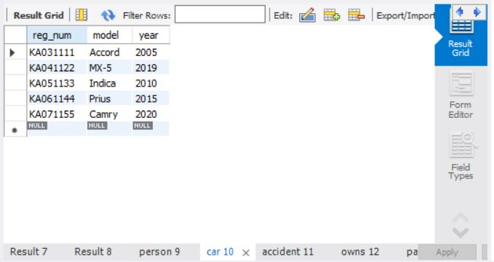

insert into accident values(111,'2020-01-01','NR Road');

insert into accident values(122,'2020-02-02','Dalhousie Road');

insert into accident values(133,'2020-03-03','Henry Road');

insert into accident values(144,'2020-04-04','Beehive Road');

insert into accident values(155,'2020-05-05','Orange Street');

commit;

select * from accident;

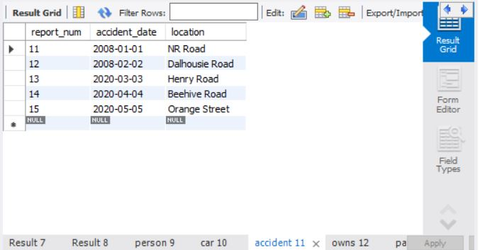

insert into owns values ('A01','KA031111');

insert into owns values ('A02','KA041122');

insert into owns values ('A03','KA051133');

insert into owns values ('A04','KA061144');

insert into owns values ('A05','KA071155');

commit;

select * from owns;

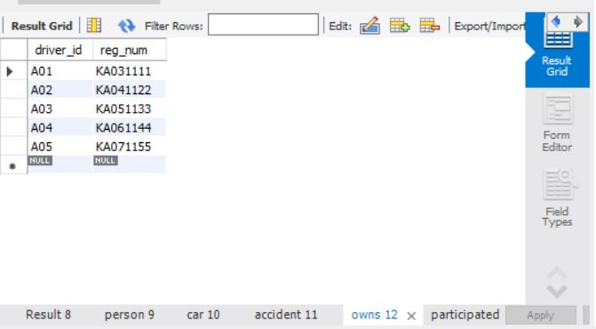

insert into participated values ('A01','KA031111',111, 10000);

insert into participated values ('A02','KA041122',122, 20000);

insert into participated values ('A03','KA051133',133, 30000);

insert into participated values ('A04','KA061144',144, 40000);

insert into participated values ('A05','KA071155',155, 50000);

commit;

select * from participated;

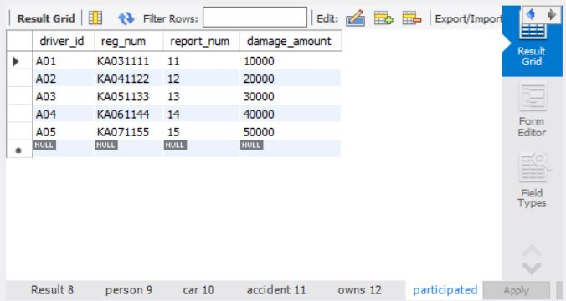

Additional Queries:

update participated

set damage_amount = 2500

where reg_num='KA031111';

select * from participated;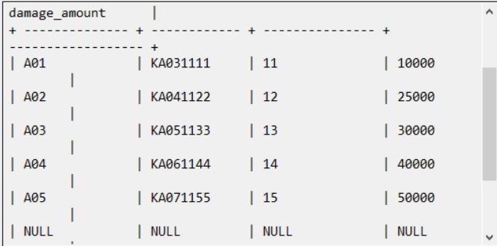

insert into accident values(101,'2008-03-08',Domlur);

insert into participated values('A01','KA031111',101, 1001);

commit;

select * from accident;

select * from participated;

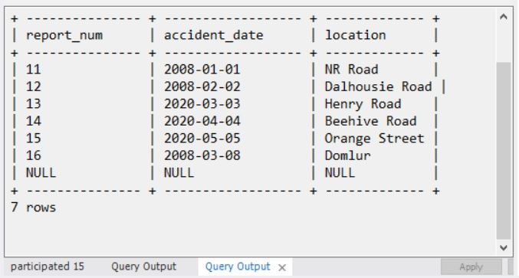

insert into car values('KA01010', 'Indica', 2002);

insert into owns values('A02', 'KA01010');

insert into accident values(200, '2008-12-01', 'Pinto Road');

insert into participated values('A02', 'KA01010', 200, 500);

commit;

select * from car;

select * from owns;

select * from accident;

select * from participated;

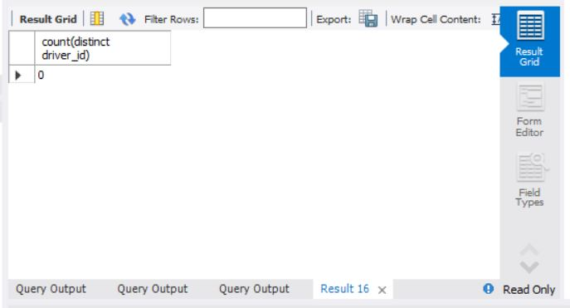

select count(*) from accident where year(accident_date)=2008;

select count(*) from participated where reg_num in ( select reg_num from car where model="Indica");

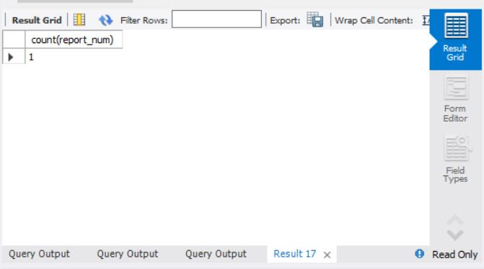

**LAB 2- QUERIES**

create database bank;

use bank;

create table branch (

branch_name varchar(25),

branch_city varchar(15),

assets int,

primary key (branch_name)

);

create table bank_account (

accno int,

branch_name varchar(25),

balance int,

primary key (accno),

foreign key (branch_name) references branch(branch_name)

);

create table bank_customer (

customer_name varchar(10),

customer_street varchar(25),

customer_city varchar(15),

primary key (customer_name)

);

create table depositer (

customer_name varchar(10),

accno int,

primary key(customer_name, accno),

foreign key (customer_name) references bank_customer(customer_name),

foreign key (accno) references bank_account(accno)

);

create table loan (

loan_number int,

branch_name varchar(25),

amount int,

primary key (loan_number),

foreign key (branch_name) references branch(branch_name)

);

insert into branch values('SBI_Chamrajpet', 'Bangalore', 50000);

insert into branch values('SBI_ResidencyRoad', 'Bangalore', 10000);

insert into branch values('SBI_ShivajiRoad', 'Bombay', 20000);

insert into branch values('SBI_ParliamentRoad', 'Delhi', 10000);

insert into branch values('SBI_Jantarmantar', 'Delhi', 20000);

commit;

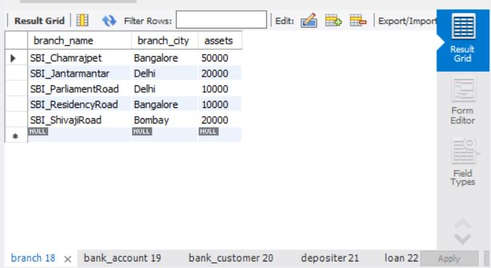

insert into bank_account values(1, 'SBI_Chamrajpet', 2000);

insert into bank_account values(2, 'SBI_ResidencyRoad', 5000);

insert into bank_account values(3, 'SBI_ShivajiRoad', 6000);

insert into bank_account values(4, 'SBI_ParliamentRoad', 9000);

insert into bank_account values(5, 'SBI_Jantarmantar', 8000);

insert into bank_account values(6, 'SBI_ShivajiRoad', 4000);

insert into bank_account values(8, 'SBI_ResidencyRoad', 4000);

insert into bank_account values(9, 'SBI_ParliamentRoad', 3000);

insert into bank_account values(10, 'SBI_ResidencyRoad', 5000);

insert into bank_account values(11, 'SBI_Jantarmantar', 2000);

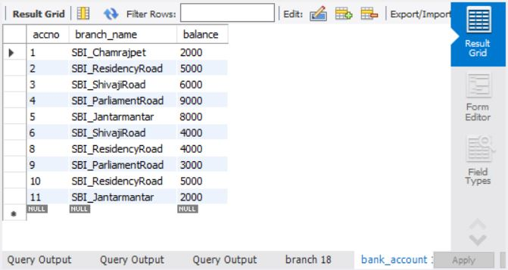

commit;

insert into bank_customer values ('Abhay', 'Bull_Temple_Road', 'Bangalore');

insert into bank_customer values ('Dhruv', 'Bannergatta_Road', 'Bangalore');

insert into bank_customer values ('Mohit', 'National_College_Road', 'Bangalore');

insert into bank_customer values ('Nick', 'Akbar_Road', 'Delhi');

insert into bank_customer values ('Rahul', 'Prithviraj_Road', 'Delhi');

commit;

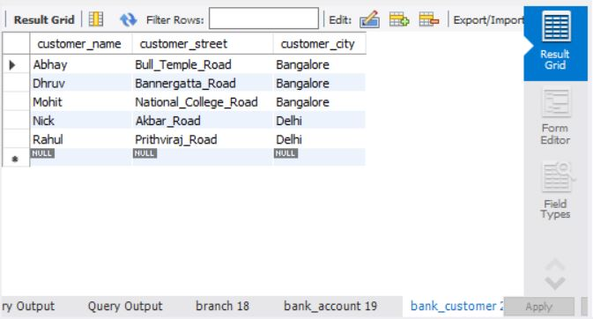

insert into depositer values('Abhay', 1);

insert into depositer values('Dhruv', 2);

insert into depositer values('Nick', 4);

insert into depositer values('Rahul', 5);

insert into depositer values('Abhay', 8);

insert into depositer values('Nick', 9);

insert into depositer values('Dhruv', 10);

insert into depositer values('Nick', 11);

commit;

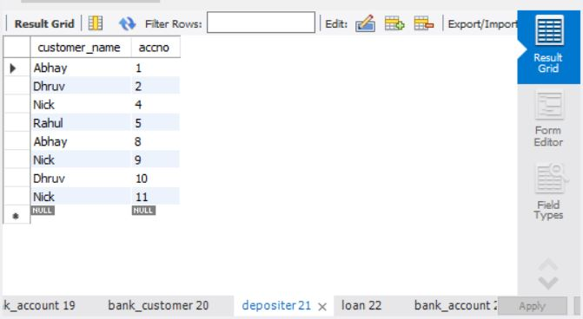

insert into loan values(1, 'SBI_Chamrajpet', 1000);

insert into loan values(2, 'SBI_ResidencyRoad', 2000);

insert into loan values(3, 'SBI_ShivajiRoad', 3000);

insert into loan values(4, 'SBI_ParliamentRoad', 4000);

insert into loan values(5, 'SBI_Jantarmantar', 5000);

commit;

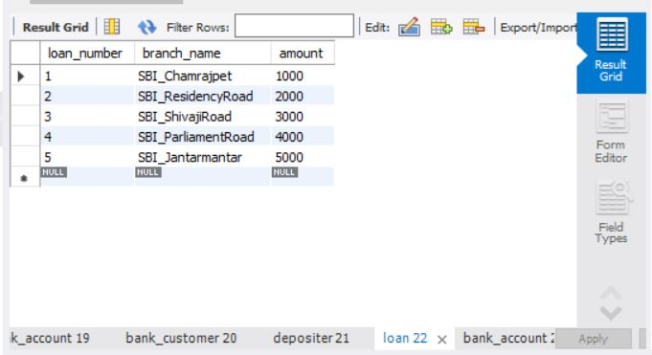

select * from branch;

select * from bank_account;

select * from bank_customer;

select * from depositer;

select * from loan;

Additional Queries:

select distinct c.customer_name from bank_customer c,bank_account b where exists(select d.customer_name,count(d.customer_name) from depositer d,bank_account ba where ba.accno = d.accno and

c.customer_name = d.customer_name and ba.branch_name = 'SBI_ResidencyRoad' group by d.customer_name having count(d.customer_name)>=2);

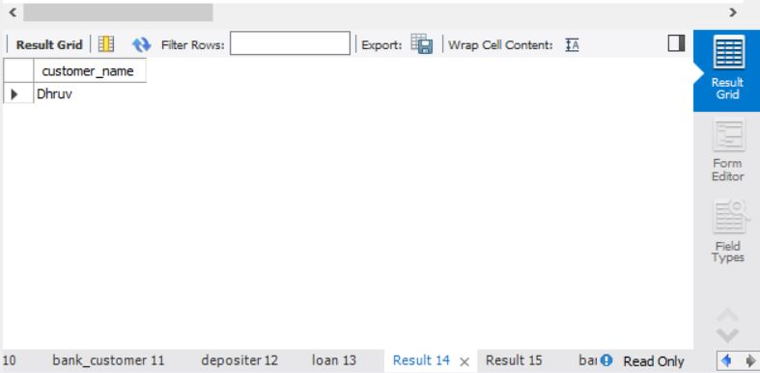

select d.customer_name from depositer d,branch b,bank_account a

where b.branch_name=a.branch_name

AND a.accno=d.accno

and branch_city='Delhi'

group by d.customer_name

HAVING COUNT(distinct b.branch_name)=(

SELECT COUNT(branch_name)

FROM branch

WHERE branch_city='Delhi');

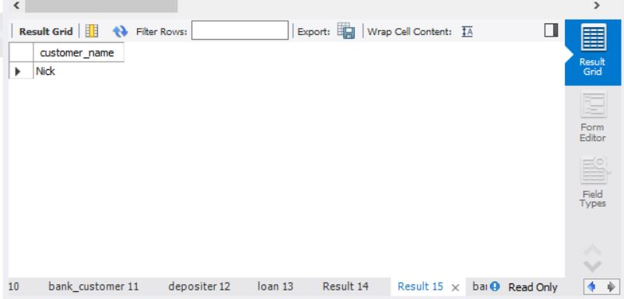

delete from bank_account where branch_name in (select branch_name from branch where branch_city = 'Bombay');

select * from bank_account;

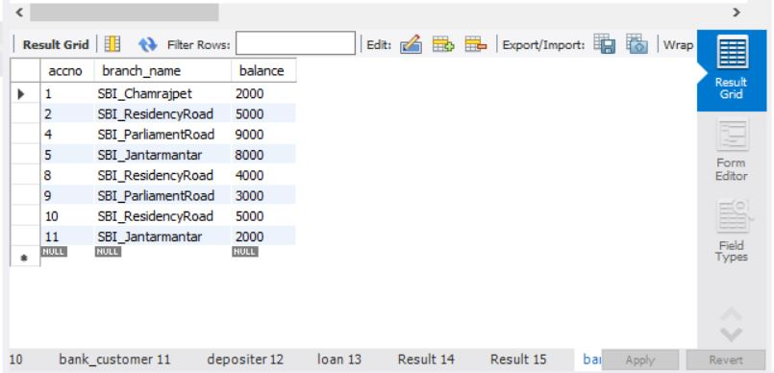

**LAB 3 QUERIES:**

create database supplier;

use supplier;

create table SUPPLIERS(sid integer,sname varchar(20),address varchar(40),primary key(sid));

INSERT INTO `supplier`.`suppliers` (`sid`, `sname`, `address`) VALUES ('10001', 'Acme Widget', 'Bangalore');

INSERT INTO `supplier`.`suppliers` (`sid`, `sname`, `address`) VALUES ('10002', 'Johns', 'Kolkata');

INSERT INTO `supplier`.`suppliers` (`sid`, `sname`, `address`) VALUES ('10003', 'Vimal', 'Mumbai');

INSERT INTO `supplier`.`suppliers` (`sid`, `sname`, `address`) VALUES ('10004', 'Reliance', 'Delhi');

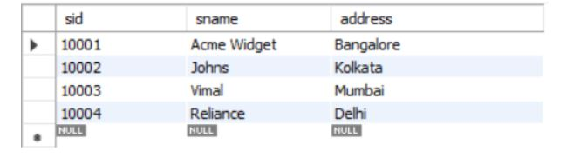

commit;

select* from SUPPLIERS;

create table PARTS(pid integer,pname varchar(20),color varchar(30),primary key(pid));

INSERT INTO `supplier`.`parts` (`pid`, `pname`, `color`) VALUES ('20001', 'Book', 'Red');

INSERT INTO `supplier`.`parts` (`pid`, `pname`, `color`) VALUES ('20002', 'Pen', 'Red');

INSERT INTO `supplier`.`parts` (`pid`, `pname`, `color`) VALUES ('20003', 'Pencil', 'Green');

INSERT INTO `supplier`.`parts` (`pid`, `pname`, `color`) VALUES ('20004', 'Mobile', 'Green');

INSERT INTO `supplier`.`parts` (`pid`, `pname`, `color`) VALUES ('20005', 'Charger', 'Black');

commit;

select* from PART;

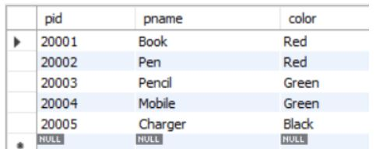

create table CATALOG(sid integer,pid integer,foreign key(sid) references SUPPLIERS(sid),foreign key(pid) references PARTS(pid),

cost integer,primary key(sid,pid));

INSERT INTO `supplier`.`catalog` (`sid`, `pid`, `cost`) VALUES ('10001', '20001', '10');

INSERT INTO `supplier`.`catalog` (`sid`, `pid`, `cost`) VALUES ('10001', '20002', '10');

INSERT INTO `supplier`.`catalog` (`sid`, `pid`, `cost`) VALUES ('10001', '20003', '30');

INSERT INTO `supplier`.`catalog` (`sid`, `pid`, `cost`) VALUES ('10001', '20004', '10');

INSERT INTO `supplier`.`catalog` (`sid`, `pid`, `cost`) VALUES ('10001', '20005', '10');

INSERT INTO `supplier`.`catalog` (`sid`, `pid`, `cost`) VALUES ('10002', '20001', '10');

INSERT INTO `supplier`.`catalog` (`sid`, `pid`, `cost`) VALUES ('10002', '20002', '20');

INSERT INTO `supplier`.`catalog` (`sid`, `pid`, `cost`) VALUES ('10003', '20003', '30');

INSERT INTO `supplier`.`catalog` (`sid`, `pid`, `cost`) VALUES ('10004', '20003', '40');

commit;

select* from CATALOG;

Additional Queries:

SELECT DISTINCT P.pname

FROM Parts P, Catalog C

WHERE P.pid = C.pid;

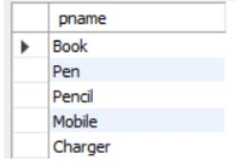

select S.sname from SUPPLIERS S where not exists

(select P.pid from PARTS P where not exists

(select C.sid from CATALOG C where C.sid = S.sid and C.pid = P.pid));

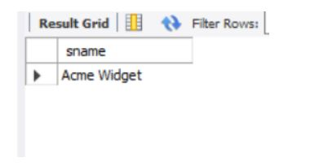

select S.sname from SUPPLIERS S where not exists

(select P.pid from PARTS P where P.color = 'Red' and

(not exists (select C.sid from CATALOG C where C.sid = S.sid and C.pid = P.pid)));

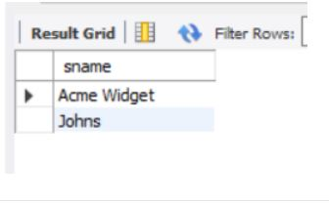

select P.pname from PARTS P, CATALOG C, SUPPLIERS S

where P.pid = C.pid and C.sid = S.sid and S.sname = 'Acme Widget'

and not exists (select * from CATALOG C1, SUPPLIERS S1

where P.pid = C1.pid and C1.sid = S1.sid and S1.sname <> 'Acme Widget');

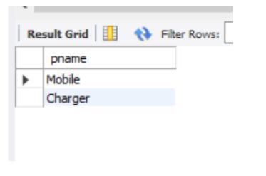

SELECT DISTINCT C.sid FROM Catalog C

WHERE C.cost > ( SELECT AVG (C1.cost)

FROM Catalog C1

WHERE C1.pid = C.pid );

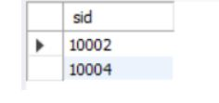

SELECT P.pid, S.sname

FROM Parts P, Suppliers S, Catalog C

WHERE C.pid = P.pid

AND C.sid = S.sid

AND C.cost = (SELECT MAX(C1.cost)

FROM Catalog C1

WHERE C1.pid = P.pid);

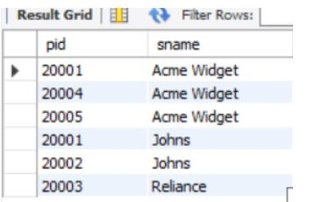

**LAB 4 QUERIES:**

CREATE DATABASE student_faculty;

USE student_faculty;

CREATE TABLE student(

snum INT,

sname VARCHAR(10),

major VARCHAR(2),

lvl VARCHAR(2),

age INT, primary key(snum));

CREATE TABLE faculty(

fid INT,fname VARCHAR(20),

deptid INT,

PRIMARY KEY(fid));

CREATE TABLE class(

cname VARCHAR(20),

metts_at TIMESTAMP,

room VARCHAR(10),

fid INT,

PRIMARY KEY(cname),

FOREIGN KEY(fid) REFERENCES faculty(fid));

CREATE TABLE enrolled(

snum INT,

cname VARCHAR(20),

PRIMARY KEY(snum,cname),

FOREIGN KEY(snum) REFERENCES student(snum),

FOREIGN KEY(cname) REFERENCES class(cname));

INSERT INTO STUDENT VALUES(1, 'jhon', 'CS', 'Sr', 19);

INSERT INTO STUDENT VALUES(2, 'Smith', 'CS', 'Jr', 20);

INSERT INTO STUDENT VALUES(3 , 'Jacob', 'CV', 'Sr', 20);

INSERT INTO STUDENT VALUES(4, 'Tom ', 'CS', 'Jr', 20);

INSERT INTO STUDENT VALUES(5, 'Rahul', 'CS', 'Jr', 20);

INSERT INTO STUDENT VALUES(6, 'Rita', 'CS', 'Sr', 21);

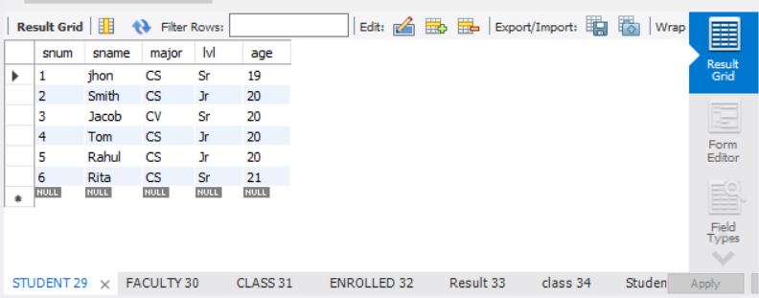

INSERT INTO FACULTY VALUES(11, 'Harish', 1000);

INSERT INTO FACULTY VALUES(12, 'MV', 1000);

INSERT INTO FACULTY VALUES(13 , 'Mira', 1001);

INSERT INTO FACULTY VALUES(14, 'Shiva', 1002);

INSERT INTO FACULTY VALUES(15, 'Nupur', 1000);

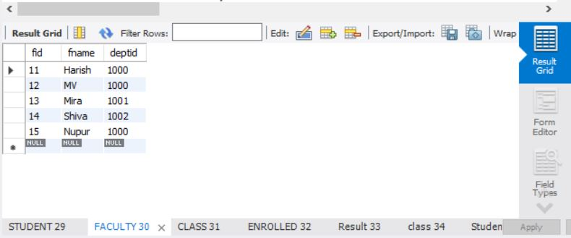

insert into class values('class1', '12/11/15 10:15:16', 'R1', 14);

insert into class values('class10', '12/11/15 10:15:16', 'R128', 14);

insert into class values('class2', '12/11/15 10:15:20', 'R2', 12);

insert into class values('class3', '12/11/15 10:15:25', 'R3', 11);

insert into class values('class4', '12/11/15 20:15:20', 'R4', 14);

insert into class values('class5', '12/11/15 20:15:20', 'R3', 15);

insert into class values('class6', '12/11/15 13:20:20', 'R2', 14);

insert into class values('class7', '12/11/15 10:10:10', 'R3', 14);

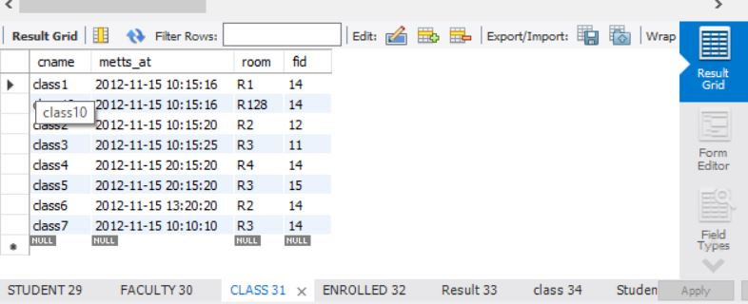

insert into enrolled values(1, 'class1');

insert into enrolled values(2, 'class1');

insert into enrolled values(3, 'class3');

insert into enrolled values(4, 'class3');

insert into enrolled values(5, 'class4');

insert into enrolled values(1, 'class5');

insert into enrolled values(2, 'class5');

insert into enrolled values(3, 'class5');

insert into enrolled values(4, 'class5');

insert into enrolled values(5, 'class5');

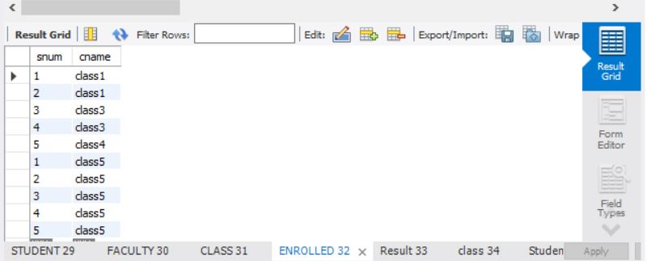

Additional Queries:

SELECT DISTINCT S.Sname

FROM Student S, Class C, Enrolled E, Faculty F

WHERE S.snum = E.snum AND E.cname = C.cname AND C.fid = F.fid AND

F.fname = 'Harish' AND S.lvl = 'Jr';

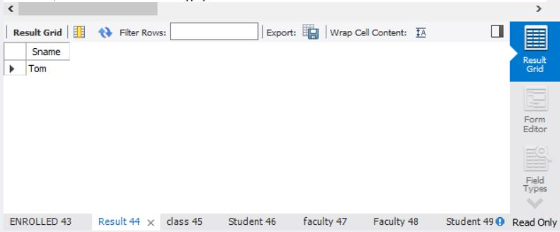

SELECT DISTINCT cname

FROM class

WHERE room='R128'

OR

cname IN (SELECT e.cname FROM enrolled e GROUP BY e.cname HAVING COUNT(*)>=5);

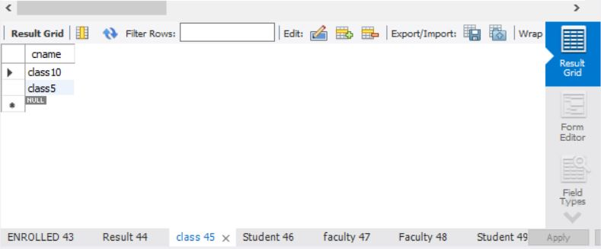

SELECT DISTINCT S.sname

FROM Student S

WHERE S.snum IN (SELECT E1.snum

FROM Enrolled E1, Enrolled E2, Class C1, Class C2

WHERE E1.snum = E2.snum AND E1.cname <> E2.cname

AND E1.cname = C1.cname

AND E2.cname = C2.cname AND C1.metts_at = C2.metts_at);

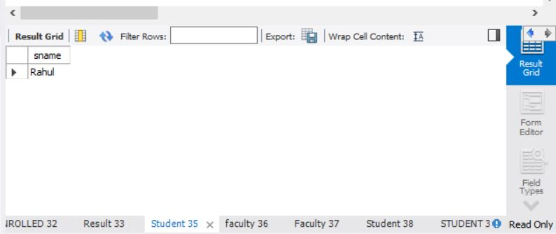

SELECT f.fname,f.fid

FROM faculty f

WHERE f.fid in ( SELECT fid FROM class

GROUP BY fid HAVING COUNT(*)=(SELECT COUNT(DISTINCT room) FROM class) );

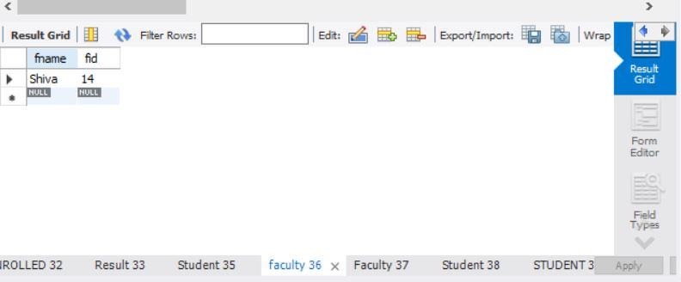

SELECT DISTINCT F.fname

FROM Faculty F

WHERE 5 > (SELECT COUNT(E.snum)

FROM Class C, Enrolled E

WHERE C.cname = E.cname

AND C.fid = F.fid);

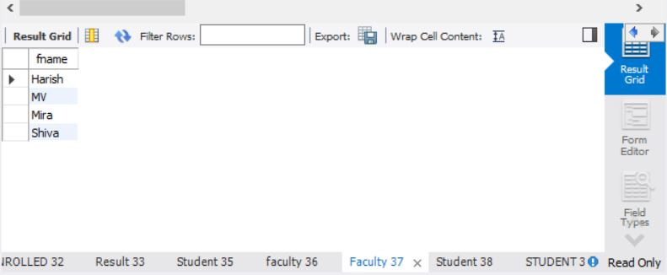

SELECT DISTINCT S.sname

FROM Student S

WHERE S.snum NOT IN (SELECT E.snum

FROM Enrolled E );

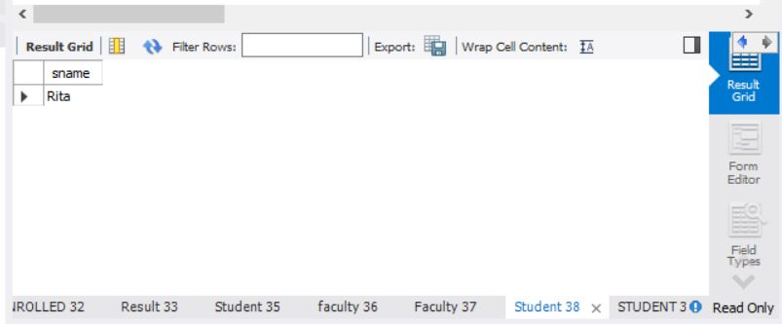

SELECT S.age, S.lvl

FROM STUDENT S

GROUP BY S.age, S.lvl

HAVING S.lvl IN(SELECT S1.lvl

FROM STUDENT S1

WHERE S1.age=S.age

GROUP BY S1.age, S1.lvl

HAVING COUNT(*) >= ALL (SELECT COUNT(*)

FROM STUDENT S2

WHERE S1.age=S2.age

GROUP BY S2.lvl, S2.age))

ORDER BY S.age;

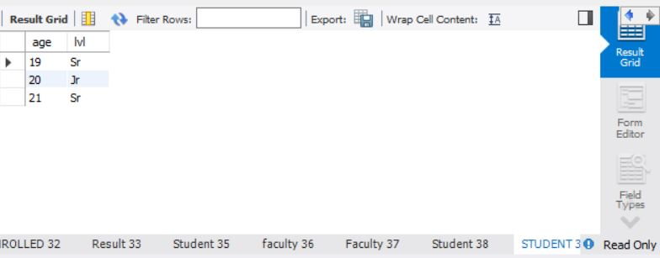

**LAB 5 QUERIES:**

create database flightdb;

use flightdb;

create table flights(

flno int,

fromplace varchar(15),

toplace varchar(15),

distance int,

departs datetime,

arrives datetime,

price int,

primary key (flno)

);

desc flights;

create table aircraft(

aid int,

aname varchar(15),

cruisingrange int,

primary key (aid)

);

desc aircraft;

create table employees (

eid int,

ename varchar(15),

salary int,

primary key (eid)

);

desc employees;

create table certified (

eid int,

aid int,

foreign key (eid) references employees(eid),

foreign key (aid) references aircraft(aid)

);

desc certified;

insert into flights values(101, 'Bangalore', 'Delhi', 2500, '2005-05-13 07:15:31', '2005-05-13 18:15:31', 5000);

insert into flights values(102, 'Bangalore', 'Lucknow', 3000, '2013-05-05 07:15:31', '2013-05-05 11:15:31', 6000);

insert into flights values(103, 'Lucknow', 'Delhi', 500, '2013-05-05 12:15:31', '2013-05-05 17:15:31', 3000);

insert into flights values(107, 'Bangalore', 'Frankfurt', 8000, '2013-05-05 07:15:31', '2013-05-05 22:15:31', 60000);

insert into flights values(104, 'Bangalore', 'Frankfurt', 8500, '2013-05-05 07:15:31', '2013-05-05 23:15:31', 75000);

insert into flights values(105, 'Kolkata', 'Delhi', 3400, '2013-05-05 07:15:31', '2013-05-05 09:15:31', 7000);

insert into flights values(106, 'Bangalore', 'Kolkata', 1000, '2013-05-05 01:15:30', '2013-05-05 09:20:30', 10000);

insert into flights values(108, 'Lucknow', 'Kolkata', 1000, '2013-05-05 11:30:30', '2013-05-05 15:20:30', 10000);

commit;

select * from flights;

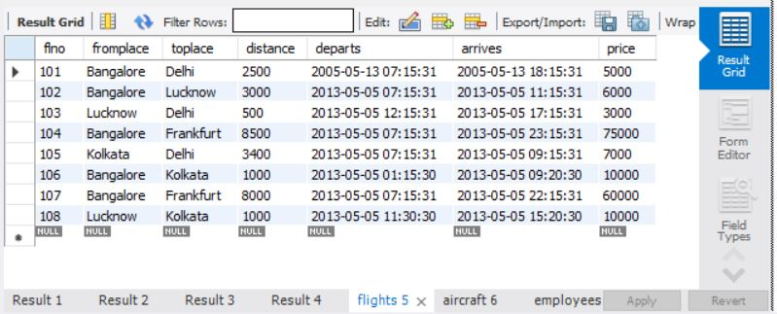

insert into aircraft values(101, '747', 3000);

insert into aircraft values(102, 'Boeing', 900);

insert into aircraft values(103, '647', 800);

insert into aircraft values(104, 'Dreamliner', 10000);

insert into aircraft values(105, 'Boeing', 3500);

insert into aircraft values(106, '707', 1500);

insert into aircraft values(107, 'Dream', 120000);

insert into aircraft values(108, '707', 760);

insert into aircraft values(109, '747', 1000);

commit;

select * from aircraft;

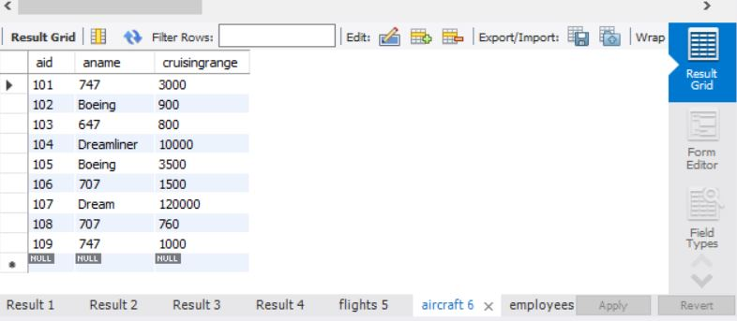

insert into employees values(701, 'A', 50000);

insert into employees values(702, 'B', 100000);

insert into employees values(703, 'C', 150000);

insert into employees values(704, 'D', 90000);

insert into employees values(705, 'E', 40000);

insert into employees values(706, 'F', 60000);

insert into employees values(707, 'G', 90000);

commit;

select * from employees;

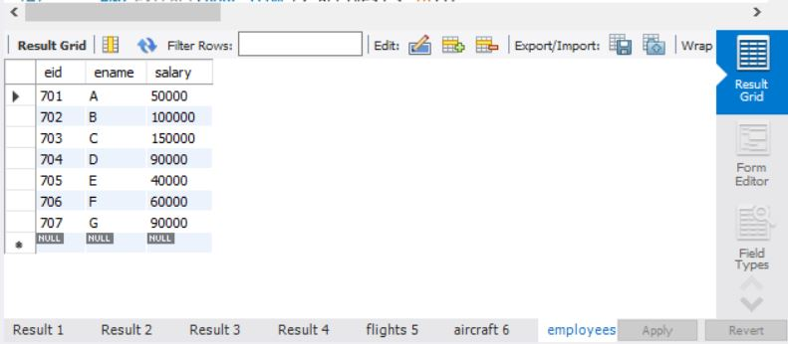

insert into certified values(701, 101);

insert into certified values(701, 102);

insert into certified values(701, 106);

insert into certified values(701, 105);

insert into certified values(702, 104);

insert into certified values(703, 104);

insert into certified values(704, 104);

insert into certified values(702, 107);

insert into certified values(703, 107);

insert into certified values(704, 107);

insert into certified values(702, 101);

insert into certified values(702, 108);

insert into certified values(701, 109);

commit;

select * from certified;

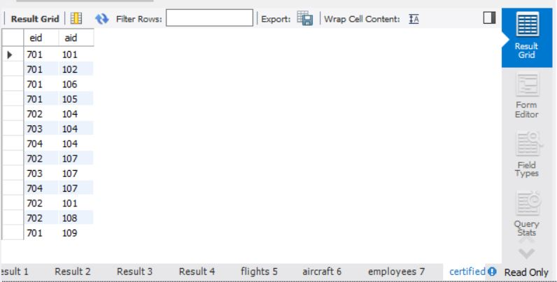

Additional Queries:

select distinct a.aname from aircraft a where a.aid in (

select c.aid from certified c, employees e where

c.eid = e.eid and not exists(

select * from employees e1 where e1.eid=e.eid and e1.salary<80000

)

);

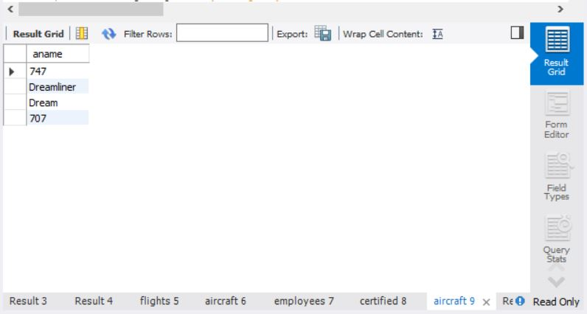n

select max(a.cruisingrange), c.eid from certified c, aircraft a where c.aid = a.aid group by c.eid having count(c.eid)>3;

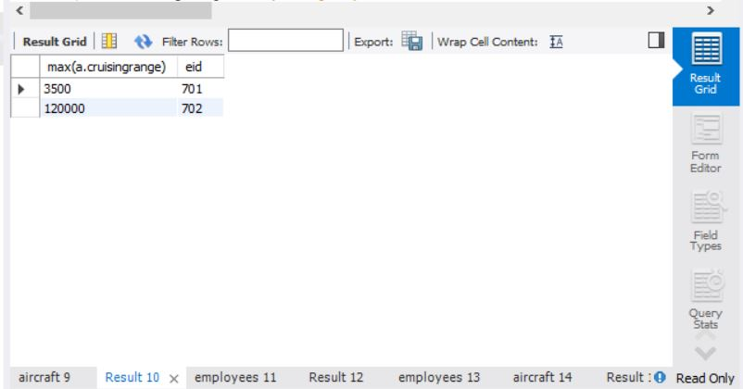

select ename from employees where salary <(

select min(price) from flights where fromplace='Bangalore' and toplace='Frankfurt');

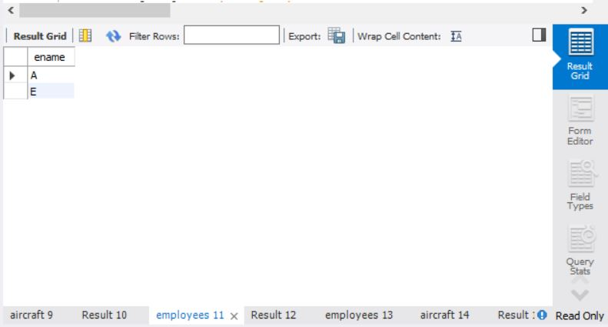

select avg(e.salary), c.aid from certified c, employees e where c.aid in(

select aid from aircraft where cruisingrange>1000) and e.eid = c.eid group by c.aid;

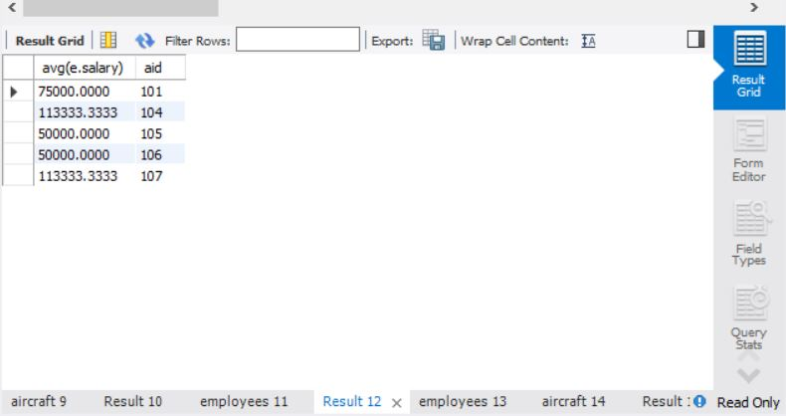

select ename from employees where eid in(

select eid from certified where aid in(

select aid from aircraft where aname = 'Boeing'));

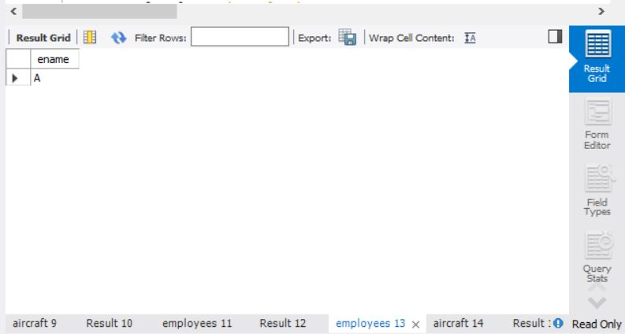

select aname from aircraft where cruisingrange > any (select distance from flights where fromplace='Bangalore' and toplace='Delhi');

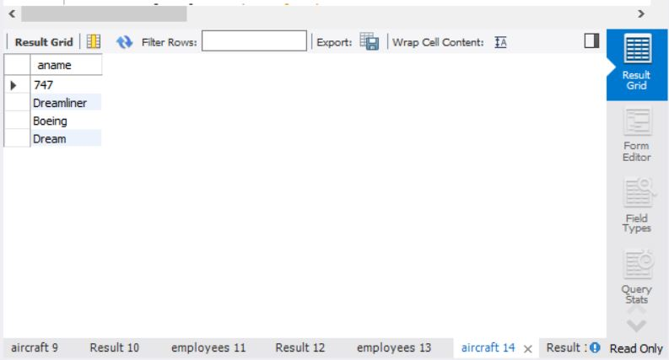

SELECT F.flno, F.departs

FROM flights F

WHERE F.flno IN ( ( SELECT F0.flno

FROM flights F0

WHERE F0.fromplace = 'Bangalore' AND F0.toplace = 'Kolkata'

AND extract(hour from F0.arrives) < 18 )

UNION

( SELECT F0.flno

FROM flights F0, flights F1

WHERE F0.fromplace = 'Bangalore' AND F0.toplace <> 'Kolkata'

AND F0.toplace = F1.fromplace AND F1.toplace = 'Kolkata'

AND F1.departs > F0.arrives

AND extract(hour from F1.arrives) < 18)

UNION

( SELECT F0.flno

FROM flights F0, flights F1, flights F2

WHERE F0.fromplace = 'Bangalore'

AND F0.toplace = F1.fromplace

AND F1.toplace = F2.fromplace

AND F2.toplace = 'Kolkata'

AND F0.toplace <> 'Kolkata'

AND F1.toplace <> 'Kolkata'

AND F1.departs > F0.arrives

AND F2.departs > F1.arrives

AND extract(hour from F2.arrives) < 18));

