AUCTION SYSTEM

An auction is a system of buying and selling goods or services by offering them for bidding—allowing people to bid and selling to the highest bidder. The bidders compete against each other, with each subsequent bid being higher than the previous bid.

**Problem Statement**

The problem that usually arises in online auction is that of the buyer’s uncertainty towards the sellers and their products due to the lack of physical evaluation of the products. Despite the increased numerous advantages of online auction there are problems that are still present, unlike in offline markets where buyers can physically evaluate the product quality and interact directly with the sellers, in online markets the buyers do not have such opportunity as the buyers only get to evaluate the product quality via the internet interface that cannot perfectly describe the products. The problem of product and the seller’s uncertainty negatively affects the key success of the outcomes of the online auctions. The implementation of an online auction system that provides detailed seller and product descriptions results in the increased certainty of the bidders towards the choice of the products and sellers that they make.

**Aim**

To implement an online auction system for the buyers and sellers.

**OBJECTIVES**

* To design and develop an online auction system that ensures the buyer’s on the sellers and the products that are being auctioned
* To computes the seller’s ratings using the feedback scores from the bid winners
* To generate reports for each completed bid in the auction system
* To notify the bidders of new bids made in the bids that they participate in.
* To computes the seller’s shill scores for each seller that sells products on the online auction system.

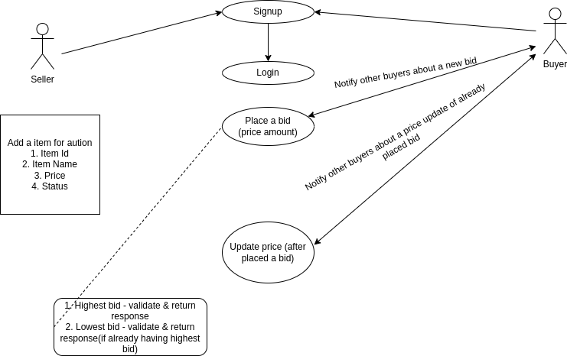

**Justification**

The use of online auction systems that do not allow for full effective product description and failure to provide decision making assistance tools to online bidders results in increased product and sellers uncertainty. The buyer’s uncertainty towards product and seller makes it difficult for the buyers to differentiate between the good and bad sellers, the lack of differentiation may force higher quality sellers to leave the market since their quality products do not signal and reward with fair prices thus reducing transaction activity.

What this new system is trying to accomplish is to create a higher level of buyer’s certainty on the type seller and products that they choose to make bids for. Through the use effective information like the use of visual and textual product description, third party product certification, product book value and product usage. The successful implementation of this project results in an online auction system that allows evaluation of the product that is far much effective and that come close or equal the physical evaluation of the product.

**Expected Results**

The successful development of this system results in the development an auction system that fully signals the products that are to be sold during the auction process. This auction system makes use decision making assistance tool that enables the auction bidders to properly evaluate the sellers and their products to enable them to make choice of the bids to participate in and be confident with the their decision.

**CONCLUSION**

After identifying the project background, problem statement, objectives, scope, justification and expected output, it reveals that the successful implementation of this online auction system will result in a more effective way of carrying out the auctioning.