1. **Quantization algorithm**

The Forward Adaptive quantization algorithm uses 256 pixels as frame size and uses min, max values as side information.  
The algorithm reads the image in blocks of frame size. For each block it finds the min and max value.  
Then the delta is calculated for each block by (max-min)/M, where M is the number of levels, in this case it is taken as 15. (So, all the quantized values will be between 0 and 15 inclusive).  
All pixels are quantized using (pixel-min)/delta and rounded off to nearest integer. (like mid-thread quantizer)  
Two quantized values are packed into one byte and the resultant byte is written into the .bin file.  
The above is repeated for all frames in the image file.

1. **Program results**  
   I have used goldhill.pgm file for testing the algorithm.  
   The source is a grayscale image having a smooth image of houses. The reconstructed image have a bit of distortion to it like we could see few fine lines rather than smooth. Yet, the image is very close to the source.   
   The original file size is 65557 bytes and the compressed file size is 15342 bytes. So the compression ratio is 4:1  
     
   I have done the compression of the same image using uniform quantizer and compared the results. My observation is that image reconstructed using uniform quantizer is more distorted than forward quantizer.  
     
   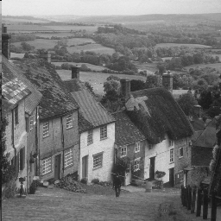

Original Image

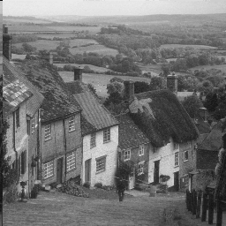

Reconstructed using Forward Quantizer

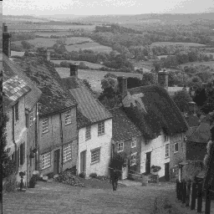

Reconstructed using Uniform Quantizer

1. Quantitative measure  
   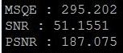  
     
   Output

