***Anitha Thanam***

***ZH9479***

***STAT 6610 Section 01 winter 2016***

***Project 1***

1. **Reproduce the More Students Are Earning visualization that was posted to the White House twitter account Search twitter for "WhiteHouse More Students Are Earning" and click on View Conversation.  Here is the link to the result** [**https://twitter.com/search**](https://twitter.com/WhiteHouse/status/558318033639198720)**.** 
   * **Start by creating an Excel spreadsheet containing the data.**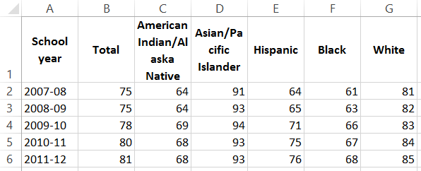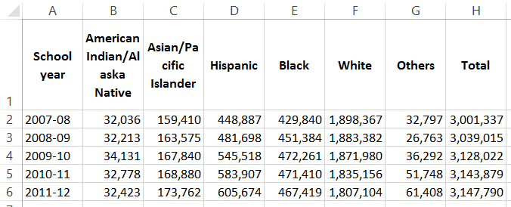
   * **What are the variables being presented?**1. School Year  
     2. Graduation Rate (percentage)
   * **Name the Title and Source.  
     Title:** High School Graduation Rate **Source:** US department of education, national centre education for statistics
   * **Use Tableau to make the visualization.  It may be helpful to use a Story in Tableau.**  
     <https://public.tableau.com/profile/anitha.thanam#!/vizhome/GraduationRate_1/StoryFinal>
   * **Explain what is wrong with the plot and how you have corrected the problem.**There is no scale and the height of the book stack is not proportional to the actual data.  
     For example, the height 78% looks double to that of 75%. And it’s not clear if the scale starts from 0.
2. **Make the following plots:**
   * **Make a bubble plot for a dataset that included the letters A and B, where the letter A occurs 100 times and the B occurs 50 times.**
     + **Start by creating an Excel spreadsheet containing the data.**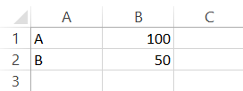
     + **Use Tableau or R to make the visualization.**(Tableau)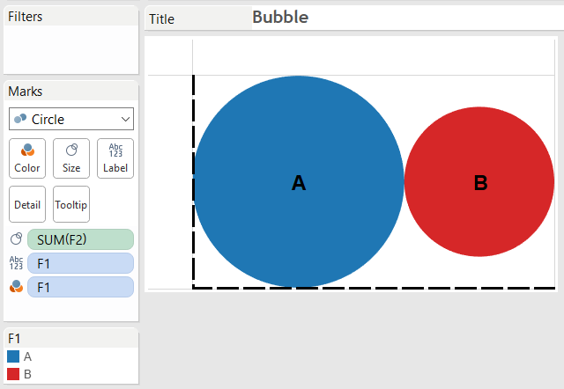
     + **Verify that the size of the circles are correct.**Yes.The circle A’s diameter is roughly about 8 units   
       And circle B’s diameter is roughly about 6 units  
       Then, the area of A is 3.14 * 4 * 4 = 50  
       And the area of B is 3.14 * 3 * 3 = 28which is roughly of ratio 50:28 ~ 100:50
   * **Make a Word Cloud for a dataset that included the letters C and D, where the letter C occurs 300 times and the D occurs 400 times.**
     + **Start by creating an Excel spreadsheet containing the data.**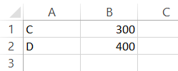
     + **Use Tableau or R to make the visualization.**(Tableau)  
       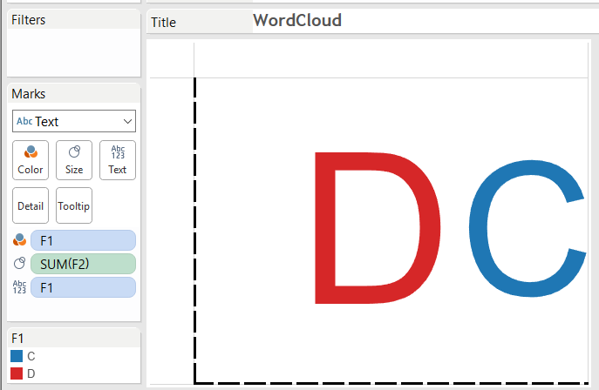
     + **Verify that the size of the circles are correct.**Yes.
3. **The following** [**article and plot**](http://www.sci.csueastbay.edu/%7Eesuess/classes/Statistics_6610/Homework/Project1/labor.jpg) **appeared in the Wall Street Journael on Tuesday, Feburary 10, 2015.** 
   * **Use the** [**China Labour Bulletin**](http://www.clb.org.hk/en/)[**Strike Map**](http://maps.clb.org.hk/strikes/en) **website.**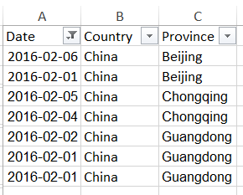
   * **Start by creating an Excel spreadsheet containing the data for each year there is data available for Beijing, Guangdong, Shanghai, and Chonging.**

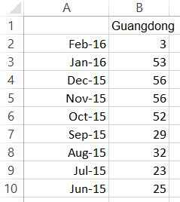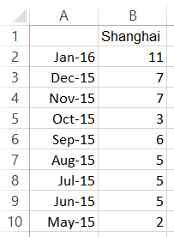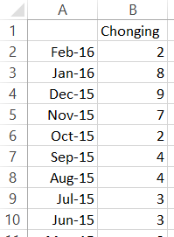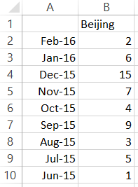

* + **Make a time plot for each location using the same scales for the axes.  (Use Tableau or R)**

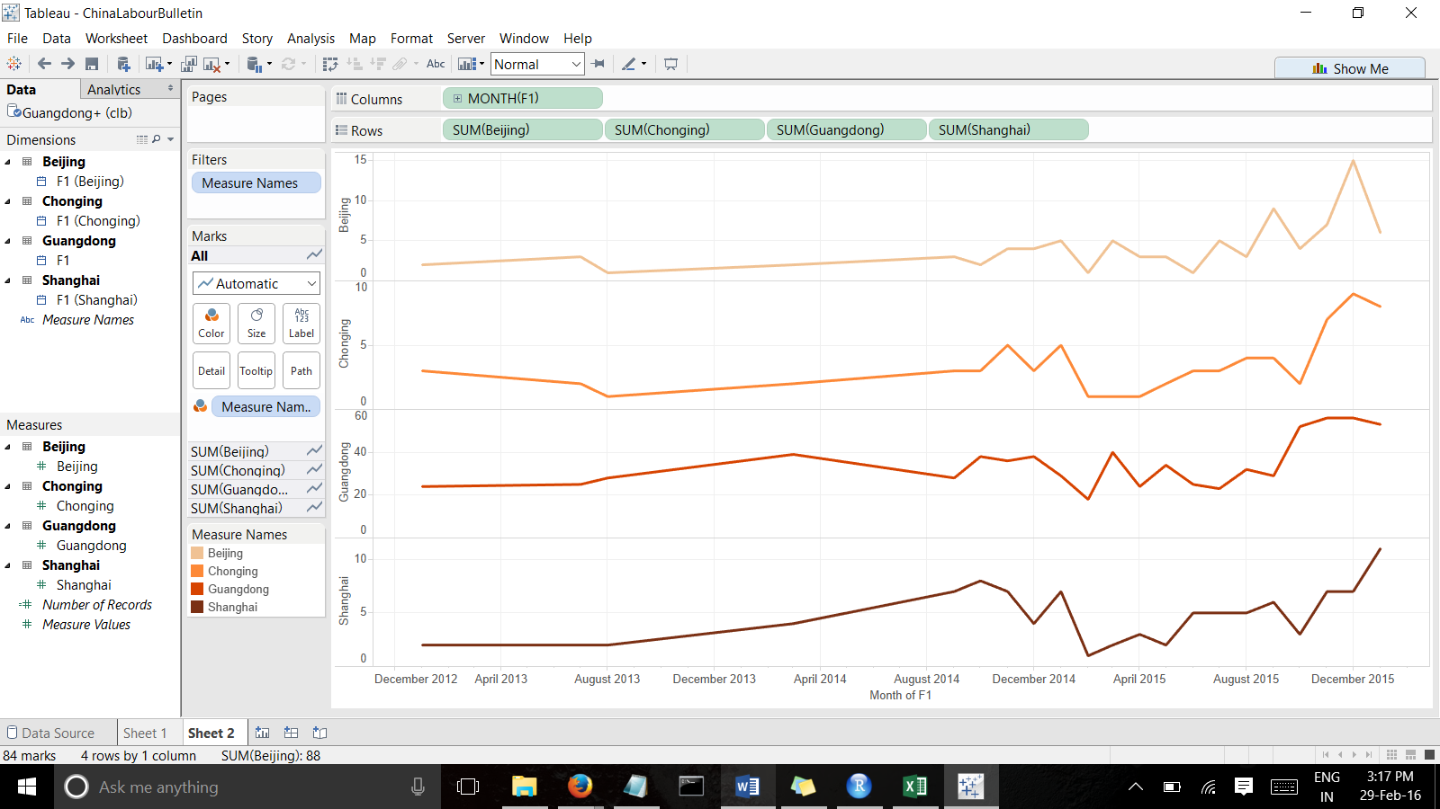

* + **Make one plot with all four locations on the same time plot in different colors.  Use colorbrewer.  (Use Tableau or R)**

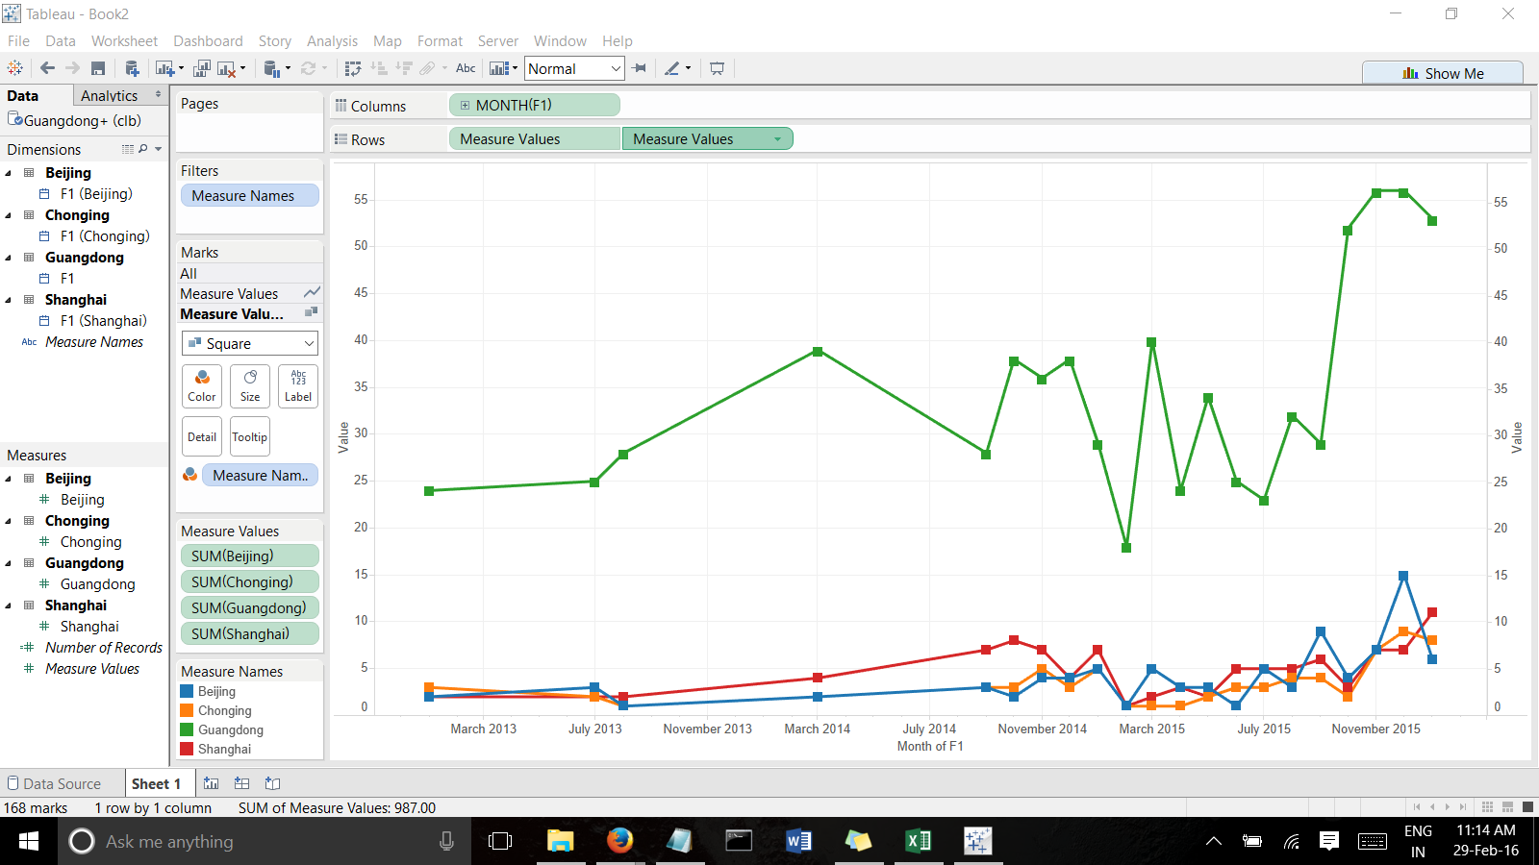

* + **Make a dynamic bubble graph using Tableau.**

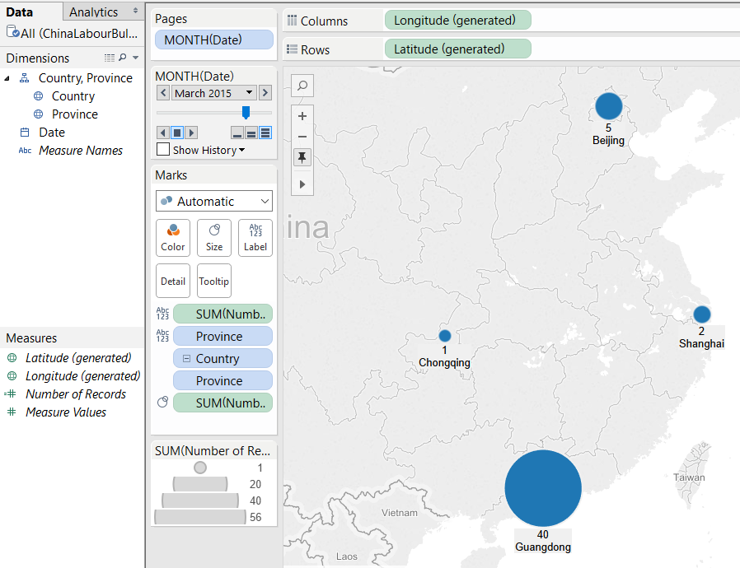

<https://public.tableau.com/profile/anitha.thanam#!/vizhome/ChinaLabourBulletin/Comparisonbetweendynamicbubblechartvsfilledmap>

* + **What is a possible problem with the data selected for comparison.  (Hint: Think about city populations size.  See the** [**City Population**](http://www.citypopulation.de/) **website.)**The charts are compared with number of strikes for each provinces which is directly proportional to the size of population in each provinces. To get a better visualization, comparison should be made to strike rate per million people.

1. **Try the code from** [**HelloFromCSUEastBay**](http://rpubs.com/esuess/HelloFromCSUEastBay)**.  Change the location and the popup.  What is leafletjs?  Show the plots you have created.**Leaflet is the leading open-source JavaScript library for mobile-friendly interactive maps.  
   Leaflet is a widely used open source JavaScript library used to build web mapping applications. First released in 2011, it supports most mobile and desktop platforms, supporting HTML5 and CSS3. Along with OpenLayers, and the Google Maps API, it is one of the most popular JavaScript mapping libraries and is used by major web sites such as FourSquare, Pinterest and Flickr.

Leaflet allows developers without a GIS background to very easily display tiled web maps hosted on a public server, with optional tiled overlays. It can load feature data from GeoJSON files, style it and create interactive layers, such as markers with popups when clicked.

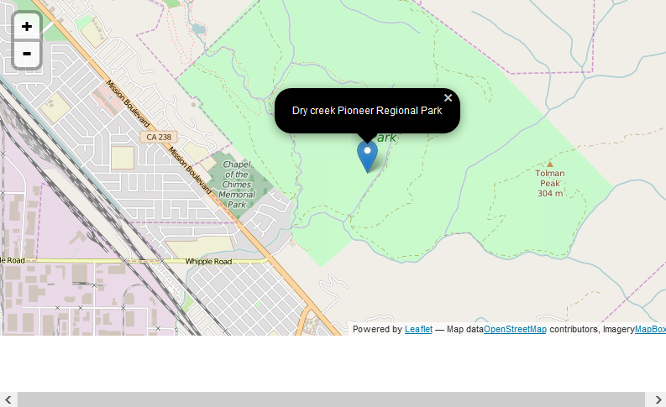

1. **Try the code from** [**WeatherToday**](http://rpubs.com/esuess/WeatherToday)**.  (Updated 2/23/2016 removed LAX, compare Seattle with SF.) The R package weathermetrics connects to Weather Underground data.  Change the aiports and rerun the code.  Show the plots you have created.**

