Anitha Thanam

ZH9479

STAT 6610 Section 01 winter 2016

Project 2

**Topic**

The topic of interest to me is women empowerment. So, I have gathered historical data emphasising women in labour force, women employers, Firms with female as top managers, seats held by women in parliament, etc., in the past few decades. The aim of this project is to compare trends of various variables related to women in work force among various countries.

**Source**

<http://databank.worldbank.org/data/reports.aspx?source=gender-statistics>

This website provides various statistical information related to women in the past few decades for a wide selection of countries. Below is a sample dataset from GenderStatistics topic.

|  |  |  |  |  |  |  |  |  |
| --- | --- | --- | --- | --- | --- | --- | --- | --- |
| **CountryName** | **IndicatorName** | **Y1960** | **Y1970** | **Y1980** | **Y1990** | **Y2000** | **Y2010** | **Y2014** |
| Brazil | Population, female | 36397541 | 48159525 | 61434663 | 75808202 | 88926004 | 100784657 | 104713195 |
| China | Population, female (% of total) | 48.5163840587564 | 48.7181669539609 | 48.7123850984747 | 48.6832291284585 | 48.6309043201851 | 48.5255464236822 | 48.4849111605221 |
| China | Labor force, female (% of total labor force) | NULL | NULL | NULL | 45.0048675872482 | 44.9450221750762 | 43.9738395254908 | 43.8665323975219 |
| China | Population, female | 323638243 | 398668068 | 477982972 | 552644715 | 614035682 | 649128661 | 661465097 |
| France | Employers, female (% of employment) | NULL | NULL | NULL | 2.20000004768372 | 2.09999990463257 | 2.09999990463257 | 2 |
| France | Labor force, female | NULL | NULL | NULL | 11115186 | 12357941 | 13990302 | 14165878 |

Data scraping is done on this dataset so that the final table would like below.

|  |  |  |  |  |  |  |  |
| --- | --- | --- | --- | --- | --- | --- | --- |
| **CountryName** | **year** | **PopulationFemale** | **PopulationFemalePercentOfTotal** | **LaborForceFemale** | **LaborForceFemalePercentOfTotalLaborForce** | **LaborForceTotal** | **ProportionOfSeatsHeldByWomenInNationalParliamentsPercent** |
| Brazil | 2014 | 104713195 | 50.8124335584983 | 48082942 | 43.7742806986552 | 109842906 | 9.9 |
| China | 2014 | 661465097 | 48.4849111605221 | 353782935 | 43.8665323975219 | 806498521 | 23.4 |
| France | 2014 | 33983769 | 51.3296255348987 | 14165878 | 47.1369779233597 | 30052580 | 26.2 |
| India | 2014 | 623824424 | 48.1609277364054 | 120124450 | 24.1718469494304 | 496960163 | 11.4 |
| Iraq | 2014 | 17194928 | 49.39321656189 | 1535511 | 17.6769062285696 | 8686537 | 25.3 |
| Italy | 2014 | 31529094 | 51.4035728543672 | 10886232 | 41.8422336188994 | 26017330 | 31.4 |
| Japan | 2014 | 65282393 | 51.3501682927038 | 27889096 | 42.7076465918193 | 65302348 | 8.1 |

The below map chart is from worldbank website which highlights the proportion of seats held by women in national parliaments in the year 2014.

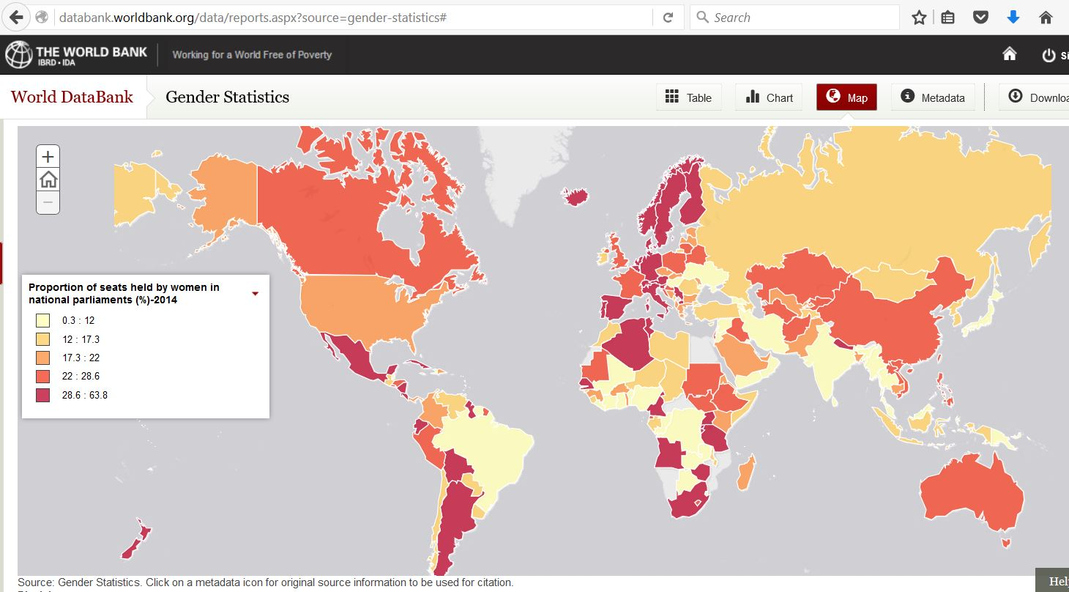

I have generated similar chart using tableau and also using year as another variable shown dynamically using pages.

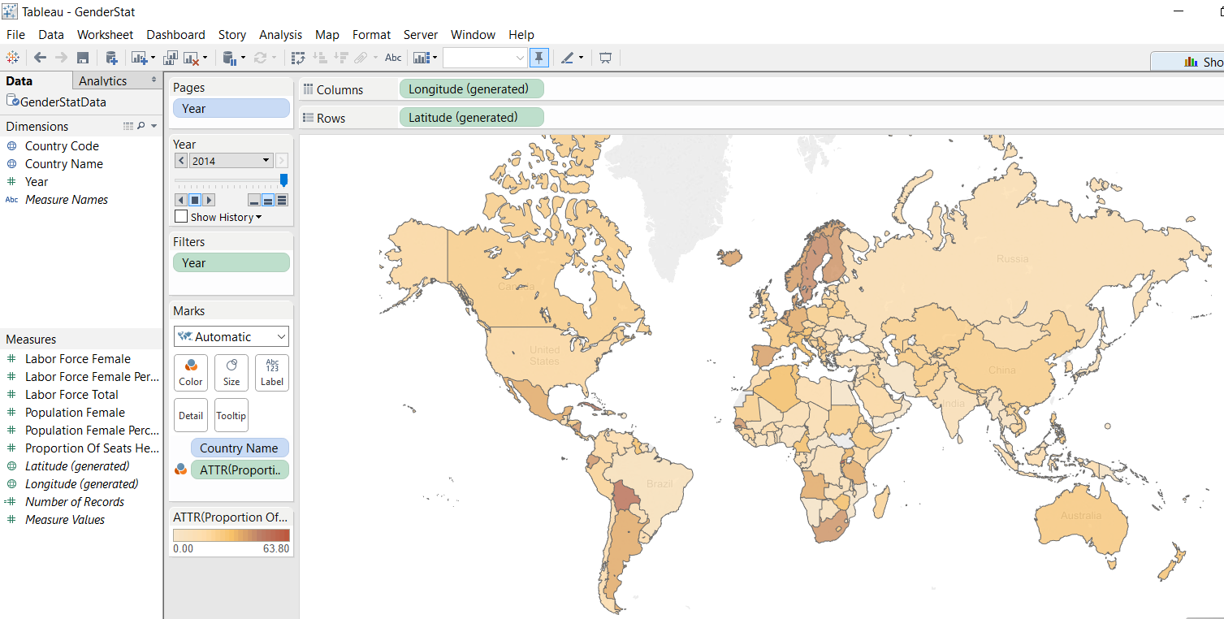

Consider the below chart which is given in the World Bank website. It shows the labor force of female in percentages across various countries.

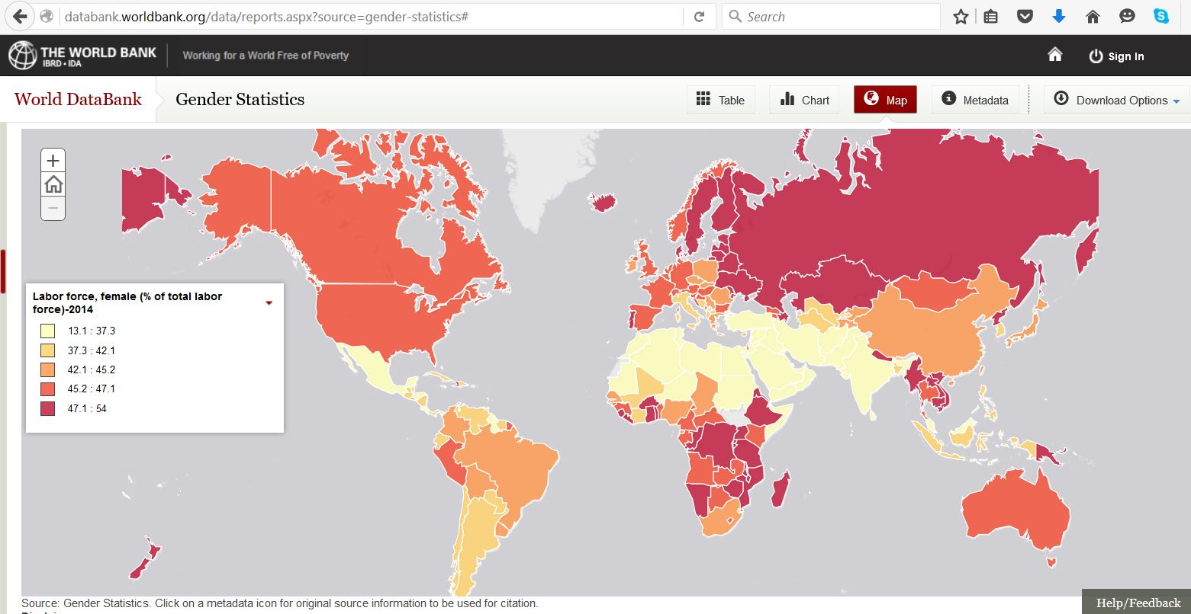

I have used bubble plot to show this variable and another closely related variable, total female labor force in the same map as below. The color of the bubble indicates the percentage of women in labor force. I have used traffic gradient, so green represents more than 33% and red represents less than 33%. The size of the bubble denotes the total population in labor force. Since this graph is dynamic, on playing it for the year, we could see the gradual increase in the size of all the bubbles and color transformation from red to green. Also, we could compare that the middle east and north Africa still have red while the rest of the world has got better in 2014.

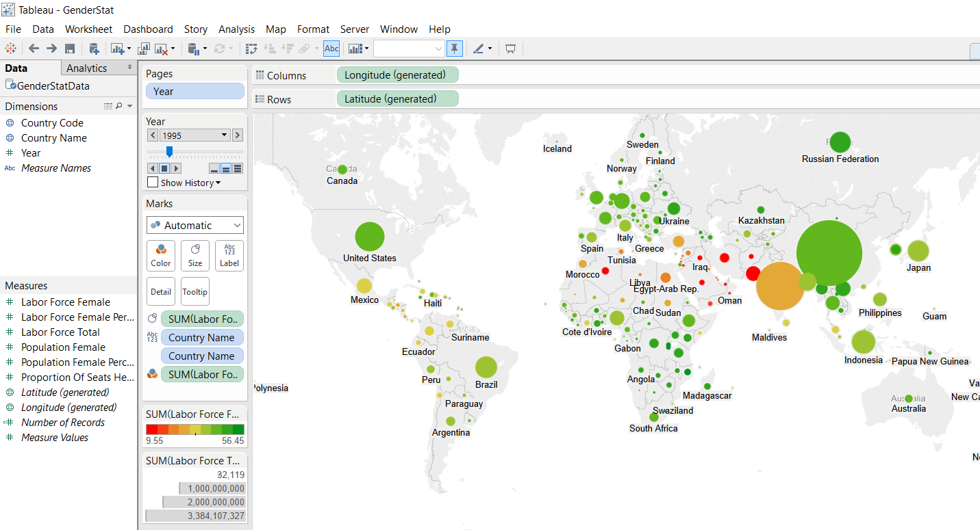

Here, in this graph exposes two variables in one map chart for comparison. And again year is available as another dynamic visulaization.

The visualization can be found in the below link <https://public.tableau.com/profile/anitha.thanam#!/vizhome/GenderStat/Story1>

In the next part of the story, let pick up only few countries and explore their trends in the women empowerment. Below are charts from world bank for selected countries.

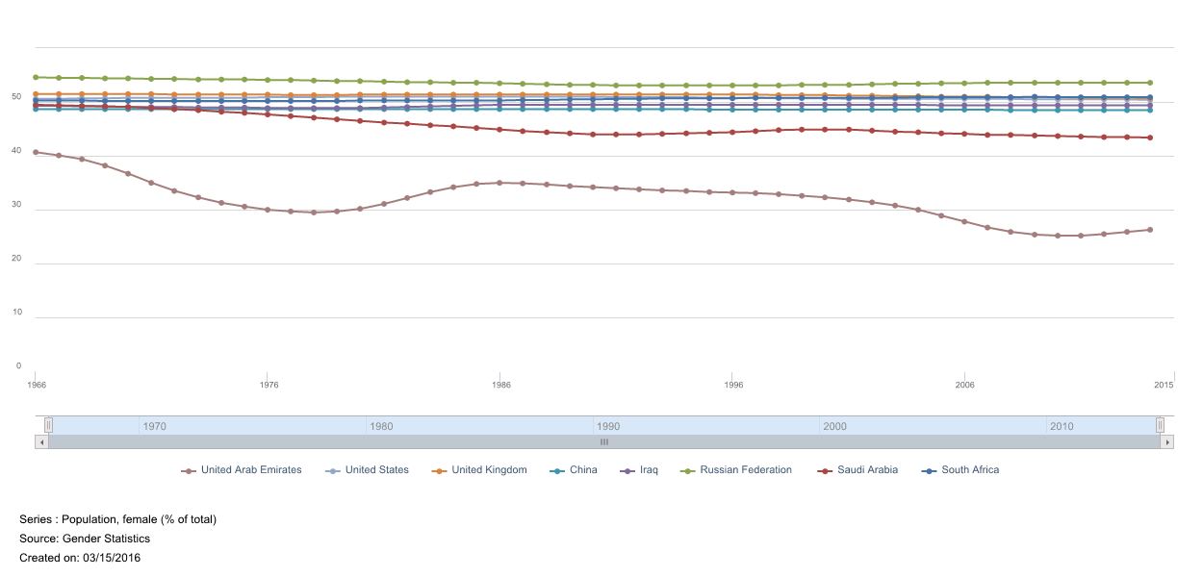

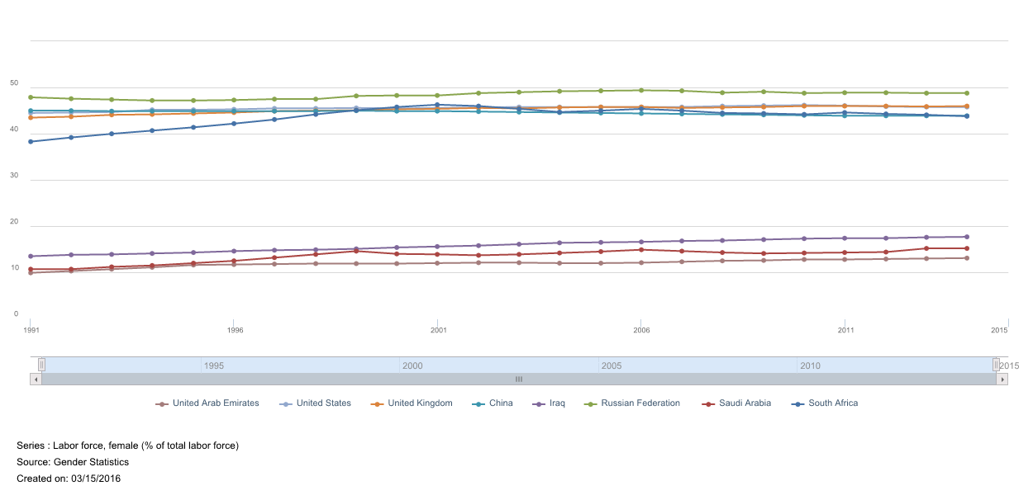

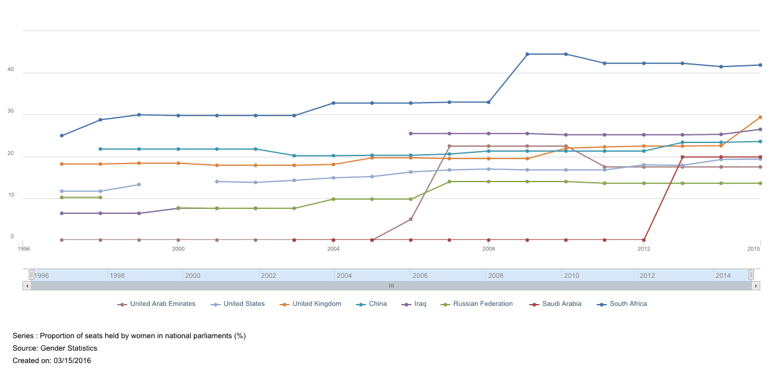

But with tableau, you can aggregate values for all these values for the world population and show trend lines. And we could see that there is a steady increase.

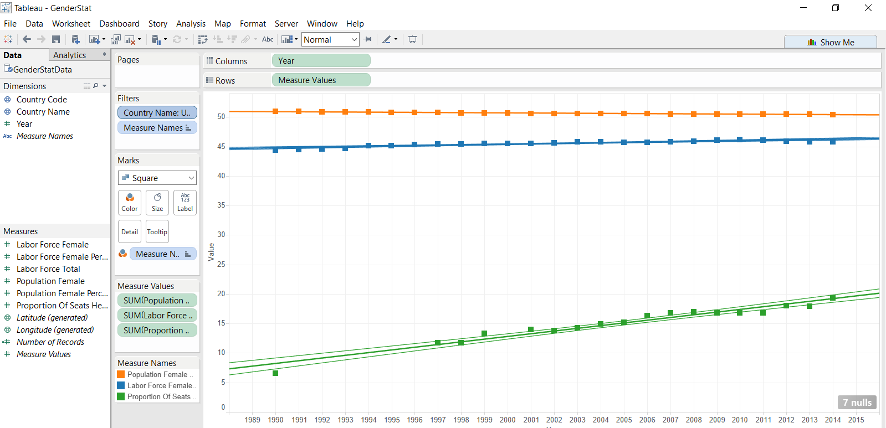

Another interesting chart we could apply for this kind of data with multiple variables are Star Charts and Nightingale Chart.

Below are examples for handpicked countries for better visualizing these countries.

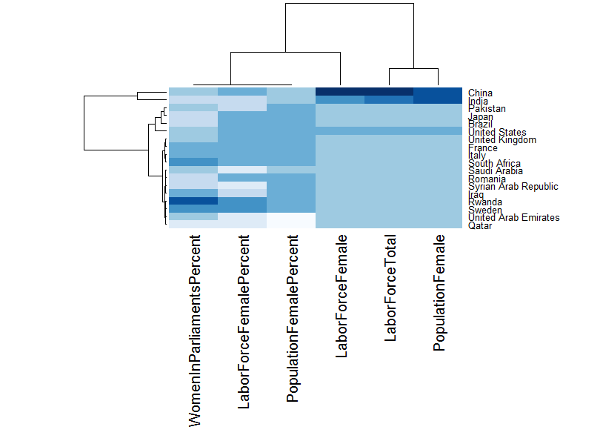

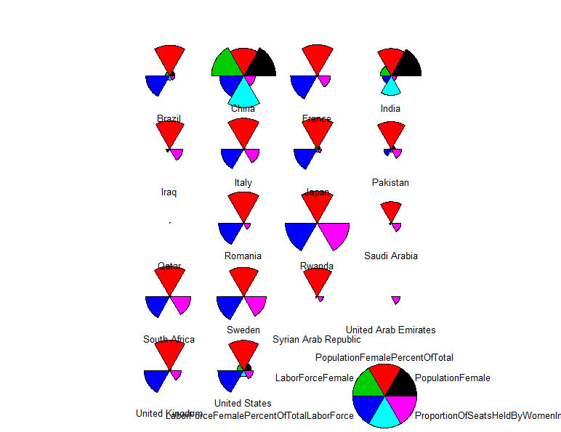

which is created using R aand the code is given below.

