Refer to README.md to understand more on bamboo specs

Screenshots:

1. Bamboo spec repository is loaded as a linked repository

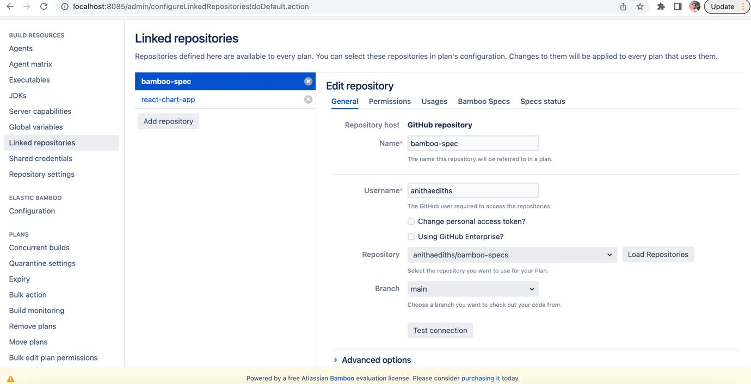

1. History of Scans

1. Projects created after Bamboo spec scan

1. Stage, jobs created for react chart plan as per ReactPlan.java

