**Online Bank Management Application**

**Objective of Bank Management application**

The bank is a major industry and still at some stage banks are doing some manual processes. So it’s really good to automate some manual processes that can help bankers and customers.

So this banking management system is a web application to manage bank activities. Where we can manage the customers, bank employees and Transection histories, Also a customer can do online payments.

**Tools and Technologies**

* Front-End: Html, CSS, bootstrap, Angular 8
* Frameworks: Spring boot, Spring MVC, Spring Data, Spring security.
* Technology/Domain: Java
* Database: MYSQL
* Server: Tomcat 9.5

**There are three types of actors in the application. Bank Manager, Bank Employee, Customer**

**Bank Manager:**

Manager is the root user of the application. The is the admin of the application

**He/she can do following activities:**

* The manager can ADD/EDIT/UPDATE bank accounts to the bank.
* manager can ADD/EDIT/UPDATE bank employee
* Bank manager authorized an bank employee (clerk) to do bank transactions
* Bank manager will manage all the online payment logs.
* When a new user will be added to the bank. A unique account number will generate automatically for the customer that the user will use during the transactions.

**Bank Employee:**

* The bank employee can do transactions as per the customer’s request.
* He/she can transfer fund, deposit amount, withdraw amount for an customer
* He can print customer transaction details on customer passbook

**Bank Customer:**

* Customer can login into the application once approved by bank manager
* Customer can check his bank balance and transaction history
* Customer can send money to another Customer
* The Customer can update his address details subjected to manager approval

**UML Diagrams:**

**1. Class Diagram**

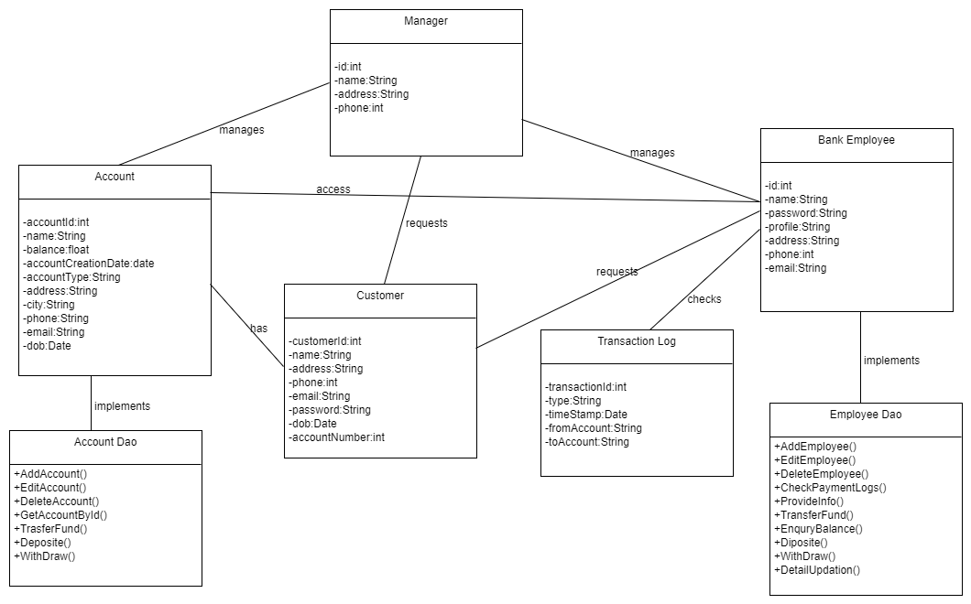

**2. Use Case Diagram**

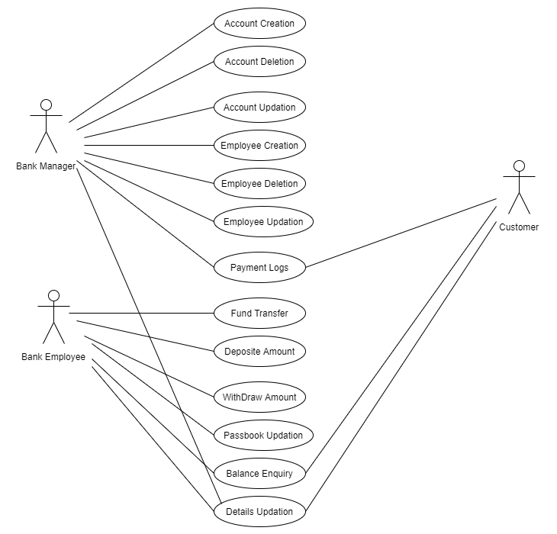

**3. Sequence Diagram**

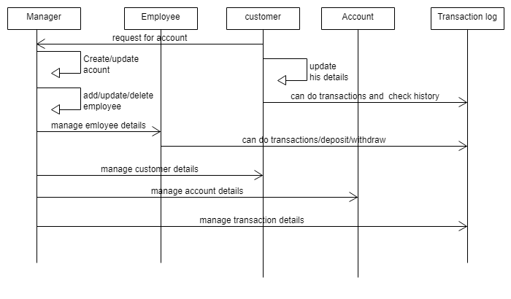

**Project Output Screenshots:**

**1. Login Page**

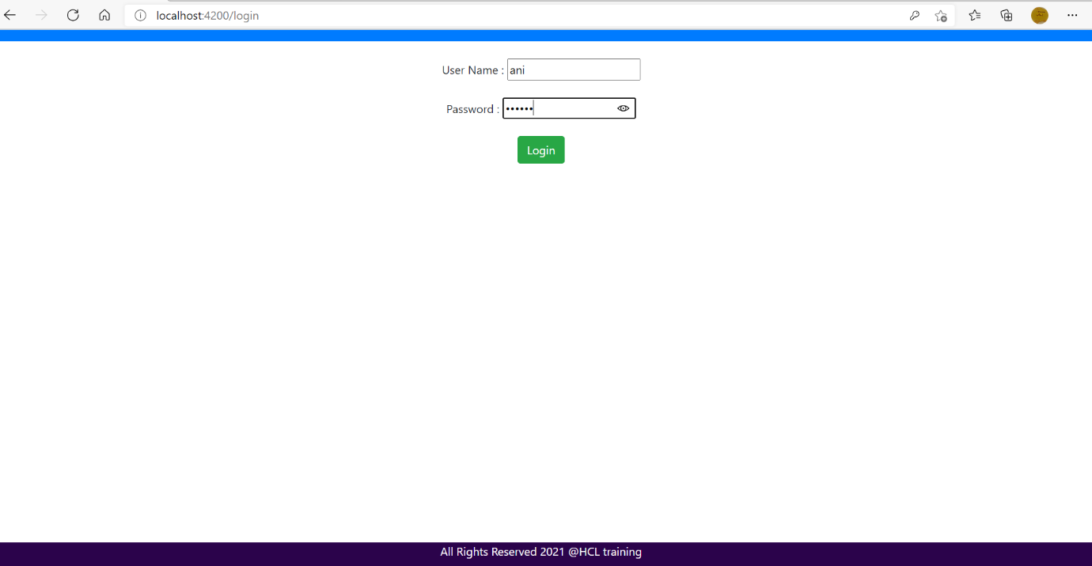

**2. Account List Page**

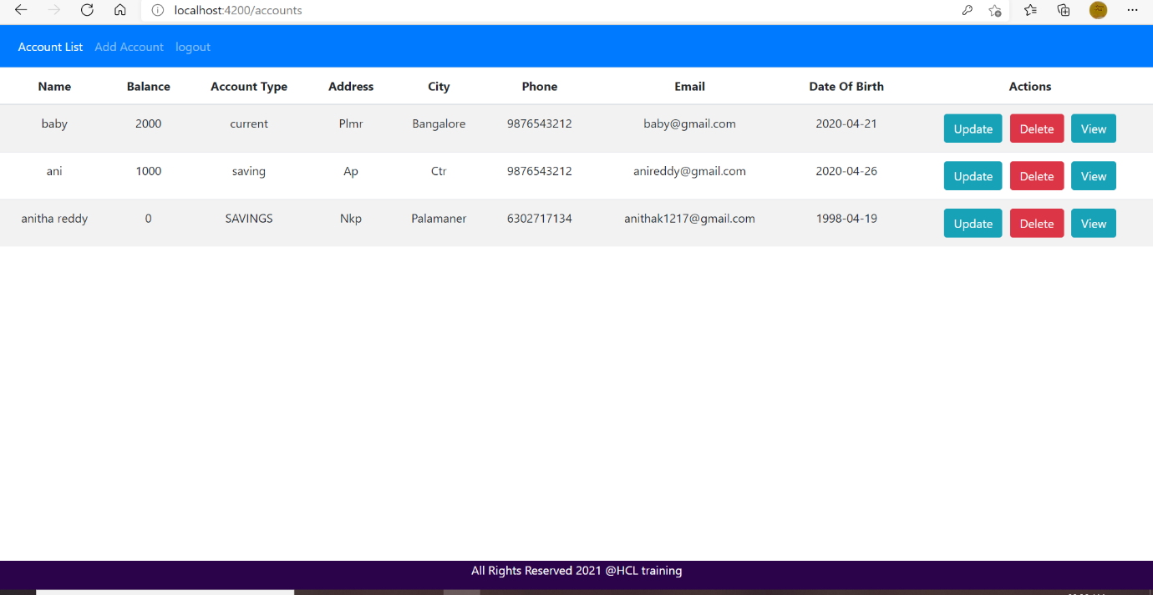

**3. Add Account Page**

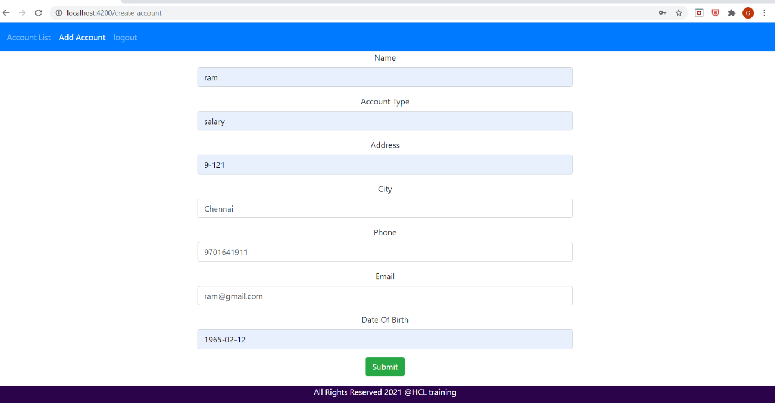

**3.1 After Adding Account**

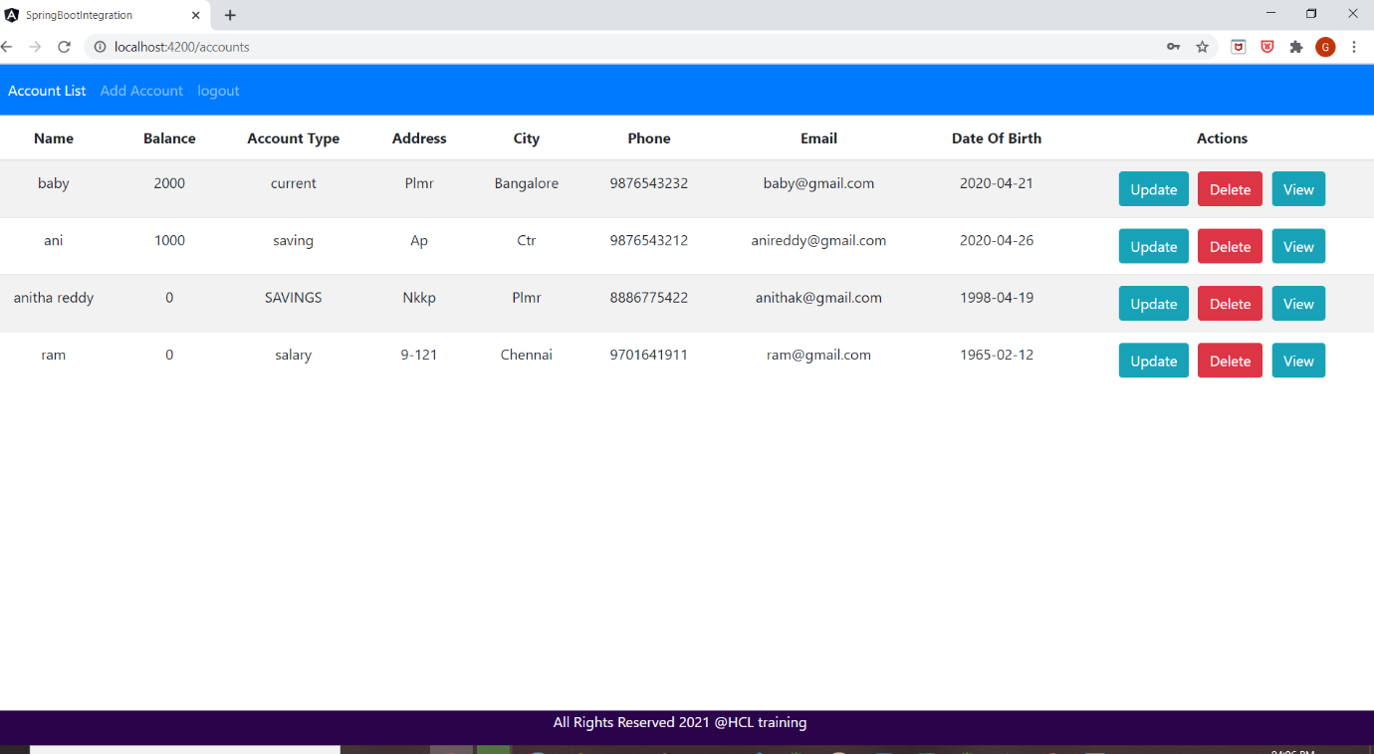

**4. Update Account Details Page**

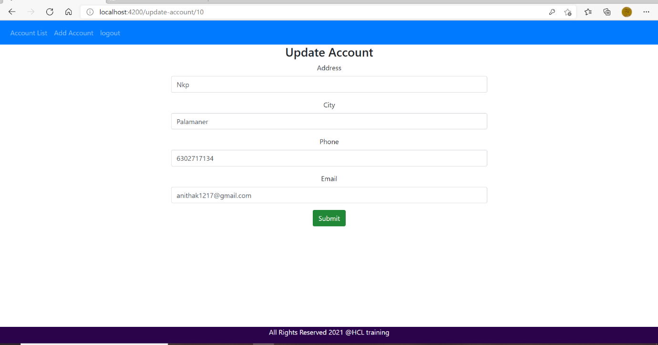

**4.1 After Updation**

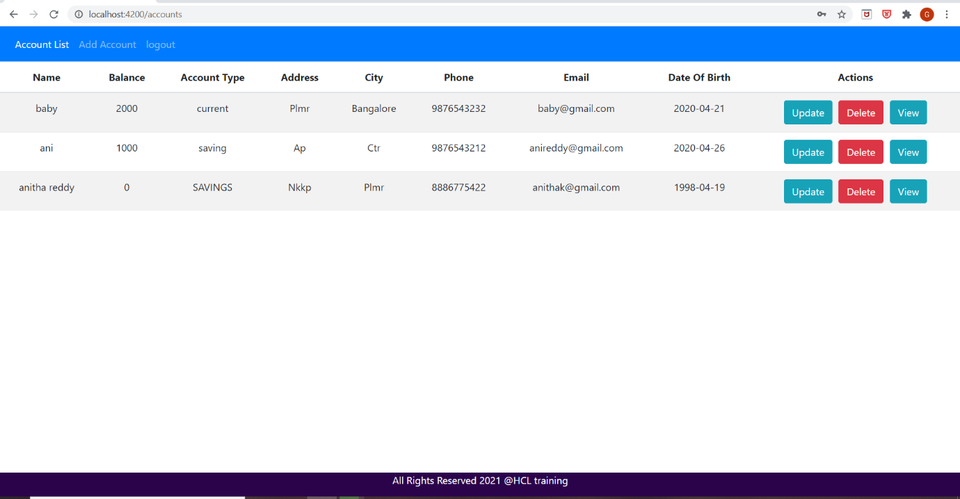

**5. Account Details View Page**

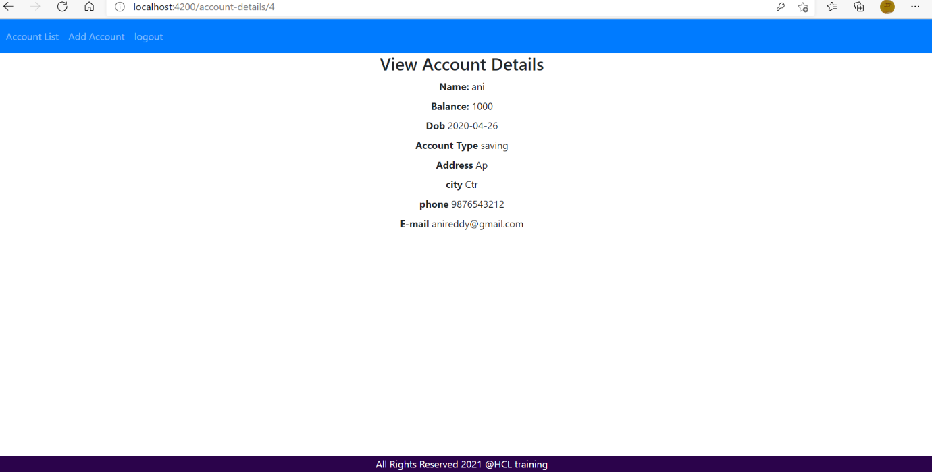

**6. Delete Account (After deleting the Account Id=3)**

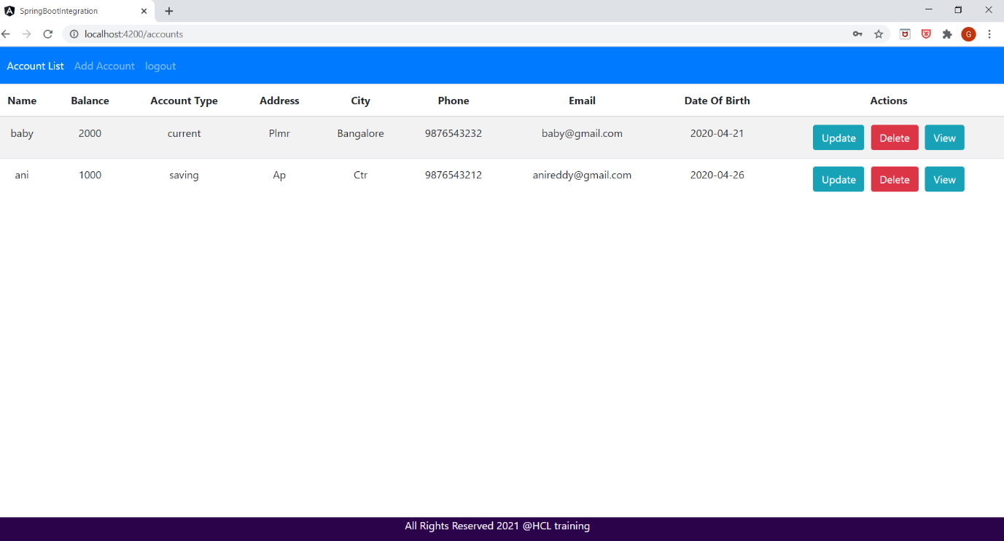

**7. Logout Page**



**7.1 After Clicking logout button. It will Navigates to Login Page**

