POWER BI INSURANCE KPI DASHBOARD
QBR / MBR Analytics — End-to-End Project Report
Power BI · DAX · Power Query · Star Schema · SQL · GitHub
Prepared by: Anitha Kumar
MSc Data Science (DSA) — EPITA Paris
Table of Contents

Executive Summary
1. Dashboard Overview
1.1 Dashboard Structure
2. Project Overview
2.1 Business Context
2.2 Technical Stack
2.3 Data Scope
3. Data Model — Star Schema
3.1 Tables
3.2 Relationships
4. Data Preparation — Power Query
5. DAX Measures
5.1 Loss Ratio KPI
5.2 Claim Frequency
5.3 Average Claim Cost
5.4 LR Status — Automated Alert
6. Analytical Results
6.1 Loss Ratio by Product
6.2 Regional Analysis
6.3 Frequency and Average Cost
6.4 Budget vs Actual
7. Data Quality and Automated Controls
7.1 Data Cleaning Summary
Appendix — Glossary

Executive Summary
This report documents the end-to-end design and build of a Power BI dashboard for insurance KPI analysis, covering the metrics used in Quarterly Business Review (QBR) and Monthly Business Review (MBR) meetings. The dashboard was built entirely in Power BI Desktop from data loading and star schema modelling through to DAX measure creation and interactive visualisation.
The dashboard gives insurance management a single-page view of all critical technical KPIs: Loss Ratio, Claim Frequency, Average Claim Cost, Budget vs Actual, and automated data quality alerts — with interactive filtering by Region, Product, and Year.
Metric | Value
Total Premiums Written | €15.68M
Total Claims Incurred | €9.06M
Overall Portfolio Loss Ratio | 60.09%
Overall Claim Frequency | 5.55%
Average Claim Cost | €684.67
Policy Count | 13,000
Highest Loss Ratio — Product | Health Insurance: 82% (⚠ Alert — above 75% threshold)
Lowest Loss Ratio — Product | Life Insurance: 36%
Products covered | 5 — Automobile, Home, Health, Life, Professional Liability
Territories covered | 6 French regions
Analysis period | January 2023 — June 2026
DAX measures built | 4 custom measures
Dashboard visuals | 10+ interactive charts, KPI cards, and quality control table

1. Dashboard Overview
The completed single-page dashboard provides interactive filtering by Region, Product, and Year. The screenshot below shows the dashboard filtered to Île-de-France region (Loss Ratio: 61.22% — slightly above the portfolio average of 60.09%, consistent with higher urban claim severity).
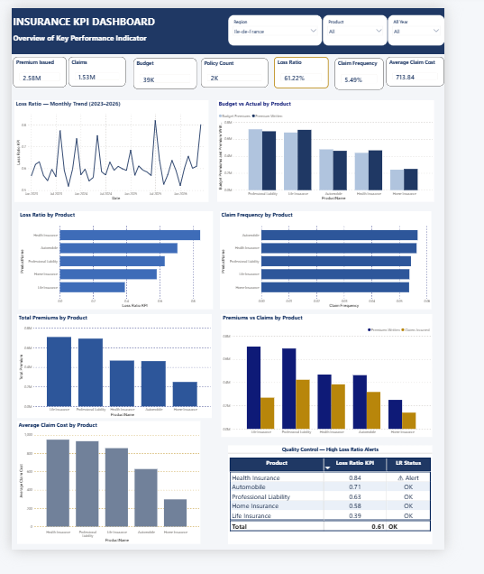
Figure 1 — Insurance KPI Dashboard (filtered: Île-de-France | Loss Ratio: 61.22%)

1.1 Dashboard Structure
Section | Content
Header | Navy blue title bar with 3 interactive slicers — Region, Product, Year
KPI Cards Row | 7 metric cards — Premium Issued, Claims, Budget, Policy Count, Loss Ratio (gold border), Claim Frequency, Average Claim Cost
Charts — Left column | Loss Ratio Monthly Trend · Loss Ratio by Product · Total Premiums by Product · Average Claim Cost by Product
Charts — Right column | Budget vs Actual by Product · Claim Frequency by Product · Premiums vs Claims by Product
Quality Control Table | Automated alert table — flags any product with Loss Ratio above 75%

2. Project Overview

2.1 Business Context
Insurance companies track technical profitability through standard KPIs reviewed in monthly (MBR) and quarterly (QBR) meetings. Without a dashboard, analysts spend days manually extracting numbers, calculating ratios in Excel, and building PowerPoint slides — prone to errors and delays. This Power BI dashboard replaces that manual workflow with a live, interactive view that updates automatically when new data loads.

2.2 Technical Stack
Tool / Technology | How it was used
Power BI Desktop | Main dashboard tool — data modelling, visuals, DAX measures, interactive slicers
DAX (Data Analysis Expressions) | 4 custom measures: Loss Ratio KPI, Claim Frequency, Average Claim Cost, LR Status
Power Query (M language) | Data cleaning and transformation — fixed spaces, duplicates, nulls, date formats
Star Schema | Data model architecture — 3 fact tables + 4 dimension tables with proper relationships
SQL | Source data validation and cross-checking calculation accuracy
GitHub | Version control — dashboard file, source data, and documentation

2.3 Data Scope
Dimension | Detail
Products | 5 — Automobile, Home Insurance, Health Insurance, Life Insurance, Professional Liability
Territories | 6 French regions — Île-de-France, Auvergne-Rhône-Alpes, PACA, Nouvelle-Aquitaine, Hauts-de-France, Grand Est
Period | January 2023 — June 2026 (42 months of data)
Policies | 1,200 individual insurance policies in the portfolio
Records | ~1,260 monthly premium records and ~1,260 monthly claims records

3. Data Model — Star Schema
The data is organised in a star schema — the Power BI industry standard for analytical modelling. Fact tables containing transactions sit at the centre; dimension tables providing descriptions (product names, regions, calendar) surround them. This enables fast filtering across all dimensions simultaneously and powers Time Intelligence functions such as Year-over-Year comparisons.
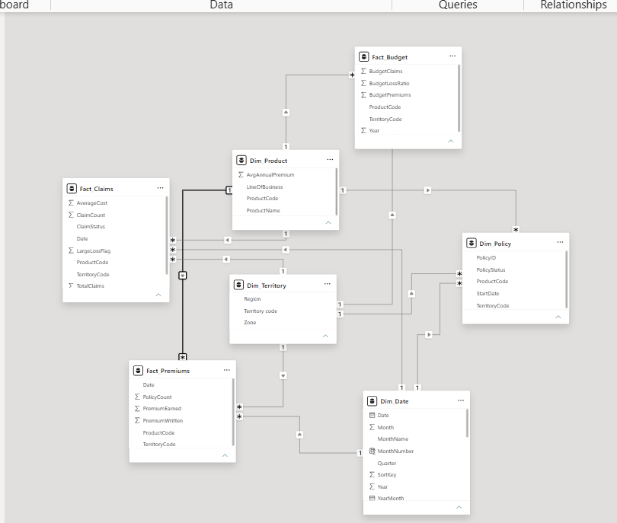
Figure 2 — Star Schema Data Model built in Power BI Desktop (Model View)

3.1 Tables
Table | Type | Key Columns
Fact_Premiums | Fact — monthly | Date, ProductCode, TerritoryCode, PremiumWritten, PremiumEarned, PolicyCount
Fact_Claims | Fact — monthly | Date, ProductCode, TerritoryCode, TotalClaims, ClaimCount, AverageCost, LargeLossFlag
Fact_Budget | Fact — annual | Year, ProductCode, TerritoryCode, BudgetPremiums, BudgetClaims, BudgetLossRatio
Dim_Date | Dimension (Date Table) | Date, Year, Quarter, Month, MonthName, YearMonth
Dim_Product | Dimension | ProductCode, ProductName, LineOfBusiness, AvgAnnualPremium
Dim_Territory | Dimension | TerritoryCode, Region, Zone
Dim_Policy | Dimension | PolicyID, ProductCode, TerritoryCode, StartDate, PolicyStatus

3.2 Relationships
- Dim_Date → Fact_Premiums and Fact_Claims on Date — active, single direction (1 to many)
- Dim_Product → Fact_Premiums, Fact_Claims, Fact_Budget on ProductCode — active, single direction
- Dim_Territory → Fact_Premiums, Fact_Claims, Fact_Budget on TerritoryCode — active, single direction
- All relationships are single-direction — prevents ambiguous filter propagation (Power BI best practice)

4. Data Preparation — Power Query
The raw source data contained data quality issues representing real-world problems found in insurance systems. These were corrected automatically using Power Query before loading into the model — ensuring every visual and measure is based on clean, consistent data.
Issue Found in Raw Data | Impact if Not Fixed | Fix Applied
Territory codes with trailing spaces ('T01 ') | Joins to Dim_Territory fail — missing data in visuals | Text.Trim + Text.Upper on all territory codes
Duplicate rows from multiple exports | Double-counting of premiums and claims | Table.Distinct removed all exact duplicates
Missing PremiumEarned values (~0.8%) | Loss Ratio calculation understates or fails | Estimated as 97% of PremiumWritten (business rule)
Date stored as text ('2023-01-01') | Time Intelligence functions (YoY, YTD) fail | Date.FromText converted all values to date type
ClaimCount = 0 on some rows | Division by zero error in Average Claim Cost | Set to minimum of 1 — claim amount exists

5. DAX Measures
Four custom DAX measures were created. All use DIVIDE() which safely handles division by zero — returning BLANK instead of a #DIV/0 error. This is Power BI best practice.

5.1 Loss Ratio KPI
The most important insurance KPI — what percentage of premiums collected was paid out in claims. Below 70% = profitable. Above 75% = alert.
Loss Ratio KPI =
DIVIDE(
SUM(Fact_Claims[TotalClaims]),
SUM(Fact_Premiums[PremiumEarned]),
BLANK()
)
Result: 60.09% portfolio-wide. Health Insurance 82% (highest). Life Insurance 36% (lowest).

5.2 Claim Frequency
Number of claims per policy — how often policyholders file a claim.
Claim Frequency =
DIVIDE(
SUM(Fact_Claims[ClaimCount]),
SUM(Fact_Premiums[PolicyCount]),
BLANK()
)
Result: 5.55% overall — 5.55 claims per 100 policies in the portfolio.

5.3 Average Claim Cost
Average amount paid per individual claim. Together with claim frequency, this drives the Loss Ratio.
Average Claim Cost =
DIVIDE(
SUM(Fact_Claims[TotalClaims]),
SUM(Fact_Claims[ClaimCount]),
BLANK()
)
Result: €684.67 per claim. Health Insurance €960 (highest). Home Insurance €290 (lowest).

5.4 LR Status — Automated Alert
Classifies each product as Alert or OK based on the 75% threshold. Powers the Quality Control table.
LR Status =
IF([Loss Ratio KPI] > 0.75, "⚠ Alert", "OK")
Result: Health Insurance is the only product flagged as ⚠ Alert (82% > 75%). All others: OK.

6. Analytical Results

6.1 Loss Ratio by Product
Health Insurance at 82% is the primary management concern — above the 75% alert threshold and the main agenda item for the next QBR meeting.
Product | Loss Ratio | Status | Management Action
Health Insurance | 82% | ⚠ Alert | Investigate — consider repricing or claims controls
Automobile | 69% | OK | Near 70% target — monitor frequency trend
Professional Liability | 63% | OK | Performing well below target
Home Insurance | 59% | OK | Stable — most profitable P&C product
Life Insurance | 36% | OK | Significantly below target — very profitable
Portfolio Total | 60.09% | OK | Overall portfolio profitable and within targets

6.2 Regional Analysis
Île-de-France shows a slightly higher Loss Ratio (61.22%) than the portfolio average (60.09%), consistent with higher claim severity in urban areas. Grand Est shows the lowest at approximately 59%.

6.3 Frequency and Average Cost
Product | Claim Frequency | Average Claim Cost | Key Observation
Health Insurance | 5.49% | €960 | Highest cost per claim — primary driver of high Loss Ratio
Professional Liability | 5.05% | €914 | High cost, low frequency — volatile long-tail product
Life Insurance | 5.05% | €770 | Low frequency — actuarially very profitable
Automobile | 6.00% | €601 | Highest frequency — typical for motor insurance
Home Insurance | 6.00% | €290 | High frequency but very low cost per claim

6.4 Budget vs Actual
Actual premiums (navy bars) track close to budget targets (light blue bars) across all products — the company is broadly meeting its revenue plan. Life Insurance and Professional Liability show the largest premium volumes, consistent with their higher average annual premiums.

7. Data Quality and Automated Controls
The Quality Control table at the bottom of the dashboard automatically shows Loss Ratio and alert status for each product — enabling managers to identify problems instantly without manually checking each line.
Product | Loss Ratio | LR Status
Health Insurance | 0.82 | ⚠ Alert
Automobile | 0.69 | OK
Professional Liability | 0.63 | OK
Home Insurance | 0.59 | OK
Life Insurance | 0.36 | OK
Portfolio Total | 0.60 | OK

7.1 Data Cleaning Summary
- 1,273 raw premium rows → 1,260 clean rows after removing 13 exact duplicates
- ~10 rows with missing PremiumEarned → imputed at 97% of PremiumWritten
- ~8 rows with ClaimCount = 0 → corrected to 1 to prevent calculation errors
- All territory codes standardised — trailing spaces removed, uppercase enforced
- All date columns converted from text to proper date type — enables Time Intelligence functions

Appendix — Glossary
Term | Definition
Loss Ratio | Claims paid ÷ Premiums earned. Below 70% = profitable. Above 75% = alert. Above 90% = critical.
Claim Frequency | Number of claims ÷ Number of policies. How often policyholders file claims per year.
Average Claim Cost | Total claims ÷ Number of claims. Average severity of each claim paid.
QBR | Quarterly Business Review — management meeting every 3 months to review performance.
MBR | Monthly Business Review — monthly management meeting to review KPI performance.
Star Schema | Data model with fact tables at the centre and dimension tables around them.
DAX | Data Analysis Expressions — the formula language in Power BI for calculated measures.
Power Query | Data transformation tool in Power BI — cleans raw data before loading.
Fact Table | Table containing transactions — every premium payment or claims record.
Dimension Table | Small descriptive table — product names, territory names, calendar dates.
DIVIDE() | DAX function for safe division — returns BLANK not an error when dividing by zero.
Slicer | Interactive filter control in Power BI — filters all visuals when selected.

