--Q1 Display all columns from the patients table.
select * from patients;
--Q2 Display only patient names and cities from patient
select patient_name,city from patients;
--Q3 Show all hospitals with their hospital type.
select hospital_name,hospital_type from hospital
order by hospital_type;
--Q4 Get all visits where total_bill_amount is greater than 5000.
select * from visits
where total_bill_amount > '5000';
--Q5 List all claims with status Approved.
select * from claims
where claim_status ='Approved';
--Q6 Show patients who live in a specific city, for example Dallas.
select * from patients
where city ='New York';
--Q7 List hospitals located in a specific city.
select * from hospital
where city ='Houston';
--Q8 Display visits that happened before 2024-01-01.
select * from visits
where visit_date < '2024-01-01'
order by visit_date asc ;
Q9 Show claims updated after 2024-06-01.
select * from claims
where last_updated > '2024-06-01';
--Q10 Display all patients sorted by patient_name.
select * from patients
order by patient_name;
--Q11 Display all hospitals sorted by hospital_name descending.
select * from hospital
order by hospital_name desc;
--Q12 Show all visits sorted by visit_date.
select * from visits
order by visit_date ;
--Q13 Show all claims sorted by claim_amount descending.
select * from claims
order by claim_amount desc;
--Q14 Get distinct genders from patients
select distinct(gender) from patients;
--Q15 Get distinct hospital types from hospital.
select distinct(hospital_type) from hospital;
--Q16 Show distinct diagnosis codes from visits.
select distinct(diagnosis_code) from visits;
--Q17 Count total number of hospitals.
select count(*) from hospital;
--Q18 Count total number of claims.
select count(*) from claims;
--Q19 Count total number of approved claims.
select count(*) from claims
where claim_status ='Approved';
--Q20 Count total number of denied claims
select count(*) from claims
where claim_status ='Denied';
There are no ‘denied’ value in claim_status

--Q21 Show maximum claim amount from claims.
select max(claim_amount)from claims;
--Q22 Show minimum claim amount from claims.
select min(claim_amount)from claims;
--Q23 Show average claim amount from claims.
select Avg(claim_amount)from claims;
--Q24 Show total bill amount across all visits.
select sum(total_bill_amount) from visits;

--Q25 Show average bill amount across all visits.
select avg(total_bill_amount) from visits;
--Q26 List visits where bill amount is between 1000 and 5000.
select * from visits
where total_bill_amount between '1000' and '5000';
--Q27 Show patients born after 1990-01-01.
select * from patients
where date_of_birth > '1990-01-01';

--Q28 Show patients born before 1980-01-01.
select * from patients
where date_of_birth < '1980-01-01';
--Q29 Display claims where claim amount is less than 1000.
select * from claims
where claim_amount < '1000';

--Q30 Display visits where diagnosis code starts with SEP.
select * from visits
where diagnosis_code like 'SEP%';
-- there are no disgnosis code starting with 'SEP', all the codes starts with 'D'

--Q31 Display patient names that start with letter A.
select * from patients
where patient_name like 'A%';
-- all the patients names starts with letter 'P'.
--Q32 Display hospitals whose names contain the word Medical.
select * from hospital
where hospital_name like '%Medical%';
-- all the hospital name starts with 'Hospital'..
--Q33 Get number of patients by city.
select city,count(*) as count from patients
group by city;

--Q34 Get number of hospitals by city.
select city,count(*) as count from hospital
group by city;

--Q35 Get number of hospitals by hospital type.
select hospital_type,count(*) as count from hospital
group by hospital_type;

--Q36 Get number of claims by claim status.
select claim_status ,count(*) as count from claims
group by claim_status;
--Q37 Get total claim amount by claim status.
select claim_status,sum(claim_amount) from claims
group by claim_status;

--Q38 Get average claim amount by claim status.
select claim_status ,AVG(claim_amount) from claims
group by claim_status;

--Q39 Show total bill amount by diagnosis code.
select diagnosis_code ,sum(total_bill_amount)from visits
group by diagnosis_code ;

--Q40 Show count of visits by diagnosis code.
select diagnosis_code ,count(*)from visits
group by diagnosis_code;
--Q1 Display all columns from the patients table.
select * from patients;
--Q2 Display only patient names and cities from patient
select patient_name,city from patients;
--Q3 Show all hospitals with their hospital type.
select hospital_name,hospital_type from hospital
order by hospital_type;
--Q4 Get all visits where total_bill_amount is greater than 5000.
select * from visits
where total_bill_amount > '5000';
--Q5 List all claims with status Approved.
select * from claims
where claim_status ='Approved';
--Q6 Show patients who live in a specific city, for example Dallas.
select * from patients
where city ='New York';
--Q7 List hospitals located in a specific city.
select * from hospital
where city ='Houston';
--Q8 Display visits that happened before 2024-01-01.
select * from visits
where visit_date < '2024-01-01'
order by visit_date asc ;
Q9 Show claims updated after 2024-06-01.
select * from claims
where last_updated > '2024-06-01';
--Q10 Display all patients sorted by patient_name.
select * from patients
order by patient_name;
--Q11 Display all hospitals sorted by hospital_name descending.
select * from hospital
order by hospital_name desc;
--Q12 Show all visits sorted by visit_date.
select * from visits
order by visit_date ;
--Q13 Show all claims sorted by claim_amount descending.
select * from claims
order by claim_amount desc;
--Q14 Get distinct genders from patients
select distinct(gender) from patients;
--Q15 Get distinct hospital types from hospital.
select distinct(hospital_type) from hospital;
--Q16 Show distinct diagnosis codes from visits.
select distinct(diagnosis_code) from visits;
--Q17 Count total number of hospitals.
select count(*) from hospital;
--Q18 Count total number of claims.
select count(*) from claims;
--Q19 Count total number of approved claims.
select count(*) from claims
where claim_status ='Approved';
--Q20 Count total number of denied claims
select count(*) from claims
where claim_status ='Denied';
There are no ‘denied’ value in claim_status

--Q21 Show maximum claim amount from claims.
select max(claim_amount)from claims;
--Q22 Show minimum claim amount from claims.
select min(claim_amount)from claims;
--Q23 Show average claim amount from claims.
select Avg(claim_amount)from claims;
--Q24 Show total bill amount across all visits.
select sum(total_bill_amount) from visits;

--Q25 Show average bill amount across all visits.
select avg(total_bill_amount) from visits;
--Q26 List visits where bill amount is between 1000 and 5000.
select * from visits
where total_bill_amount between '1000' and '5000';
--Q27 Show patients born after 1990-01-01.
select * from patients
where date_of_birth > '1990-01-01';

--Q28 Show patients born before 1980-01-01.
select * from patients
where date_of_birth < '1980-01-01';
--Q29 Display claims where claim amount is less than 1000.
select * from claims
where claim_amount < '1000';

--Q30 Display visits where diagnosis code starts with SEP.
select * from visits
where diagnosis_code like 'SEP%';
-- there are no disgnosis code starting with 'SEP', all the codes starts with 'D'

--Q31 Display patient names that start with letter A.
select * from patients
where patient_name like 'A%';
-- all the patients names starts with letter 'P'.
--Q32 Display hospitals whose names contain the word Medical.
select * from hospital
where hospital_name like '%Medical%';
-- all the hospital name starts with 'Hospital'..
--Q33 Get number of patients by city.
select city,count(*) as count from patients
group by city;

--Q34 Get number of hospitals by city.
select city,count(*) as count from hospital
group by city;

--Q35 Get number of hospitals by hospital type.
select hospital_type,count(*) as count from hospital
group by hospital_type;

--Q36 Get number of claims by claim status.
select claim_status ,count(*) as count from claims
group by claim_status;
--Q37 Get total claim amount by claim status.
select claim_status,sum(claim_amount) from claims
group by claim_status;

--Q38 Get average claim amount by claim status.
select claim_status ,AVG(claim_amount) from claims
group by claim_status;

--Q39 Show total bill amount by diagnosis code.
select diagnosis_code ,sum(total_bill_amount)from visits
group by diagnosis_code ;
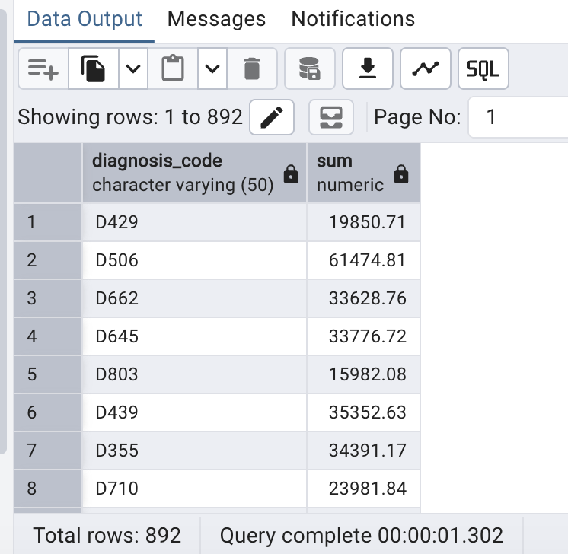

--Q40 Show count of visits by diagnosis code.
select diagnosis_code ,count(*)from visits
group by diagnosis_code;
