Recipe Service Overview

Technology stack
Java | 11
Spring Boot | 2.7.9
Junit | 5.8.2
Database | H2

Architectural Design
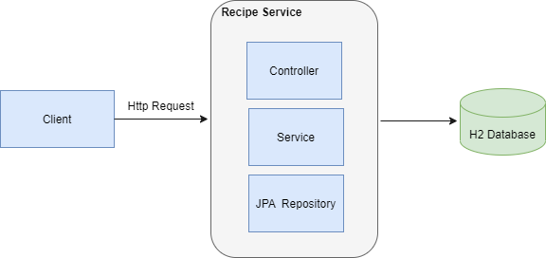

Entity Relationship Diagram
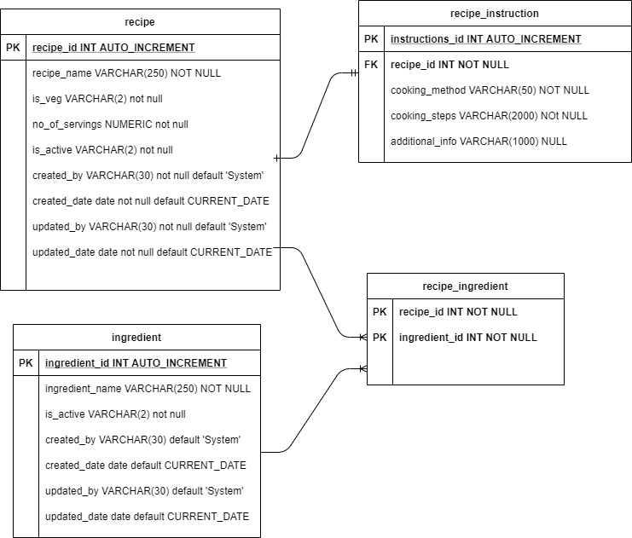

Code Coverage

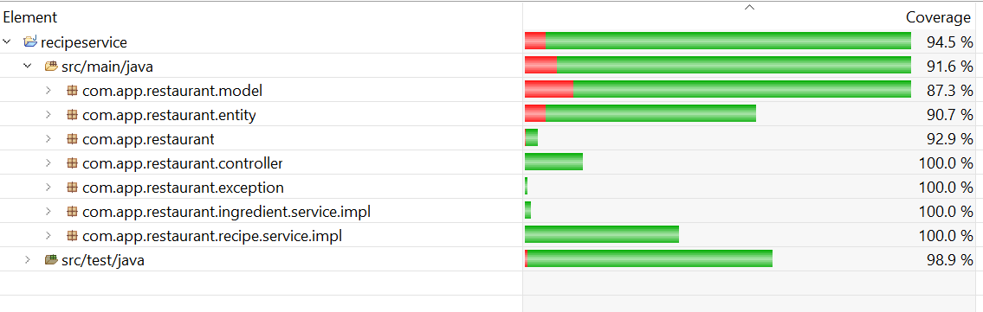

Application Running Instructions

Run jar using below command
java -jar <jar-location>\recipeservice-1.0.jar

Swagger Documentation
http://localhost:8080/recipeservice/swagger-ui/

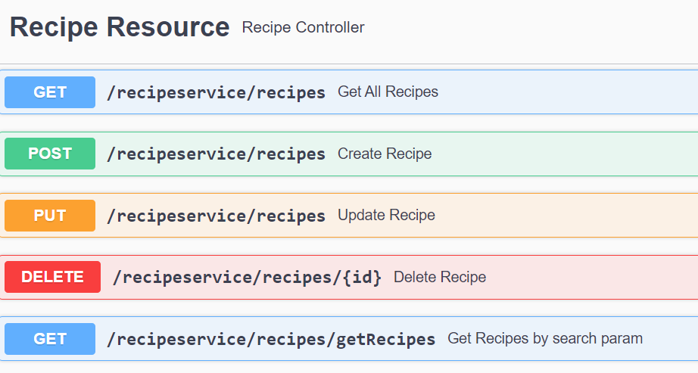

Accessing H2 database
URL: http://localhost:8080/recipeservice/h2
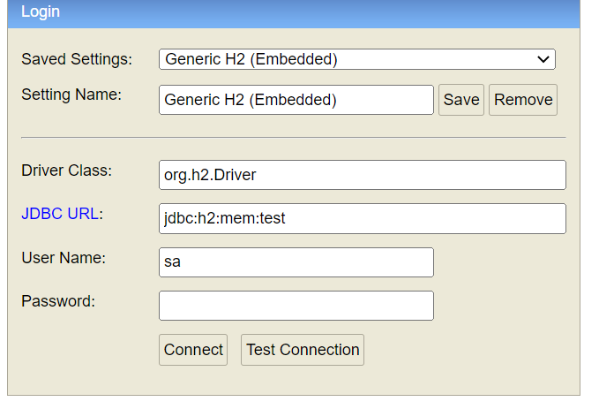

Initial Data


Achieved functionalities
- Completed all given functionalities
- Created Integration test (RepiceServiceControllerIT.java)
- Created Unit test case
- Swagger documentation

