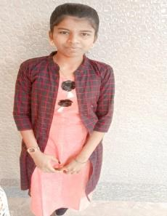**RESUME**

**ANITHA**

**Email id:** nithyabala601@gmail.com

**Mobile No:** 8807xxxx50.

**Address:** 6/287,north street,

Arsoor pudhukottai-628653.

**CAREER OBJECTIVE**

* Obtain a responsible position in an organization with the best capabilities, skills and knowledge.

**ACADEMIC QUALIFICATION:**

* 12th from Sri Ramakrishna Hr.sec.school.
* 10th from Sri Ramakrishna Hr.sec.school.

**PROFESSIONAL SKILLS:**

* Basic knowledge of computer.
* Typing

**WORK EXPERIENCE:**

* Fresher

**PERSONAL DETAILS:**

Father’s Name : Arjunapandiyan M

Date of birth : 03/10/2003

Gender : Female

Nationality : Indian

Marital Status : Unmarried

Languages Known : English & Tamil

Hobbies : Playing football

**Anitha A**