# DISASTER RECOVERY WITH IBM CLOUD VIRTUAL SERVICES

# To enable disaster recovery, organizations must back up data on a regular basis – once every 24 hours is a common schedule. These disaster recovery backups are saved to disk or tape and stored off-site or saved in cloud storage.

# Two tools used for backup purposes that support business continuity and ensure that data can be accessed during a disaster are cloud backup solutions and offsite backup. Cloud backup solutions involve storing data on remote servers through the internet.

# A DRaaS service model allows you to back up your data and IT infrastructure and host them on a third-party provider's cloud infrastructure.

# During a crisis, the provider will implement and orchestrate your DR plan to help recover access and functionality with minimal interruption to operations.

# Using DRaaS to prepare for a disaster: An organization can continue to run applications—it just runs them from the service provider's cloud or hybrid cloud environment instead of from the disaster-affected physical servers. This means recovery time after a disaster can be much faster, or even instantaneous.

# MODEL AND ARCHIECTURE OF DISASTER RECOVERY:

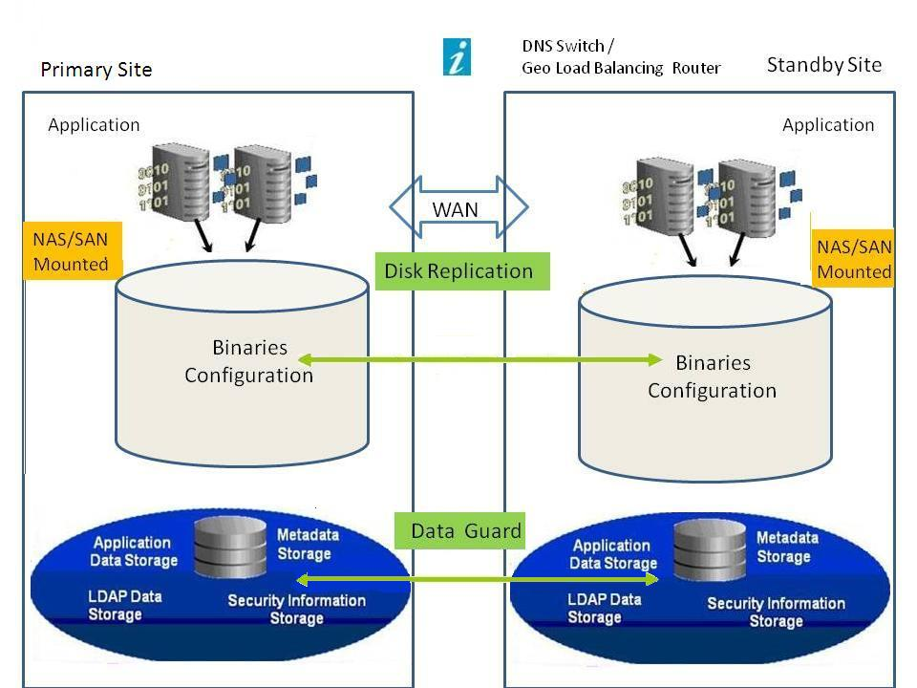

# https://blog-assets.freshworks.com/freshworks/wp-content/uploads/2021/08/20043054/DBaaSDR001-1024x638.png

# To maintain multiple backups outside virtual server instances created with Hyper Protect Virtual Servers, you can package the data with tar , encrypt it with GnuPG and store it in IBM Cloud® Object Storage. Also, install the application to the recovery virtual server instance to enable a quick failover.

# Disaster recovery (DR) is an organization's ability to restore access and functionality to IT infrastructure after a disaster event, whether natural or caused by human action (or error).

# INSTRUCTIONS:

# Create a disaster recovery team.

# Identify and assess disaster risks.

# Determine critical applications, documents, and resources.

# Specify backup and off-site storage procedures.

# Test and maintain the DRP.