Faculty of Computing
CS344: Web Engineering
Class: Fall 2026
Lab 3: HTML Advanced – Personal Portfolio II
Date: September 24, 2026
Instructor: Ms. Naema Asif / Dr Muhammad Khuram Shahzad
Lab Engineer: Engr. Ayesha Asif

Name | Aryan Zia
Registration No. | 505899
Section | A (SE15A)
Program | BE Software Engineering, SEECS, NUST
Course | CS344: Web Engineering (Fall 2026)

1. Introduction
In this lab I extended my personal portfolio website (built in Lab 2) by improving the design with external CSS, organizing the project into proper folders, and publishing it online using GitHub Pages. This lab introduced professional practices of project organization, version control and deployment. All styling is now kept in a single external stylesheet, the navigation menu and page content are arranged using the CSS float and clear properties, and the finished website is available live on the internet. In addition, I gave the website a modern, clean look with a light and dark theme, smooth hover effects and subtle animations - all achieved with pure CSS.

2. Objectives
By the end of this lab, I was able to:
- Organize HTML, CSS and images into proper folders.
- Use an external CSS file to improve styling and reusability.
- Apply the float and clear properties in CSS to arrange content into simple layouts.
- Upload the project to GitHub and track changes using version control.
- Deploy and view the portfolio live using GitHub Pages.

3. Tools / Software Requirements
- Text editor: Visual Studio Code.
- Web browser: Microsoft Edge / Google Chrome.
- Version control: Git for Windows.
- GitHub account (free) for hosting the repository and GitHub Pages.
- Internet access for cloning, pushing and viewing the live site.

4. Description

4.1 Organizing Files in Folders
The Lab 2 project was a flat collection of HTML files. For Lab 3, the files were reorganized into a clear folder structure: every web page sits in the project root, all styling is inside the css/ folder (style.css) and all pictures are inside the images/ folder. A README.md file was also added to document the project. The Lab 2 home page was renamed from portfolio.html to index.html so that GitHub Pages loads it automatically as the default page.

4.2 CSS Improvements
- All styling was moved into one external file, css/style.css, and every page links it using <link rel="stylesheet" href="css/style.css">. No inline or internal CSS is left in the HTML.
- A modern design system was built using CSS custom properties (variables) for colours, shadows, spacing and rounded corners, so the whole look can be controlled from one place.
- Consistent typography (a system font stack) and a sophisticated slate + indigo colour scheme are used across all pages.
- The navigation menu is aligned horizontally using float (each list item floats left) and is now a sticky, frosted-glass bar.
- The Home page profile picture is floated left with a gradient ring, and the welcome text wraps neatly beside it.
- The image gallery is arranged with float, three figures per row, and each image zooms smoothly on hover.
- The clear property (and a clearfix rule) is used to fix the layout problems caused by floated elements so that cards and the footer never overlap.
- Subtle animations were added with pure CSS: a fade-up on page load, hover lifts on cards and buttons, and animated skill bars.
- No JavaScript and no CSS framework were used, as required by the lab. All motion is disabled automatically for users who prefer reduced motion.

4.3 Light and Dark Theme
The website supports both a light and a dark theme. By default it follows the operating system / browser preference using the CSS media query prefers-color-scheme. A small sun/moon toggle in the header lets the visitor switch to the opposite theme at any time. This toggle is implemented entirely in CSS using a hidden checkbox and the :has() selector - no JavaScript is used.

4.4 Version Control with Git
A Git repository was initialized inside the project folder. All files were committed with meaningful messages, and the repository was pushed to GitHub.
git init -b main
git add -A
git commit -m "Lab 3: HTML Advanced - Personal Portfolio II"
git commit -m "Redesign UI: modern tokenized CSS, light/dark theme"
git remote add origin https://github.com/anithepani/portfolio.git
git push -u origin main

4.5 Deployment via GitHub Pages
GitHub Pages was enabled from the repository settings with the source set to the main branch and the root (/) folder. After the build completed, the portfolio became available at the live URL in Section 7.

5. Folder Structure
portfolio/
|-- index.html (Home page)
|-- hobbies.html (Hobbies page)
|-- skills.html (Personal Skills page)
|-- gallery.html (Image Gallery page)
|-- contact.html (Contact Me page)
|-- css/
| `-- style.css (single external stylesheet)
|-- images/
| |-- profile.jpg
| |-- photo1.jpg
| |-- photo2.jpg
| |-- photo3.jpg
| |-- photo4.jpg
| |-- photo5.jpg
| `-- photo6.jpg
`-- README.md

6. Screenshots
The screenshots below show the final website in both themes and the live deployment on GitHub Pages.
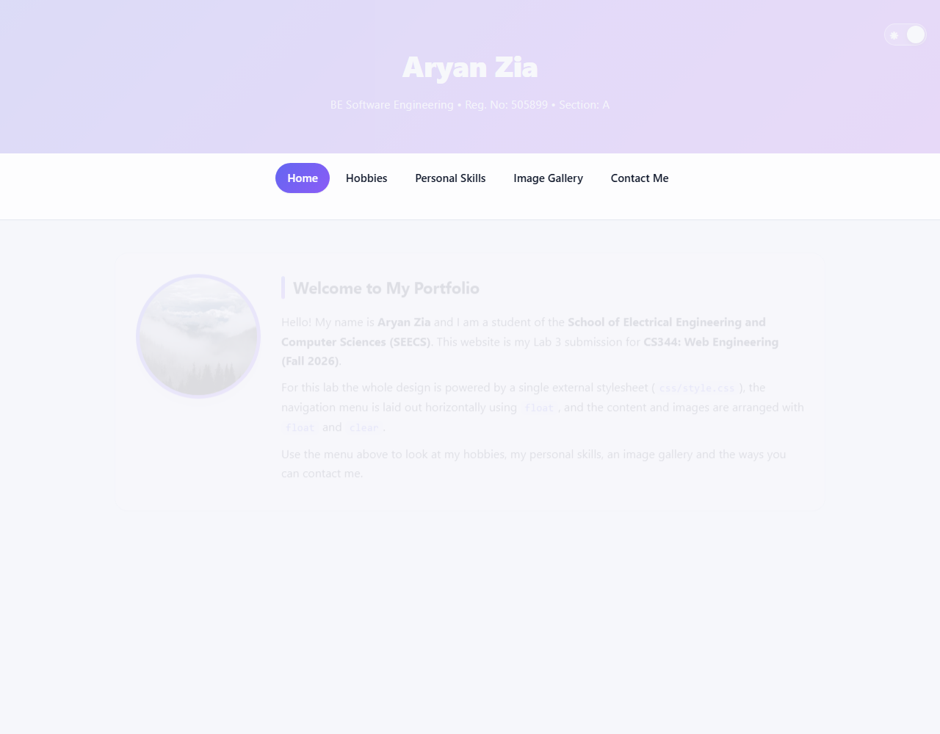
Figure 1: Home page - light theme.
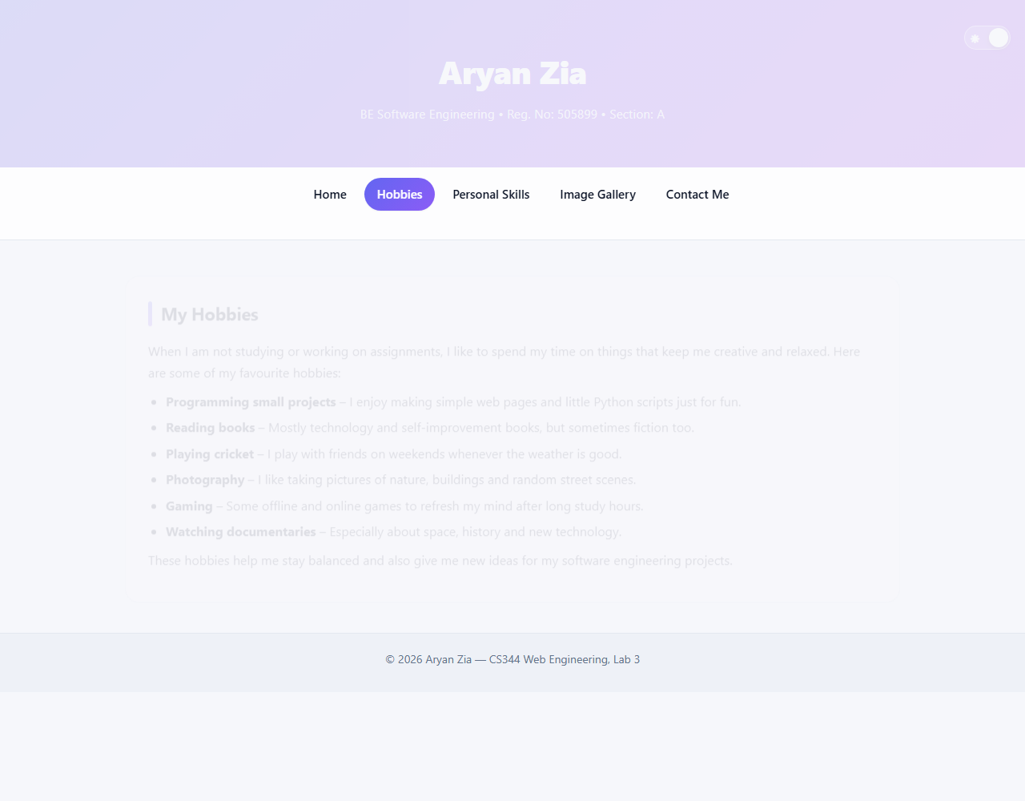
Figure 2: Hobbies page - light theme.
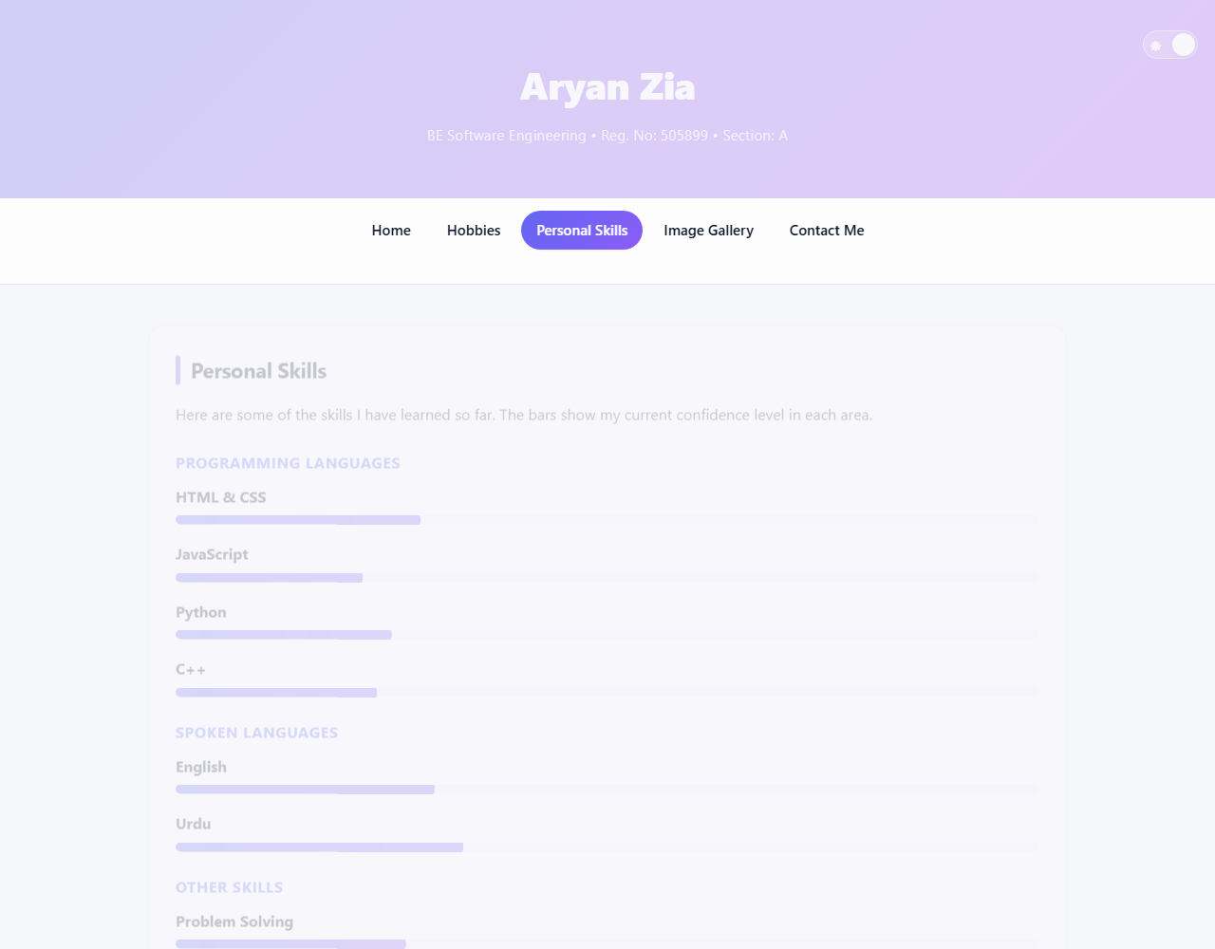
Figure 3: Personal Skills page - light theme.
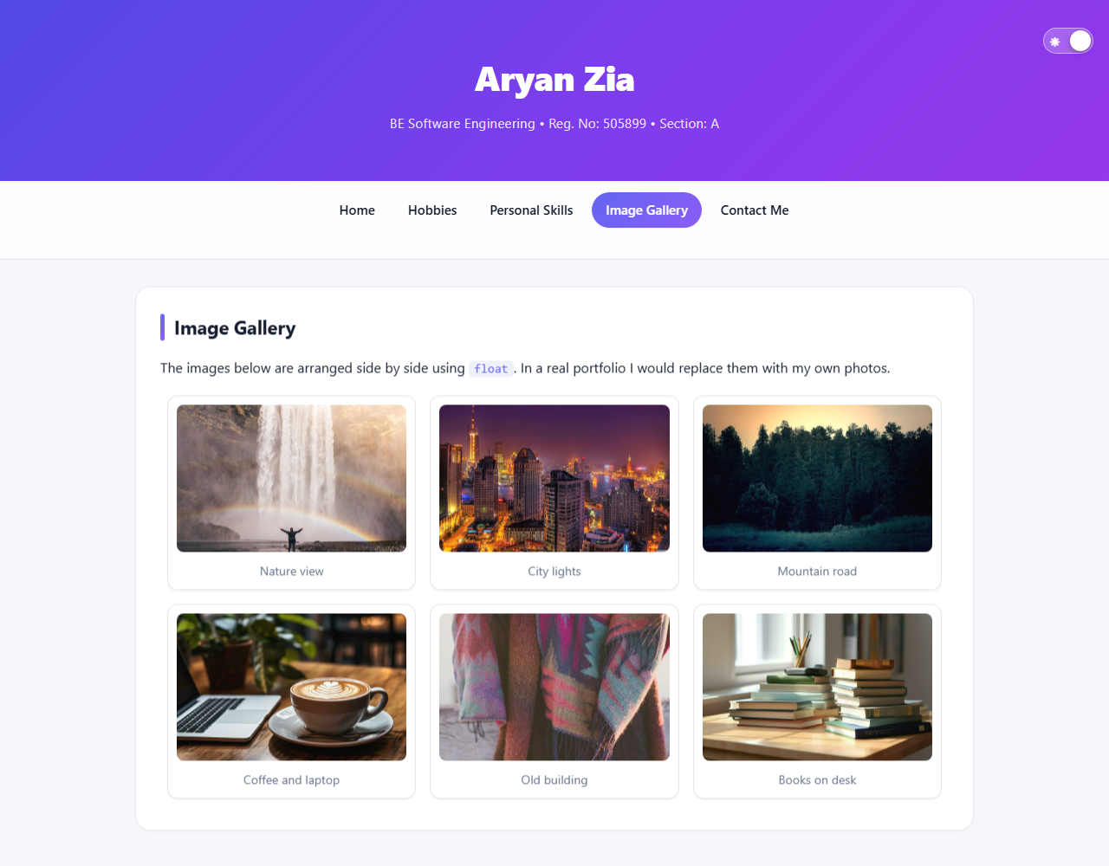
Figure 4: Image Gallery page - light theme (images arranged using float).
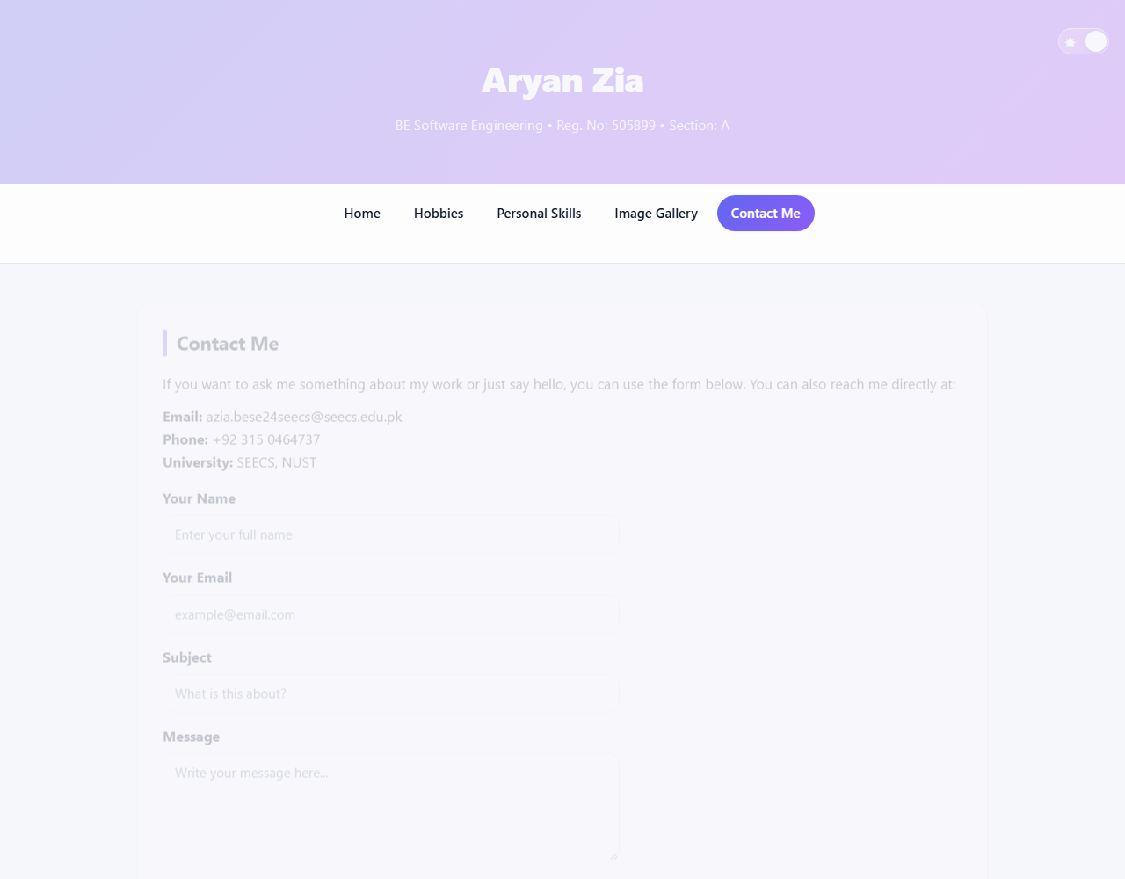
Figure 5: Contact Me page - light theme.
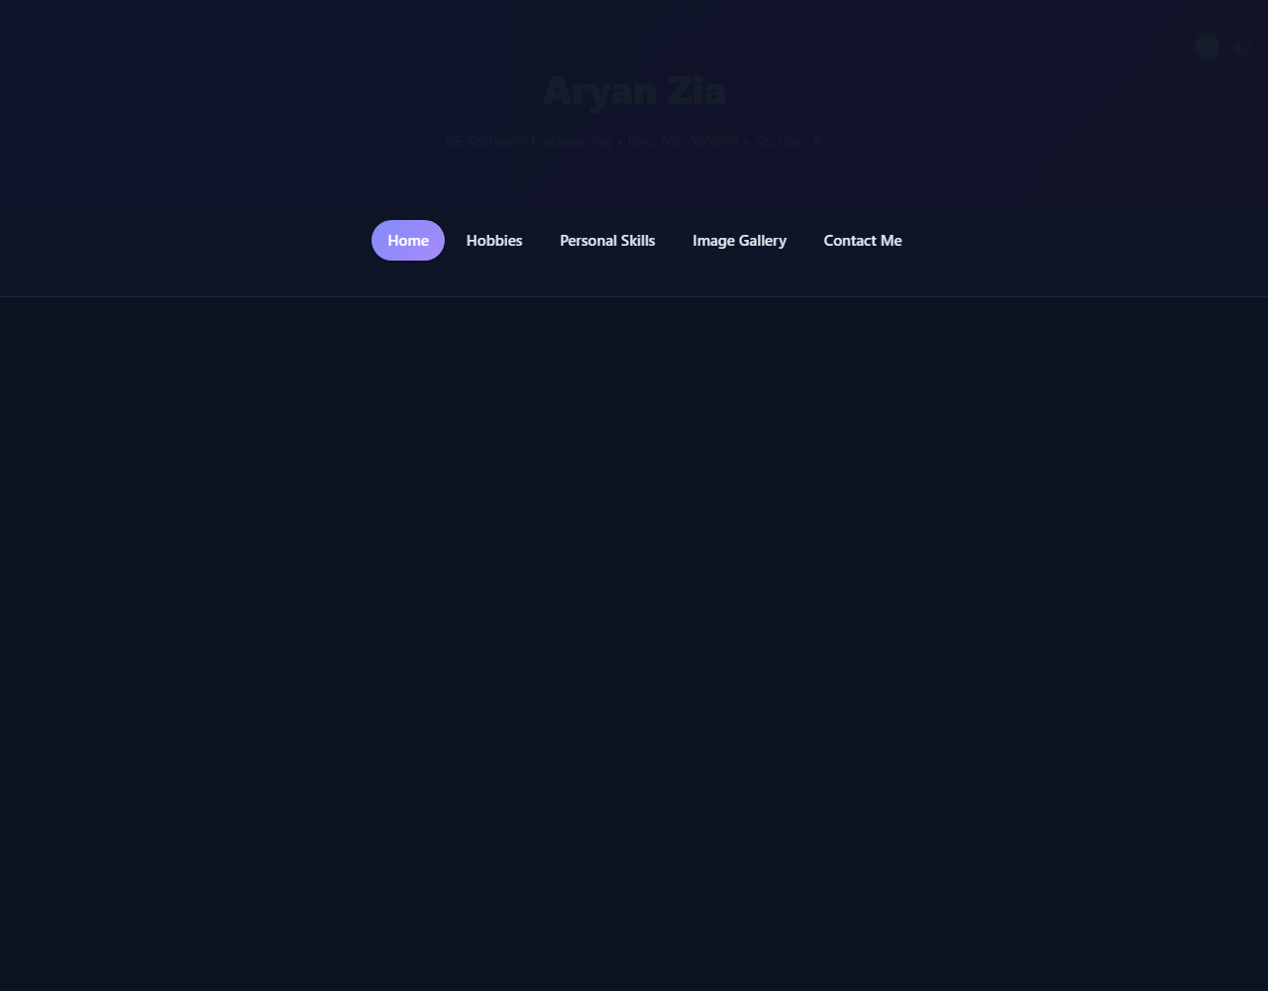
Figure 6: Home page - dark theme (toggled with the CSS-only switch).
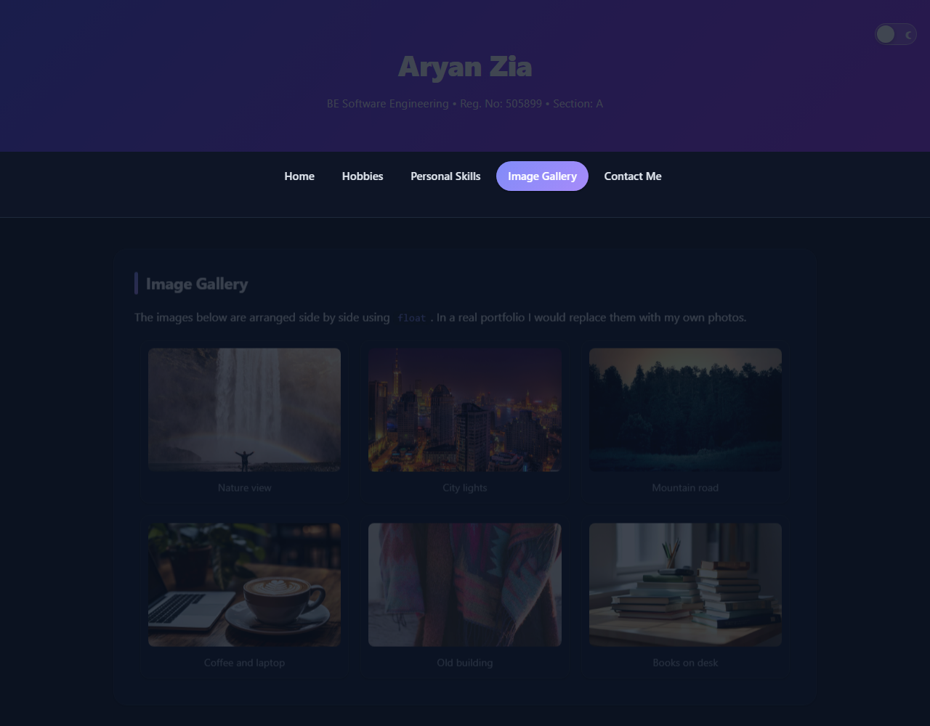
Figure 7: Image Gallery page - dark theme.
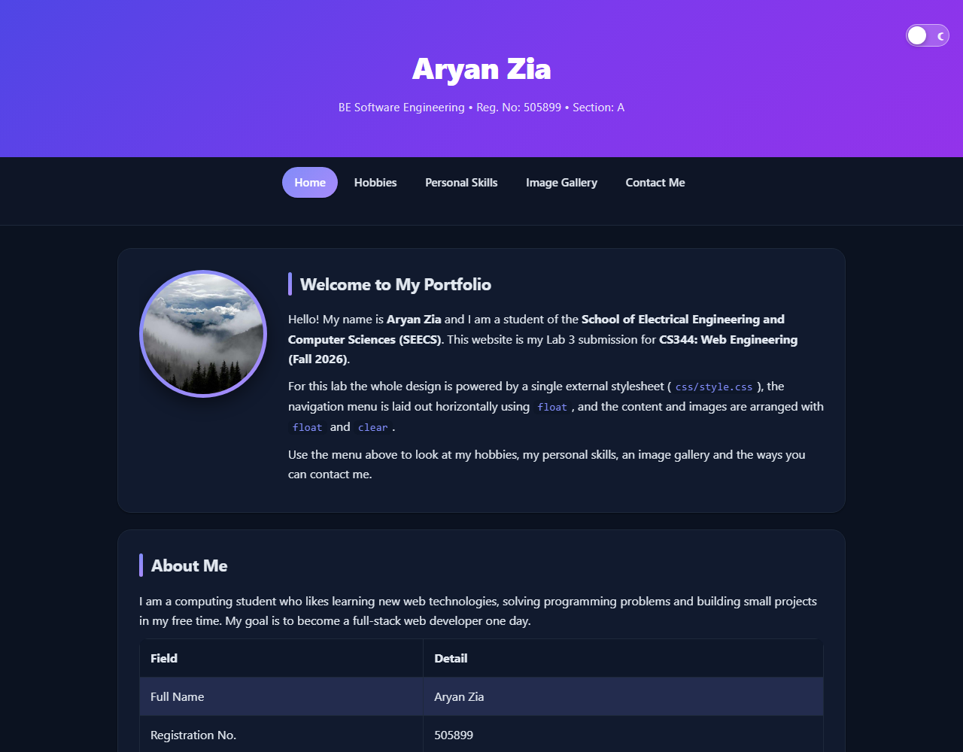
Figure 8: The live website running on GitHub Pages.

7. GitHub Repository and Live Link
GitHub Repository:
https://github.com/anithepani/portfolio
Live Portfolio (GitHub Pages):
https://anithepani.github.io/portfolio/

8. Pitfalls Avoided
- CSS was moved entirely to the external style.css instead of being kept inline.
- The CSS file is correctly linked in all five HTML pages.
- The folder structure is clean - CSS and images are organized in their own folders.
- GitHub Pages was enabled and verified after uploading the project.
- No JavaScript and no CSS framework/API was used anywhere in the project (the theme toggle is pure CSS).

9. Lab Tasks Completed
- Moved all CSS to an external stylesheet (css/style.css).
- Created a navigation menu styled with CSS and aligned horizontally using float.
- Used float and clear to arrange text and images neatly.
- Created an image gallery with six images aligned using float.
- Organized project files into css/ and images/ folders.
- Uploaded the project to GitHub.
- Deployed the portfolio using GitHub Pages.
- Extended the design with a modern UI, light/dark theme, hover effects and subtle animations (pure CSS).

10. Conclusion
In this lab I successfully converted my Lab 2 portfolio into a professionally organized, modern and deployed website. I learned how to separate structure (HTML) from presentation (external CSS), how to use float and clear to build simple layouts, how to build a light/dark theme and subtle CSS animations without JavaScript, how to manage a project with Git and GitHub, and how to publish a website live using GitHub Pages.

