**Verilog Assignment - 6**

Group – 47

Anit Mangal

Omair Alam

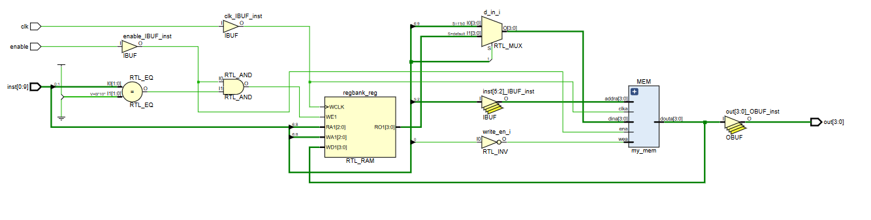

**TOP LEVEL MODULE**

    /*

    10-bit instruction: 2-bit opcode, 4-bit memory location, 4-bit data/3-bit register address. Leftover bits are don’t care bits

    00  _ _ _ _   _ _ _ _ (mem <- data)

    01  _ _ _ _   _ _ _ (mem <- reg)

    10  _ _ _ _   _ _ _ (mem -> reg)

    11  _ _ _ _ (display mem)

    */