# ASSIGNMENT : 1

# MODULE : 1

* What is SDLC.
* **SDLC** stands for **Software Development Life Cycle**.
* It is a structured process used by software developers and organizations to design, develop, test, and deploy software systems efficiently and with high quality.
* What is software testing?
* **Testing** is process use to identify correctness, completeness and quality of devlop computer software.
* What is agile methodology?
* Agile SDLC model is a combination of iterative and incremental process models with focus on process adaptability and customer satisfaction by rapid delivery of working software product.
* Agile Methods break the product into small incremental builds.
* Every iteration involves cross functional teams working simultaneously on various areas like planning, requirements analysis, design, coding, unit testing, and acceptance testing.
* What is SRS.
* A software requirements specification (SRS) is a complete description of the behavior of the system to be developed.
* Use cases are also known as functional requirements.
* Non-functional requirements are requirements which impose constraints on the design or implementation.
* What is oops
* OOP is object oriented programming language.
* Objects communicate to other objects by sending messages.
* Messages are received by the methods of an object.
* Object-oriented programming has a web of interacting objects, each house-keeping its own state.
* Write Basic Concepts of oops.

1. Object

2. Class

3. Encapsulation

4. Inheritance

5. Polymorphism

6. Abstraction

* What is Object.
* **object** is a **self-contained unit** that combines **data** and **methods** (functions) that operate on that data. It is a **concrete instance of a class**
* **object** is a fundamental building block in object-oriented programming. It is an **instance of a class** that contains both **data** and the **methods** that act on that data.
* What is class.
* **class** in programming, especially in **object-oriented programming (OOP)**, is essentially a **blueprint** or **template** for creating objects.
* What is encapsulation.
* Encapsulation is the practice of including in an object everything it needs hidden from other objects.
* Encapsulate in plain English means to enclose or be enclosed in or as if in a capsule. In Java, a class is the capsule (or unit).
* What is enheritance.
* Inheritance means that one class inherits the characteristics of another class. This is also called a “is a” relationship.
* Inheritance describes the relationship between two classes.
* A class can get some of its characteristics from a parent class and then add unique features of its own.
* What is polymorphism.
* Poly refers to many. That is a single function or an operator functioning in many ways different upon the usage is called polymorphism.
* The ability to change form is known as polymorphism.
* Draw usecase on online book shopping.
* DIAGRAME

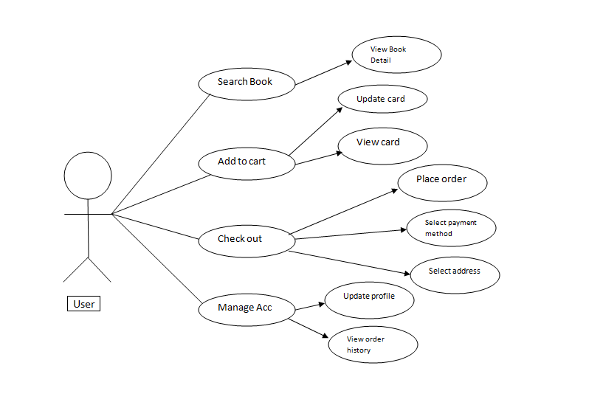

* Draw usecase on online bill payment system  
  (paytm).
* DIAGRAME

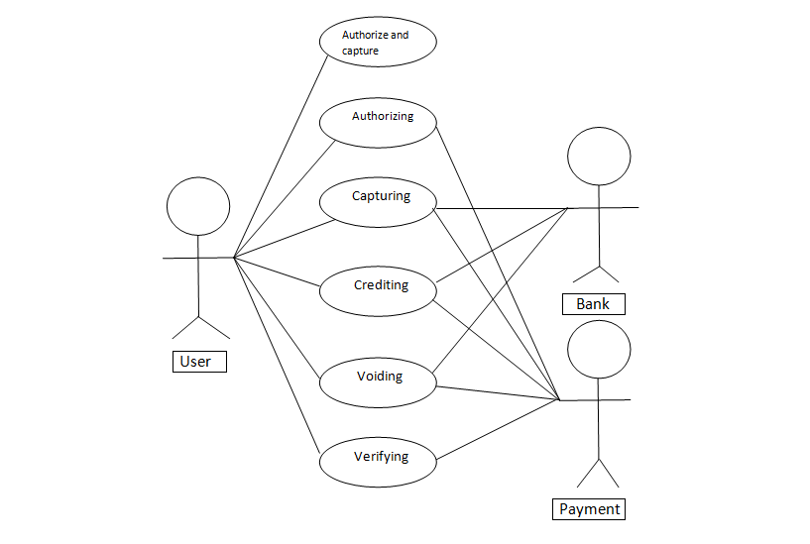

* Write SDLC phase with basic introduction.
* Requirement collection/Gathering
* Although requirements may be documented in written form, they may be incomplete, unambiguous, or even incorrect.
* Inadequately captured or expressed in the first place.
* Analysis
* The analysis phase defines the requirements of the system, independent of how these requirements will be accomplished.
* This analysis represents the “what” phase.
  + Design
* Design Architecture Document
* The architecture team also converts the typical scenarios into a test plan.
  + Implementation
* In the implementation phase, the team builds the components either from scratch or by composition.
* The implementation phase deals with issues of quality, performance, baselines, libraries, and debugging.
  + Testing
* Simply stated, quality is very important. Many companies have not learned that quality is important and deliver more claimed functionality but at a lower quality level.
  + Maintenance
* Software maintenance is one of the activities in software engineering, and is the process of enhancing and optimizing deployed software.
* The maintenance phase is the phase which comes after deployment of the software into the field.
* Explain phase of the waterfall model.
* The waterfall is unrealistic for many reasons, especially
* Requirements must be “frozen” to early in the life cycle.
* Requirements are validated too late.
  + Pros
* Simple and easy to understand and use.
* Easy to manage due to the rigidity of the model.
* Phases are processed and completed one at a time.
* Works well for smaller projects where requirements are very well understood.
* Clearly defined stages.
  + Cons
* No working software is produced until late during the life cycle.
* High amounts of risk and uncertainty.
* Not a good model for complex and object-oriented projects.
* Poor model for long and ongoing projects.
* Not suitable for the projects where requirements are at a moderate to high risk of changing.
* Adjusting scope during the life cycle can end a project.
* Write phases of spiral model.
* Spiral Model is very widely used in the software industry as it is in synch with the natural development process of any product.
* For medium to high-risk projects.
* Long-term project commitment because of potential changes to economic priorities as the requirements change with time.
  + Pros
* Changing requirements can be accommodated.
* Allows for extensive use of prototypes Requirements can be captured more accurate.
* Development can be divided into smaller parts and more risky parts can be developed earlier which helps better risk management.
  + Cons
* Management is more complex.
* End of project may not be known early.
* Not suitable for small or low risk projects and could be expensive for small projects.
* Large number of intermediate stages requires excessive documentation.
* Write agile manifesto principles.

1. **Our highest priority is to satisfy the customer** through early and continuous delivery of valuable software.
2. Agile processes harness change for the customer's competitive advantage.
3. **Deliver working software frequently**. from a couple of weeks to a couple of months.
4. **Business people and developers must work together daily**Close.
5. **Build projects around motivated individuals** Give them the environment and support they need.
6. **Face-to-face conversation is the best form of communication.**
7. **Working software is the primary measure of progress**  
   Delivering valuable.
8. **Sustainable development** Agile processes promote sustainable development.
9. **Continuous attention to technical excellence and good design**Enhances agility.
10. **Simplicity the art of maximizing the amount of work not done is essential** Focus on what truly adds value.

* Explain working methodology of agile model and also write pros and cons.
* Agile SDLC model is a combination of iterative and incremental process models with focus on process adaptability and customer satisfaction.
* Agile Methods break the product into small incremental builds.
* Each iteration typically lasts from about one to three weeks.
* Every iteration involves cross functional teams working simultaneously on various areas like planning, requirements analysis, design, coding, unit testing, and acceptance testing.
* Pros
* Is a very realistic approach to software development
* Promotes teamwork and cross training.
* Functionality can be developed rapidly and demonstrated.
* Resource requirements are minimum.
* Suitable for fixed or changing requirements Delivers early partial working solutions.
* Good model for environments that change steadily.
* Cons
* Not suitable for handling complex dependencies.
* More risk of sustainability, maintainability and extensibility.
* An overall plan, an agile leader and agile PM practice is a must without which it will not work.
* Strict delivery management dictates the scope, functionality to be delivered.
* Depends heavily on customer interaction, so if customer is not clear, team can be driven in the wrong direction.
* Draw usecase on online shopping product using COD
* DIAGRAME

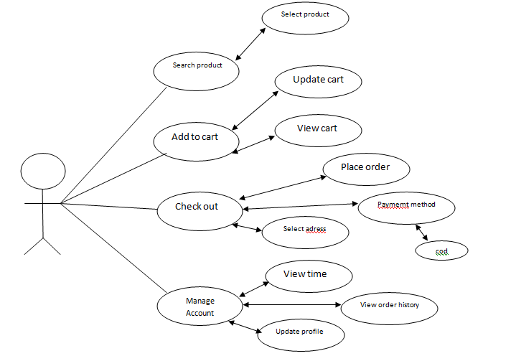

* Draw usecase on online shopping product using payment gateway.
* DIAGRAME

