**# System Monitor**

A real-time system monitoring dashboard that tracks CPU, memory, disk usage, and system uptime. Built with FastAPI and Chart.js, featuring a responsive dark-themed UI.

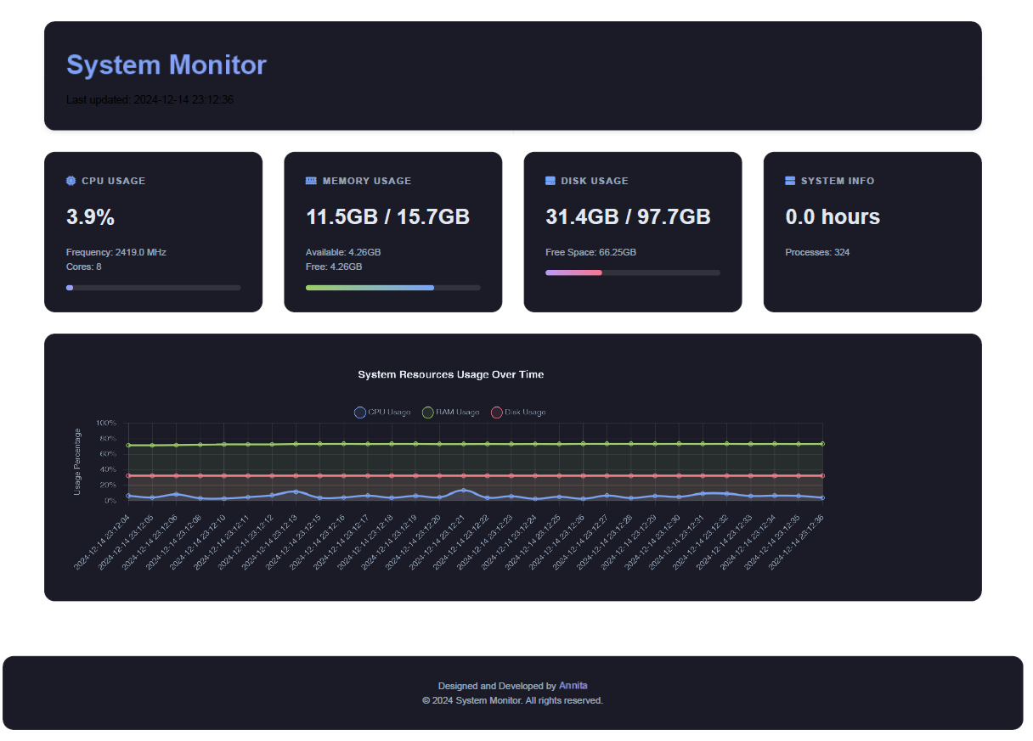

**## Features**

- Real-time system metrics monitoring

- CPU usage

- Memory (RAM) usage

- Disk space utilization

- System uptime

- Process count

- Temperature (where available)

- Interactive charts showing historical data

- Customizable alert thresholds

- Data export in CSV and JSON formats

- Responsive dark theme design

- Keyboard shortcuts for quick actions

**## Technologies Used**

- Backend:

- FastAPI

- psutil

- uvicorn

- Frontend:

- HTML5/CSS3

- Chart.js

- Font Awesome

- Deployment:

- Docker

- Docker Compose

## Prerequisites

- Docker and Docker Compose

- Git (for cloning the repository)

**### Dashboard Features**

- **Real-time Updates**: Metrics update every 2 seconds

- **Historical Data**: View trends with interactive charts

- **Alert System**: Visual and audio alerts for high resource usage

- **Data Export**: Export historical data in CSV or JSON format

**## Configuration**

Alert thresholds can be modified in `app/main.py`:

```python

ALERT_THRESHOLDS = {

"cpu_percent": 80.0, # Alert if CPU usage is above 80%

"ram_percent": 85.0, # Alert if RAM usage is above 85%

"disk_percent": 90.0 # Alert if disk usage is above 90%

}

```

**## Contact**

Annita - anittagarvadis99@gmail.com