AVARCAS Footwear

Ani Vartani

Kate Kurtin

Cal State LA

COMM 4320

December 14, 2020

Table of Contents

Introduction 3

Creative Brief 3

SWOT Analysis 4

Mission and Vision Statement: 4

Competition Analysis 5

Client Analysis 5

Consumer Analysis 6

Creative Execution/Explanation 7

Creatives 8

The GIF video 8

The Images 9

Media Plan and Execution 10

Targeting 11

Bloggers 12

Media Timeline 14

# Introduction

Despite the rather widespread opinion, footwear play an important role in the overall appearance of the individual. Along with hats and accessories, this part of one’s wardrobe perfectly emphasizes the identity of its owner and effectively compliments the entire image as a whole. It has become an essential piece that is put on at any time of the day and worn with pleasure. In order to update one’s collection, people often pay attention to bright posters and signs. However, shoe advertisements either often seduce us, or fail to evoke any emotion at all. What is the reason for this? What methods and techniques do advertisers use to attract buyers? In addition, how effective are they?

Avarcas is a shoe company making open-toe sandals in a traditional Spanish design first crafted by farmers in the 19th century. Avarcas are handcrafted from premium Spanish leather. Their footwear are comfortable, versatile, and built to withstand years of wear. The first Avarcas were crafted in the 19th century by farmers on the Mediterranean island of Menorca, Spain. Their workshop is located on the same island, where they honor the tradition and heritage of the first Avarcas sandals by slowly handcrafting them paying the utmost attention to each and every detail. This is why their sandals are very comfortable and will last for years

to come.

# Creative Brief

The creative brief of the Avarcas company is presented below. Its purpose is to analyze the market, target audience, clientele, as well as the means that its marketing department will apply in order to increase sales. Naturally, the marketing department is to fully adhere to the social values and responsibilities that are upheld by the company. Among these are:

* Transparency and using their product for good by maintaining their connection to the arts of creating menorquinas
* Combating climate change by partnering up with One Tree Plant
* Utilizing recycled materials in production
* Partnering up with a local non-profit organization called S’AUBA

*Target Audience:* Women between ages 30 to 65.

# SWOT Analysis

|  |  |
| --- | --- |
| Strengths | Weaknesses |
| * Great quality * Long lasting shoewear * Different styles that come in variations of sizes and colors * Handmade products * Sustainable, natural, clean * Help the less fortunate (Philanthropic approach) | * Very exclusive niche * High price point * Their social outreach needs to be improved because not everyone knows about the company * Pricey * Very limited styles for their footwear |
| Opportunities | Threats |
| * Partnership with eco-friendly programs and communities to help promote their products * Increased social corporate responsibility * Offer brand deals and partnerships on social media. For example, using discount codes and utilizing Instagram influencers to market their company more * - Collaborate with more brands | * Their pricing is a bit high. When customers see it, they might change their minds * Other companies have similar sandals but for cheaper (Highly competitive market) * Low online engagement |

# Mission and Vision Statement:

Avarcas is passionate about its products and its identity as a sustainable brand; its goals and values align strongly with their mission. The company is eager to get people to know about their sandals. Only by buying Avarcas Menorcans can one ensure that one is getting an authentic Menorcan shoe which contributes to the preservation of this centenary profession. The only authentic Menorcan shoe of the finest quality, a quality that we can guarantee after years of effort and hard work to keep the tradition alive can be purchased from Avarcas.

Avarcas products are 100% authentically made in Menorca. The company combines artisan techniques with the most innovative processes to guarantee the best quality of your espadrilles or 'abarcas'. Avarcas offers a traditional Spanish leather sandals with a modern twist, keeping on-trend by adapting style, fabrics and colors to suit every taste.

At Avarcas everyone loves the job and is dedicated to ensuring the perfect balance between tradition and innovation, to keep progressing without losing our roots. We guarantee the best quality and long life of our product..

# Competition Analysis

The Avarcas website is very easy to navigate and is aesthetically pleasing. One may think that the simplicity of their products make it easier for people to want to come back. A streamlined, simplistic, and unified design gives customers a better understanding of the product and allows them to focus on comfort and functionality. Can you come up with another factor that sets Avarcas apart from their competition?

# Client Analysis

The study involved 100 randomly selected women between the age of 35 and 65 years, a demographic that preferred to buy footwear with the upper part made from natural materials, which, in their opinion, are more comfortable and prestigious. If natural materials were almost unanimously chosen for the upper part of the shoe, then in the materials of the bottom of the shoe, women required attention to the seasonality of wear, which was expressed in approximately equal shares. Most of the women surveyed showed significant awareness of the purpose of sole materials, but at the same time, about a tenth found it difficult to answer the question. More than half of the respondents prefer laces as a way of fixing footwear on the foot, in the second and third places with significant separation of elastic bands and Velcro tape. According to the survey results, the optimal number of outer parts in the upper shoe was found to be the smallest and the average, which is probably explained by the respondents' tendency towards the classic trends in shoe fashion. The client’s requirements are characterized by quality, convenience, affordable price, natural materials, durability, and adoption of fashion trends.

# Consumer Analysis

Shoe manufacturers need to know the sociological portrait of the modern consumer. Anyone who knows how demand, product supply, and prices will change - in a month, in a year, in five years - can make the most effective commercial decision. When developing a new assortment, the management of the enterprise should remember that the product combines tangible and intangible parameters to meet consumer demand. A new product implies a modification to an existing product or innovation that the consumer considers significant. For a new product to succeed, it must be unique and have the parameters desired by consumers. Such parameters for women's footwear are the following signs:

* Beautiful appearance (namely: silhouette, material, color, decoration, performance design, interior decoration), grace, elegance, relevance to fashion trends
* Plasticity, lightness, flexibility
* The comparability of the product, which is due to the conformity of the shape and size of the shoe to the shape and size of the foot
* The ability of the manufactured footwear to maintain the external and internal shape and dimensions during the entire product life.

One particular importance in women's footwear for the buyer is the correspondence of the proposed models to the fashion direction, which now calls for moderation and restraint, the restoration of ties with nature. In other words, women prefer comfort and quality when choosing footwear. Based on the results of the research of consumer preferences, it is possible to develop a range of shoe models that meet the needs of consumers. Shoe models on a single base may differ in the materials used for the top and bottom, the degree of processing of parts and assemblies, and types of decorative finishes. Besides, a change in the color scheme in the developed models will make it possible to transform the presented assortment endlessly, instantly responding to market requirements and keeping in line with the fashion trend. Externally similar footwear models can be made using various technological processes, which will have a significant impact on their cost price. As a result, the price of manufactured footwear models will fluctuate in a wide range, which will allow the company to respond more quickly to fluctuations in demand and increase its market share, consequently improving its economic performance and increasing the efficiency of the AVARCAS Sandals enterprise.

# Creative Execution/Explanation

Unlike PR for other types of goods, shoe advertising is confronted with a number of difficulties. In particular, creative and marketing agencies often face one single challenge. Largely, they have to wrack their brains over how to make a small detail visible to the consumer (Visser et al., 2015). Then a number of options appear, for example, in advertising one can use the image of people modeling the product. However, these images must be presented in such a way that the attention of buyers does not shift in favor of a person, but is addressed exclusively to footwear. What are the ways to achieve this?

One of the most common techniques that can be observed in shoe advertising is the partial elimination of a direct competitor for the attention of viewers is the person. In this case, the models themselves posing on the covers are not completely deleted. From them only legs are left, shod in advertised footwear (Visser et al., 2015). The main feature of such a PR is a bright background and finishing touches that accompany the image. Depending on the plot of the video or photo session, they can simply walk down the street, look out of the elevator or car, and open the doors. As such, an advertisement for footwear not only sets the necessary focus, but also makes the viewer mentally draw the figure of the owner of these very legs. Moreover, no one ever limits the flight of fantasy in this case (Visser et al., 2015).

The second interesting technique used by advertisers is to deliberately increase the details in size. For example, advertising for children's footwear will surely attract a buyer if a baby is standing in the photo in huge boots, footwear or sandals. According to marketers, an increase in detail, even in violation of all existing laws of proportion, allows you to make a competent emphasis.

Advertising for clothes and footwear sometimes uses the technique of highlighting details against the general background. To do this, beautiful footwear or a dress can be placed in a similarly beautiful frame, and a camera lens or a spotlight beam can be directed at them. Thus, things and objects will be highlighted against the general background, which will also increase their chances of attracting attention.

Continuing the concept of "fashion model footwear", advertisers abandon the image of shod people and models and prefer to create a "talking background" or use a form of uniform content. Alternatively, many photographers try to shade or shadow the human figure. In contrast to such a fuzzy picture, they display footwear, which are highlighted in bright colors. In some cases, the emphasis is shifted due to overlapping the upper part of the model's body and highlighting the lower one. Therefore, it is imperative to turn the attention to the footwear and not the owner.

# Creatives

The online advertising is to comprise two types of ads for AVARCAS, namely a looped video in GIF format and several images in a slideshow presentation (operated by the user who has to “swish” or scroll the images to see them).

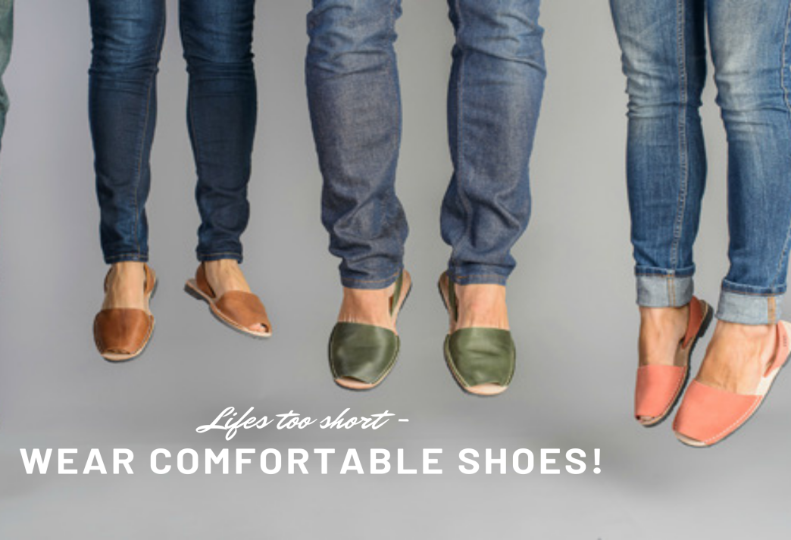

## The GIF video

The looped video to be included on the AVARCAS website must have the camera on top of the shoe facing forward, just like as if it were on the hood of the car with only the front part being seen. The shots taken with the female feet inside them, yet the nails are not brightly colored allowing to maintain focus on the footwear alone. AVARCAS footwear are demonstrated in five different locations: Paris, London, New York, Tokyo and Sydney. The slogan will read as “Treading Lightly Will Take YOU Anywhere”. At the end of the sequence an image of the shoe appears changing form and color in accordance to the customization options one will be able to choose from online. This allows to target the audience as well as to show the global outreach of the brand.

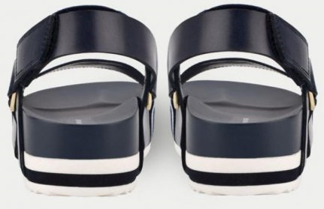

Fig. 1. Shoe images back

## The Images

Simply focusing on the footwear without any model for it is rather boring and uninteresting. Instead, one will create a slideshow presentation of the footwear standing on a pedestal of a shoe store demonstrating them as a prized jewel. This concept will focus the attention on the product itself, creating a contrast that will not disturb the potential client from analyzing the benefits of AVARCAS footwear. Of course, this may be a minimalistic approach. However, instead of making up a fancy image of the AVARCAS sandals, this slideshow will showcase their quality and and how the clients will benefit if they make the purchase.

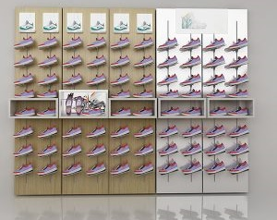

Fig. 2. Shoe Stand

# Media Plan and Execution

Considering the swift expansion and development of the technological reach of social media, one suggests to use Instagram as the main platform for promoting the product. Instagram became a trend in marketing promotion back in 2016. Since then, its audience and popularity for promoting various business projects continues to grow. The audience of users has already exceeded 1 billion people, of which 67% are people between the ages of 18 and 34; arguably the most valuable demographic for marketers. Thus, advertising on Instagram is an effective and easy way to reach millions of potential customers.

There are two main types of advertising on Instagram: official targeted advertising and account advertising through influencers, for example, from bloggers or in promoted public pages. Each of these types of advertising has advantages and disadvantages, which requires a different advertising budget.

## Targeting

Targeting is easy to launch and control. By choosing this method of promotion for oneself, one can independently choose gender, age, region of residence, interests and other parameters of users to whom one’s offer will be shown. The main advantages of targeted advertising include:

* Quick start, convenient control
* Lack of a human factor
* Flexible customization of the audience for views
* Full control over the timing, quantity and period of impressions
* Detailed reporting.

One would like to note right away that all targeted advertising on Instagram goes through Facebook. One can connect it even without having a business account on Instagram itself. All one needs to do is create a page representing AVARCAS and the Facebook profile. The social network functionality offers advertisers many advanced tools for promoting their business. Instagram's arsenal includes:

* *Advertising in Stories*. More than 500 million people visit the Instagram stories section every day. A short ad will help grab their attention. The main advantage of this method is that this ad is as native as possible, organically fitting into the rest of the content.
* *Posts with photos in the feed*. This is a simple but less effective example of brand promotion. This format allows one to show one’s company or the proposed product in all its glory.
* *Video advertising*. These ads have the same advantages as the previous format, but this time one can add motion and sound to the picture.
* *Loop gallery or collection*. By choosing this format, one can place several images or clips at once, which will turn over. This is a great option for store accounts. For example, one might place multiple models of footwear or cosmetics in one ad and show “before and after” results.
* One can launch an *official feed* from Instagram in one’s native application, through one’s Facebook profile, or using the tools in Ads Manager. For page advertising on Instagram to be effective, one needs to be able to beautifully present one’s product. Photos and videos must be professional, the message must be clear from the first seconds of viewing, and meet all the requirements of the social network.
* Internal advertising is the main source of income for any social network. There is no single answer how much contextual advertising will cost that meets all one’s requirements. The cost of advertising on Instagram is set using complex calculation algorithms and is not fixed. One will be familiarized with the final cost before launching an advertisement, and one can track all changes immediately when adjusting the filtering. Depending on one’s settings, one click in targeted advertising can cost from $ 0.20 to $ 6.70. One can independently set both the daily advertising budget and the total cost of the advertising campaign.

## Bloggers

When looking for potential customers, advertisers can find a different solution - order brand advertising from bloggers or in public. Bloggers already have a “warm” loyal audience, and, accordingly, they can provide maximum response. They are trusted. Such advertising is perceived sincerely and looks like a direct recommendation. Top bloggers may have their own views on the appearance of advertising, and instead of a post detailing the benefits of products, one can easily be offered a version that matches the overall style of the blogger's page. In this case, everything is purely individual and discussed personally. However, one always have to pay for advertising. Different variations of promotion require different advertising budgets. To a large extent, the cost depends on the number of impressions, the desired audience reach, as well as the product being promoted.

How much blogger advertising will cost also depends on many factors. Initially, there was an unspoken rule: every 10,000 followers are about $ 10 per ad post. Now everything has changed dramatically, new formats have appeared, and prices have almost doubled. This is due to the fact that the number of commercial pages now many times exceeds the number of quality bloggers, so many owners of popular pages sometimes unreasonably overstate the cost of their services. As a payment, they generally set a fixed amount + require a free product. The cost also depends on the ad format. One can choose among, advertising post, mention in the post, recording a story, video review, joint drawing and so on. Many factors affect the cost of advertising for a particular blogger:

* Audience loyalty
* Ad response statistics
* Pace of development and popularity
* What audience is subscribed to the blogger-influencer
* Whether blogging is the main activity and so on.

Prices are uneven. The average cost of placing an advertising post for a blogger with an audience of 10 to 30 thousand followers will cost about $ 10-35. Naturally, the larger the audience, the greater the cost. So, for an audience of readers from 300 thousand, one will have to pay more than $ 250. Advertising in Stories usually costs two to two and a half times more than advertising in a post. AVARCAS on Instagram therefore, one suggests to start of both a targeted ad and contact some prominent bloggers in each country of entry. Therefore, the execution ought to be well-planned in advance. Advertising choice Blogger choice:

- experienced blogger with an audience of over 100000 followers: $1000 + free merchandise

- less experienced blogger with an audience of 50k – 100 k: $500 + free merchandise

- blogger with an audience of less than 50k: free merch

- Hire a professional photographer to make photos of the goods with and without models: $200 per hour. The total photo shoot is planned to take six hours in various locations to create the necessary amount of footage for the marketing team to work with.

Thus, the total marketing budget comprises:

Bloggers: $800 + $500 + merchandise worth $1300 = $2600

Targeted advertising: $200 * 6 = $1200

Total: **$3800 USD** for the adverting campaign

# Media Timeline

Start March 1st 2021 – until May 31st 2021.

|  |  |  |
| --- | --- | --- |
| **Date Start** | **Action** | **Date Completed** |
| **February 1st 2021** | Find an appropriate photographer and create the necessary footage for the campaign | **March 1st 2021** |
| **March 1st 2021** | Approach bloggers and have them start advertising among their audience of followers | **March 31st 2021** |
| **March 1st 2021** | Start advertising in Instagram via feed and stories | **May 31st 2021** |
| **April 1st 2021** | Include video advertising and monitor the amount of followers on the Avarcas official account | **May 31st 2021** |

Sixth Component

For my 6th component of this portfolio, I have chosen to be the art director for the Korean beauty company, Nature Republic.



Nature Republic believes in the perfection of nature. It aims to discover gifts from pristine nature around the world and to provide them in the most natural state to customers. The company provides reasonably-priced products to customers by finding the balance between quality and price in order for everybody to fully enjoy its products. Through nature republics products and brand, people of the world will be able to enjoy the gift of nature.



These ads that I have created will help Nature Republic out with their new launch. It is a simple and easy way to get their target audiences attention. Not only will it attract new incoming customers, but it will gain attention aesthetically through posting these on their social media platforms.