Innovations in Technology
Technological advancements are progressing at an unprecedented rate, fundamentally transforming various aspects of our lives. Below are some of the most noteworthy innovations in technology:

Artificial Intelligence and Machine Learning
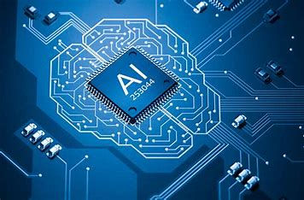
Artificial intelligence (AI) and machine learning (ML) are revolutionizing numerous industries. These technologies enable the processing of vast amounts of data, facilitating predictive analytics, autonomous vehicles, and personalized recommendations. Machine learning models, such as neural networks, are now capable of recognizing speech, understanding images, and generating human-like text.

Quantum Computing
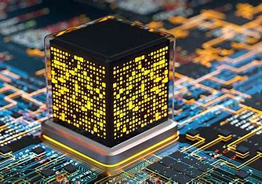
Quantum computing promises to solve complex problems that are beyond the capabilities of classical computers. By leveraging quantum bits (qubits), quantum computers can perform multiple calculations simultaneously. This innovation has the potential to revolutionize fields such as cryptography, materials science, and drug discovery.

Internet of Things (IoT)
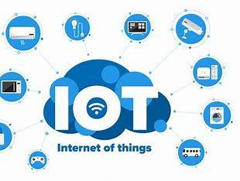
The Internet of Things (IoT) connects everyday objects to the internet, allowing them to send and receive data. From smart homes to industrial automation, IoT is enhancing efficiency and convenience. Smart sensors and devices can monitor environmental conditions, track assets, and improve energy consumption.

Biotechnology and Genetic Engineering

Advancements in biotechnology and genetic engineering are transforming healthcare. CRISPR-Cas9, a revolutionary gene-editing technology, enables precise modifications to DNA. This innovation holds the potential to treat genetic disorders, enhance crop resistance, and even de-extinct species.

Renewable Energy Technologies

Innovations in renewable energy technologies are crucial for addressing climate change. Solar panels, wind turbines, and energy storage systems are becoming more efficient and affordable. Breakthroughs in battery technology are enabling longer-lasting electric vehicles and sustainable energy grids.

3D Printing and Additive Manufacturing
3D printing, also known as additive manufacturing, is revolutionizing the production process. This technology allows for the creation of complex, customized objects layer by layer. 3D printing is being utilized in industries ranging from healthcare (prosthetics and implants) to aerospace (lightweight components).

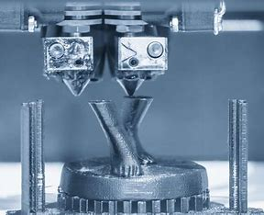
Blockchain and Decentralized Technologies

Blockchain technology provides a secure, decentralized way to record transactions. It underpins cryptocurrencies like Bitcoin and has applications in supply chain management, voting systems, and digital identity verification.
Technological innovations are continuously reshaping our world, driving advancements that make our lives more efficient, connected, and sustainable. From the leaps in artificial intelligence and quantum computing to the transformative potential of biotechnology and renewable energy, these innovations hold the promise of a brighter future. As we navigate this ever-evolving landscape, it is essential to embrace these advancements responsibly, ensuring they contribute positively to society and the environment. The future of technology is not just about what is possible but also about what is beneficial for humanity.

