KENDRIYA VIDYALAYA NO. 3
📅 Monthly Digital Newsletter - March 2025 Edition

📜 PAGE 1 (LEAF 1) – ABOUT THE SCHOOL
🏫 Kendriya Vidyalaya No. 3
📍 Location: Gandhi Nagar, New Delhi – 110011
☎ Contact: +91 98765 43210 | ✉ Email: kv3@kendriyavidyalaya.gov.in
🌐 Website: www.kv3delhi.edu.in

🏆 Motto: "ज्ञानम् परमं ध्येयम्" (Knowledge is Supreme)

📖 Vision & Mission
At Kendriya Vidyalaya No. 3, we believe in nurturing young minds with knowledge, discipline, and creativity. Our mission is to provide quality education while encouraging students to excel in academics, sports, and extracurricular activities.

👩‍🏫 Principal’s Message
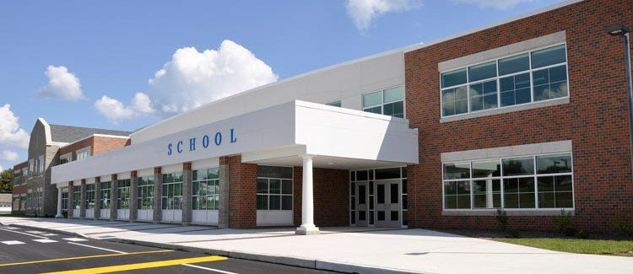
"Dear Students & Parents,
It brings me immense pleasure to present our first-ever digital newsletter. This initiative reflects our commitment to keeping students and parents informed about the school’s progress. Let’s continue our journey of excellence!"
— Dr. Suman Sharma, Principal

📊 PAGE 1 (LEAF 2) – LAST YEAR’S BOARD RESULTS

🎓 CBSE Board Exam Results – 2024
Class | Total Students | Pass Percentage | Highest Marks | Topper
10th | 120 | 98.5% | 497/500 | Shobit Nirwan
12th | 85 | 96.3% | 489/500 | Alakh Pandey
🔹 Subject-wise Toppers (Class 12th):
- Science: Prashanth Kirad (PCM - 482/500)
- Commerce: Digraj Singh Rajput (478/500)
- Arts: Charan Vennela (475/500)
📈 Outstanding performance by our students! Kudos to all achievers! 🎉

🏆 PAGE 2 (LEAF 3) – SCHOOL ACHIEVEMENTS (2024-25)
1️⃣ Won 1st Place in the CBSE National Science Exhibition 🧪
🔹 Project on "AI in Healthcare" by Class 11 Students
2️⃣ District-Level Football Champions ⚽
🔹 KV No. 3 Boys Team won the Inter-School Tournament
3️⃣ 100% Success in NTSE Stage 1 🏅
🔹 5 students from KV No. 3 cleared NTSE Level 1
4️⃣ Best School in Swachh Bharat Abhiyan Drive 🧹
🔹 Organized a cleanliness drive in Gandhi Nagar with 300+ student volunteers
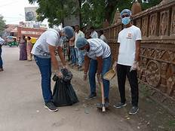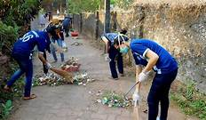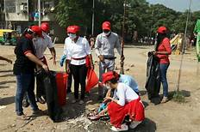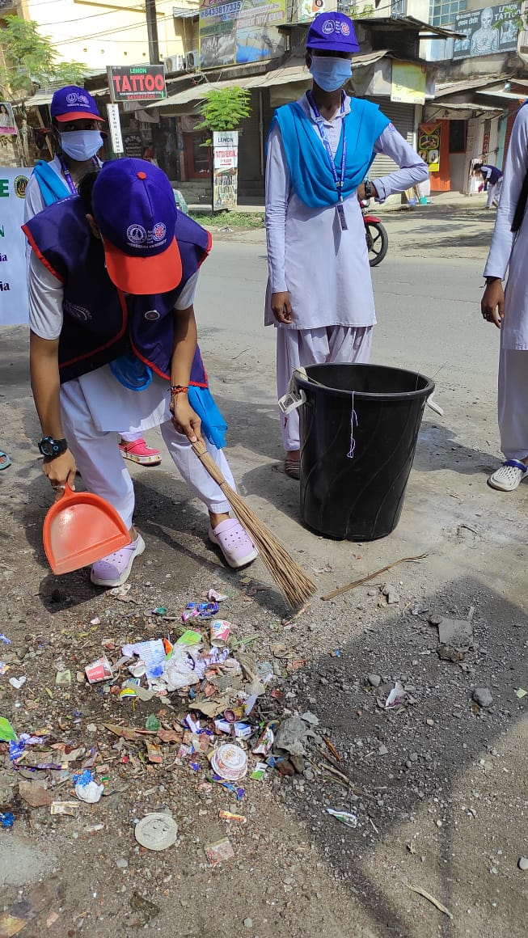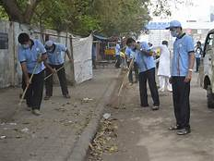

📝 PAGE 2 (LEAF 4) – STUDENT ARTICLES & POEMS

Article: "The Future of AI in Education" 🤖
📖 By: Yashwanth Gudupu (Class 12, Science)
"Artificial Intelligence is reshaping how students learn. From smart classrooms to AI tutors, education is becoming more personalized and efficient..."

Poem: "My School, My Pride" 🎶
📜 By: Kasish Bonthu (Class 10, Section B)
"A place where knowledge flows like a stream,
With teachers who help us dream.
From morning prayers to evening sun,
Every moment here is filled with fun!"*

Designed by: Ravish Pandey

