Hello, sir/ma'am,

I am Anirudh Vempati, grade 8 of Unicent school.

I'd like to provide the following article for the NIE paper: -

**Title: "** **Unleashing Imagination with Scratch: An Introduction to Coding for Kids"**

Article:

Scratch is a very helpful programming language for kids. It was developed by MIT and allows kids to create their own interactive stories, games, and animations using building blocks. This type of programming is referred to as block coding. Scratch is also an online community where kids can share their projects and learn from each other.

Scratch is easy to use and fun to learn. Kids can drag and drop different blocks to make their characters move, talk, and interact. They can also add sounds, music, and backgrounds to make their projects more engaging. Scratch helps kids develop their creativity, logic, and problem-solving skills.

Scratch is free and available for Windows, macOS, and some Android devices. You can also use Scratch in your web browser by going to scratch.mit.edu and clicking on "Create". If you want to learn more about Scratch, you can check out online courses or tutorials on YouTube and many other platforms.

by Anirudh Vempati

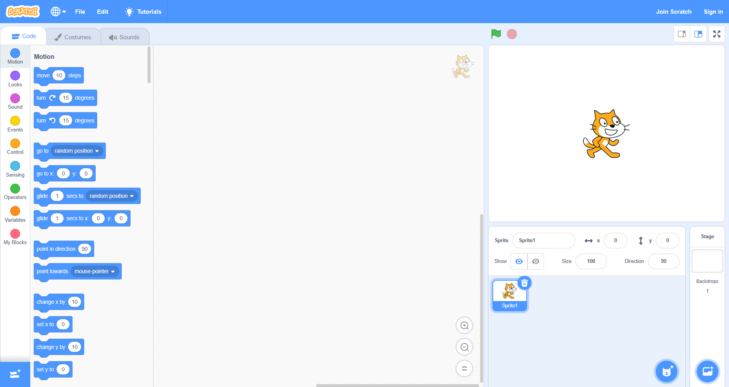

**Scratch Interface**