ITM University Gwalior
School of Computing and Intelligent Systems
Project-Based Learning (PBL)
Mini Project Report — Submission Format
Course: Data Analytics Using Python
Course Code: CSL0312
Program: B.Tech. CSE (Artificial Intelligence & Machine Learning)
Semester: III Section: F
Academic Session: July–Dec 2026
Project Details
Project Title: Comparative Sales and Trends Analysis (Samsung Global Product Sales)
Domain (as per Section 6): Finance and Economics
Team Leader Name & Roll No.: Gonaboyina Vamsi – BETN1AI25160
Team Member Name & Roll No.: —
Team Member Name & Roll No.: —
Faculty Mentor: Dr. Sanjay Jain
Date of Submission: ____________________

Table of Contents
1. Introduction & Problem Statement 3
2. Dataset Description & Source 3
3. Data Cleaning & Preprocessing 5
4. Exploratory Data Analysis (EDA) 7
5. Data Visualization & Observations 10
6. Statistical Analysis (Basic) 20
7. Key Insights & Interpretation 22
8. Conclusion & Future Scope 23
9. References 23
10. AI Tool Usage Declaration 23
11. Project Links & Deliverables 24
12. Report Structure Checklist (Section 8 Compliance) 24
13. Declaration by Student(s) 24
14. For Faculty Use Only — PBL Final Report Evaluation 25

1. Introduction & Problem Statement
Every company that sells products in many countries wants to know where its revenue comes from, which product lines carry the business, and who is buying them. Samsung is a great example. It sells smartphones, tablets, smart watches, televisions, computer monitors, home appliances, and accessories across dozens of countries through multiple retail and online channels. When all these transactions sit in a single large dataset, it is hard to see the business patterns without structured analysis.
The problem in this project is simple. Businesses often do not know why some markets perform better than others, which customer groups generate the most sales, and how discounts and 5G connectivity affect revenue. Without this knowledge, inventory planning, pricing, and marketing choices become guesses rather than informed decisions.
In this project, I used Python to perform a comparative sales and trend analysis on the Samsung Global Product Sales dataset from Kaggle. The dataset contains 15,500 sales records from 52 countries between 2021 and 2024. I compared sales across geographic regions and product categories, studied customer segments and age groups, examined return rates and customer ratings, and identified clear insights supported by the data.
The analytical scope of this project is strictly focused on descriptive and inferential data analytics. No machine learning models, train-test splits, or predictive algorithms were built. The dataset records sales channels rather than individual store names, and does not include customer income or repeat purchase histories. As a result, store comparisons were conducted using regions, countries, and channels, while customer retention was evaluated using return status, customer ratings, and previous device operating systems.
2. Dataset Description & Source
Dataset Name: samsung_global_sales_dataset.csv (Samsung Global Product Sales Dataset)
Source / Organization: Kaggle (ashyou09)
Dataset Link (URL): https://www.kaggle.com/datasets/ashyou09/samsung-global-product-sales-dataset
Type of Dataset: ☑ Public ☐ Private ☐ Self-Collected
Number of Records: 15,500
Number of Attributes/Columns: 28
The dataset meets the minimum quality criteria of the PBL guidelines: it has far more than 500 records and more than 5 columns. Most columns are complete. Only three columns have missing values (storage, previous device OS, and customer rating), and their handling is explained in Section 3.
☑ Dataset meets minimum quality criteria (Section 7)
A brief description of all 28 attributes is provided in Table 1 below, grouping related columns together:
Table 1: Dataset Attribute Description (All 28 Columns)
Column(s) | What it means
sale_id | Unique transaction identifier for each sale (S000001 to S015500).
sale_date | Date of the sale between 2021-01-01 and 2024-12-31.
year, quarter, month | Time of sale split into calendar year, quarter (Q1 to Q4), and month name.
country, region, city | Geographic location of the sale covering 52 countries, 8 regions, and 555 cities.
product_name, category | Specific product model name and its broader category across 11 hardware lines.
storage, color | Internal memory specification (e.g., 128GB, 1TB) and device exterior finish.
is_5g | Hardware connectivity flag indicating whether the device supports 5G (Yes/No).
unit_price_usd | Original retail catalog price per unit in US Dollars ($8.20 to $5,442.70).
discount_pct | Promotional discount percentage applied to the order (0% to 20%).
units_sold | Number of hardware units purchased in the order (1 to 10 units).
discounted_price_usd | Unit price after deducting discount: unit_price_usd * (1 - discount_pct/100).
revenue_usd | Total transaction revenue in USD: discounted_price_usd * units_sold.
currency, fx_rate_to_usd, revenue_local_currency | Local sales currency, foreign exchange rate to USD, and gross revenue in local currency.
sales_channel | Retail or online channel (Samsung Stores, E-commerce, Retail, Resellers, etc.).
payment_method | Customer payment instrument (Credit Card, Debit Card, Net Banking, Cash, Samsung Pay, etc.).
customer_segment | Buyer group category (Consumer, Corporate, Enterprise, Education, Government).
customer_age_group | Customer demographic bracket (18-24, 25-34, 35-44, 45-54, 55+).
previous_device_os | Operating system of customer's previous device (Android, iOS, Windows, Unknown).
customer_rating | Post-purchase customer satisfaction score on a 2.5 to 5.0 star scale.
return_status | Order fulfillment outcome: Kept (85.9%), Returned (9.2%), or Exchanged (4.9%).

3. Data Cleaning & Preprocessing
Checked the data first. I used head(), info(), and describe() to inspect the raw data. The file contains 15,500 rows and 28 columns without any missing rows or blank files.
Dropped irrelevant columns. I removed sale_id, sale_date, city, product_name, currency, revenue_local_currency, and fx_rate_to_usd. These columns are identifiers, have too many unique values, or repeat information already available in year, quarter, month, country, and revenue_usd.
Handled missing values. Three columns contained missing values: storage (7,849 missing, 50.6%), previous_device_os (9,373 missing, 60.5%), and customer_rating (4,251 missing, 27.4%). Missing storage and previous OS are structural: televisions, appliances, and accessories do not have mobile storage or phone operating systems, so they were filled with 'Not_Applicable' and 'Unknown'. Missing ratings reflect survey non-response, so they were imputed with the median rating of 3.70 to avoid outlier bias.
Table 2: Missing Value Audit and Imputation Strategy
Column | Missing Count | Percentage | What I did
storage | 7,849 | 50.6% | Filled with 'Not_Applicable' because non-phone categories do not have storage.
previous_device_os | 9,373 | 60.5% | Filled with 'Unknown' because the information was not recorded.
customer_rating | 4,251 | 27.4% | Filled with median rating (3.70) because it is not affected by extreme values.

Data quality checks. I checked for duplicate rows and found 0 duplicates, confirming 15,500 unique sales. An en dash in customer_age_group ('25–34') was replaced with a standard hyphen ('25-34') to keep all five age brackets consistent. A revenue formula check confirmed 0 mismatches exceeding $1.00 between logged revenue and unit_price * units * (1 - discount).
Changed data types. Storage strings were converted into numeric gigabytes (1 TB = 1024 GB, 0 for Not_Applicable). The is_5g column was mapped from Yes/No to 1/0. Quarter strings ('Q1'–'Q4') were converted to numbers 1 to 4, and month names were converted to integers 1 to 12.
Outliers. Using the IQR method (Q3 + 1.5 * IQR), revenue had 1,387 sales (8.95%) above $3,856.89, and unit price had 434 sales (2.80%) above $2,068.49. I kept all outliers because they represent real purchases of high-end products (such as Smart TVs and foldable phones) rather than data entry errors.
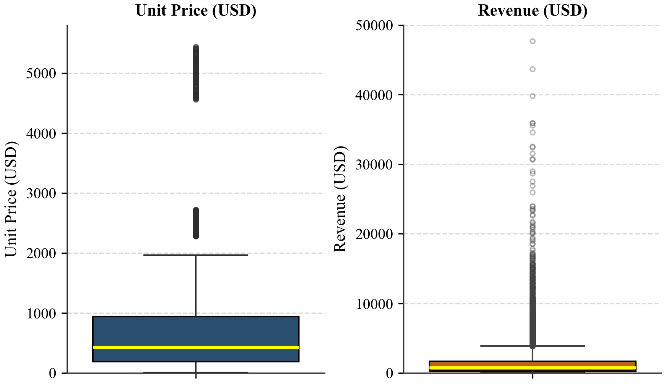
Figure 1: Outlier Box Plots for Unit Price and Revenue
Observation: Unit price has 434 outliers above $2,068.49, while revenue has 1,387 outliers above $3,856.89. Both metrics show a long right tail of high-value commercial sales.
Encoding categorical variables. Customer age groups were ordinally encoded from 0 to 4 to preserve age order. Hardware connectivity (is_5g) was binary encoded to 0 and 1. Product categories were one-hot encoded into 11 binary dummy columns for distance calculations.
Standardization and normalization. I tested Min-Max normalization (scaling between 0 and 1) and Z-score standardization (mean 0, standard deviation 1) on the four continuous numeric features. Because raw revenue has a high maximum Z-score of 19.50 due to outliers, a natural log transformation log1p(revenue) was computed, which stabilized variance and brought skewness from 5.62 to -0.36.
Table 3: Feature Scaling Summary (Before vs. After Normalization & Standardization)
Attribute | Original Mean | Original Std | Min-Max Min | Min-Max Max | Z-Score Min | Z-Score Max
unit_price_usd | $665.12 | $736.01 | 0.00 | 1.00 | -0.89 | 6.49
units_sold | 2.36 | 1.90 | 0.00 | 1.00 | -0.72 | 4.03
discount_pct | 5.71% | 6.41% | 0.00 | 1.00 | -0.89 | 2.23
revenue_usd | $1,478.15 | $2,368.69 | 0.00 | 1.00 | -0.62 | 19.50

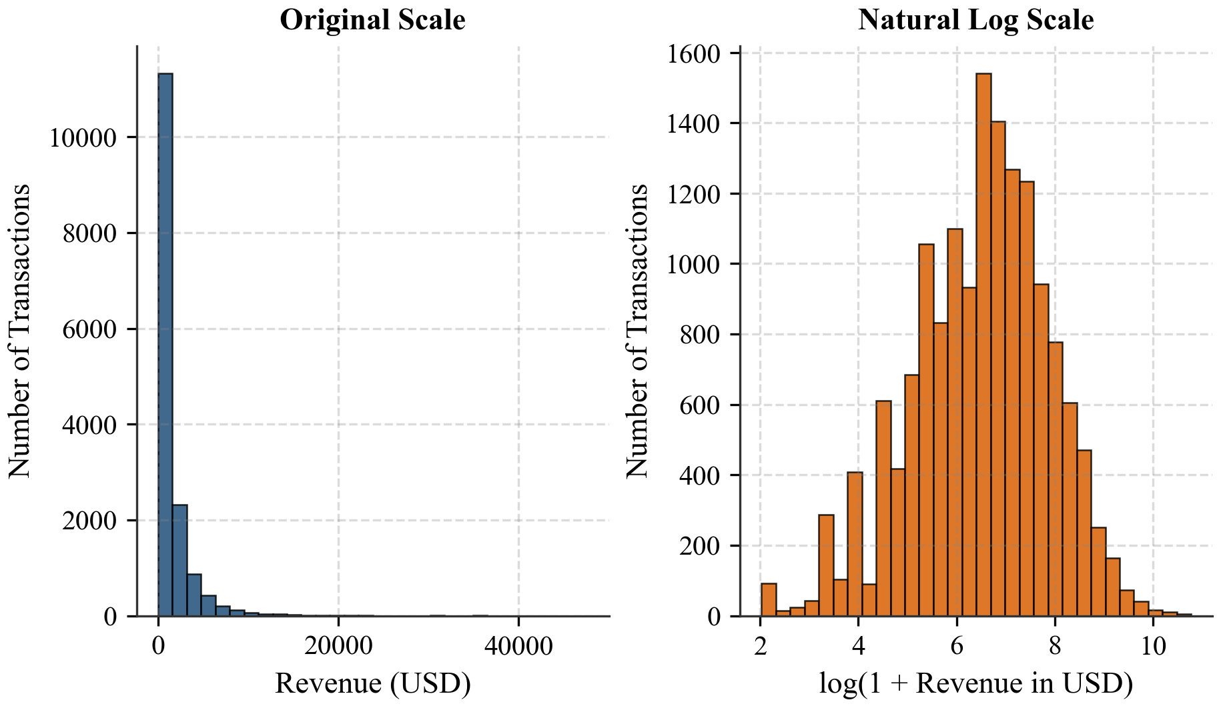
Figure 2: Revenue Distribution Before and After Natural Log Transformation
Observation: Raw revenue is heavily right-skewed with a peak near zero and a long tail. Log transformation successfully creates a balanced bell-shaped distribution.
Skewness check. Skewness measures how lopsided a distribution is. Revenue had high right skewness (5.62), unit price was 3.04, units sold was 1.91, discount percentage was 0.88, customer rating was 0.08 (nearly symmetrical), and log revenue was -0.36.
Code snippet
# 1. Drop irrelevant columns
df.drop(['sale_id', 'sale_date', 'city', 'product_name', 'currency',
'revenue_local_currency', 'fx_rate_to_usd'], axis=1, inplace=True)
# 2. Handle missing values
df['storage'] = df['storage'].fillna('Not_Applicable')
df['previous_device_os'] = df['previous_device_os'].fillna('Unknown')
df['customer_rating'] = df['customer_rating'].fillna(df['customer_rating'].median())
# 3. Data wrangling and type conversions
df['customer_age_group'] = df['customer_age_group'].str.replace('–', '-')
df['storage_gb'] = df['storage'].apply(lambda x: float(str(x).replace('TB',''))*1024
if 'TB' in str(x) else (float(str(x).replace('GB','')) if 'GB' in str(x) else 0))
df['is_5g'] = df['is_5g'].map({'Yes': 1, 'No': 0})
df['quarter'] = df['quarter'].str.replace('Q', '').astype(int)
df['month'] = pd.to_datetime(df['month'], format='%B').dt.month
# 4. Log transform revenue
df['log_revenue'] = np.log1p(df['revenue_usd'])
4. Exploratory Data Analysis (EDA)
After cleaning, I explored the data using descriptive statistics and group-wise comparisons. In total, the dataset holds $22.91M USD in revenue from 36,580 units sold across 15,500 transactions from 2021 to 2024. Table 4 presents summary statistics for continuous attributes.
Table 4: Descriptive Statistics of Core Continuous Attributes
Metric | Mean | Median | Std. Dev. | Min | Max | Skewness
revenue_usd | $1,478.15 | $739.38 | $2,368.69 | $6.61 | $47,665.90 | 5.62
unit_price_usd | $665.12 | $421.49 | $736.01 | $8.20 | $5,442.70 | 3.04
units_sold | 2.36 | 2.00 | 1.90 | 1.00 | 10.00 | 1.91
discount_pct | 5.71% | 3.00% | 6.41% | 0.00% | 20.00% | 0.88
customer_rating | 3.73 | 3.70 | 0.61 | 2.50 | 5.00 | 0.08

Category performance. Grouping sales by category shows that Smart TVs are the top revenue generator at $5.56M USD (24.3%), followed by Galaxy S phones at $4.73M USD (20.6%) and Galaxy Z foldables at $2.77M USD (12.1%). Accessories have 871 orders and generate only 1.1% of revenue ($0.25M USD) due to their low unit prices.
Table 5: Category-wise Revenue and Volume Breakdown
Product Category | Orders | Revenue (USD) | Revenue Share (%) | Mean Ticket (USD)
Smart TV | 2,149 | $5,559,342.55 | 24.3% | $2,586.94
Galaxy S | 2,316 | $4,728,112.37 | 20.6% | $2,041.50
Galaxy Z | 1,058 | $2,765,867.41 | 12.1% | $2,614.24
Galaxy Tab | 1,524 | $2,451,712.69 | 10.7% | $1,608.74
Appliances | 1,444 | $2,253,734.40 | 9.8% | $1,560.76
Monitor | 1,038 | $2,108,941.32 | 9.2% | $2,031.74
Galaxy A | 1,892 | $1,154,772.22 | 5.0% | $610.34
Galaxy Watch | 1,399 | $913,148.29 | 4.0% | $652.72
Galaxy M | 736 | $425,853.53 | 1.9% | $578.61
Galaxy Buds | 1,073 | $298,759.24 | 1.3% | $278.43
Accessories | 871 | $250,714.86 | 1.1% | $287.85

Regional performance. Europe ($7.90M USD, 34.5%) and Asia ($6.73M USD, 29.4%) together bring about 64% of total sales. Africa ($2.22M USD) and South America ($2.12M USD) follow. Average revenue per sale is nearly identical across regions ($1,355 to $1,506), proving that regional differences stem from transaction counts rather than order size.
Table 6: Regional Revenue and Sales Volume Summary
Region | Orders | Units Sold | Total Revenue (USD) | Share (%) | Mean Revenue
Europe | 5,327 | 12,476 | $7,903,104.02 | 34.5% | $1,483.59
Asia | 4,481 | 10,795 | $6,732,880.38 | 29.4% | $1,502.54
Africa | 1,512 | 3,538 | $2,223,891.75 | 9.7% | $1,470.83
South America | 1,470 | 3,489 | $2,119,745.70 | 9.2% | $1,442.00
North America | 913 | 2,142 | $1,363,648.44 | 5.9% | $1,493.59
Middle East | 589 | 1,363 | $887,007.49 | 3.9% | $1,505.95
Europe/Asia | 607 | 1,399 | $866,429.72 | 3.8% | $1,427.40
Oceania | 601 | 1,378 | $814,551.38 | 3.6% | $1,355.33

Pivot table analysis. A two-dimensional pivot table of year by category revealed steady annual revenue across all lines. Smart TV produced $1.40M in 2021, $1.41M in 2022, $1.46M in 2023, and $1.29M in 2024. Galaxy S produced $1.11M in 2021, $1.20M in 2022, $1.16M in 2023, and $1.25M in 2024, showing consistent customer demand.
Feature transformations. Using groupby().transform(), I computed region_revenue_share by dividing each order revenue by its regional total, and category_avg_revenue to benchmark transactions against category averages. I also calculated discount_amount_usd to quantify price markdowns.
Data filtration. Boolean filtration isolated three operational subsets: (1) orders with revenue over $10,000 yielded 197 transactions ($2.65M total); (2) European 5G orders in 2023 captured 449 orders ($0.80M total); and (3) countries with over 300 completed sales captured 6,845 orders across 22 nations.
Joining and merging. I created a country-to-continent reference mapping covering all 52 countries and performed a left join with zero unmapped rows. A category-to-product-type lookup was also merged across all 15,500 rows. Table 7 summarizes gross sales grouped by continent.
Table 7: Revenue Aggregation by Continent (from Relational Join)
Continent | Total Orders | Total Revenue (USD) | Revenue Share (%)
Europe | 5,934 | $8,769,533.74 | 38.3%
Asia | 5,070 | $7,619,887.87 | 33.3%
Africa | 1,512 | $2,223,891.75 | 9.7%
South America | 1,470 | $2,119,745.70 | 9.2%
North America | 913 | $1,363,648.44 | 5.9%
Oceania | 601 | $814,551.38 | 3.6%

Code snippet
# 1. Grouping and aggregation
cat_summary = df.groupby('category')['revenue_usd'].agg(['count', 'sum', 'mean'])
reg_summary = df.groupby('region')['revenue_usd'].agg(['count', 'sum', 'mean'])
# 2. Pivot table
piv_yr_cat = df.pivot_table(index='year', columns='category', values='revenue_usd', aggfunc='sum')
# 3. Transformations
df['region_rev_share'] = df['revenue_usd'] / df.groupby('region')['revenue_usd'].transform('sum')
df['cat_avg_rev'] = df.groupby('category')['revenue_usd'].transform('mean')
# 4. Filtration
high_rev_orders = df[df['revenue_usd'] > 10000]
eu_2023_5g = df[(df['region'] == 'Europe') & (df['year'] == 2023) & (df['is_5g'] == 1)]
# 5. Joining
df = df.merge(continent_lookup_df, on='country', how='left')
5. Data Visualization & Observations
Data visualization helps turn numerical tables into clear visual insights. In this project, Matplotlib is the primary library for charts, Pandas plotting is used for direct series plots, and Seaborn is used only for linear regression plots. The 18 charts below present the visual findings from the analysis.
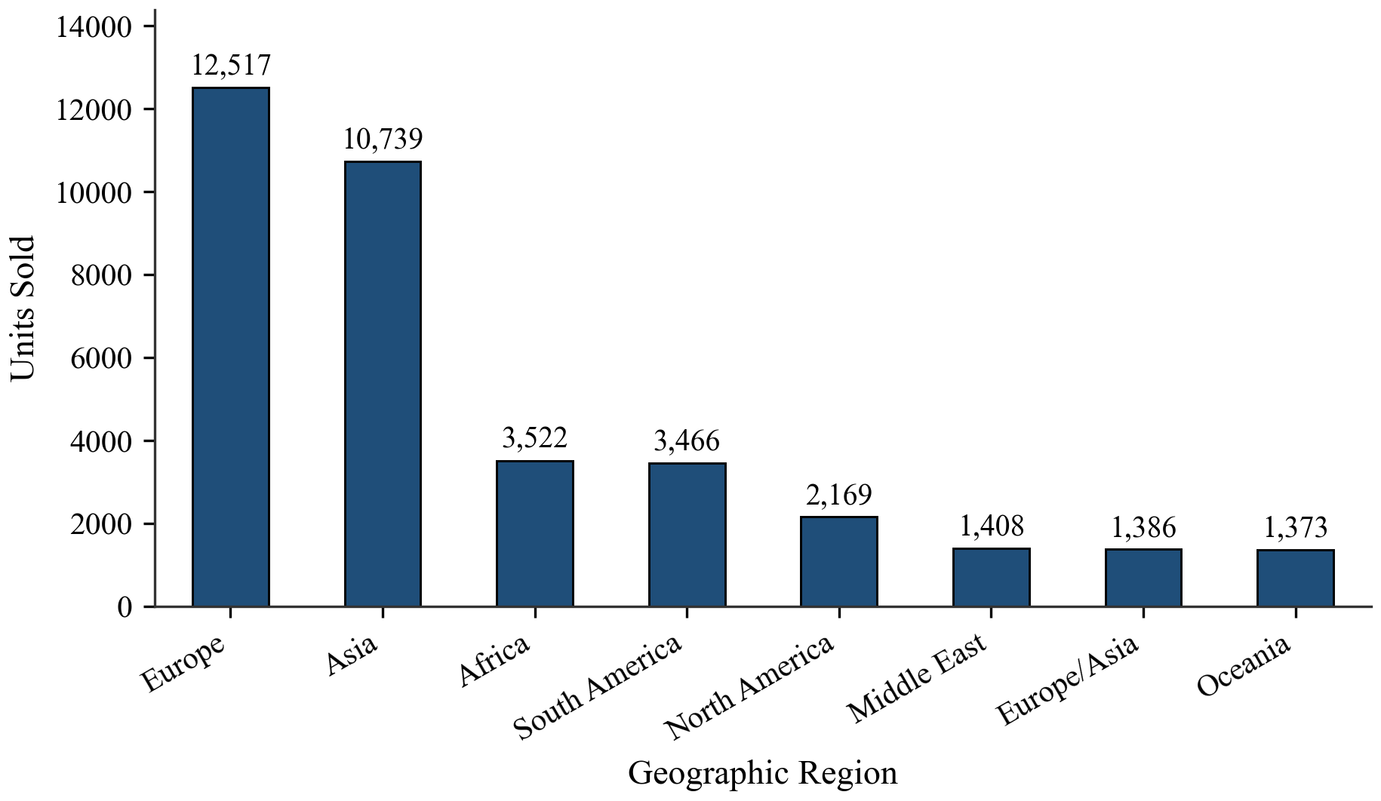
Figure 3: Total Units Sold by Region (Pandas Bar Plot)
Observation: Europe (12,476 units) and Asia (10,795 units) lead in physical sales volume, while Oceania has the lowest volume at 1,378 units. Regional unit sales closely follow regional revenue totals.
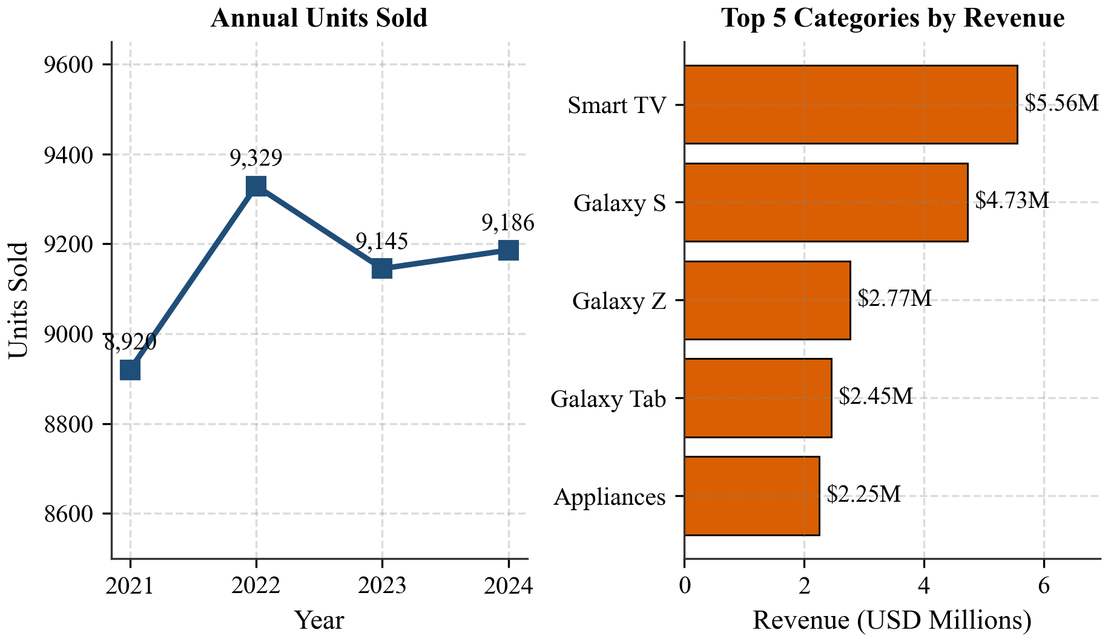
Figure 4: Matplotlib Dual Subplot Demonstration (Annual Units and Top 5 Categories)
Observation: Annual units sold remained steady near 9,100 units per year. The right panel confirms that Smart TVs and Galaxy S smartphones lead revenue by a wide margin.
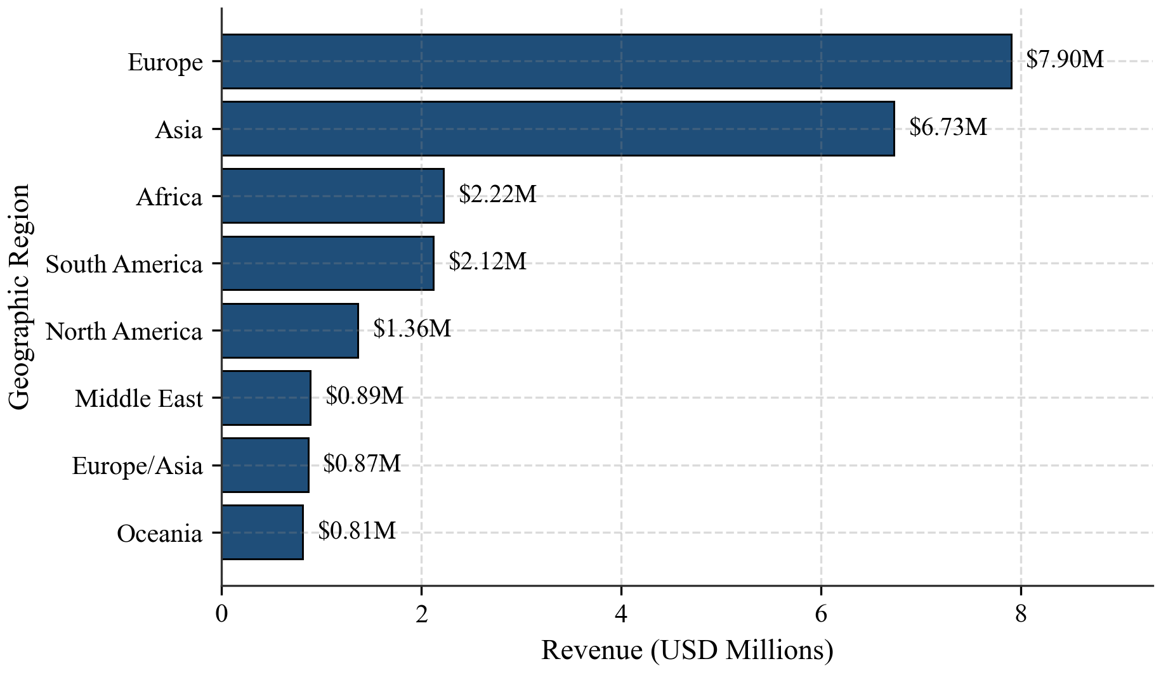
Figure 5: Total Revenue by Region
Observation: Europe leads with $7.90M USD (34.5%), followed by Asia with $6.73M USD (29.4%), together generating about 64% of total sales. North America accounts for only 5.9% ($1.36M USD).
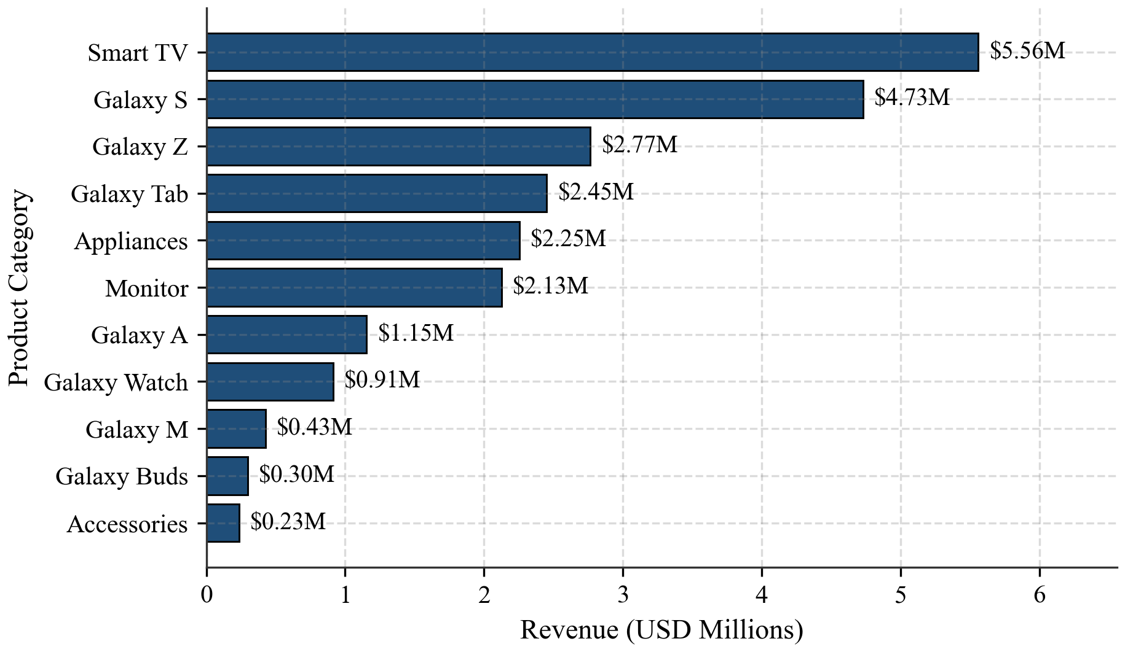
Figure 6: Total Revenue by Product Category
Observation: Smart TV generates the highest revenue at $5.56M USD (24.3%), followed by Galaxy S at $4.73M USD (20.6%) and Galaxy Z at $2.77M USD (12.1%). Accessories and Galaxy Buds generate the least.
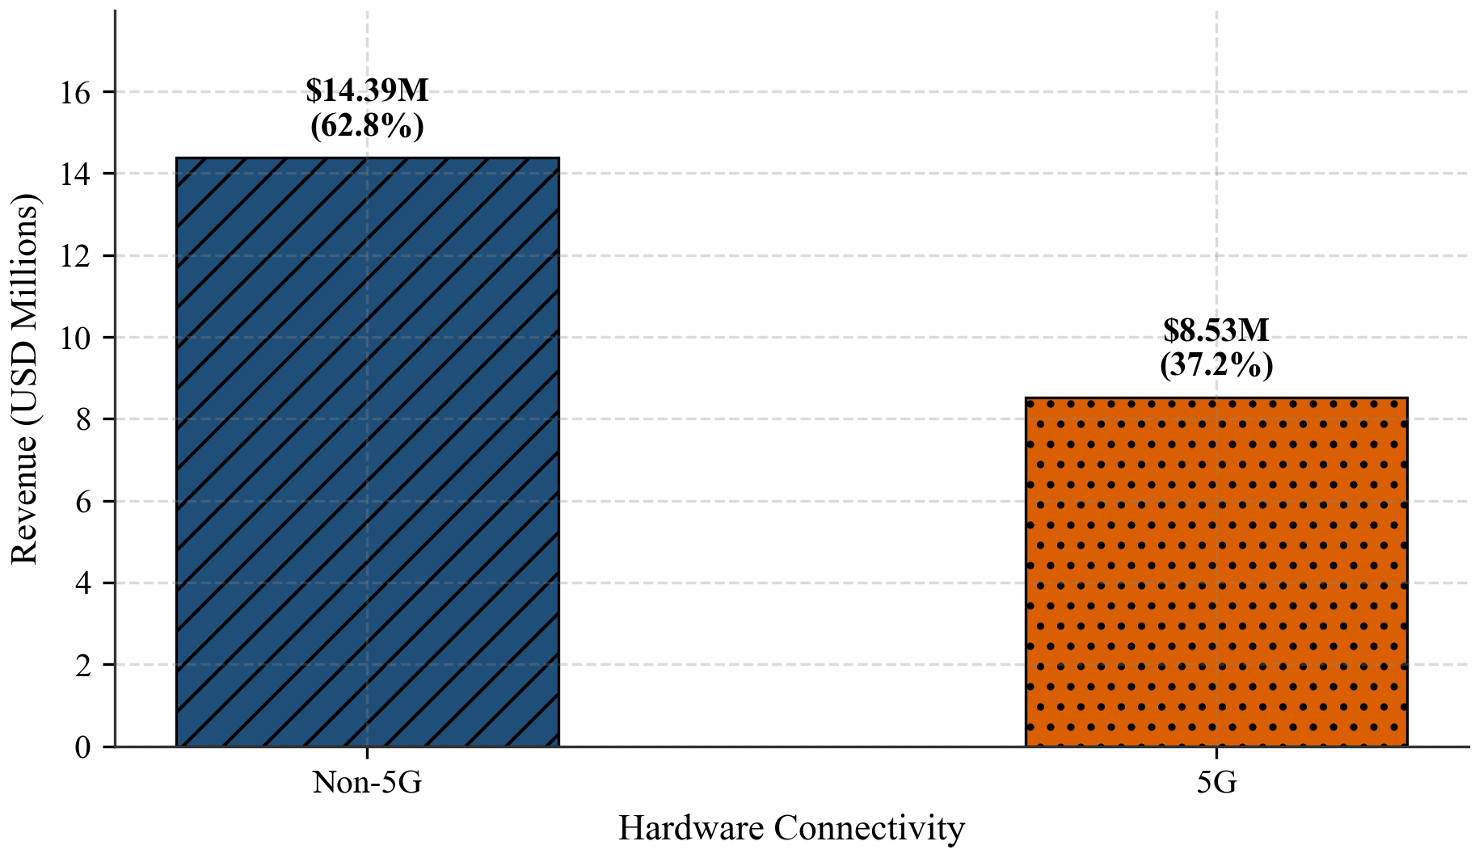
Figure 7: Total Revenue: 5G vs Non-5G
Observation: Non-5G products bring higher total revenue ($14.39M vs $8.53M USD) because they include TVs and appliances. However, 5G devices earn a higher average revenue per sale.
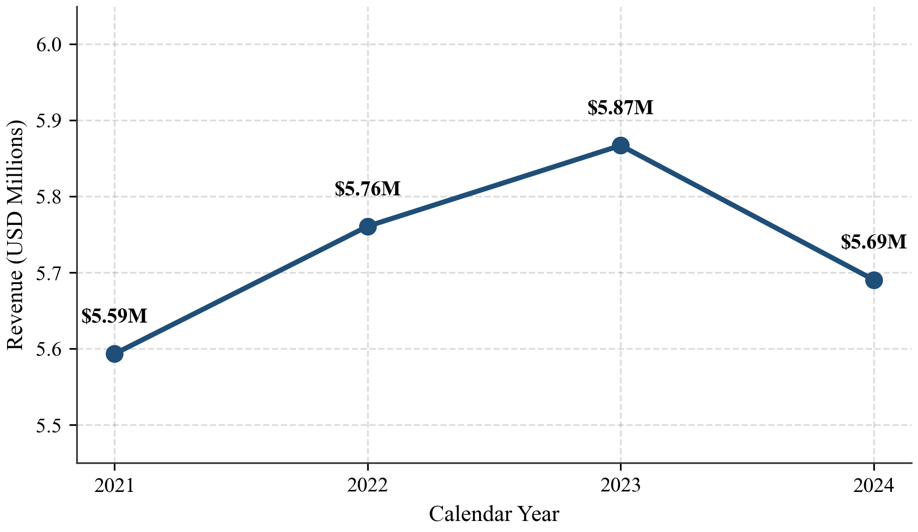
Figure 8: Yearly Revenue Trend (2021–2024)
Observation: Annual revenue grew from $5.59M in 2021 to $5.76M in 2022 and $5.87M in 2023, then dipped slightly to $5.69M in 2024. Overall sales performance remained steady across the four years.
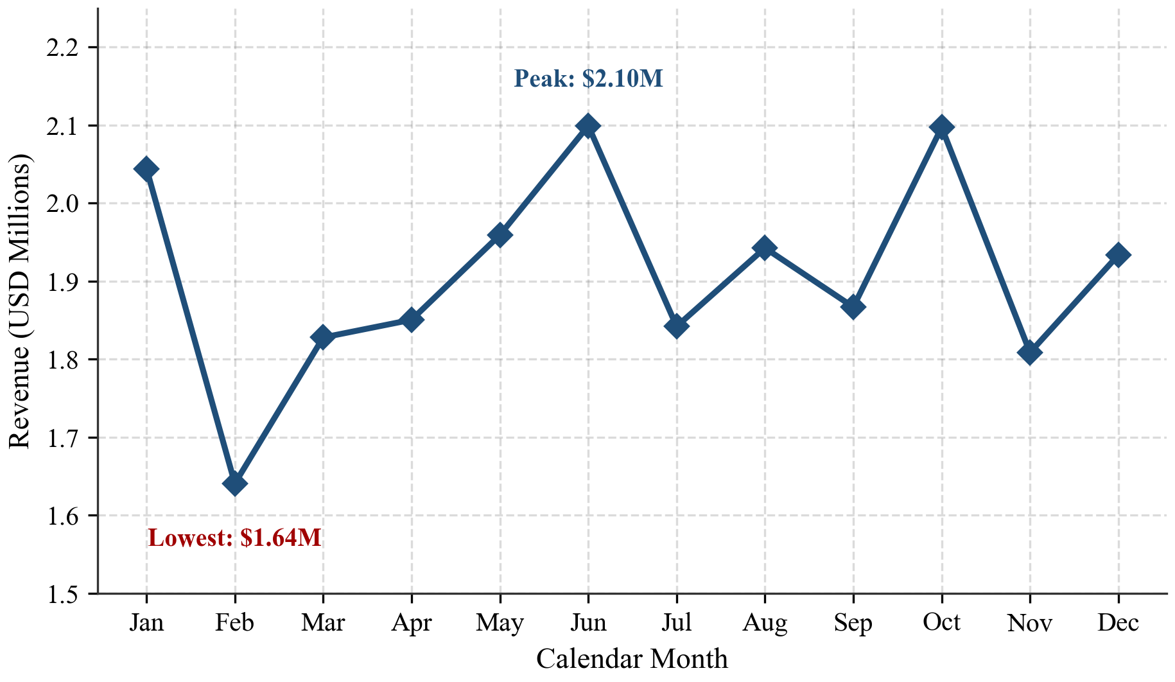
Figure 9: Monthly Revenue Trend
Observation: Monthly revenue was lowest in February at $1.64M USD and peaked in June and October at $2.10M USD each. Sales rose slightly during year-end shopping months.
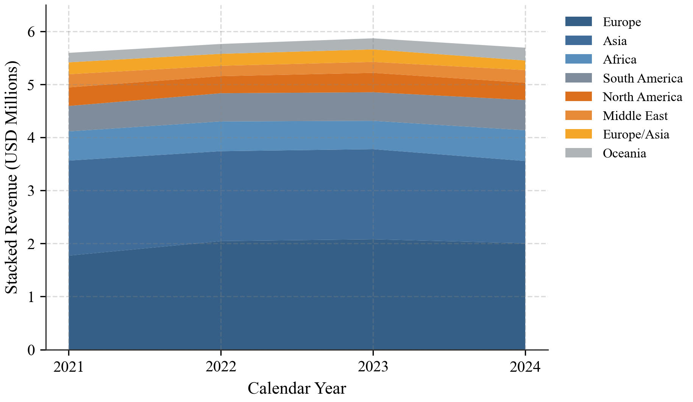
Figure 10: Stacked Yearly Revenue by Region
Observation: Europe and Asia make up the largest share of the area in every year. Regional proportions stayed stable from 2021 to 2024 without major regional shifts.
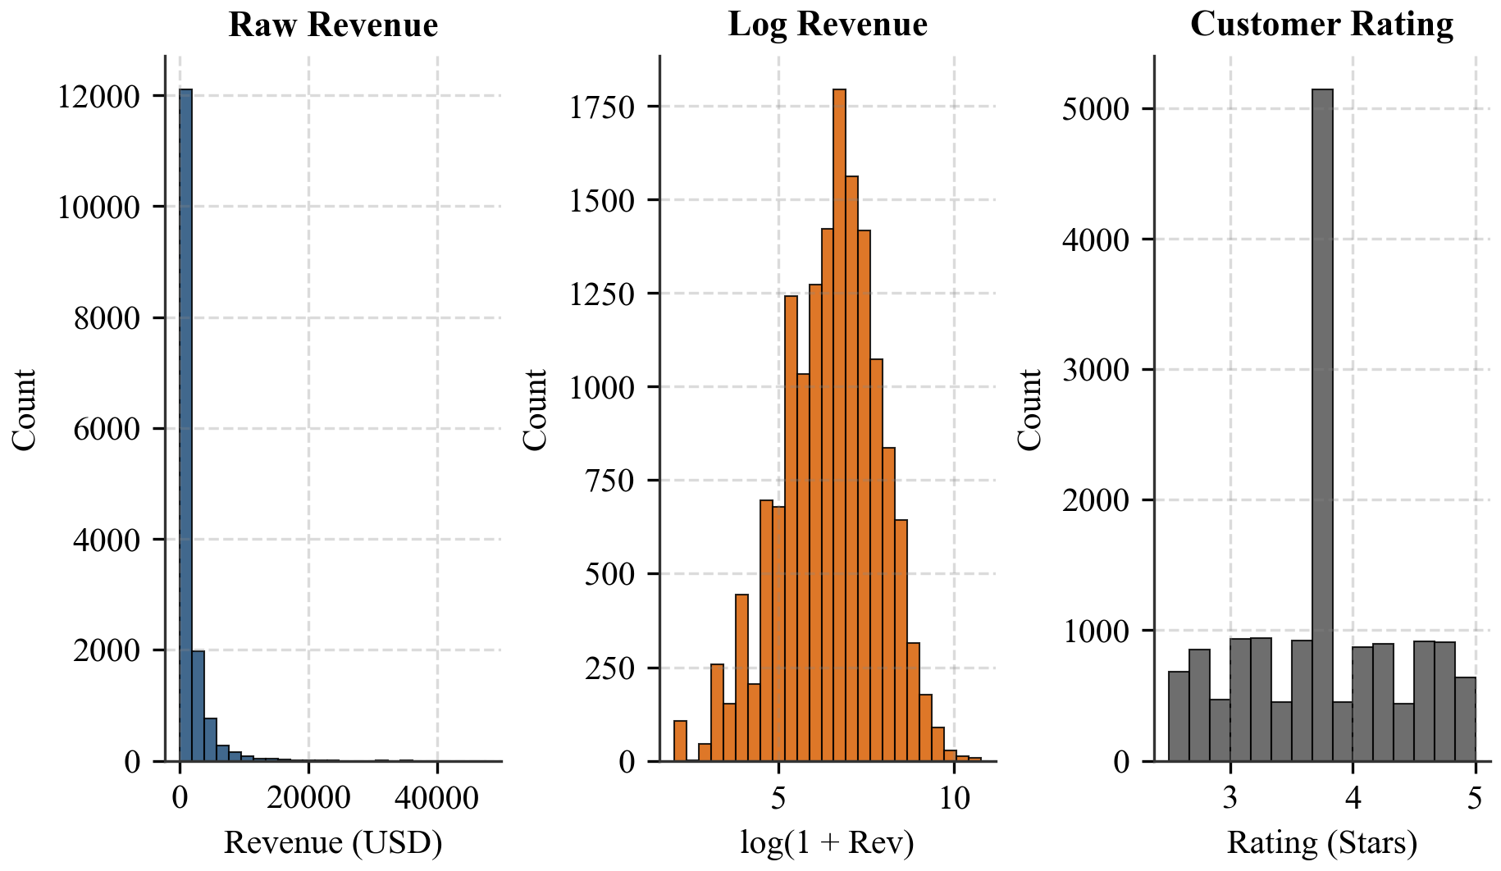
Figure 11: Histograms of Raw Revenue, Log Revenue, and Customer Rating
Observation: Raw revenue is heavily right-skewed, while log-transformed revenue produces an approximately normal bell shape. Customer ratings are centered around 3.73 stars.
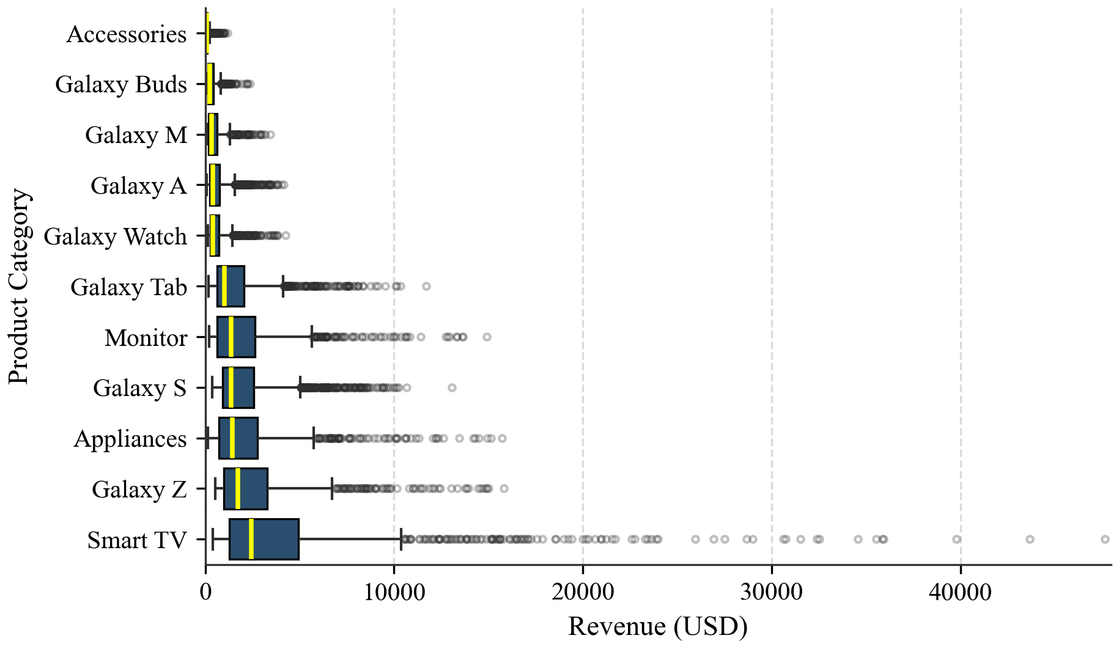
Figure 12: Revenue Distribution by Category
Observation: Smart TV and Galaxy S have the highest medians and widest spreads, with top sales exceeding $10,000 USD. Galaxy Buds and Accessories have tight, low-value boxes.
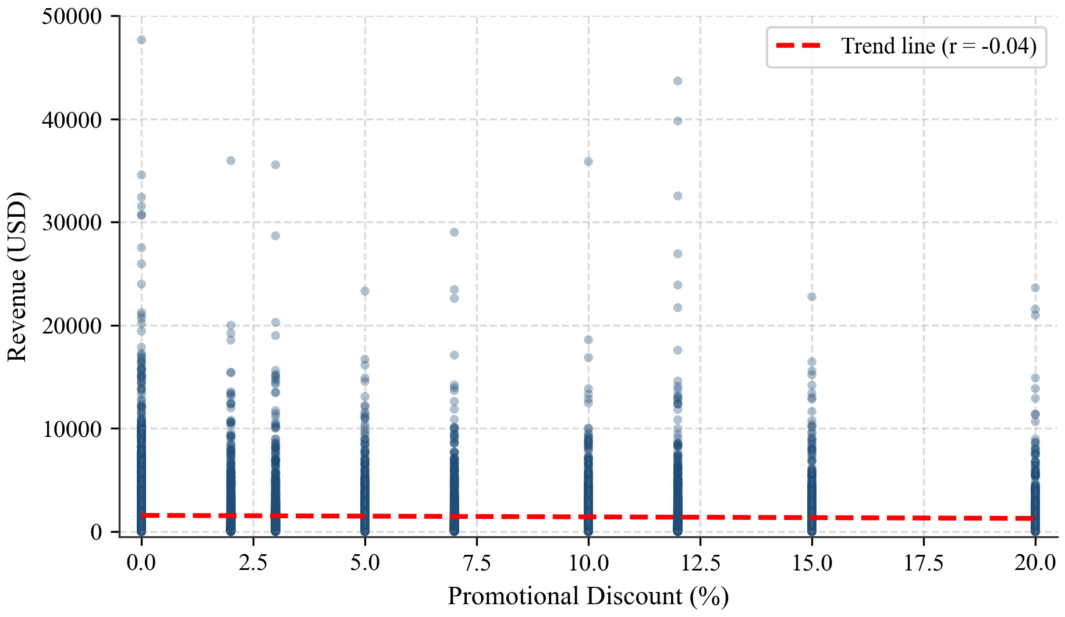
Figure 13: Discount Percentage vs Revenue
Observation: Sales are spread evenly across all discount levels from 0% to 20%. Higher discounts do not produce higher revenue transactions (correlation r = -0.04).
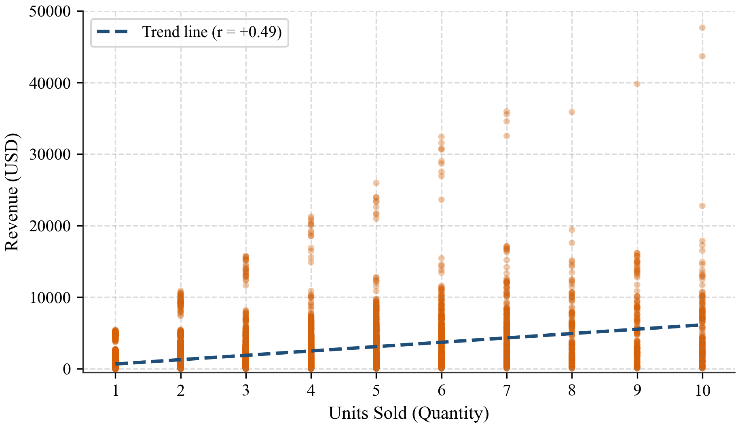
Figure 14: Units Sold vs Revenue
Observation: Higher unit sales generally lead to higher revenue (r = 0.49). However, a single Smart TV often earns more than an order of multiple accessories.
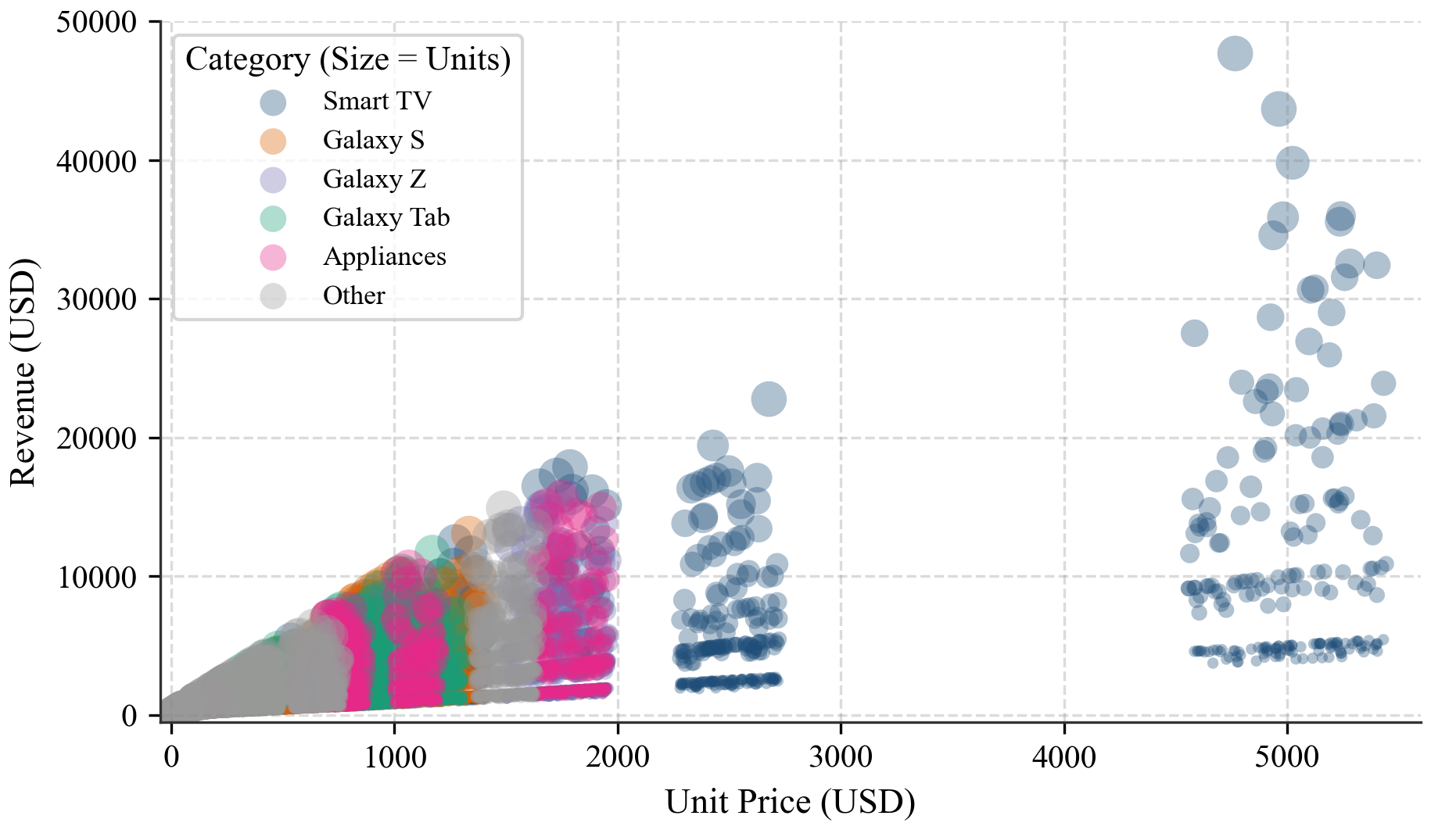
Figure 15: Unit Price vs Revenue (Bubble Size = Units Sold)
Observation: The highest revenue points appear in the upper right, where expensive products are bought in quantities of 5 to 10 units. Most orders cluster at lower unit prices.
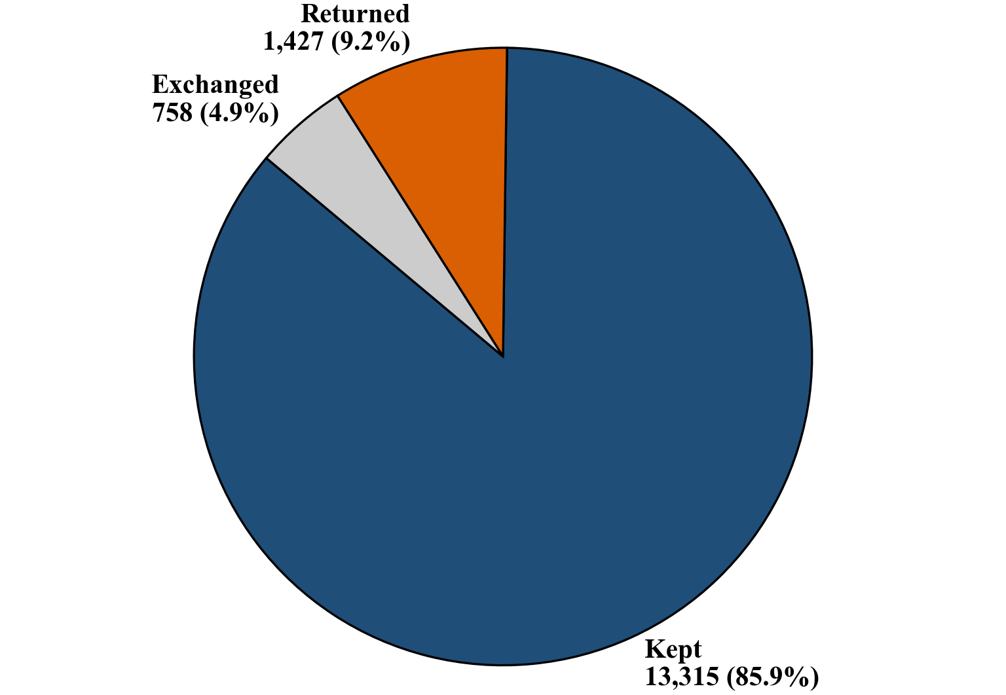
Figure 16: Order Return Status (Pie Chart)
Observation: Most orders (85.9%, 13,315 sales) were kept. About 9.2% (1,427 sales) were returned for refunds, and 4.9% (758 sales) were exchanged.
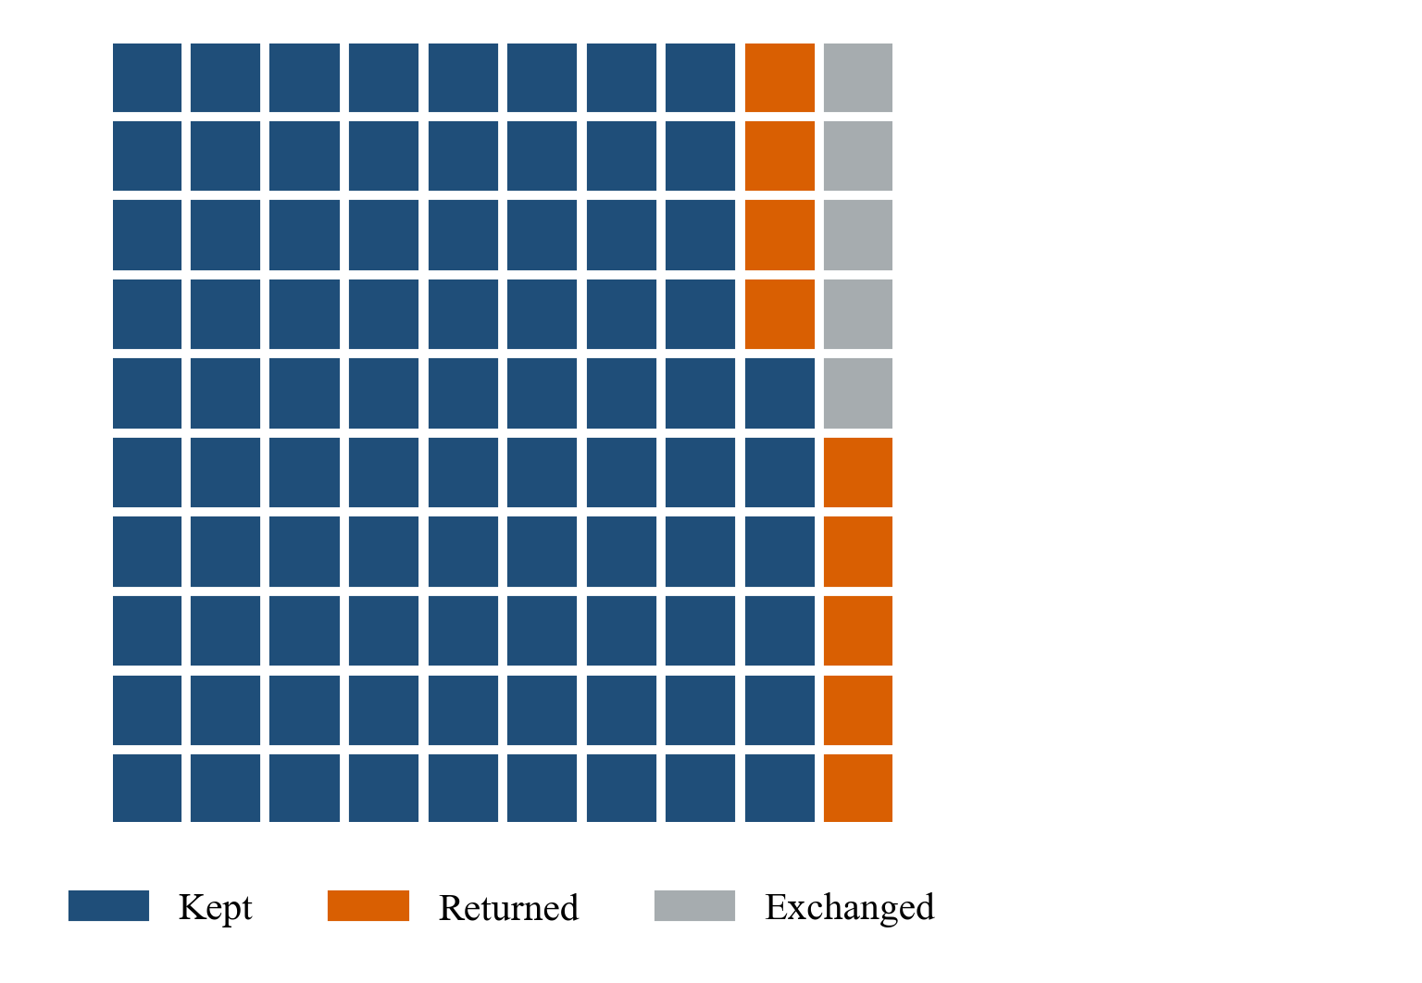
Figure 17: Waffle Chart of Order Return Status
Observation: Each square represents 1% of total orders: 86 green squares show kept products, 9 red squares show returns, and 5 yellow squares show exchanges.
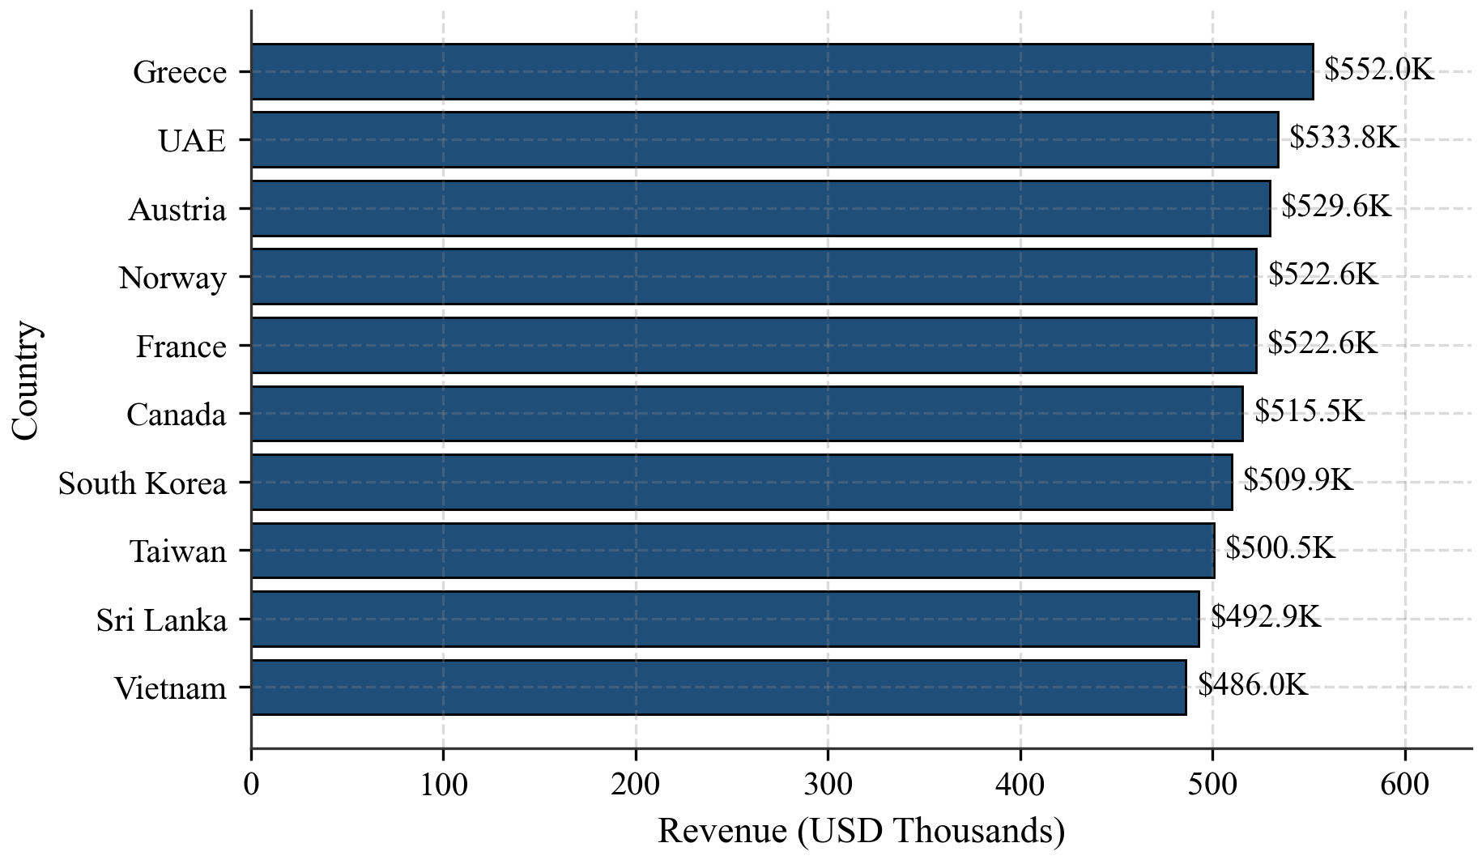
Figure 18: Top 10 Countries by Revenue
Observation: Greece leads with $551.97K USD, followed by UAE ($533.78K), Austria ($529.64K), Norway ($522.62K), and France ($522.56K). Revenue is evenly distributed across top nations.
Additional balanced distributions. Other distributions in the dataset are also remarkably balanced. Revenue across the five customer segments was evenly split between 19.5% and 20.7% ($4.48M to $4.75M USD each). The seven sales channels contributed between 13.6% and 15.0% ($3.11M to $3.43M USD each), led by Samsung Stores and E-commerce. The eight payment methods ranged from 11.6% to 13.1% ($2.65M to $2.99M USD each), led by Samsung Pay and Net Banking. Average customer ratings were also uniform across all 11 categories, staying between 3.70 and 3.78 stars.
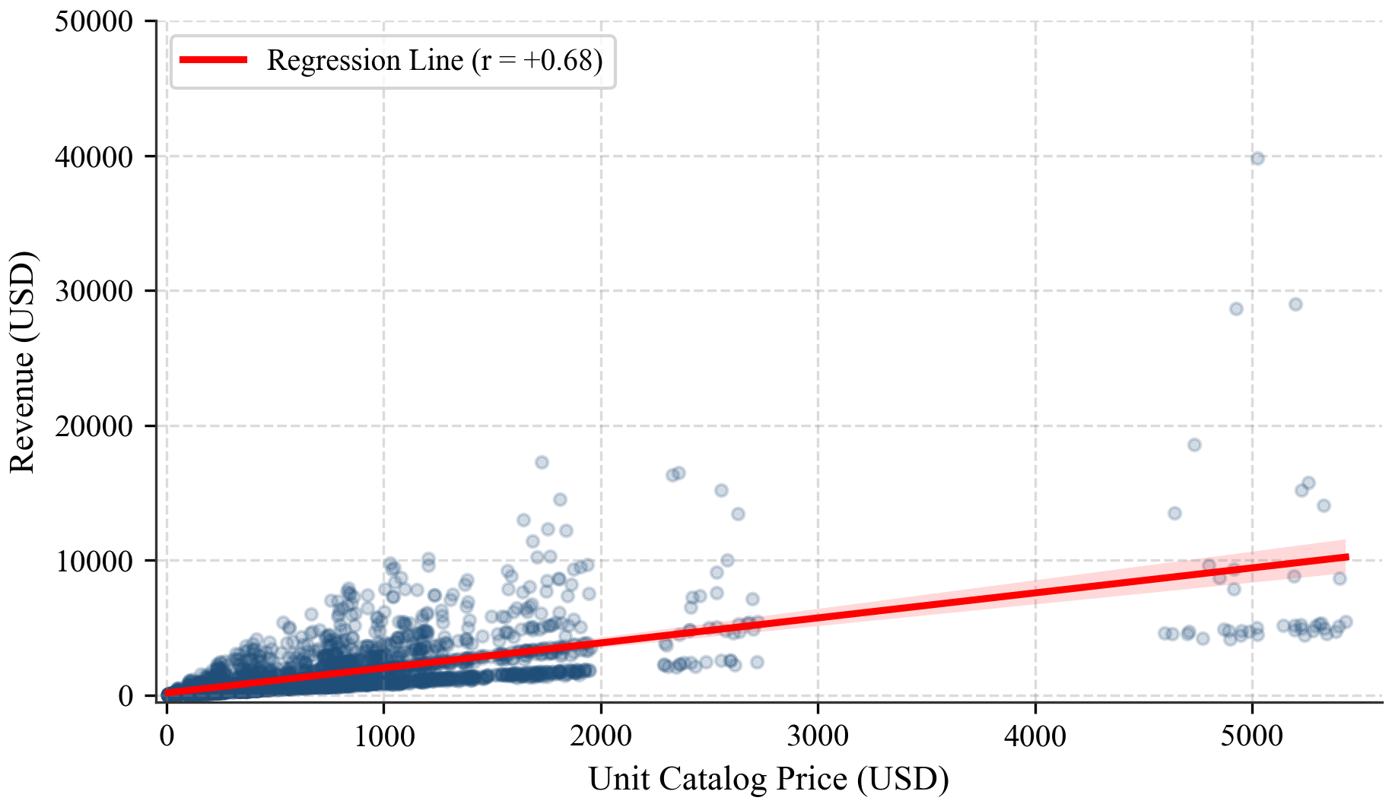
Figure 19: Unit Price vs Revenue (Seaborn Regression Plot)
Observation: The regression line shows a clear positive slope (r = 0.68), confirming that higher unit catalog prices drive higher revenue per transaction.
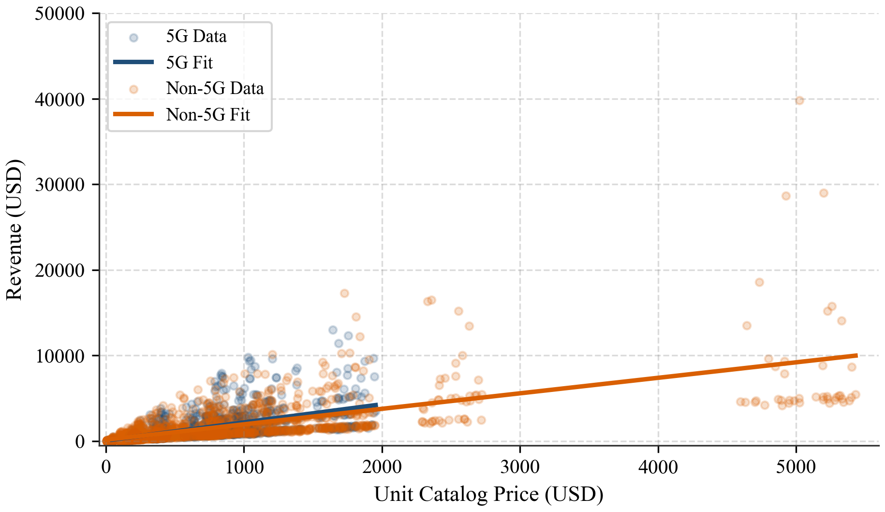
Figure 20: Unit Price vs Revenue Split by 5G (Seaborn lmplot)
Observation: Both 5G and non-5G products show positive regression slopes. The 5G group operates at higher prices and generates higher average order revenue.
Code snippet
# 1. Matplotlib bar chart
df.groupby('category')['revenue_usd'].sum().sort_values().plot(kind='bar')
# 2. Matplotlib line chart
plt.plot(df.groupby('year')['revenue_usd'].sum(), marker='o')
# 3. Scatter plot
plt.scatter(df['discount_pct'], df['revenue_usd'], alpha=0.3)
# 4. Pie chart
df['return_status'].value_counts().plot(kind='pie', autopct='%1.1f%%')
# 5. Seaborn regplot
sns.regplot(data=df, x='unit_price_usd', y='revenue_usd')
6. Statistical Analysis (Basic)
Central tendency and spread. Central tendency and spread describe the center and dispersion of numerical features. Revenue has a mean of $1,478.15 USD and a median of $739.38 USD. Because revenue is right-skewed (skewness 5.62), the median reflects a typical order better than the mean. The average discount is 5.71% (maximum 20%), and the average order quantity is 2.36 units.
Table 8: Central Tendency and Spread of Numeric Features
Attribute | Mean | Median | Standard Deviation
revenue_usd | $1,478.15 | $739.38 | $2,368.69
unit_price_usd | $665.12 | $421.49 | $736.01
units_sold | 2.36 | 2.00 | 1.90
discount_pct | 5.71% | 3.00% | 6.41%
customer_rating | 3.73 | 3.70 | 0.61

Correlation with revenue. Pearson correlation measures the linear relationship between continuous variables on a scale from -1.0 to +1.0. Unit price has a strong positive correlation with revenue (r = 0.68), and units sold has a moderate positive correlation (r = 0.49). Discount percentage shows nearly zero correlation with revenue (r = -0.04), and customer rating has no link to revenue (r = 0.00).
Table 9: Pearson Correlation of Numeric Attributes with Revenue
Variable | Correlation (r) | Meaning
unit_price_usd | 0.68 | Strong positive relationship with revenue.
units_sold | 0.49 | Moderate positive relationship with revenue.
discount_pct | -0.04 | Almost no relationship (slightly negative).
customer_rating | 0.00 | No linear relationship with revenue.

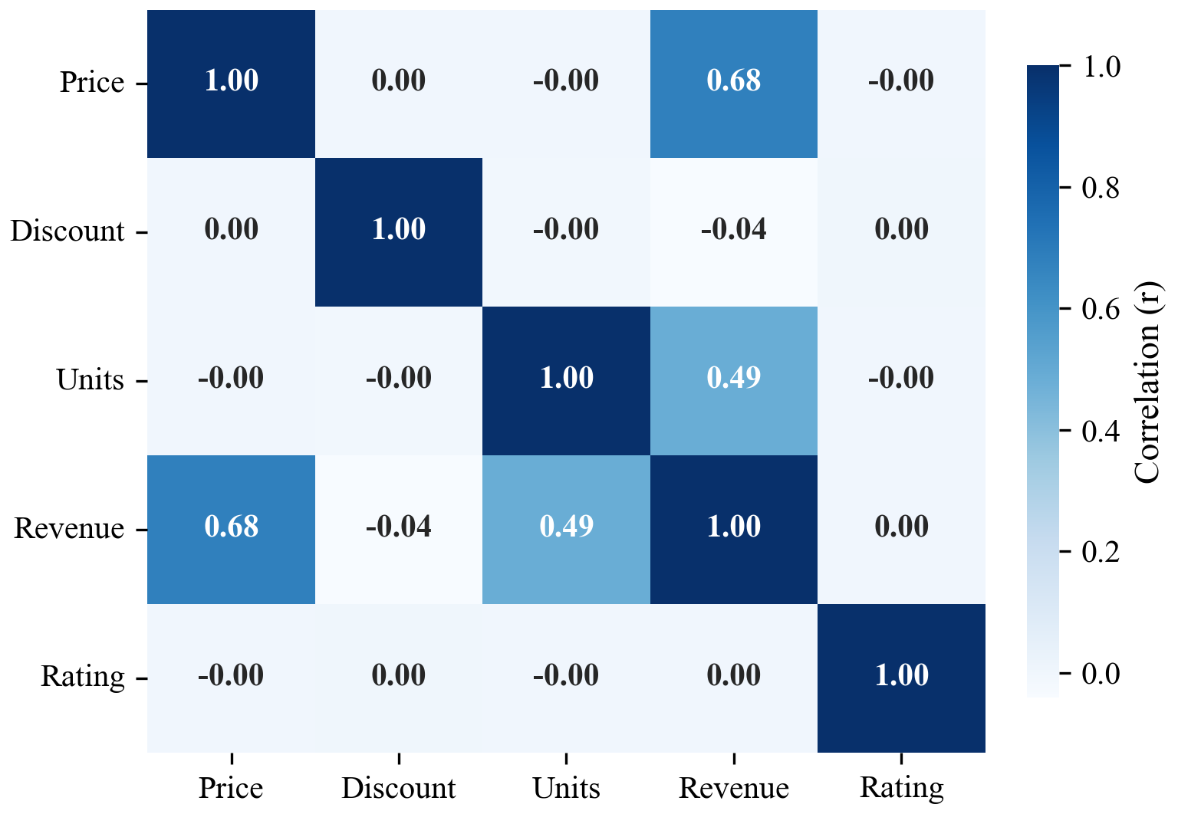
Figure 21: Correlation Matrix Heatmap of Numeric Features
Observation: Unit price (r = 0.68) and units sold (r = 0.49) are the only variables with strong positive links to revenue. Discount and rating have near-zero correlations.
Group comparison (5G vs Non-5G). Comparing 5G and non-5G products shows that 5G devices make up about a third of sales (32.7%) but bring 37.2% of revenue. 5G products earn an average of $1,681.17 per sale compared to $1,379.43 for non-5G products (about $300 more per sale). Part of this difference exists because the non-5G group includes cheaper accessories and monitors.
Table 10: 5G vs Non-5G Hardware Sales Comparison
Group | Sales Count | Total Revenue (USD) | Revenue Share (%) | Avg Revenue per Sale
Non-5G Hardware | 10,429 | $14,386,045.79 | 62.8% | $1,379.43
5G-Capable Hardware | 5,071 | $8,525,213.09 | 37.2% | $1,681.17

One-Way ANOVA tests. One-Way ANOVA tests whether group averages differ significantly. The null hypothesis (H0) states that group means are equal, while the alternative hypothesis (H1) states that at least one group mean is different. Using a 5% significance level (alpha = 0.05), none of the three tests reject H0. In simple words, regions and customer segments differ in total revenue because of order volume, not because transaction sizes differ.
Table 11: One-Way ANOVA Hypothesis Testing Summary
Question Tested | F-Statistic | p-Value | Conclusion
Does average revenue differ across 8 regions? | 0.4105 | 0.8964 | No real difference (Fail to reject H0)
Does average revenue differ across 5 customer segments? | 0.2373 | 0.9174 | No real difference (Fail to reject H0)
Does customer rating differ across 11 categories? | 1.6482 | 0.0867 | No real difference (Fail to reject H0)

Code snippet
# 1. Pearson correlation matrix
corr_matrix = df[['unit_price_usd', 'discount_pct', 'units_sold',
'revenue_usd', 'customer_rating']].corr()
# 2. ANOVA across regions
region_groups = [g['revenue_usd'].values for _, g in df.groupby('region')]
f_reg, p_reg = stats.f_oneway(*region_groups)
# 3. ANOVA across customer segments
seg_groups = [g['revenue_usd'].values for _, g in df.groupby('customer_segment')]
f_seg, p_seg = stats.f_oneway(*seg_groups)
# 4. ANOVA across categories for rating
cat_groups = [g['customer_rating'].dropna().values for _, g in df.groupby('category')]
f_cat, p_cat = stats.f_oneway(*cat_groups)
7. Key Insights & Interpretation
1. Europe and Asia are the core markets: Together they bring $14.64M USD (63.9% of total revenue). Because average revenue per sale is similar everywhere (~$1,480), their lead comes from higher transaction volume rather than larger individual purchases.
2. Smart TVs, Galaxy S, and Galaxy Z drive the money: Smart TVs make $5.56M USD (24.3%), Galaxy S makes $4.73M USD (20.6%), and Galaxy Z adds $2.77M USD (12.1%). Together, these three lines account for 57.0% of total sales, whereas accessories bring only 1.1%.
3. 5G products command higher value per sale: 5G devices bring 37.2% of revenue from 32.7% of sales and earn about $300 more per transaction ($1,681.17 vs $1,379.43). Pushing 5G-capable devices is an effective way to raise average basket size.
4. Discounts have almost no link to revenue: The correlation between discount percentage and revenue is almost zero (r = -0.04). Offering discounts up to 20% does not produce larger orders and likely reduces profit margins without boosting sales.
5. Balanced customer segments and uniform ratings: Sales channels, customer segments, and payment methods are all balanced (~20% per segment, ~14% per channel). Ratings stay near 3.73 stars across all categories, and ANOVA confirms no significant differences. Overall return rate is 9.2%, with Galaxy Z foldables having the highest return rate at 10.9%.
8. Conclusion & Future Scope
This project analyzed 15,500 Samsung sales records from 2021 to 2024 across regions, categories, channels, and customer segments. The main finding is that revenue is driven by product type and order quantity rather than customer demographics or discount size. Europe, Asia, Smart TVs, Galaxy S phones, and 5G products stand out as the primary commercial pillars. Sales were consistent over the four-year period, with a small 3% dip in 2024. For business strategy, stock and marketing should prioritize premium products and high-volume regions, discount policies should be reviewed, and return rates in foldables should be monitored.
Limitations: The dataset has several limitations. It lacks individual customer IDs, household income, and repeat purchase tracking, which prevents customer lifetime value analysis. The balanced distribution across segments and channels also suggests partly synthetic data. In addition, there is no product manufacturing cost or shipping data to calculate profit margins.
Future scope: Future work should expand this analysis in several directions:
• Build sales forecasting models (such as ARIMA or Prophet) to forecast demand by category.
• Incorporate product cost data to evaluate net profit margins rather than gross revenue.
• Develop interactive business intelligence dashboards in Power BI or Tableau.
• Collect customer-level data to study customer retention and repeat purchase behavior.
9. References
1. Ashyou09. (2024). Samsung Global Sales Dataset [Data file]. Kaggle. Retrieved from https://www.kaggle.com/datasets/ashyou09/samsung-global-product-sales-dataset
2. VanderPlas, J. (2016). Python Data Science Handbook: Essential Tools for Working with Data. O'Reilly Media.
3. McKinney, W. (2022). Python for Data Analysis: Data Wrangling with pandas, NumPy, and Jupyter (3rd ed.). O'Reilly Media.
4. Harris, C. R., Millman, K. J., van der Walt, S. J., et al. (2020). Array programming with NumPy. Nature, 585(7825), 357–362. https://doi.org/10.1038/s41586-020-2649-2
5. The pandas development team. (2024). pandas-dev/pandas: Pandas 2.2.0 (Version v2.2.0). Zenodo. https://doi.org/10.5281/zenodo.3509134
6. Hunter, J. D. (2007). Matplotlib: A 2D graphics environment. Computing in Science & Engineering, 9(3), 90–95. https://doi.org/10.1109/MCSE.2007.55
7. Waskom, M. L. (2021). seaborn: statistical data visualization. Journal of Open Source Software, 6(60), 3021. https://doi.org/10.21105/joss.03021
8. Virtanen, P., Gommers, R., Oliphant, T. E., et al. (2020). SciPy 1.0: Fundamental Algorithms for Scientific Computing in Python. Nature Methods, 17(3), 261–272. https://doi.org/10.1038/s41592-019-0686-2
10. AI Tool Usage Declaration
As per Section 4 & 15 of the PBL guidelines, any use of AI tools (e.g., ChatGPT, GitHub Copilot, Google Colab AI, Gemini, Claude) must be transparently declared below.
☐ No AI tools were used in this project.
☑ AI tools were used, as detailed below:
I wrote the first versions of the code and the report myself. I used Claude and Antigravity to help refine them. Claude helped me improve the wording and layout of the report, and Antigravity helped me fix and improve my code. I ran the code and checked all the numbers and results before submitting.
11. Project Links & Deliverables
GitHub Repository Link: https://github.com/anix-works/samsung-global-sales-analysis
Python Notebook (.ipynb) File Name: data_analytics_sales_samsung.ipynb
PBL Report File Name: PBL_Report_Gonaboyina_Vamsi.docx
Confirm that the GitHub repository includes the code, notebook, and a PBL report as required.
☑ GitHub repository includes code, notebook, and a PBL report and README
12. Report Structure Checklist (Section 8 Compliance)
Table 12: Report Structure Checklist (Section 8 Compliance)
S. No. | Report Section (as per Section 8 format) | Included (✓)
1 | Title Page | ✓
2 | Introduction & Problem Statement | ✓
3 | Dataset Description & Source | ✓
4 | Data Cleaning & Preprocessing | ✓
5 | Exploratory Data Analysis (EDA) | ✓
6 | Data Visualization & Observations | ✓
7 | Statistical Analysis (Basic) | ✓
8 | Key Insights & Interpretation | ✓
9 | Conclusion & Future Scope | ✓
10 | References | ✓

13. Declaration by Student(s)
I/We hereby declare that this Mini Project Report is our own original work, prepared using publicly available/open datasets. All sources of data, references, and AI tool assistance have been duly acknowledged. I/We understand that any instance of plagiarism in code or report will attract strict academic action, as per Section 15 of the PBL guidelines.
Team Leader Signature: _____________________________________
Team Member Signature(s): _____________________________________
Date: _____________________________________
14. For Faculty Use Only — PBL Final Report Evaluation
Evaluation Component B — PBL Final Report Submission | Mid-Term (PBL Based): 10 Marks (Section 10 of PBL Guidelines)
Table 13: PBL Final Report Evaluation Scheme
Evaluation Criteria | Max Marks | Marks Awarded
Data Cleaning & Preprocessing | 2
Exploratory Data Analysis (EDA) | 2
Visualization & Observations | 2
Statistical Analysis | 2
Insights, Interpretation & Conclusion | 2
Total (out of 10) | 10

Faculty Remarks:
_____________________________________________________________________________
_____________________________________________________________________________
Faculty Mentor Signature: _____________________________________
Date: _____________________________________

