Week 5: Cloud Deployment on Heroku

Name: Aman Niyaz
Batch Code: LISP01
Submission DateL: 28 March 2021
Submitted to: Data Glacier

Step 1: Added requirements.txt
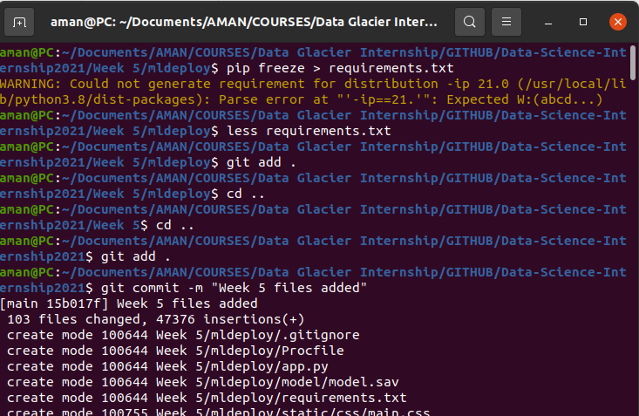

Step 2: Create another branch for Heroku deployment
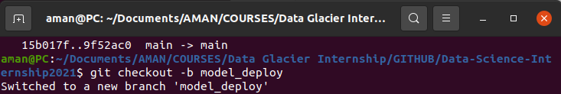
Step 3: Create Procfile for Heroku
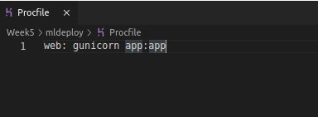

Step 4: Create a new app in Heroku: dublin-house-predict
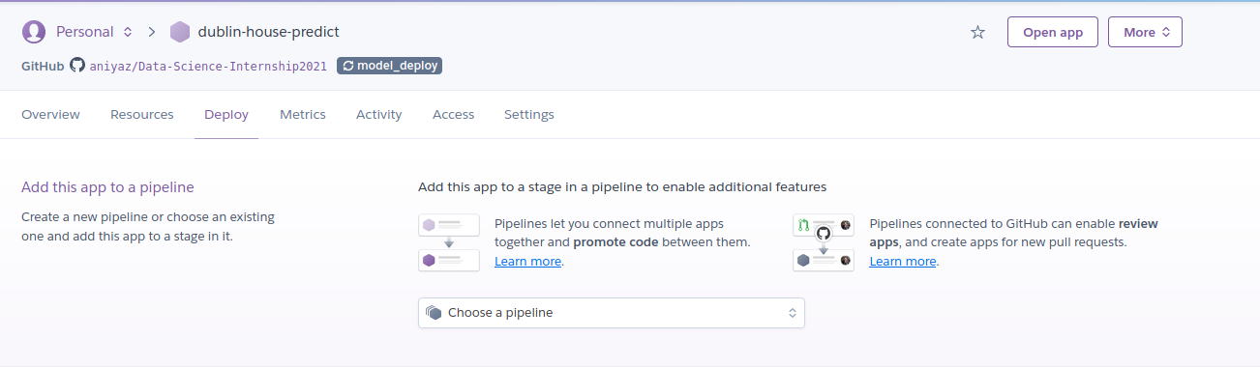
Step 5: Select the repo from Github and select a branch in which application is written and then deploy
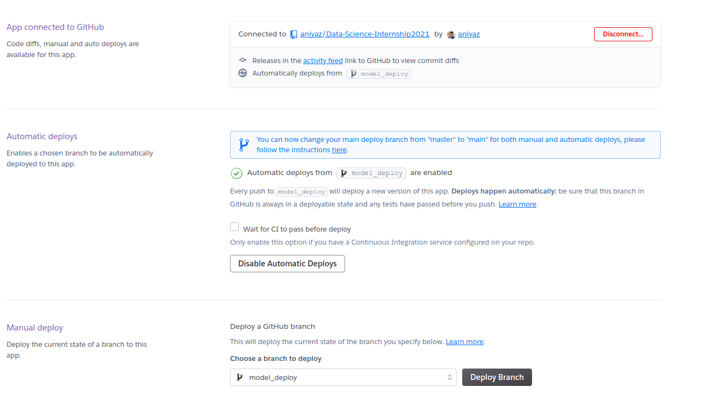
Step6: Heroku install the necessay requirements and then finishes the build and deploy it.
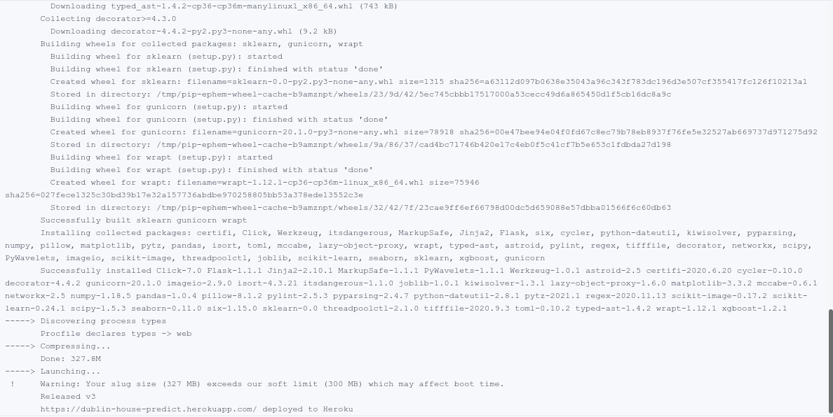

Step 7: Our application is successfully deployed and can be accessed at
https://dublin-house-predict.herokuapp.com/

