HOUSEHOLD APPLIANCES STORE DATABASE MODEL
Descriptions

Author: Ani Zviadauri
Program: EPAM Data Analytics Engineering Mentoring Program SP26
April 2026

CONTENTS
Business Description 3
1.1 The Benefits of Implementing a Database. Project Vision 3
Model Description 3
2.1 Definitions & Acronyms 3
2.2 Logical Scheme 4
2.3 STEP-BY-STEP APPROACH TO MODELLING 6
2.4 COMMENTS ON DESIGN CHOICE 8
2.5 Objects 8

Business Description

1.1 The Benefits of Implementing a Database. Project Vision
The household appliances store database is designed to support the main operations of a store in one organized relational system. In the model, there is information about customers, employees, products, categories, suppliers, sales transactions, transaction items, and procurement activities.
The main benefit of implementing this database is that all important store data is centralized. Instead of keeping product, customer, or transaction information in separate files or spreadsheets, the store can store everything in one consistent system. This improves data quality and also makes the information easier to access, analyze, and maintain.
The database ensures data integrity and consistency by using primary keys, foreign keys, and constraints such as NOT NULL, UNIQUE, CHECK, and ENUM-based restricted values. These rules help to prevent invalid, duplicated, or incomplete data from being inserted into the system. For example, prices cannot be negative, product names cannot be blank, and transaction status can only contain approved values.
The database also preserves historical information because sales transactions and procurement records are stored as separate events. Instead of overwriting previous values, the model keeps records of when sales happened and when goods were delivered. In this way, the system can be used not only for daily operations but also for later analysis.
Scalability is also considered in the design. If the store introduces new products, suppliers, or categories, the structure can support this without major redesign. The same applies if more reporting requirements appear later. Because the schema is normalized and clearly divided into separate entities, future changes can be implemented more easily.
The project vision is to create a reliable database that supports operational processes, keeps data clean, and allows the store to grow while maintaining consistency and structure.

Model Description

2.1 Definitions & Acronyms
Below are key terms that may require clarification for correct understanding of the model:
Customer - a person who purchases products from the store.
Employee - a staff member who processes customer transactions.
Category - a classification used to group products by type.
Supplier - a company or business partner that provides products to the store.
Sales Transaction - a sales event in which one customer buys one or more products.
Sales Transaction Item - a row inside a transaction that represents one specific product and its quantity.
Procurement - a restocking event that records product delivery from a supplier.
City - a lookup table that stores supplier city names separately to avoid repeated city values.
Job Title - a lookup table that stores employee job titles separately to avoid repeated role values.
Brand - a lookup table that stores product brand names.
Product Model - a table that stores model-level information, including model name and warranty months.
3NF - Third Normal Form, a normalization level where all non-key attributes depend only on the primary key.
Even though some of these terms may look straightforward, they can mean slightly different things in different business systems, so it is useful to define them clearly.

2.2 Logical Scheme
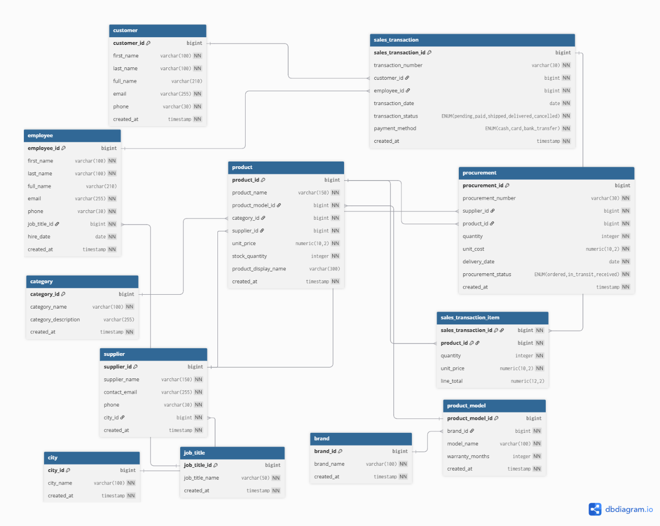
Figure 1. Logical Data Model of the household appliances store database

Modelling decision
One of the main modelling decisions in this project was handling the many-to-many relationship between sales transactions and products. A single sales transaction may include multiple products, and at the same time the same product may appear in many different transactions.
To solve this correctly and keep the model normalized, I introduced the bridge table sales_transaction_item. This table stores the product-level details inside each transaction, such as quantity and price. This design helps maintain 3NF and avoids repeated transaction data.
Preventing data anomalies
The design prevents several common anomalies:
- update anomaly - category and supplier information is stored in separate tables, so if a category or supplier value changes, I only update it once.
- insertion anomaly - I can add a new supplier or category without first having to create a transaction.
- deletion anomaly - deleting one transaction does not remove product, customer, or supplier data from the system.

Scalability of the model
The model is scalable because the entities are clearly separated and linked through keys. If the store later needs to add more product details, discount information, or delivery tracking, this can be done by extending the existing structure instead of rebuilding the whole database.
Future changes that might be expected
The tables most likely to change in the future are product, sales_transaction, and procurement. For example:
- product may later include technical specifications, energy class, or dimensions
- sales_transaction may later include discount or coupon information
- procurement may later include warehouse location or supplier invoice details
Because the schema is normalized, such changes can be introduced with limited impact on the rest of the system.

How normalization to 3NF was achieved
The schema was designed according to Third Normal Form (3NF). To achieve this, I ensured that each table represents one main business entity and that non-key attributes depend only on the primary key of that table.
After feedback, I improved the normalization by separating repeating descriptive values into lookup tables. Employee job titles are stored in the job_title table, supplier cities are stored in the city table, and product brands are stored in the brand table. I also created the product_model table because model and warranty information describe a specific product model rather than the product sale record itself.
This structure prevents repeated text values in multiple rows and makes updates easier. For example, if a brand name or job title needs to be changed, it can be updated in one table instead of being repeated in many records.

Cardinality of Relationships
The relationships reflect the store’s real business logic:
1. one customer can have many sales transactions
2. one employee can process many sales transactions
3. one job title can belong to many employees
4. one city can be related to many suppliers
5. one category can include many products
6. one supplier can supply many products
7. one brand can have many product models
8. one product model can be used by one or more product records
9. one sales transaction can contain many products
10. one product can appear in many sales transactions
11. one supplier and one product can appear in many procurement records
The many-to-many relationship between sales_transaction and product is implemented through sales_transaction_item.

Design assumptions
To simplify the model while keeping it realistic, I made the following assumptions:
1. Each transaction belongs to exactly one customer and one employee.
2. Each employee has one job title, but one job title can be shared by many employees.
3. Each supplier belongs to one city, but one city can have many suppliers.
4. Each product belongs to one category, one supplier, and one product model.
5. Each product model belongs to one brand.
6. Warranty months are stored in product_model because warranty usually depends on the model rather than on each individual product record.
7. Status and method fields use restricted ENUM values because they have a small fixed set of acceptable values.
8. The model represents one store, not a chain of stores.
9. The sales_transaction_item table uses a composite primary key based on sales_transaction_id and product_id. This avoids using both a surrogate key and a separate unique constraint for the same logic.

2.3 STEP-BY-STEP APPROACH TO MODELLING
I approached the modelling process step by step.
Step 1
First, I selected the household appliances store subject area. I decided to model one store rather than a chain of stores because this approach is simpler and more suitable for the scope of the task.
Step 2
Then I selected the main business entities that needed to be stored in the database:
customer, employee, job_title, category, supplier, city, brand, product_model, product, sales_transaction, sales_transaction_item, and procurement.
Step 3
After identifying the entities, I defined the relationships between them. At this stage, I paid special attention to the many-to-many relationship between transactions and products and resolved it through a separate bridge table.
Step 4
I then checked the structure against Third Normal Form. I moved repeating or reusable values into separate lookup tables. For example, job titles, cities, brands, and product models are stored independently and referenced with foreign keys.
Step 5
After the logical model was ready, I selected physical data types. I used:
- BIGINT for identifiers
- VARCHAR for names and text values
- NUMERIC(10,2) for monetary values
- INTEGER for quantities
- DATE and TIMESTAMP for time-related attributes
Step 6
I added primary keys, foreign keys, unique constraints, not null constraints, and check constraints. I also used ENUM types for fields with fixed values such as transaction status, payment method, and procurement status.
Step 7
After that, I created a separate database and schema and then created tables in the correct order: parent tables first and child tables later. This helped avoid foreign key errors.
Step 8. I inserted sample data
Then I inserted sample data for the last three months. I made sure each table had at least six rows and that no surrogate keys were inserted manually.
Step 9
At the end, I created one update function, one transaction insert function, one analytics view, one read-only manager role.
Like that I completed both the operational and reporting parts of the task.

2.4 COMMENTS ON DESIGN CHOICE
Why I used specific constraints
I used a composite primary key in sales_transaction_item because the combination of sales_transaction_id and product_id uniquely identifies each product inside one transaction. This means the same product cannot be repeated twice in the same transaction.
I used check constraints to prevent invalid values. For example:
- quantity cannot be negative
- prices must be positive
- text fields such as product name cannot be blank
- transaction date and delivery date must satisfy the required time rule
I gave each check constraint a meaningful name so that the script remains easy to understand.
Why I used specific data types
I changed created_at to TIMESTAMP in all tables to keep the data type consistent across the schema. TIMESTAMP is more suitable than DATE here because it stores both date and time when a record was created.
- I used NUMERIC(10,2) for prices because monetary values require exact decimal precision.
- I used VARCHAR for text because names, emails, and labels are text values of variable length.
- I used INTEGER for quantity values because they are whole numbers.
Why I used ENUM
I used ENUM for transaction status, payment method, and procurement status because these attributes have small and fixed sets of values. This prevents invalid values from being inserted and keeps data entry consistent.

2.5 Objects
1. Table: customer
Description:
The customer table stores information about people who buy products from the store. Each row represents one customer.
Relationship:
There is a one-to-many relationship between customer and sales_transaction because one customer can make many transactions.
Table Name | Field name | Field Description, constraint | Data Type
customer | customer_id | unique identifier of the customer, PK | BIGINT
 | first_name | customer’s first name, NOT NULL | VARCHAR(100)
 | last_name | customer’s last name, NOT NULL | VARCHAR(100)
 | full_name | generated full name, GENERATED ALWAYS AS STORED | VARCHAR(210)
 | email | customer email, NOT NULL, UNIQUE | VARCHAR(255)
 | phone | customer phone number, NOT NULL, UNIQUE | VARCHAR(30)
 | created_at | record creation timestamp, DEFAULT CURRENT_TIMESTAMP | TIMESTAMP

2. Table: employee
Description:
The employee table stores information about store employees who process sales transactions.
Relationship:
There is a one-to-many relationship between employee and sales_transaction because one employee can process many transactions.
Also, each employee has one job title.
Table Name | Field name | Field Description, constraint | Data Type
employee | employee_id | unique identifier of the employee, PK | BIGINT
 | first_name | employee first name, NOT NULL | VARCHAR(100)
 | last_name | employee last name, NOT NULL | VARCHAR(100)
 | full_name | generated full name, GENERATED ALWAYS AS STORED | VARCHAR(210)
 | email | employee email, NOT NULL, UNIQUE | VARCHAR(255)
 | phone | employee phone number, NOT NULL, UNIQUE | VARCHAR(30)
 | job_title_id | reference to job_title, FK, NOT NULL | BIGINT
 | hire_date | date when employee was hired, NOT NULL | DATE
 | created_at | record creation timestamp, DEFAULT CURRENT_TIMESTAMP | TIMESTAMP

3. Table: category
Description:
The category table stores product categories. I store categories separately to avoid repeating category names in the product table.
Relationship:
There is a one-to-many relationship between category and product because one category can include many products.
Table Name | Field name | Field Description, constraint | Data Type
category | category_id | unique identifier of the category, PK | BIGINT
 | category_name | product category name, NOT NULL, UNIQUE | VARCHAR(100)
 | category_description | description of the category | VARCHAR(255)
 | created_at | record creation timestamp, DEFAULT CURRENT_TIMESTAMP | TIMESTAMP

4. Table: supplier
Description:
The supplier table stores information about companies that provide products to the store.
Relationship:
There is a one-to-many relationship between supplier and product because one supplier can supply many products.
Each supplier belongs to one city.
Table Name | Field name | Field Description, constraint | Data Type
supplier | supplier_id | unique identifier of the supplier, PK | BIGINT
 | supplier_name | supplier company name, NOT NULL, UNIQUE | VARCHAR(150)
 | contact_email | supplier contact email, NOT NULL, UNIQUE | VARCHAR(255)
 | phone | supplier phone number, NOT NULL, UNIQUE | VARCHAR(30)
 | city_id | reference to city, FK, NOT NULL | BIGINT
 | created_at | record creation timestamp, DEFAULT CURRENT_TIMESTAMP | TIMESTAMP

5. Table: product
Description:
The product table stores information about appliances sold in the store. Each product belongs to one category and one supplier and one product model.
Relationship:
There is a many-to-one relationship from product to category, supplier, and product_model.
Table Name | Field name | Field Description, constraint | Data Type
product | product_id | unique identifier of the product, PK | BIGINT
 | product_name | product name, NOT NULL | VARCHAR(150)
 | product_model_id | reference to product_model, FK, NOT NULL | BIGINT
 | category_id | reference to category table, FK, NOT NULL | BIGINT
 | supplier_id | reference to supplier table, FK, NOT NULL | BIGINT
 | unit_price | product selling price, NOT NULL | NUMERIC(10,2)
 | stock_quantity | available stock quantity, NOT NULL, DEFAULT 0 | INTEGER
 | product_display_name | display name of product | VARCHAR(300)
 | created_at | record creation timestamp, DEFAULT CURRENT_TIMESTAMP | TIMESTAMP

6. Table: sales_transaction
Description:
The sales_transaction table stores general transaction information. It represents the transaction header, such as customer, employee, date, status, and payment method.
Relationship:
One customer can have many sales transactions. One employee can process many sales transactions. One sales transaction can include many transaction items.
Table Name | Field name | Field Description, constraint | Data Type
sales_transaction | sales_transaction_id | unique identifier of the transaction, PK | BIGINT
 | transaction_number | business transaction number, NOT NULL, UNIQUE | VARCHAR(30)
 | customer_id | reference to customer table, FK, NOT NULL | BIGINT
 | employee_id | reference to employee table, FK, NOT NULL | BIGINT
 | transaction_date | date of transaction, NOT NULL, DEFAULT CURRENT_DATE | DATE
 | transaction_status | transaction status, NOT NULL | ENUM('pending','paid','shipped','delivered','cancelled')
 | payment_method | payment method, NOT NULL | ENUM('cash','card','bank_transfer')
 | created_at | timestamp when transaction was created, DEFAULT CURRENT_TIMESTAMP | TIMESTAMP

7. Table: sales_transaction_item
Description:
The sales_transaction_item table stores products included in each transaction. This table is a bridge table between sales_transaction and product.
Relationship:
This table resolves the many-to-many relationship between sales transactions and products. One transaction can include many products, and one product can appear in many transactions.
Table Name | Field name | Field Description, constraint | Data Type
sales_transaction_item | sales_transaction_id | reference to sales_transaction table, PK, FK, NOT NULL | BIGINT
 | product_id | reference to product table, PK, FK, NOT NULL | BIGINT
 | quantity | sold quantity, NOT NULL | INTEGER
 | unit_price | product price at sale time, NOT NULL | NUMERIC(10,2)
 | line_total | generated total amount, GENERATED ALWAYS AS quantity * unit_price STORED | NUMERIC(12,2)

8. Table: procurement
Description:
The procurement table stores product restocking records. It shows which supplier delivered which product, quantity, cost, and delivery date.
Relationship:
There is a many-to-one relationship from procurement to supplier and from procurement to product.
Table Name | Field name | Field Description, constraint | Data Type
procurement | procurement_id | unique identifier of procurement record, PK | BIGINT
 | procurement_number | business procurement number, NOT NULL, UNIQUE | VARCHAR(30)
 | supplier_id | reference to supplier table, FK, NOT NULL | BIGINT
 | product_id | reference to product table, FK, NOT NULL | BIGINT
 | quantity | delivered quantity, NOT NULL | INTEGER
 | unit_cost | product cost from supplier, NOT NULL | NUMERIC(10,2)
 | delivery_date | date when products were delivered, NOT NULL | DATE
 | procurement_status | procurement status, NOT NULL | ENUM('ordered','in_transit','received')
 | created_at | timestamp when procurement record was created, DEFAULT CURRENT_TIMESTAMP | TIMESTAMP

9. Table: city
Description:
The city table stores supplier city names separately to avoid repeating the same city value.
Relationship:
One city can be linked to many suppliers.
Table Name | Field name | Field Description, constraint | Data Type
city | city_id | unique identifier, PK | BIGINT
 | city_name | city name, NOT NULL, UNIQUE | VARCHAR(100)
 | created_at | record creation timestamp, DEFAULT CURRENT_TIMESTAMP | TIMESTAMP

10. Table: job_title
Description:
The job_title table stores employee job roles separately to avoid repeating text values.
Relationship:
One job title can belong to many employees.
Table Name | Field name | Field Description, constraint | Data Type
job_title | job_title_id | unique identifier, PK | BIGINT
 | job_title_name | job title name, NOT NULL, UNIQUE | VARCHAR(50)
 | created_at | record creation timestamp, DEFAULT CURRENT_TIMESTAMP | TIMESTAMP

11. Table: brand
Description:
The brand table stores product brand names separately.
Relationship:
One brand can have many product models.
Table Name | Field name | Field Description, constraint | Data Type
brand | brand_id | unique identifier, PK | BIGINT
 | brand_name | brand name, NOT NULL, UNIQUE | VARCHAR(100)
 | created_at | record creation timestamp, DEFAULT CURRENT_TIMESTAMP | TIMESTAMP

12. Table: product_model
Description:
The product_model table stores model-level information, including warranty.
Relationship:
One brand can have many models. One model can be used in products.
Table Name | Field name | Field Description, constraint | Data Type
product_model | product_model_id | unique identifier, PK | BIGINT
 | brand_id | reference to brand, FK, NOT NULL | BIGINT
 | model_name | model name, NOT NULL, unique together with brand_id | VARCHAR(100)
 | warranty_months | warranty period, NOT NULL, DEFAULT 12 | INTEGER
 | created_at | record creation timestamp, DEFAULT CURRENT_TIMESTAMP | TIMESTAMP

