CloudMart E-Commerce Platform
Group Number – 12

1. System Overview
CloudMart is a cloud-native, scalable e-commerce platform that showcases high-performance data processing, multi-cloud interoperability, and contemporary microservices architecture. The system allows users to register, manage a shopping cart, place orders, and search for items using semantic vector search in a generic online marketplace. Because the application is based on a Microservices Architecture, component scalability and loose coupling are guaranteed. It uses Terraform and Infrastructure as Code (IaC) to provision resources across two different cloud providers: GCP (Provider B) for specialised analytics workloads and AWS (Provider A) for core application hosting.
Important characteristics of it:
- Hybrid Database Approach: The system adopts a strategic hybrid data model, leveraging both Relational (SQL) databases for transactional integrity and NoSQL databases for high-velocity, semi-structured data storage to ensure optimal performance.
- Event-Driven Architecture: The platform implements a decoupled, event-driven design by utilizing AWS Lambda for scalable serverless image ingestion and Apache Kafka to facilitate high-throughput, asynchronous order processing between microservices.
- GitOps Deployment: All Kubernetes application lifecycles are managed through a rigorous GitOps workflow using ArgoCD, ensuring that the runtime cluster state is automatically synchronized with the configuration defined in version control.

2. Cloud Deployment Architecture
Terraform is used exclusively for infrastructure provisioning, following industry-standard IaC procedures. In order to show high availability and service interoperability, the deployment spans two cloud providers.
2.1 Provider A: Amazon Web Services (AWS) - Core Infrastructure
The primary workload is hosted on AWS within a custom Virtual Private Cloud (VPC).
- Compute: Amazon EKS (Elastic Kubernetes Service) hosts the stateless microservices.
- Databases:
  - Amazon RDS (PostgreSQL): Stores transactional data (Users, Orders).
  - Amazon DynamoDB: Stores high-throughput, semi-structured session data (Shopping Carts).
  - Amazon OpenSearch Service: Stores vector embeddings for semantic search.
- Storage: Amazon S3 stores raw product images and static frontend assets.
- Messaging: Amazon MSK (Managed Streaming for Apache Kafka) handles event streaming.
- Serverless: AWS Lambda handles asynchronous image processing and embedding generation.
- Frontend Hosting: S3 bucket behind CloudFront CDN for the React application.
2.2 Provider B: Google Cloud Platform (GCP) - Analytics
To satisfy the multi-cloud requirement, the analytics subsystem is hosted on GCP.
- Processing: Google Cloud Dataproc (running Apache Flink) or GKE.
- Function: Consumes order events from AWS MSK via a secure public endpoint/VPN tunnel to perform real-time aggregation (e.g., "Top selling items per minute").

3. Microservices Architecture & Responsibilities
The application comprises six distinct microservices, each responsible for a specific business domain.
3.1 API Gateway (Service 1)
- Technology: Python (FastAPI)
- Responsibility: Acts as the single entry point for the frontend. It handles request routing, composition, and security.
- Key Functions:
  - Validates JWT tokens.
  - Aggregates responses from User, Order, and Search services.
  - Provides a unified REST API to the React Frontend.
3.2 User Service (Service 2)
- Technology: Python (FastAPI)
- Responsibility: Manages user identity and authentication.
- Key Functions:
  - User registration and login (generating JWTs).
  - Password hashing (Bcrypt).
  - Manages the users table in RDS PostgreSQL.
3.3 Search Service (Service 3)
- Technology: Python (FastAPI) + SentenceTransformers (BERT)
- Responsibility: Handles the product catalog and search functionality.
- Key Functions:
  - Performs semantic k-NN vector search using OpenSearch.
  - Provides a fallback text search using SQL (ILIKE) if the vector index is unavailable.
  - Retrieves item details including captions and image URLs.
3.4 Order Service (Service 4)
- Technology: Python (FastAPI)
- Responsibility: Manages the shopping cart and order lifecycle.
- Key Functions:
  - Cart Management: Uses DynamoDB for low-latency read/write of user carts.
  - Order Placement: Moves items from DynamoDB (Cart) to RDS (Orders/OrderItems) in a transactional manner.
  - Event Publishing: Pushes a "Order Placed" event to the orders topic in Kafka for the analytics service.
3.5 Ingestion Service (Service 5 - Serverless)
- Technology: AWS Lambda (Python)
- Responsibility: Asynchronous data processing.
- Trigger: S3 Object Create (Image Upload).
- Key Functions:
  - Triggered when a new item image is uploaded to the raw S3 bucket.
  - Generates a vector embedding for the image/description using a BERT model.
  - Upserts the item metadata and vector into the OpenSearch index.
3.6 Analytics Service (Service 6 - Multi-Cloud)
- Technology: Apache Flink (Java/Python) on GCP Dataproc.
- Responsibility: Real-time business intelligence.
- Key Functions:
  - Consumes the orders topic from AWS MSK.
  - Performs time-windowed aggregation (e.g., Rolling sales count every 1 minute).
  - Writes results to an analytics_results topic.

4. Architecture Diagrams

4.1 System Context Diagram
A high-level overview of the CloudMart platform is given by the System Context Diagram, which shows how external actors interact with the main boundaries of the system. The hybrid cloud architecture is illustrated, emphasising the division of duties between Provider A (AWS) and Provider B (GCP). The flow of data from the end-user's React frontend into the core microservices hosted on AWS via the secure API Gateway is depicted in the diagram. The system's multi-cloud interoperability and decoupled design are further demonstrated by the asynchronous integration with the GCP-hosted analytics engine via Apache Kafka.

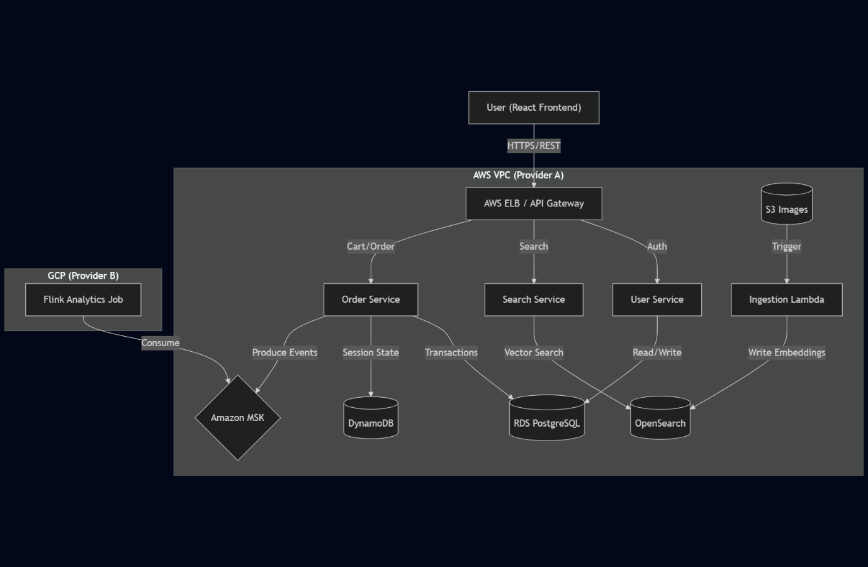

4.2 Infrastructure & Network Diagram (Deployment View)
The physical topology of the application in the AWS cloud environment is described in this Deployment View. It shows how a Virtual Private Cloud (VPC) is used to implement a tiered network security model. To uphold the least privilege principle, the architecture divides resources into separate public and private subnets. Only the Application Load Balancer (ALB) and NAT Gateway, which manage incoming and outgoing traffic, are present in the Public Subnet. The Amazon EKS cluster, which houses the application logic, is protected from direct internet access by the Private Application Subnet. The Private Data Subnet, which is located deepest in the network, protects stateful persistence layers like Amazon RDS, DynamoDB, and MSK and makes sure that only authorised microservices within the VPC can access them.

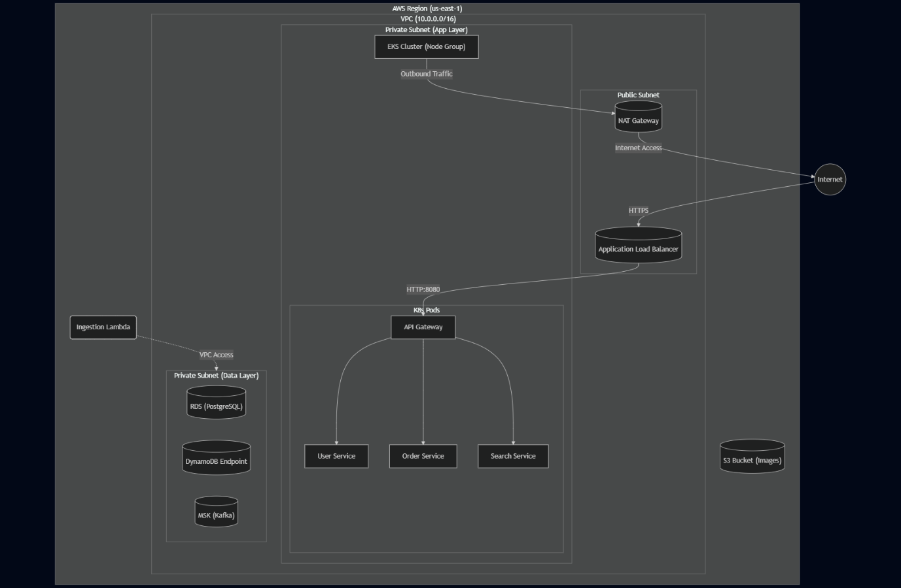

4.3 Microservice Interaction Diagram (Logical View)
The logical connections and communication patterns among the system's distinct components are shown in the Microservice Interaction Diagram. It emphasises the "Database-per-Service" pattern, which is a fundamental component of microservices architecture and ensures loose coupling by allowing each service (User, Order, Search) to retain exclusive ownership of its data store. Managing synchronous REST/HTTP requests from the client, the API Gateway is portrayed as the central orchestrator. The diagram also shows the particular persistence technologies selected for each domain: OpenSearch for specialised vector queries, DynamoDB for high-velocity session data, and PostgreSQL for relational user/order data.

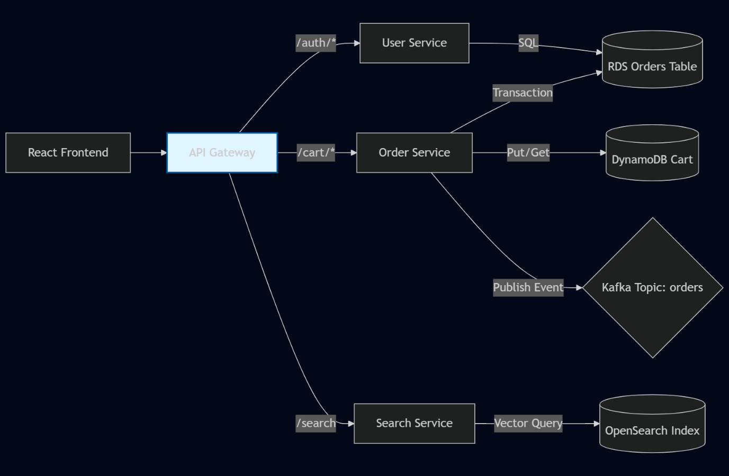

4.4 Sequence Diagram: "Place Order" Flow (Process View)
This Sequence Diagram shows how the system maintains data consistency across dispersed components and offers a thorough chronological view of the "Place Order" business process. A distributed transaction involving several storage engines is depicted in the flow. Ephemeral cart items are first retrieved from the NoSQL cache (DynamoDB). In order to preserve the order record, the system starts an ACID transaction in the SQL database (RDS) after validation. Lastly, by separating the transactional write from real-time processing and publishing an immutable "OrderPlaced" event to the Kafka message bus, the system guarantees eventual consistency for downstream analytics.

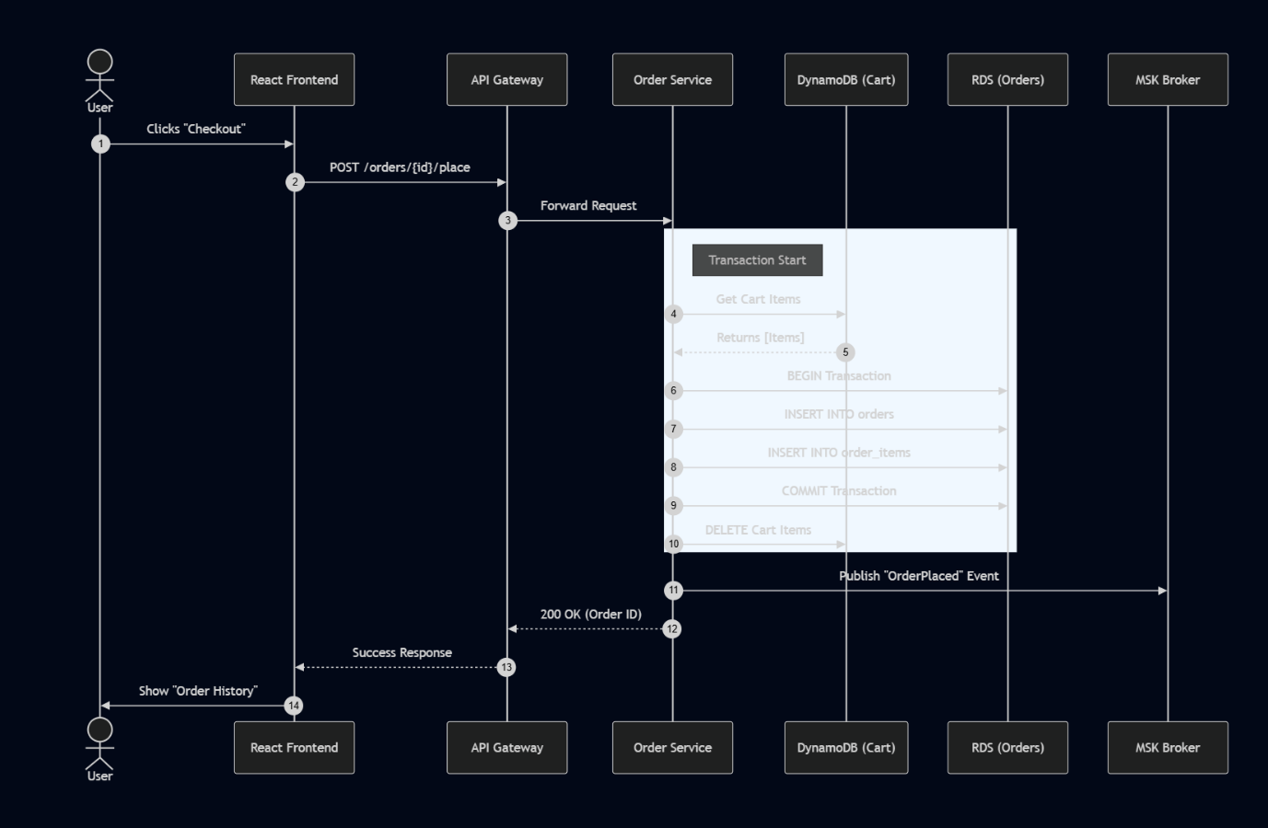

5. Interconnection Mechanisms
5.1 Synchronous Communication (REST/HTTP)
Internal service-to-service communication within the Kubernetes cluster uses REST APIs over HTTP.
- Mechanism: Kubernetes DNS (http://user-service.default.svc.cluster.local).
- Format: JSON payloads.
- Usage: The API Gateway synchronously calls the backend services (User, Search, Order) to fulfill user requests immediately (e.g., Login, Add to Cart).
5.2 Asynchronous Communication (Event Streaming)
To decouple the transaction processing from analytics, the system uses Apache Kafka.
- Mechanism: Amazon MSK.
- Usage: The Order Service acts as a Producer, publishing “OrderPlaced” events. The Analytics Service acts as a Consumer. This ensures that if the Analytics service is down, order processing is not blocked.
5.3 Event-Driven (Triggers)
- Mechanism: AWS S3 Event Notifications.
- Usage: Uploading a file to S3 automatically triggers the Lambda function. This "Fire and Forget" pattern is efficient for heavy tasks like image processing.

6. Rationale Behind Design Choices
6.1 Why Hybrid Database (SQL + NoSQL)?
- RDS (PostgreSQL): Chosen for Order and User information. Strict relational integrity and ACID compliance are necessary for these domains (e.g., an Order Item must belong to a valid Order).
- DynamoDB: chosen for shopping carts. Carts are high-churn, transient data. For session-based data, DynamoDB's key-value architecture enables infinite scaling without the need to manage schemas and single-digit millisecond latency.
6.2 Why Separate Search Service with OpenSearch?
Semantic queries cannot be handled by standard SQL databases (LIKE %query%), and they perform poorly for search relevance. With OpenSearch's k-Nearest Neighbour (k-NN) vector search, users can locate items based on "meaning" (embeddings) instead of just exact keyword matches.
6.3 Why Multi-Cloud (AWS + GCP)?
The ability to avoid vendor lock-in and make use of "Best of Breed" services (such as Google's robust data analytics ecosystem) is demonstrated by offloading Analytics to GCP, even though AWS hosts the core application for data locality.
6.4 Why GitOps (ArgoCD)?
Applying kubectl commands directly lacks an audit trail and is prone to errors. ArgoCD makes sure that the configuration in the Git repository always corresponds to the cluster's current state. It offers self-healing, automated syncing, and simple rollbacks—all essential for contemporary DevOps workflows.
6.5 Why Managed Services (RDS, MSK, EKS)?
Operational overhead (patching, backups, high availability setup) is decreased by using managed services. This frees up the team to concentrate on application logic (FastAPI/React) instead of database management.

