CYBERSECURITY INTERNSHIP
Week 2 Task
Virtual Security Incident Response Simulation
Incident response plan and post-incident analysis for a simulated phishing-to-ransomware breach
Prepared by | Anjali Kumari
GitHub | https://github.com/anjal-iiii
Report date | 2 October 2026
Classification | Educational simulation - isolated virtual lab only
Frameworks used | NIST SP 800-61, SANS PICERL, MITRE ATT&CK, Cyber Kill Chain, ISO/IEC 27035

Contents and Document Control
Section | Title | What it covers
1 | Executive Summary | What happened, how it was handled, key metrics
2 | Introduction, Scope and Ethics | Simulation design, safety rules, assumptions
3 | Frameworks and Real-World Background | NIST, SANS, ISO 27035 and four famous incidents
4 | Scenario and Environment | Lab network, assets, starting conditions
5 | Detection and Analysis | Indicators of compromise, attack path, scope
6 | Incident Response Plan | Roles, severity matrix, playbook by phase
7 | Simulated Response Log | Containment, eradication and recovery actions
8 | Post-Incident Analysis | Root cause, gap analysis, metrics, cost
9 | Lessons Learned and Prevention | Changes to the security framework with roadmap
10 | Appendices and References | Checklists, templates, sources

Document control
Item | Detail
Document | Week 2 - Virtual Security Incident Response Simulation (plan and post-incident report)
Version | 1.0 (final for submission)
Environment | Isolated virtual lab; adversary activity generated with benign simulation tools and marker files
Frameworks | NIST SP 800-61 (Computer Security Incident Handling Guide), SANS PICERL, MITRE ATT&CK, Lockheed Martin Cyber Kill Chain
Audience | Management (Sections 1, 8, 9), SOC and IT (Sections 5-7)

Authenticity note
The incident, timings, indicators and costs in this document are a designed simulation used to practise response. Domains and IP addresses are reserved documentation values (for example the 203.0.113.0/24 range) and no real malware was used. Replace the illustrative panels with your own screenshots and log excerpts from your lab run so the evidence reflects work you actually did.

1. Executive Summary
This report documents a simulated ransomware-style intrusion against NorthStar Retail, a fictional online retailer with about 200 staff. The scenario starts with a targeted phishing email containing a macro-enabled invoice and ends with encryption markers appearing on the company file server. The attacker spent roughly 39 hours inside the network before being detected, moved from one workstation to the file server using stolen credentials, and copied about 2.1 GB of data to an external cloud storage service before launching the simulated encryption stage.
Detection finally came from a SIEM correlation rule triggered by mass file renames. The response team declared an incident within 38 minutes of the alert, isolated the affected network segment within one hour and three minutes of detection, eradicated the attacker's access in about 18 hours and restored services from clean backups by the fourth day. No evidence of data loss through encryption remained after recovery, but the earlier data copy had to be treated as a confirmed data breach, which triggers notification duties.
Metric | Result | Target after improvements
Dwell time before detection (MTTD) | 39.3 hours | under 4 hours
Time from detection to containment (MTTC) | 1.1 hours | under 30 minutes
Time to eradicate (MTTE) | 17.9 hours | under 8 hours
Time to recover services (MTTR) | 55.9 hours | under 24 hours
Systems affected | 3 of 24 servers and workstations (WKS-07, FS-01, DC-01 credentials exposed) | -
Data exfiltrated | about 2.1 GB (HR and finance shares) | 0
Modelled business impact | about USD 130,500 | -

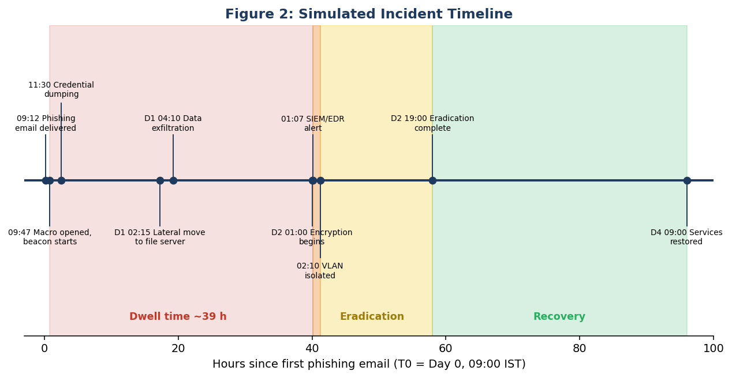
Figure 2 (preview): simulated incident timeline

Key conclusions
- Detection was the weakest phase. Early warning signs (a macro spawning PowerShell, an LSASS access alert) existed but were not correlated or triaged.
- Containment worked well once started because the team had pre-approved authority to isolate network segments.
- Backups saved the recovery, but only one of four test restores had ever been performed before the incident.
- The root cause was a chain, not a single failure: weak email filtering, macros allowed, shared local admin passwords and flat network access to file shares.

2. Introduction, Scope and Ethics

2.1 Why incident response matters
Prevention will never be perfect. Sooner or later an attack gets through a control, a person makes a mistake or a new vulnerability appears before a patch. Incident response (IR) is the discipline that decides how well an organisation performs on that bad day. Well-prepared teams find problems sooner, limit the damage and recover faster, and the difference in cost is large. IBM's Cost of a Data Breach report has consistently found that organisations with tested IR plans and teams pay noticeably less per breach, and that breaches take on the order of 250 days on average to identify and contain when no special measures exist.

2.2 Objectives
- Understand the breach scenario, its context and its impact.
- Identify indicators of compromise (IoCs) and the likely source and method of attack.
- Produce a step-by-step response plan based on NIST and SANS.
- Carry out a simulated response and document every action.
- Analyse gaps, record lessons learned and propose improvements.

2.3 Simulation design
The attacker behaviour was generated with benign adversary-emulation tools such as Atomic Red Team test cases and MITRE Caldera in an isolated virtual network. These tools run harmless equivalents of real techniques: for example, a test that touches the same Windows APIs a credential dumper would use, a script that creates and renames a set of dummy files to mimic ransomware activity, and a transfer of a synthetic data set to a lab-hosted server standing in for cloud storage. Detections therefore fire as they would in real life, but no real malware, customer data or external system is involved.

2.4 Rules and safety controls
- Host-only virtual network; no route to the internet; VM snapshots taken before the exercise.
- Only synthetic data. File names and contents were generated for the exercise.
- Every simulated attacker action was written to a control log, so analysts later could compare what was done with what was detected.
- A named exercise controller held authority to stop the exercise at any time.

2.5 Assumptions
- The company has no 24x7 SOC; alerts are read during working hours and by one on-call engineer.
- Endpoint protection (EDR) is installed but its Office-macro rules are in audit mode only.
- Regulatory notification applies (personal data of employees was in the copied files).

3. Frameworks and Real-World Background

3.1 NIST SP 800-61 lifecycle
NIST's Computer Security Incident Handling Guide describes incident response as a lifecycle with four phases: Preparation; Detection and Analysis; Containment, Eradication and Recovery; and Post-Incident Activity. The phases form a cycle because lessons from one incident improve preparation for the next. The newer revision of the guide (Rev. 3, 2025) aligns incident response with the NIST Cybersecurity Framework 2.0 and treats it as part of overall risk management, but the practical flow remains the same.
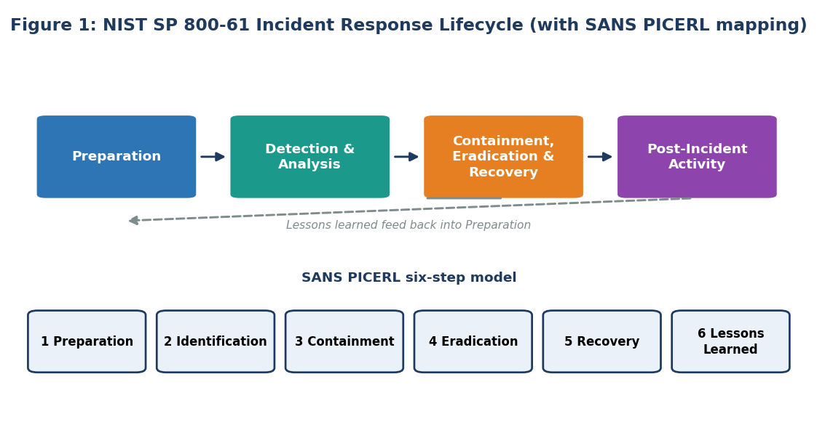
Figure 1: NIST SP 800-61 lifecycle with the six SANS PICERL steps

3.2 Comparing frameworks
Framework | Phases | Best used for
NIST SP 800-61 | Preparation; Detection and Analysis; Containment, Eradication, Recovery; Post-Incident | Common baseline, referenced by regulators
SANS PICERL | Preparation, Identification, Containment, Eradication, Recovery, Lessons Learned | Practical, step-by-step playbooks
ISO/IEC 27035 | Plan and prepare; detect and report; assess and decide; respond; lessons learned | Organisations certified to ISO 27001
MITRE ATT&CK | Describes adversary tactics and techniques | Mapping what the attacker did and what to detect
Cyber Kill Chain | Seven attack stages from recon to objectives | Finding the best place to break an attack

This report uses NIST SP 800-61 for the overall structure, SANS PICERL for the step-by-step plan, and ATT&CK with the Kill Chain for analysis.

3.3 Four real incidents and what they teach
Real-world case: Target, 2013
Security tools did raise alerts about the malware being installed, but they were not acted on in time, and attackers collected payment card data for weeks. Lesson: detection that nobody triages is not detection. This is the weakness found in our simulation.

Real-world case: Maersk and NotPetya, 2017
A destructive worm spread through the shipping company's global network, wiping tens of thousands of computers. Recovery was possible only because one domain controller in a remote office happened to be offline during a power cut and held a clean copy of Active Directory. Maersk reported losses of about USD 200-300 million. Lesson: protect and test backups of identity systems, and plan for total loss of the network.

Real-world case: Colonial Pipeline, 2021
Attackers entered through a legacy VPN account protected only by a password, deployed ransomware and forced the company to halt pipeline operations for several days as a precaution. A ransom was paid and part of it was later recovered by US authorities. Lesson: MFA on remote access and a decision process for isolating operational systems that was agreed before the crisis.

Real-world case: Uber, 2022
An attacker obtained a contractor's credentials and repeatedly triggered MFA prompts until an employee approved one, then found administrative secrets on an internal share. Lesson: use phishing-resistant MFA and keep secrets out of file shares and scripts.

4. Scenario and Environment

4.1 Scenario brief
On a Monday morning a finance employee received an email that appeared to come from a regular supplier and contained an invoice document. The document asked the recipient to enable macros to view the content. The next two days of events are not known to the staff; the response team learns about them only through logs after the alert on Wednesday at 01:07.

4.2 Environment
Asset | Role | Notes
WKS-07 | Finance workstation (patient zero) | Office macros allowed; user is local admin
WKS-12 | Marketing workstation | Not compromised; used as a control
FS-01 | File server with HR and finance shares | Same local admin password as WKS-07
DC-01 | Active Directory domain controller | Credentials exposed on WKS-07 session
DB-01 | Order database | Not reached
WEB-01 | Public e-commerce server in DMZ | Not reached
Wazuh SIEM | Central logs | Receives endpoint and firewall logs
pfSense | Firewall | Allows all outbound HTTPS

4.3 Security posture at the start
Area | State at start | Why it matters
Email security | Basic spam filter, no attachment sandbox | Macro document delivered
Endpoints | EDR in audit mode for Office macro rules | Execution not blocked
Accounts | Users are local administrators; shared local admin password | Easy privilege escalation and spread
Network | Flat internal network, SMB open between all hosts | Lateral movement unimpeded
Egress | All outbound HTTPS allowed | Data leaves unnoticed
Logging | Logs collected but no correlation rules for the attack chain | Alerts missed
Backups | Nightly backup, one restore test in the last year | Recovery uncertain
IR plan | One-page contact list, no playbooks | Slow and unstructured start

5. Detection and Analysis

5.1 How the incident was detected
The first alert that reached a human was a high-severity SIEM correlation at 01:07 on Wednesday: more than 500 files had been renamed with an unknown extension within two minutes on FS-01, followed by deletion of volume shadow copies. The on-call engineer triaged the alert at 01:20, confirmed the activity on the server console and escalated to the incident commander, who declared a formal incident at 01:45. Earlier signals existed in the logs but none had produced an alert that anyone read.
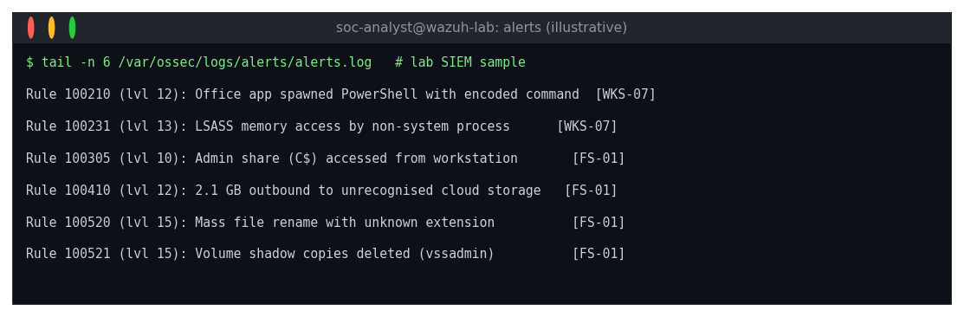
Figure 11: SIEM alerts relevant to the incident (illustrative lab output)

5.2 Indicators of compromise
An indicator of compromise is an observable artefact that suggests that a system has been breached. IoCs are collected during analysis and then used for scoping (finding other affected systems) and for eradication (blocking and removing them). Values below use reserved documentation addresses and defanged domains.
Type | Indicator (lab values) | Source | Meaning
Email | Subject: Overdue invoice 4471; sender domain supplier-billing[.]example | Mail gateway | Phishing delivery
File | Invoice_4471.docm (macro-enabled) | EDR | Initial payload
Process | WINWORD.EXE spawning powershell.exe -enc ... | EDR | Macro execution
Network | HTTPS beacon to 203.0.113.45 every 60 s with jitter | Firewall, DNS | Command and control
Domain | update-cdn[.]example | DNS logs | C2 domain
Registry | HKCU\...\Run entry named WinUpdateSvc | EDR | Persistence
Account | Local admin used on FS-01 from WKS-07 at 02:15 | Windows event 4624 | Lateral movement
Process | Access to LSASS memory by a non-system process | Sysmon event 10 | Credential dumping
Network | 2.1 GB outbound to 198.51.100.77 (cloud storage lookalike) | Firewall | Exfiltration
File | Mass renames with .locked extension; ransom note README_RESTORE.txt | FS-01 logs | Encryption stage
Command | vssadmin delete shadows | Event logs | Backup destruction

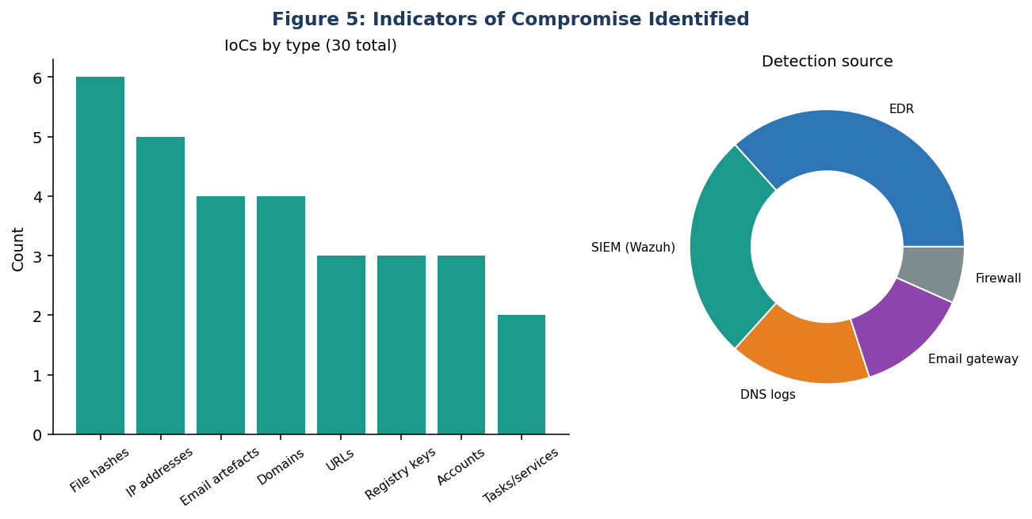
Figure 5: indicators of compromise by type and detection source

5.3 Attack analysis: kill chain and ATT&CK
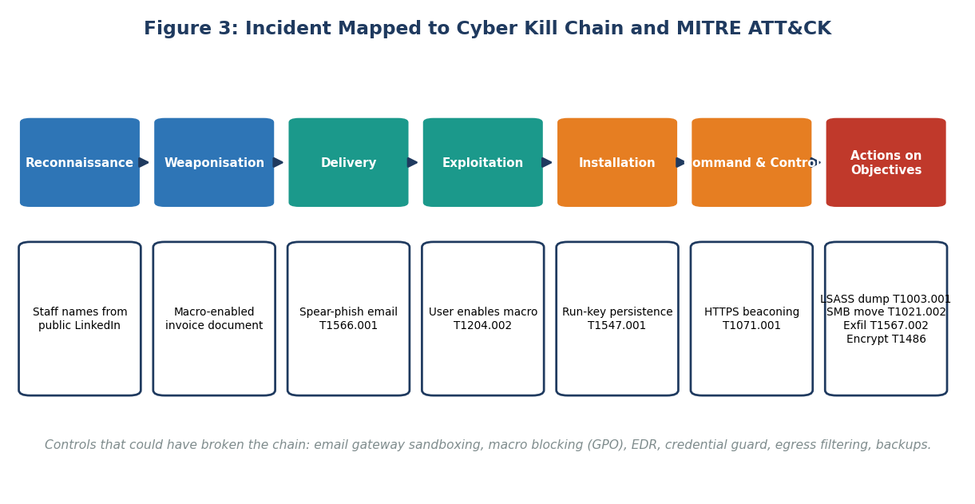
Figure 3: incident mapped to Cyber Kill Chain stages and ATT&CK techniques
Tactic | Technique (ID) | Evidence in lab
Initial Access | Phishing: Spearphishing Attachment (T1566.001) | Email with .docm attachment
Execution | User Execution: Malicious File (T1204.002); PowerShell (T1059.001) | Word spawning PowerShell
Persistence | Registry Run Keys (T1547.001) | WinUpdateSvc entry
Defense Evasion | Obfuscated Files or Information (T1027); Masquerading (T1036) | Encoded command; look-alike service name
Credential Access | OS Credential Dumping: LSASS Memory (T1003.001) | Sysmon event 10
Discovery | Network Share Discovery (T1135); Account Discovery (T1087) | Share enumeration from WKS-07
Lateral Movement | Remote Services: SMB/Windows Admin Shares (T1021.002) | C$ access to FS-01
Collection | Data Staged: Local Data Staging (T1074.001) | Archive created in temp folder
Command and Control | Application Layer Protocol: Web (T1071.001) | HTTPS beaconing
Exfiltration | Exfiltration to Cloud Storage (T1567.002) | 2.1 GB outbound
Impact | Data Encrypted for Impact (T1486); Inhibit System Recovery (T1490) | Renames and shadow copy deletion

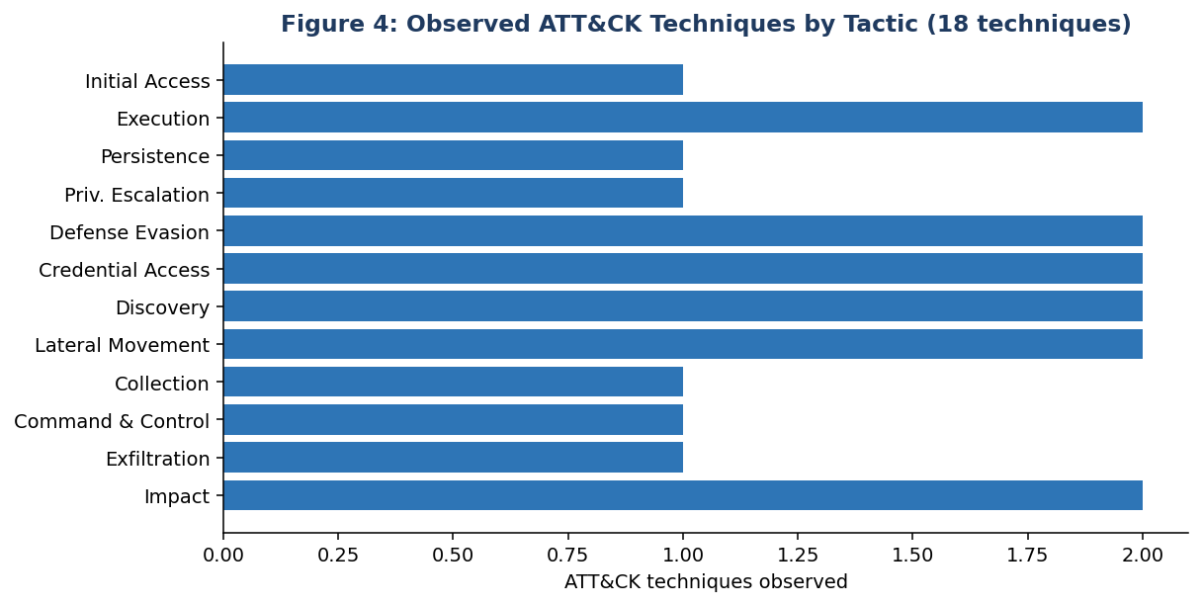
Figure 4: ATT&CK techniques observed by tactic

5.4 Determining scope
Scoping answered three questions: which systems did the attacker touch, which accounts are compromised and what data left the network. The team searched for each IoC across all endpoint and network logs, listed every host with a match and then validated each by looking at process and authentication history. The result was three affected systems (WKS-07, FS-01 and DC-01 where credentials had been exposed but no changes were found), four accounts to reset (the finance user, two local administrators and one service account) and one confirmed data transfer.

5.5 Severity classification
The incident was classified Severity 1 (Critical) because it combined confirmed data exfiltration, active encryption of business data and domain credentials exposure.

6. Incident Response Plan
The plan below is the document that NorthStar Retail should have had before the incident. It follows SANS PICERL and is written so that a tired person at 01:00 can follow it.

6.1 Team roles
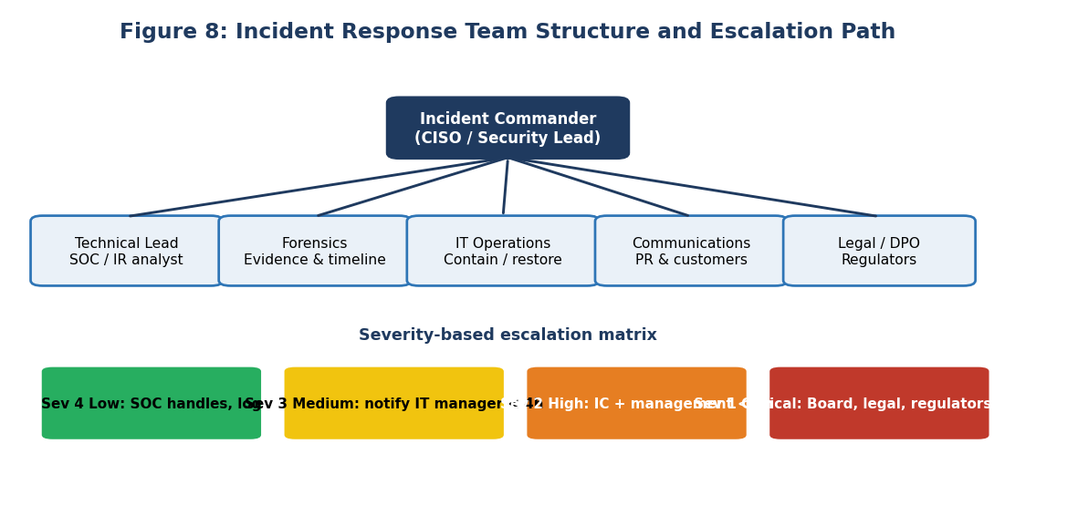
Figure 8: incident response team structure and severity-based escalation
Role | Responsibility | Primary / backup
Incident Commander | Owns decisions, approves containment and communications | CISO / IT Director
Technical Lead | Directs analysis and technical response | Senior security analyst / sysadmin
Forensics | Preserves evidence, builds timeline | Security analyst / external DFIR retainer
IT Operations | Executes isolation, rebuilds and restores | Infrastructure lead / network engineer
Communications | Staff, customer and media messaging | Marketing head / HR
Legal and Privacy | Regulatory notification, contracts, evidence rules | Legal counsel / Data Protection Officer
Scribe | Keeps the time-stamped incident log | Any trained team member

6.2 Severity and escalation matrix
Severity | Definition | Notify | Response time
4 Low | Single endpoint, no sign of spread | SOC | Next business day
3 Medium | Malware on several endpoints, no data loss | IT manager | 4 hours
2 High | Server compromise or suspected data access | IC and management | 1 hour
1 Critical | Confirmed exfiltration, encryption or domain compromise | Executive team, legal, DPO, cyber insurer | 30 minutes

6.3 Playbook by phase

Phase 1: Preparation (before any incident)
- Maintain contact tree, decision authority and an out-of-band communication channel (assume email may be compromised).
- Build baseline logging: endpoint, DNS, authentication, firewall and email logs to one SIEM.
- Keep a trained team, a jump bag of tools and a retainer with an external forensics firm.
- Hold backups offline or immutable, and test restores quarterly.
- Run tabletop exercises twice a year.

Phase 2: Identification
- Validate the alert; record the time, source and who saw it first.
- Decide severity using the matrix; start the incident log.
- Collect volatile evidence before changes (memory, network connections, running processes).
- Hunt for the same IoCs on all systems to find scope.

Phase 3: Containment
- Short term: isolate affected hosts from the network (EDR isolate, VLAN quarantine); do not power off unless imaging is impossible, as memory evidence is lost.
- Disable compromised accounts and revoke sessions; block C2 domains and IPs at DNS and firewall.
- Long term: apply temporary segmentation rules and increase logging while clean systems are prepared.

Phase 4: Eradication
- Remove persistence (run keys, scheduled tasks, services); rebuild rather than clean heavily compromised hosts.
- Reset all exposed credentials, including service accounts; rotate the KRBTGT account twice if domain compromise is possible.
- Patch the entry vector and verify with scanning.

Phase 5: Recovery
- Restore from known-good backups, scan restored data before reconnecting.
- Return systems in priority order, monitor closely for 14 days for re-infection.
- Confirm business owners accept the restored service.

Phase 6: Lessons learned
- Hold a blameless review within two weeks.
- Update plan, detections and controls; track each action to completion.

6.4 Ransomware decision points
Decision | Questions | Rule agreed in advance
Isolate production systems? | Is encryption actively spreading? | Yes if spreading; commander may authorise without further approval
Pay a ransom? | Are backups viable? Are payments legal? Is data stolen too? | Not paid by default; board and legal decision, with law-enforcement advice
Notify regulators and customers? | Was personal data accessed or exfiltrated? | Notify within the legal deadline, for example 72 hours under GDPR; DPDP Act and sector rules also apply
Engage external help? | Is internal capability sufficient? | Call the DFIR retainer for any Severity 1

6.5 Evidence handling
Evidence must be preserved in a way that would stand up to scrutiny. Each item is given an ID, hashed with SHA-256, recorded in a chain-of-custody log (who, when, why) and stored read-only. Working is done on copies. A disk image is taken of FS-01 and WKS-07 before rebuild.

7. Simulated Response Log
The table records the actions performed during the simulated response, in the order they happened, along with the reason. Times use the exercise clock.
Time | Phase | Action | Reason
D2 01:07 | Identification | SIEM alert for mass renames on FS-01 | Trigger
01:20 | Identification | On-call analyst confirms activity on server and calls the commander | Validate; avoid false alarm
01:45 | Identification | Incident declared Severity 1; scribe starts the log | Formalise authority
01:50 | Identification | Memory and process list captured from FS-01; hash recorded | Preserve volatile evidence
02:10 | Containment | Quarantine VLAN 999 created; FS-01 and WKS-07 moved there; EDR isolation applied | Stop spread
02:20 | Containment | Finance user, two local admin accounts and a service account disabled | Cut attacker access
02:30 | Containment | C2 domain and IP blocked at DNS and firewall; egress allowed only to approved destinations | Stop exfiltration and remote control
03:00 | Analysis | IoC sweep across 24 systems; WKS-07 identified as patient zero from email and process logs | Establish scope
04:30 | Analysis | Data transfer volume computed from firewall logs: about 2.1 GB to external storage | Quantify breach
06:00 | Management | Legal and DPO informed; notification clock noted | Regulatory duty
08:00 | Eradication | Disk images taken; WKS-07 reimaged; run-key and scheduled task persistence documented | Preserve then clean
11:00 | Eradication | Domain-wide password reset for exposed accounts; KRBTGT reset (first of two) | Remove stolen credentials
14:00 | Eradication | Shared local admin password replaced with unique, managed passwords (LAPS) | Remove root cause
19:00 | Eradication | Sweep repeated; no IoCs remaining; second KRBTGT reset after replication interval | Verify clean
D3 08:00 | Recovery | FS-01 rebuilt; data restored from the last backup before the intrusion (D0 02:00) | Known-good state
D3 14:00 | Recovery | Restored files scanned; integrity checked against catalogue | Avoid re-introducing malware
D4 09:00 | Recovery | Services restored to users; enhanced monitoring for 14 days | Return to business
D5 | Closure | Staff briefing, customer and regulator notifications issued, lessons-learned meeting scheduled | Close and learn

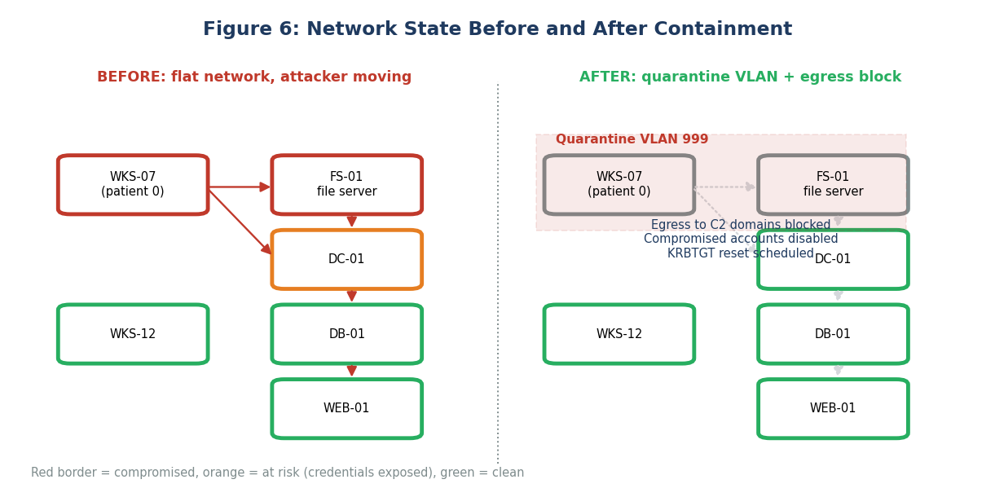
Figure 6: network state before and after containment

7.1 Key decisions and justification
- Isolate instead of power off: isolation stopped network spread but kept memory for forensics.
- Restore from the backup before the intrusion: the backup from D0 02:00 predates the phishing email, so no attacker access was restored with it. Files created on D0-D2 were recovered from user copies.
- No ransom discussion: data was recoverable, and paying would not delete the stolen data.
- Out-of-band communications: the team used a phone bridge because email might be read by the attacker.

7.2 Communication log
Audience | Message | When
Executive team | Severity 1 incident; containment in progress; business impact on file services | 02:30
All staff | Do not use the file server; do not open unexpected attachments; password reset instructions | 09:00
Regulator and DPO | Notification of personal-data breach (HR files) | Within 72 hours
Affected employees | What data, risks, what the company is doing, free credit monitoring where appropriate | D5
Customers | Statement that customer systems were not affected | D5

8. Post-Incident Analysis

8.1 Root cause analysis
A 5-Whys analysis traces the incident from symptom back to cause.
Why | Answer
1 Why was data encrypted and stolen? | The attacker had domain-level access to the file server for 24 hours before encryption.
2 Why could the attacker reach the file server? | Local administrator credentials were identical on workstations and the server, and SMB was open to all internal hosts.
3 Why did a workstation compromise exist? | A user opened a macro-enabled attachment and macros were allowed to run.
4 Why did the attachment reach the user? | The email filter had no sandboxing and the EDR macro rule was audit-only.
5 Why was the attacker not detected for 39 hours? | No detection rules existed for the attack chain, and alerts on PowerShell and LSASS access were not triaged by anyone.

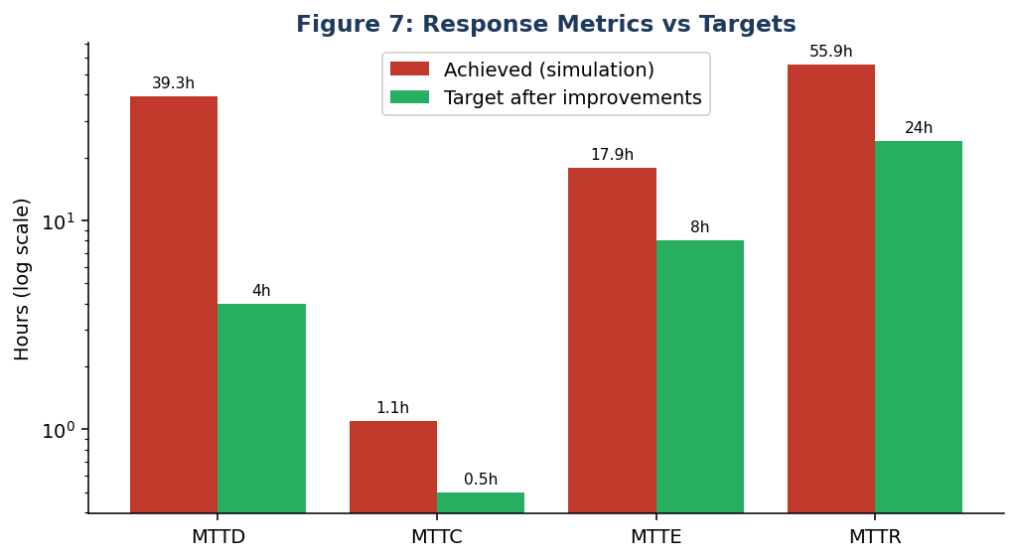
Figure 7: response metrics achieved versus targets

8.2 What went well and what did not
Went well | Needs improvement
Fast triage after the alert (13 minutes) | 39 hours of undetected dwell time
Commander had authority to isolate | No playbook; steps decided on the fly
Evidence preserved before rebuild | Only one test restore of backups in a year
Clear external communication | Shared admin passwords and local admin rights for users
Backup predated the intrusion | No alert correlation across email, endpoint and network

8.3 Gap analysis against the initial security set-up
Control area | Gap found | Recommended improvement | Priority
Email | No sandbox, macros delivered | Attachment sandboxing; block macros from the internet by policy | High
Endpoint | EDR rules in audit mode; users are local admins | Move rules to block mode; remove local admin rights | Critical
Identity | Shared local admin password; exposed domain credentials | LAPS; tiered admin accounts; credential guard | Critical
Network | Flat network; SMB open | Segmentation; block workstation-to-workstation SMB | High
Egress | All HTTPS allowed outbound | Egress filtering, DNS filtering, alert on large uploads | High
Detection | No correlation rules, no 24x7 monitoring | Use-case library mapped to ATT&CK; managed detection service or on-call rota | Critical
Backups | Untested restores | Immutable offline copies; quarterly restore tests | High
IR readiness | No playbooks or exercises | Adopt this plan; run tabletop twice a year | Medium
Awareness | No phishing simulation | Monthly simulations and reporting button | Medium

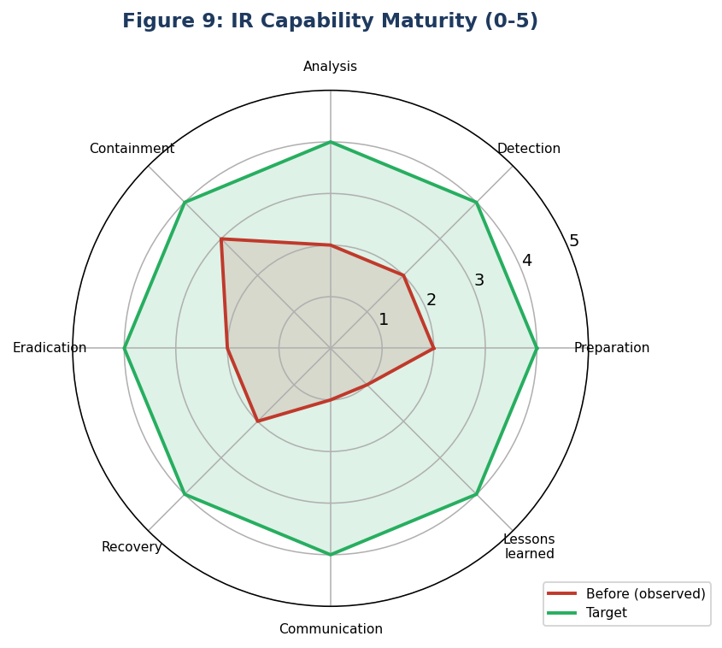
Figure 9: IR capability maturity before and target

8.4 Business impact
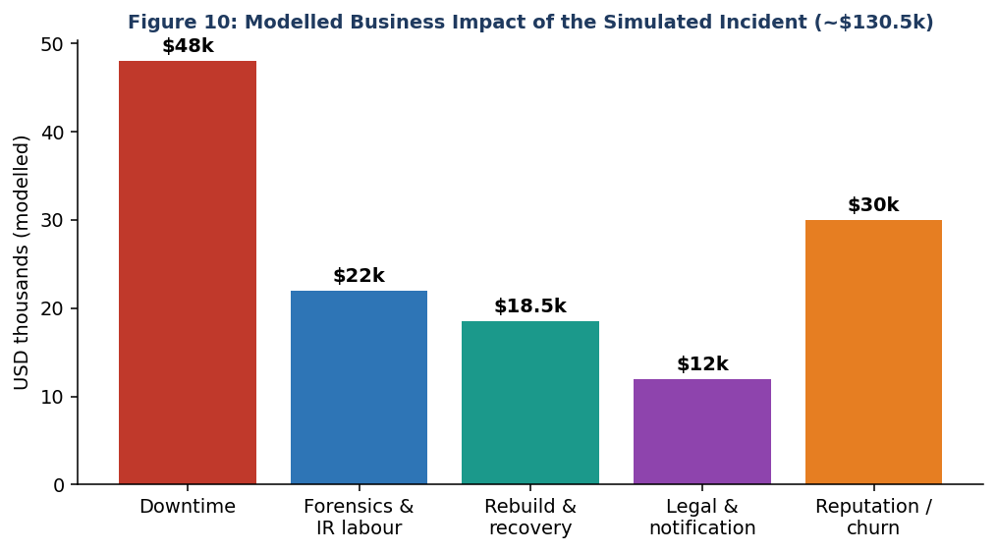
Figure 10: modelled business impact of the simulated incident
Costs are modelled, not measured. They illustrate the point that downtime and reputation can exceed the direct technical response cost. For comparison, IBM's 2024 report put the global average cost of a breach at about USD 4.88 million; a smaller company with fast detection and containment would normally sit far below the average, which is consistent with the figure modelled here.

9. Lessons Learned and Prevention

9.1 Lessons learned
1. Detection speed decides outcome. Every hour of dwell time gave the attacker more access. Investing in correlation rules gives the best return.
2. Basic hygiene beats advanced tools. Unique admin passwords, no local admin for users and blocked macros would each have broken the chain.
3. Practise before the crisis. Authority to isolate and a clear call tree turned a potential 12-hour argument into a 1-hour action.
4. Test backups. A backup is a hypothesis until you restore it.
5. Think about data theft as well as encryption. Modern ransomware groups steal first and encrypt second; restoring from backup does not remove the breach duty.

9.2 Proposed changes to the security framework
Layer | Change | Framework reference
Govern | Approve IR policy, name an incident commander, set notification procedures | NIST CSF 2.0 GV; ISO 27001 A.5.24-A.5.28
Protect | Macro blocking, LAPS, MFA (phishing-resistant for admins), segmentation, egress filtering | CIS Controls 4, 5, 6, 12, 13
Detect | SIEM use cases mapped to ATT&CK, EDR in block mode, 24x7 alert triage | NIST CSF DE.CM, DE.AE; CIS Control 8, 13
Respond | Playbooks, retainer, tabletop exercises | NIST CSF RS; CIS Control 17
Recover | Immutable backups, quarterly restore tests, AD recovery runbook | NIST CSF RC; CIS Control 11

9.3 Implementation roadmap
Timeframe | Actions | Owner
0-30 days | Block macros, move EDR rules to block, deploy LAPS, restrict SMB between workstations, publish the IR plan | IT security
30-90 days | Detection rules for the ten ATT&CK techniques in this incident, egress filtering, restore tests, phishing simulation programme | Security / IT ops
3-6 months | Segmentation, tiered admin model, DFIR retainer, first tabletop exercise | CISO
6-12 months | 24x7 monitoring (in-house or managed), second exercise, review against ISO 27035 | CISO / Board

9.4 Success metrics
- MTTD under 4 hours and MTTC under 30 minutes in the next exercise.
- 100% of servers with unique local admin passwords.
- Quarterly restore tests passed for critical systems.
- Phishing report rate above 50% and click rate below 5%.

10. Appendices and References

Appendix A: First-hour checklist
Done | Step
[ ] | Record time, reporter and symptoms in the incident log
[ ] | Assess severity using the matrix; call the incident commander if 2 or 1
[ ] | Capture memory, running processes and network connections
[ ] | Isolate affected hosts; do not power off
[ ] | Disable suspected accounts; block known-bad domains and IPs
[ ] | Open the out-of-band communication channel
[ ] | Notify legal and DPO if personal data may be involved
[ ] | Preserve logs; extend retention

Appendix B: Chain-of-custody template
Evidence ID | Description | Collected by | Date and time | SHA-256 | Stored at
E-001 | Memory image FS-01 | [name] | D2 01:50 | [hash] | Evidence vault A
E-002 | Disk image WKS-07 | [name] | D2 08:00 | [hash] | Evidence vault A
E-003 | Firewall logs D0-D2 | [name] | D2 04:30 | [hash] | Evidence vault B

Appendix C: Post-incident review agenda
- Timeline walk-through (15 min).
- What worked, what did not (20 min).
- Root cause and contributing factors (20 min).
- Actions with owners and dates (15 min).
- Plan and playbook updates (10 min).

References
- NIST SP 800-61 Rev. 2 and Rev. 3, Incident Response Recommendations and Considerations.
- SANS Institute, Incident Handler's Handbook (PICERL model).
- ISO/IEC 27035-1:2023, Information security incident management.
- MITRE ATT&CK knowledge base, attack.mitre.org.
- Lockheed Martin, Intelligence Driven Computer Network Defense (Cyber Kill Chain).
- IBM Security, Cost of a Data Breach Report 2024.
- Greenberg, A. (2018). The Untold Story of NotPetya. WIRED; Maersk public statements on 2017 losses.
- US Senate Commerce Committee report on the Target breach (2014).
- CISA and FBI advisories on DarkSide and the Colonial Pipeline incident (2021).
- CERT-In directions (2022) on reporting cyber incidents within six hours.

