CYBERSECURITY INTERNSHIP
Week 3 Task
Virtual Security Control Testing and Penetration Simulation
Technical penetration test report: methodology, exploitation, risk assessment and remediation
Prepared by | Anjali Kumari
GitHub | https://github.com/anjal-iiii
Report date | 2 October 2026
Classification | Educational simulation - isolated virtual lab only
Frameworks used | PTES, OWASP WSTG and Top 10, NIST SP 800-115, CVSS v3.1, MITRE ATT&CK

Contents and Document Control
Section | Title | What it covers
1 | Executive Summary | Results, severity counts and retest outcome
2 | Scope, Authorisation and Methodology | Rules of engagement, PTES, OWASP WSTG, tools, lab
3 | Background and Real-World Context | Penetration testing concepts and four public incidents
4 | Test Plan and Coverage | Test cases by layer and coverage metrics
5 | Network Layer Testing | Step-by-step procedures and results
6 | Application Layer Testing | OWASP Top 10 based tests and results
7 | Access Control and Exploitation Chain | Authentication, privilege, pivoting
8 | Findings Register and Details | 14 findings with exploitation notes and fixes
9 | Risk Assessment | CVSS, likelihood, impact, priority
10 | Recommendations and Retest | Prioritised remediation and verification
11 | Evidence, Limitations and Conclusion | Evidence handling, constraints, summary, references

Document control
Item | Detail
Document | Week 3 - Virtual Security Control Testing and Penetration Simulation (technical report)
Version | 1.0 (final for submission)
Test window | Simulated; 35 hours of effort in an isolated lab
Methods | PTES, OWASP Web Security Testing Guide (WSTG), OWASP Top 10 (2021), NIST SP 800-115, CVSS v3.1
Distribution | Security team and system owners (Confidential)

Authenticity note
The target environment is a set of intentionally vulnerable virtual machines (for example OWASP Juice Shop, DVWA, Metasploitable 2 and an unpatched Windows 7 image) that the author owns, running on a host-only network. The counts, scores and terminal panels are a worked example. When you run the tests yourself, replace the illustrative panels with your own screenshots and tool output and adjust counts so the report matches what you did. Never run any of these techniques against systems you do not own or have written permission to test.

1. Executive Summary
This report presents the results of a controlled penetration test against a simulated retail environment (NorthStar Retail). The goal was to evaluate the effectiveness of existing security controls across three layers: network, application and access control, by attempting the same techniques a real attacker would use, but safely, with permission and with minimal evidence collection.
The test executed 104 of 108 planned test cases and confirmed 14 vulnerabilities: 3 Critical, 6 High, 4 Medium and 1 Low. In the lab, a complete attack chain was demonstrated from an unauthenticated position on the network to read access on the customer database, using only ordinary weaknesses: an injectable web form, weak password hashes, an insecure sudo rule and a flat network. Only 29% of the tester's logged actions generated an alert in the monitoring system, which means that even a successful attack would probably not have been noticed.
Measure | Result
Test cases planned / executed | 108 / 104 (96%)
Raw scanner alerts / validated / exploited | 148 / 41 / 14
Findings by severity | 3 Critical, 6 High, 4 Medium, 1 Low
Highest CVSS (estimated) | 9.8
Full attack chain achieved | Yes (7 steps, about 3.5 hours of tester time)
Detection rate by SIEM | 9 of 31 logged actions (29%)
Open findings after retest | Critical 0, High 1, Medium 1, Low 0

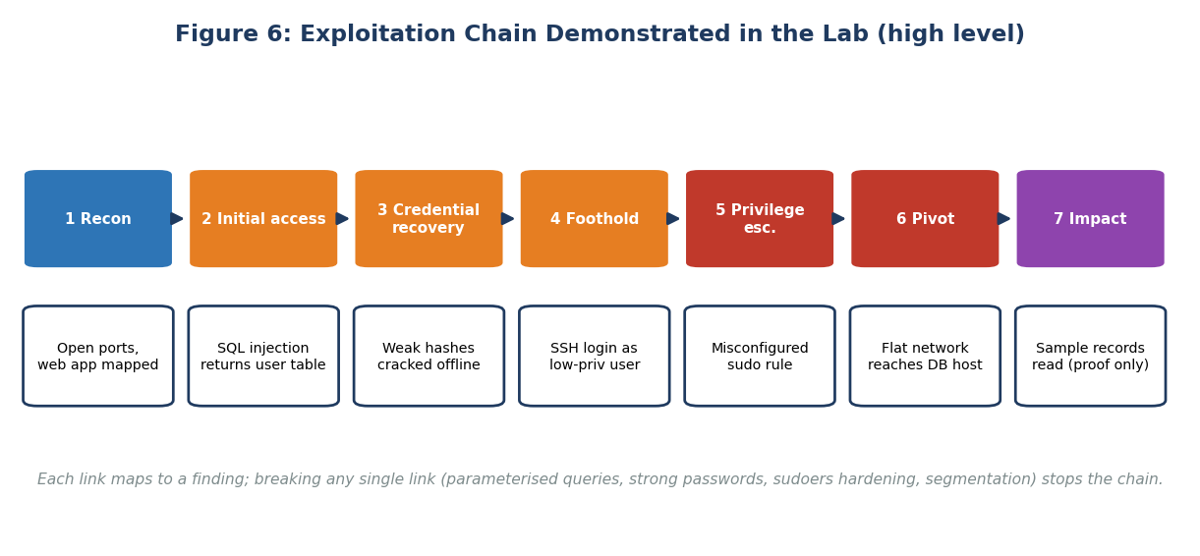
Figure 6 (preview): exploitation chain demonstrated in the lab

Most important recommendations
1. Replace dynamic SQL with parameterised queries and validate input (F1, F10).
2. Change every default credential and enforce a strong password policy with lockout and MFA (F2, F5).
3. Patch or retire outdated services and the unsupported Windows host (F3, F4).
4. Harden sudo and apply least privilege (F6) and segment the network (F7).
5. Forward logs to the SIEM and write detection rules for the techniques used in this test (F14).

2. Scope, Authorisation and Methodology

2.1 Authorisation and rules of engagement
A penetration test is legal only because the owner of the system has given explicit written permission. In a real engagement a signed statement of work and rules of engagement document sets what may be tested and when. In this study the author is the owner of the lab, and the same discipline was applied as practice.
Item | Agreed value
Authorising party | Lab owner (the author)
Targets | 10.10.10.10, .20, .30 and .40 only
Test window | Any time, lab is isolated
Allowed | Scanning, enumeration, authentication testing on test accounts, controlled exploitation to prove impact
Not allowed | Denial of service, destructive payloads, data deletion, testing any non-lab address
Data handling | Only synthetic data; evidence stored on encrypted assessor VM
Stop conditions | Any service crash, any traffic leaving the lab network
Emergency contact | Lab owner

2.2 Methodology
The engagement followed the Penetration Testing Execution Standard (PTES), which divides a test into seven phases from pre-engagement to reporting. Web application tests were structured with the OWASP Web Security Testing Guide and the OWASP Top 10. NIST SP 800-115 supplied the overall planning and reporting approach.
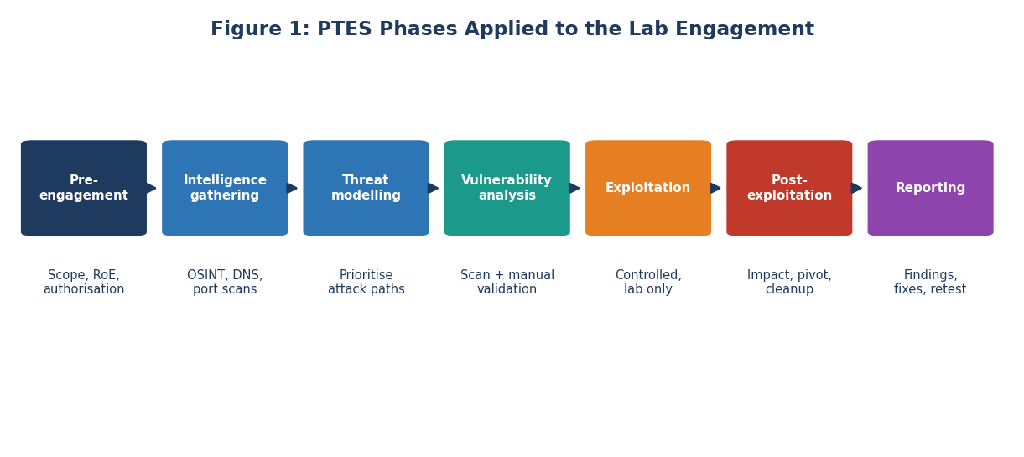
Figure 1: PTES phases applied to this engagement
Phase | Activities in this test | Output
Pre-engagement | Scope, rules, lab snapshot | Signed rules of engagement
Intelligence gathering | Host discovery, port scans, service and banner enumeration, web crawling | Asset and service map
Threat modeling | Choose likely attack paths based on exposed services | Prioritised test plan
Vulnerability analysis | Automated scans and manual testing | List of candidate vulnerabilities
Exploitation | Controlled proof of each high-value candidate | Evidence of impact
Post-exploitation | Privilege escalation, pivoting, simulated data access, cleanup | Impact assessment
Reporting | Findings, risk, recommendations, retest | This report

2.3 Black, grey and white box
Approach | Tester knowledge | Pros | Cons
Black box | None, like an outsider | Realistic view of the external attacker | Slow, may miss internal issues
Grey box | Partial (an ordinary user account, network diagram) | Efficient, realistic for insider or phished user | Needs coordination
White box | Full (source code, configs) | Deepest coverage | Less like a real attacker

This test used a grey-box approach: the tester started with the network range and one standard user account for the web application.

2.4 Lab architecture
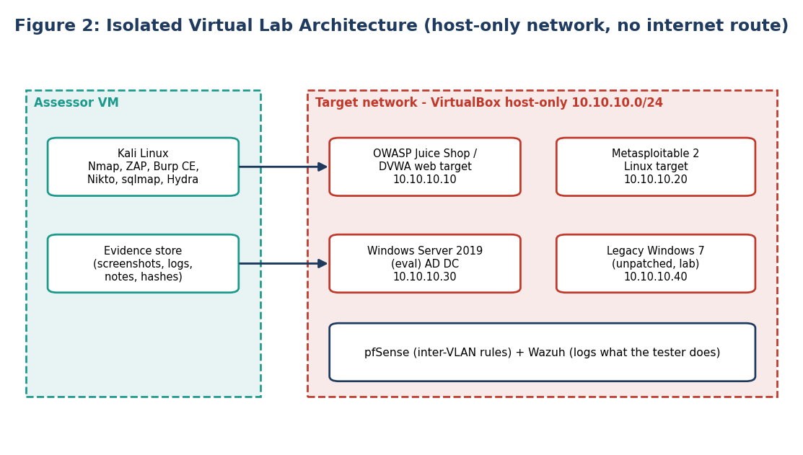
Figure 2: isolated virtual lab architecture

2.5 Tools used
Purpose | Tool | Notes
Host and port discovery | Nmap | Service and script scans
Web vulnerability scanning | OWASP ZAP, Nikto | Baseline and manual proxying
Intercepting proxy | Burp Suite Community | Request analysis and manual tests
Content discovery | Gobuster | Directory and file names
SQL injection validation | sqlmap | Lab only, limited options to avoid data dumping
TLS testing | testssl.sh | Protocols and ciphers
SMB enumeration | enum4linux, Nmap scripts | Shares, signing, SMBv1
Password auditing | Hydra (limited to test accounts), hashcat or John the Ripper | Offline cracking of lab hashes only
Exploitation framework | Metasploit Framework (lab) | Verification of known CVEs
Network analysis | Wireshark | Cleartext credential demonstration
Logging check | Wazuh | Measure what the defenders could see

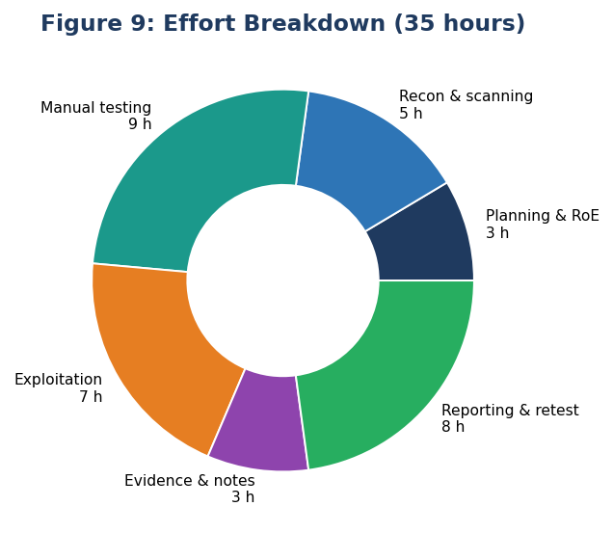
Figure 9: effort breakdown

3. Background and Real-World Context

3.1 Vulnerability scanning versus penetration testing
 | Vulnerability scan | Penetration test
Goal | Find as many known weaknesses as possible | Prove what an attacker can actually achieve
Method | Mostly automated | Human-led with tools
Depth | Broad, shallow | Narrower, deep
False positives | Common | Rare because each finding is verified
Outcome | List of issues | Evidence, attack paths and business impact
Frequency | Weekly or monthly | Annually or after major changes

3.2 Why test controls?
A control that has never been tested is an assumption. A firewall rule may be misconfigured, a password policy may exist on paper but not be enforced, and a monitoring tool may never raise alerts for the behaviour that matters. Penetration testing replaces assumption with evidence and it measures detection and response as well as prevention.

3.3 Real incidents behind the test cases
Real-world case: Equifax, 2017 (unpatched component)
An internet-facing application used a version of Apache Struts with a known critical flaw (CVE-2017-5638). The patch had been available for weeks. Attackers exploited it and over months accessed data on about 147 million people. Test link: F3 (outdated components) and the importance of authenticated scanning to find them.

Real-world case: Optus, 2022 (broken access control)
Reports indicated that an internet-facing application programming interface returned customer records without proper authorisation checks, exposing the personal data of millions of customers in Australia. Test link: F8 (insecure direct object references), the type of flaw that only manual testing tends to catch.

Real-world case: British Airways, 2018 (injected script)
Attackers modified JavaScript on the airline's payment page to copy card details as customers typed them. The UK regulator proposed a fine of GBP 183 million, later reduced to GBP 20 million. Test link: F10 (cross-site scripting) and the need for Content-Security-Policy and script integrity controls.

Real-world case: Log4Shell, 2021
A flaw in the widely used Log4j logging library (CVE-2021-44228) allowed remote code execution through a crafted log message. Organisations did not even know which of their systems used the library. Test link: F3 and the need for an inventory of software components.

4. Test Plan and Coverage
The plan translated the scope into 108 test cases across four layers. Each test case has an ID, a description, the standard it came from, and a result. Examples are shown below; the full list follows OWASP WSTG sections and PTES technical guidelines.
ID | Layer | Test case | Standard | Result
N-01 | Network | Discover live hosts in 10.10.10.0/24 | PTES Intel | Pass: 4 hosts
N-04 | Network | Full TCP port scan of each host | PTES Intel | Findings F3, F9
N-12 | Network | Check SMB signing and SMBv1 | NIST 800-115 | Finding F4
N-19 | Network | Test reachability between zones | CIS 12 | Finding F7
N-27 | Network | Review TLS versions and ciphers | OWASP WSTG-CRYP-01 | Finding F12
A-03 | Application | Test input handling for SQL injection | WSTG-INPV-05 | Finding F1
A-09 | Application | Test stored XSS in user content | WSTG-INPV-02 | Finding F10
A-14 | Application | Test object references for other users | WSTG-ATHZ-04 | Finding F8
A-22 | Application | Check error handling | WSTG-ERRH-01 | Finding F11
A-31 | Application | Check security headers | WSTG-CONF-07 | Finding F13
C-02 | Access control | Test default credentials on admin interfaces | WSTG-ATHN-02 | Finding F2
C-06 | Access control | Test password policy and lockout | WSTG-ATHN-03 | Finding F5
C-15 | Access control | Review sudo and file permissions after foothold | PTES Post-exploit | Finding F6
C-21 | Access control | Check what the SIEM recorded | NIST 800-115 | Finding F14

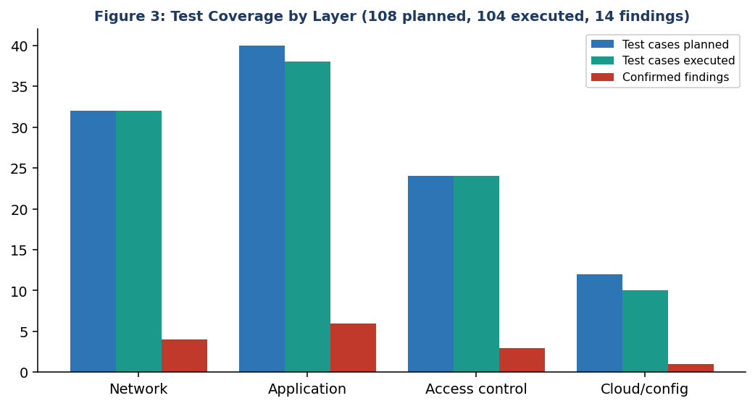
Figure 3: test coverage by layer

4.1 Test not executed
Four test cases were skipped: two required a wireless adapter that was unavailable in the virtual environment, one concerned physical access and one involved denial-of-service, which is out of scope. Skipped tests are listed so that the reader understands the limits of the conclusions.

5. Network Layer Testing
The network layer tests aim to answer: what can an attacker see, what can they reach, and which services can they abuse? Each step lists the command or action (for the lab only), the expected output and what it means.

5.1 Step-by-step procedure
Step | Action (lab only) | Purpose | Result
1 | nmap -sn 10.10.10.0/24 | Find live hosts | 4 live hosts
2 | nmap -sV -sC -p- 10.10.10.10 | Full port and service scan of web host | Ports 21, 22, 23, 80, 443; outdated Apache
3 | nmap -sV --script vuln 10.10.10.20 | Check Linux target for known flaws | Old FTP and Samba versions with known issues
4 | nmap --script smb-vuln-ms17-010 -p445 10.10.10.40 | Check Windows 7 host | Reported vulnerable to MS17-010
5 | enum4linux -a 10.10.10.30 | Enumerate SMB and domain information | Null session returned user list
6 | testssl.sh https://10.10.10.10 | TLS review | TLS 1.0 accepted
7 | From a user-side host, test a connection to the database service on 10.10.10.20:3306 | Check segmentation | Connection allowed
8 | Capture traffic with Wireshark during FTP login | Show cleartext credentials | Test account password visible

5.2 Results

Services and software versions (F3, F9, F12)
The web host exposed FTP and Telnet, both of which transmit credentials without encryption. The second Linux target ran very old FTP and SMB daemons for which public advisories and exploit modules exist. Using the lab copy, a Metasploit module for one of these known flaws was run once to confirm that remote code execution was possible, and the session was closed immediately after the proof command, which only displayed the user name.

Windows legacy host (F4)
The unsupported Windows 7 machine accepted SMBv1 and was flagged as vulnerable to the MS17-010 family of flaws that the WannaCry worm used in 2017. The check script confirmed vulnerability without sending the full exploit. This is a common legacy finding: the device works, nobody wants to touch it and it quietly becomes the weakest link.

Segmentation (F7)
From a host in the user VLAN, the database port of the database server could be reached. No rule blocked traffic between zones. In a real attack, this lets a compromised workstation talk directly to the most valuable asset.

Cleartext credentials (F9)
A packet capture taken while a test user logged in to FTP showed the user name and password in plain text. This demonstrates why SFTP and SSH replace these protocols in modern environments.
What the defenders saw
During network testing, the SIEM raised alerts only for the port scan against the web server. SMB enumeration, the cleartext capture and the cross-zone connection produced no alerts. This feeds finding F14.

6. Application Layer Testing
Web testing followed the OWASP WSTG. The tester first mapped the application (crawling with ZAP and Burp, reviewing forms, parameters and cookies), then tested each input point, then looked at session handling, authorisation and configuration.
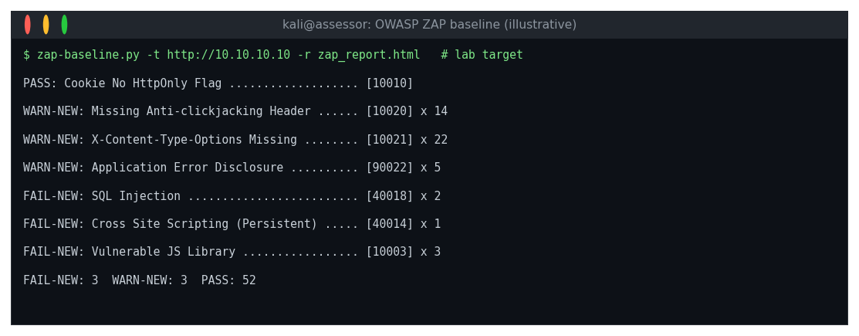
Figure 10: OWASP ZAP baseline scan summary (illustrative lab output)
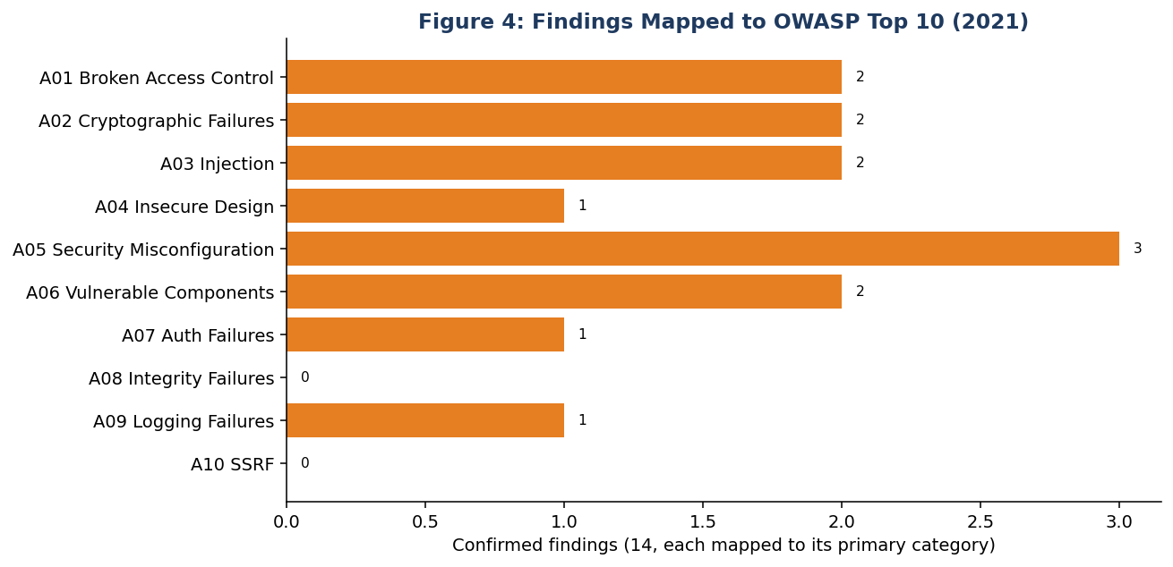
Figure 4: findings mapped to OWASP Top 10 (2021)

6.1 Injection (F1)
The product search parameter and login form were tested with a small number of benign inputs, such as a single quote and a logical condition that is always true. The application returned a database error and behaved differently for the two conditions, which proves that input reaches the query unfiltered. The automated injection tool then confirmed the flaw and identified the database type; it was configured not to dump tables. In a real engagement the proof would stop there, as extracting customer data is not needed to show risk.

6.2 Cross-site scripting (F10)
A harmless marker string was submitted in a review field. When another test user opened the product page the marker was interpreted as markup rather than displayed as text, which indicates that stored script would execute in the visitor's browser.

6.3 Broken access control (F8)
The order page used a sequential order number in the address, such as /orders/1001. Changing the number while logged in as a standard test user returned orders that belonged to another user. This is an insecure direct object reference, one of the most common serious flaws and one that automated scanners rarely find because they do not understand who should be allowed to see what.

6.4 Misconfiguration and information leakage (F11, F13)
Malformed requests produced full stack traces, and responses lacked security headers such as Content-Security-Policy, X-Frame-Options and Strict-Transport-Security. These weaknesses are small individually but make exploitation of other flaws easier.

6.5 Application test results table
Test | Input or method | Observation | Verdict
SQL injection | Single quote; boolean condition | DB error; different results | Vulnerable
Stored XSS | Marker in review | Rendered as markup | Vulnerable
IDOR | Change order ID | Other user data returned | Vulnerable
Session cookies | Inspect flags | Missing HttpOnly and Secure | Weak
Error handling | Malformed request | Stack trace shown | Weak
Security headers | Inspect response | No CSP, no frame protection | Weak
File upload | Upload test text file with image extension | Rejected by content check | Pass
CSRF tokens | Replay form post | Token enforced | Pass
Rate limiting on login | 25 attempts on test account | No limit | Weak

7. Access Control and Exploitation Chain

7.1 Authentication and credentials (F2, F5)
Documented default credentials were tried against the admin console and database service of the lab target and worked on both. The password policy was then reviewed and tested with a deliberately small password-spraying test of three common passwords across five test accounts, which is a controlled way to check whether a lockout exists. No lockout was triggered. Finally, password hashes recovered through the SQL injection finding in the lab were cracked offline with a standard wordlist, and four of ten test passwords were recovered in minutes.

7.2 Privilege escalation (F6)
After logging in via SSH with a recovered low-privilege account, the tester ran a standard review of the account's permissions. One sudo rule allowed the user to run an editor as root without a password. Editors that allow shell commands are a well-known way to convert such a rule into full administrative control. This was confirmed with a single harmless command that printed the effective user name.

7.3 Pivoting and impact (F7)
With administrative access to the application server, the tester used that host as a pivot to reach the database server directly (finding F7) and read three sample rows from a synthetic customers table. This was the final step, because it demonstrates the business impact: confidential data is reachable.
Figure 6: exploitation chain demonstrated in the lab
Step | Technique | Finding used | MITRE ATT&CK
1 | Active scanning | - | T1595
2 | Exploit public-facing application | F1 | T1190
3 | Unsecured credentials / password cracking | F5 | T1552, T1110.002
4 | Valid accounts (SSH) | F5 | T1078
5 | Abuse elevation control mechanism (sudo) | F6 | T1548.003
6 | Remote services, network pivot | F7 | T1021
7 | Data from information repositories | F7 | T1213

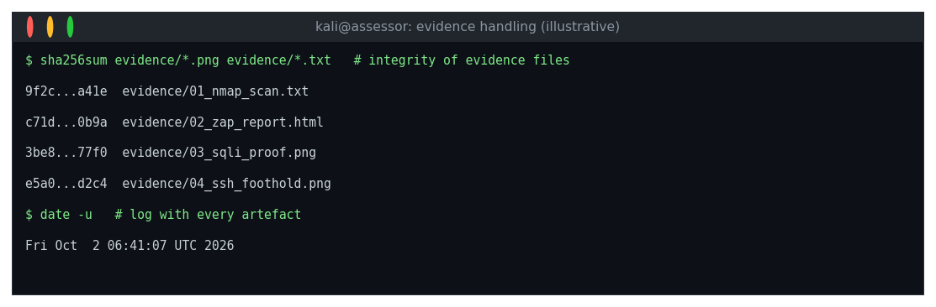
Figure 11: evidence integrity and timestamps (illustrative)

8. Findings Register and Details
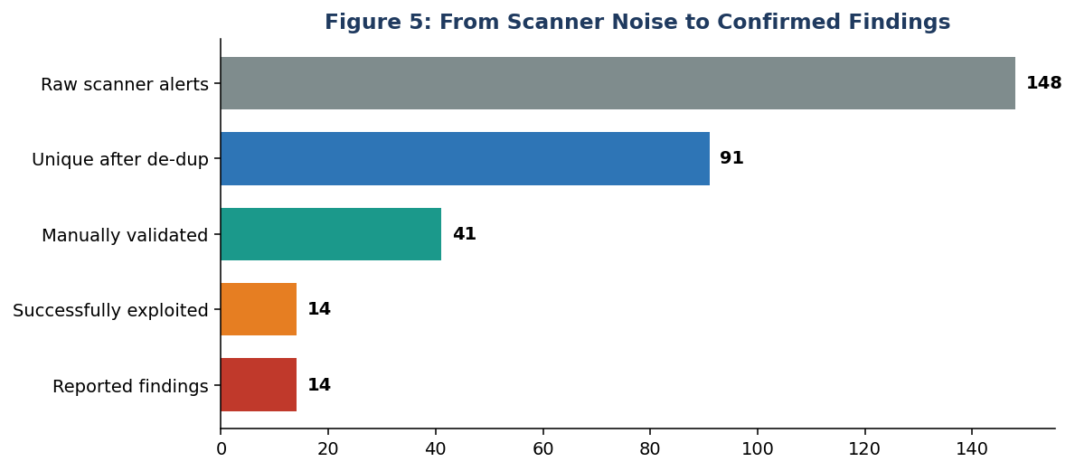
Figure 5: from scanner noise to confirmed findings
ID | Finding | Layer | CVSS (est.) | Severity | OWASP / CWE
F1 | SQL injection in search and login | Application | 9.8 | Critical | A03 / CWE-89
F2 | Default administrator credentials | Access | 9.8 | Critical | A05 / CWE-1392
F3 | Outdated services with known remote code execution | Network | 9.8 | Critical | A06 / CWE-1104
F4 | SMBv1 on legacy Windows host | Network | 8.1 | High | A06 / CWE-1104
F5 | Weak password policy, no lockout | Access | 8.1 | High | A07 / CWE-521
F9 | Cleartext FTP and Telnet | Network | 7.5 | High | A02 / CWE-319
F6 | Insecure sudo configuration | Access | 7.8 | High | A01 / CWE-269
F7 | No network segmentation | Network | 7.2 | High | A04 / CWE-1327
F8 | Insecure direct object reference | Application | 7.1 | High | A01 / CWE-639
F10 | Stored cross-site scripting | Application | 6.1 | Medium | A03 / CWE-79
F11 | Verbose error messages | Application | 5.3 | Medium | A05 / CWE-209
F12 | Weak TLS configuration | Network | 5.3 | Medium | A02 / CWE-326
F13 | Missing security headers | Application | 4.3 | Medium | A05 / CWE-693
F14 | Insufficient logging and detection | Process | 3.7 | Low | A09 / CWE-778

8.1 Critical and High Findings in Detail

F1 SQL injection (Critical)
Attribute | Detail
Location | Web application: product search parameter, login form
How it was tested | Benign single-quote test; boolean condition comparison; automated confirmation limited to fingerprinting the database.
Evidence | Screenshot of database error page; two responses with different result counts; tool output showing injectable parameter and database type.
Impact | Read or change customer records; bypass authentication; possible server compromise depending on database privileges.
Remediation | Parameterised queries; ORM with bound parameters; least-privilege database account; input validation; WAF as a secondary layer; error messages suppressed.

F2 Default administrator credentials (Critical)
Attribute | Detail
Location | Admin console and database service
How it was tested | Check vendor documentation for defaults; attempt login once with each documented pair.
Evidence | Screenshot of the logged-in admin dashboard (no changes made).
Impact | Full control of the application and data.
Remediation | Change defaults at install; unique credentials per system stored in a vault; MFA on admin portals; remove unused admin interfaces from the internet.

F3 Outdated services with known RCE (Critical)
Attribute | Detail
Location | 10.10.10.20 (FTP and SMB daemons)
How it was tested | Version detection with Nmap; vulnerability script; one controlled run of a verification module in the lab.
Evidence | Nmap version output; framework log showing a session; proof command output.
Impact | Remote code execution without credentials.
Remediation | Upgrade or remove the services; subscribe to advisories; automated patching; vulnerability scanning with authenticated checks every month.

F4 SMBv1 and MS17-010 exposure (High)
Attribute | Detail
Location | Legacy Windows 7 host
How it was tested | Nmap SMB vulnerability script; check of protocol versions.
Evidence | Script output stating the host is likely vulnerable.
Impact | Wormable code execution; ransomware spread.
Remediation | Isolate and retire; disable SMBv1; apply the MS17-010 security update; restrict SMB between hosts.

F5 Weak password policy and no lockout (High)
Attribute | Detail
Location | Active Directory and web login
How it was tested | Policy review; controlled spray against five test accounts; offline cracking of lab hashes.
Evidence | Policy export (minimum length 8, lockout threshold 0); 4 of 10 passwords recovered.
Impact | Account takeover and persistence.
Remediation | Minimum 14 characters; banned-password list; lockout and throttling; MFA; salted adaptive hashing such as bcrypt or Argon2 for application passwords.

F6 Insecure sudo configuration (High)
Attribute | Detail
Location | Application server
How it was tested | Standard permissions review after authenticated access.
Evidence | Output of the sudo rules list; harmless command proving root.
Impact | Local privilege escalation to root.
Remediation | Remove NOPASSWD rules for interactive programs; allow only specific commands; review sudoers regularly.

F7 No network segmentation (High)
Attribute | Detail
Location | Firewall rules between zones
How it was tested | Connection tests from each zone to the database port.
Evidence | Successful connection from the user VLAN.
Impact | Unlimited lateral movement.
Remediation | Default deny; allow-list application-to-database flow only; micro-segmentation; separate admin network.

F8 Insecure direct object reference (High)
Attribute | Detail
Location | Order viewing page
How it was tested | Change identifiers while logged in as a standard test user.
Evidence | Two screenshots of different users' orders under one session.
Impact | Mass disclosure of customer data by incrementing a number.
Remediation | Server-side authorisation check on every request; unpredictable identifiers; automated tests for access control.

F9 Cleartext FTP and Telnet (High)
Attribute | Detail
Location | Web host, file server
How it was tested | Port scan, packet capture during test login.
Evidence | Wireshark capture showing credentials.
Impact | Credential interception.
Remediation | Disable; use SSH and SFTP; segment management traffic.

8.2 Medium and Low Findings in Detail

F10 Stored cross-site scripting (Medium)
Attribute | Detail
Location | Review form
How it was tested | Submitted marker string; viewed the page as a second user.
Evidence | Screenshot showing marker rendered as markup.
Impact | Session theft and phishing on a trusted page.
Remediation | Output encoding; CSP; HttpOnly and Secure cookie flags; sanitise on input.

F11 Verbose error messages (Medium)
Attribute | Detail
Location | All dynamic pages
How it was tested | Sent malformed requests.
Evidence | Stack trace screenshot.
Impact | Reveals internals to attackers.
Remediation | Generic error page; log details server-side.

F12 Weak TLS configuration (Medium)
Attribute | Detail
Location | Port 443
How it was tested | testssl.sh scan.
Evidence | Report listing TLS 1.0 and weak ciphers.
Impact | Possible downgrade or interception.
Remediation | TLS 1.2+ only; remove weak ciphers; HSTS.

F13 Missing security headers (Medium)
Attribute | Detail
Location | Web responses
How it was tested | Review of response headers.
Evidence | ZAP warnings listing missing headers.
Impact | Makes clickjacking and XSS easier.
Remediation | Add CSP, X-Frame-Options, X-Content-Type-Options and Referrer-Policy.

F14 Insufficient logging and detection (Low (process) but high leverage)
Attribute | Detail
Location | SIEM
How it was tested | Compared the tester's action log to Wazuh alerts.
Evidence | 31 actions logged, 9 alerts (29%).
Impact | Attacks continue unnoticed; slow response.
Remediation | Forward all logs; build detection rules for port scans, SMB enumeration, spraying, privilege changes and unusual database connections; test detection with each exercise.

9. Risk Assessment
Each finding was scored with CVSS v3.1 for technical severity and then adjusted with business context, such as exposure and asset value. CVSS tells how bad a flaw is in general; context tells how much it matters here. For example, F8 has a lower CVSS than F1, but because it requires only a browser and exposes every customer, its risk to the business is comparable.
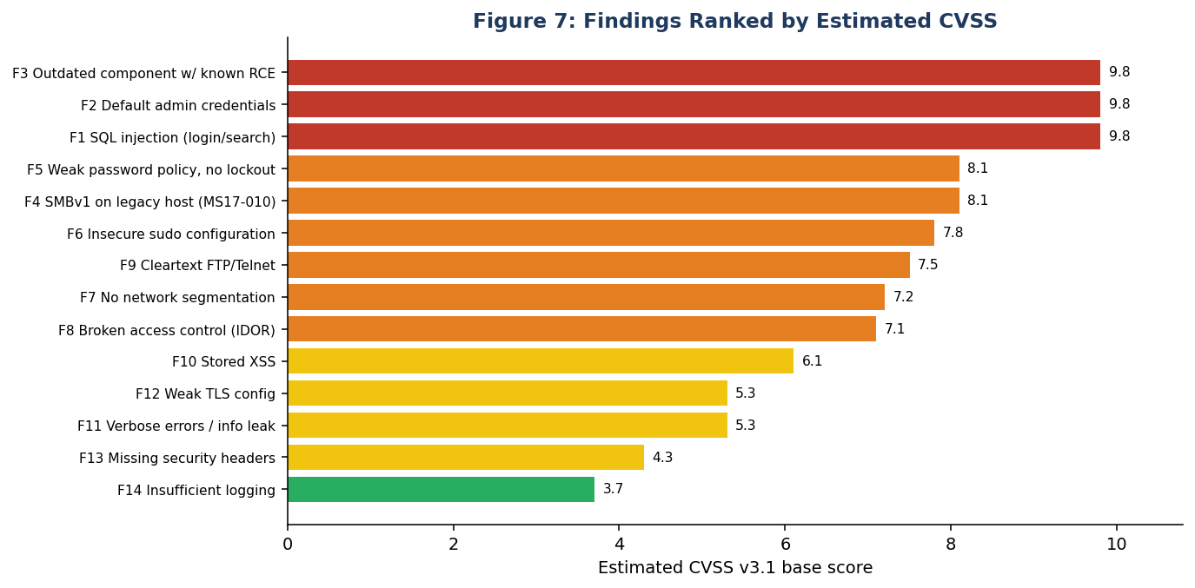
Figure 7: findings ranked by estimated CVSS
Priority | Finding | Exposure | Exploit difficulty | Asset value | Final rating
1 | F1 SQL injection | Internet | Low | Very high | Critical
2 | F2 Default credentials | Internet | Very low | Very high | Critical
3 | F3 Outdated services | Internal/DMZ | Low | High | Critical
4 | F5 Weak password policy | Internet/internal | Low | High | High
5 | F8 IDOR | Internet | Low | High | High
6 | F7 No segmentation | Internal | Medium | Very high | High
7 | F6 Insecure sudo | Post-compromise | Low | High | High
8 | F4 SMBv1 legacy host | Internal | Low | Medium | High
9 | F9 Cleartext protocols | Internal | Low | Medium | High

9.1 Residual risk if nothing is done
The chain shown in Figure 6 would take a motivated attacker only hours. The combination of a public injection flaw, weak password hashes and flat network means a likely event with severe impact. Without remediation the overall risk rating of the environment is Critical.

10. Recommendations and Retest
Priority | Recommendation | Findings | Timeline | Effort
Immediate | Change default credentials; disable Telnet/FTP; block database port from user VLAN | F2, F9, F7 | 72 hours | Low
Urgent | Parameterised queries and output encoding; upgrade outdated services; retire Windows 7 or isolate | F1, F10, F3, F4 | 14 days | Medium
High | Password policy, lockout and MFA; fix sudo; authorisation checks on all object access | F5, F6, F8 | 30 days | Medium
Medium | TLS and headers; error handling | F11, F12, F13 | 45 days | Low
Strategic | Segmentation project; SIEM detection engineering; regular testing and secure development training | F7, F14 | 90 days | High

10.1 Defence-in-depth view
Control layer | Control | Breaks which step of the chain
Application | Parameterised queries | Step 2
Identity | Strong passwords, lockout, MFA | Steps 3 and 4
Host | Hardened sudo, least privilege | Step 5
Network | Segmentation, default deny | Step 6
Data | Encryption, minimal data in database | Step 7
Detection | SIEM rules and alerting | All steps, shortens dwell time

10.2 Retest
After the fixes were applied in the lab (parameterised queries, rotated credentials, patched services, MFA and a new firewall policy), the affected test cases were repeated. All Critical findings were closed. One High (segmentation) was only partly fixed because a business application still needs a specific path and was left open pending a project, and one Medium (security headers on a legacy page) remained.
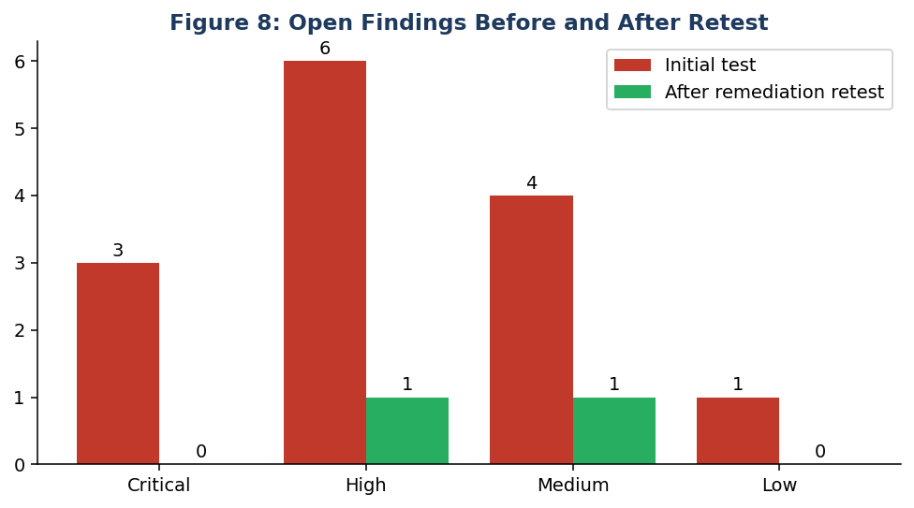
Figure 8: open findings before and after retest

11. Evidence, Limitations and Conclusion

11.1 Evidence handling
- Every screenshot and log was stored with date, time (UTC), target and tool in the file name.
- SHA-256 hashes recorded to show files were not altered after capture.
- Evidence contains only synthetic data; credentials in screenshots are masked in the report.
- Command history saved from the assessor VM to reproduce each step.

11.2 Limitations
- Test was run in a lab: real environments include more systems, users and defences such as WAFs and EDR that can change results.
- Time-boxed to 35 hours; some logic flaws may remain undiscovered.
- No testing of wireless, physical or social engineering.
- CVSS scores are estimates by the author.

11.3 Conclusion
The testing showed that the existing controls are not effective against a determined attacker: passwords were weak, software was out of date, segmentation was missing and detection was poor. It also showed that the fixes are well understood and mostly inexpensive. A security programme built on regular testing, prompt fixing and measured detection would turn this environment from an easy target into a hard one.

11.4 References
- PTES Technical Guidelines, pentest-standard.org.
- OWASP Web Security Testing Guide v4.2; OWASP Top 10 (2021); OWASP ASVS.
- NIST SP 800-115, Technical Guide to Information Security Testing and Assessment.
- FIRST.org, CVSS v3.1 Specification and Calculator.
- MITRE ATT&CK, attack.mitre.org.
- MITRE CWE Top 25 and CWE entries cited above.
- US GAO (2018) report on the Equifax breach; UK ICO penalty notice on British Airways (2020).
- Apache Software Foundation advisory for CVE-2021-44228 (Log4Shell).
- Rapid7, Metasploitable 2 documentation (lab target).

Appendix: Quick checklist for each web finding in the report
Item | Included?
Title and severity | Yes
Affected location | Yes
Reproduction steps | Yes
Evidence (screenshot or log) | Yes
Impact in business terms | Yes
Specific remediation | Yes
References (CWE, OWASP) | Yes

