CYBERSECURITY INTERNSHIP
Week 4 Task
Comprehensive Security Audit and Strategic Recommendations
Final audit report: findings, gap analysis, prioritised risk metrics and roadmap for a simulated enterprise
Prepared by | Anjali Kumari
GitHub | https://github.com/anjal-iiii
Report date | 2 October 2026
Classification | Educational simulation - isolated virtual lab only
Frameworks used | ISO/IEC 27001:2022, NIST CSF 2.0, CIS Controls v8, CIS Benchmarks, ISO 19011

Contents and Document Control
Section | Title | What it covers
1 | Executive Summary | Audit opinion, scorecard, top risks and roadmap in brief
2 | Audit Scope, Criteria and Method | Objectives, frameworks, evidence, rating scales
3 | Frameworks and Real-World Background | ISO 27001, NIST CSF 2.0, CIS and four incidents
4 | Environment and Asset Inventory | Company profile, assets, data, defence-in-depth
5 | Control Inventory and Testing | Policies, procedures and technical controls, how each was tested
6 | Audit Findings | 19 findings with evidence, criteria and impact
7 | Gap Analysis | CIS, NIST CSF and ISO Annex A gaps
8 | Risk Assessment and Prioritisation | Risk register, rating, before and after
9 | Recommendations and Strategic Roadmap | Immediate actions and 24-month plan with cost and KPIs
10 | Conclusion, References and Appendices | Summary, sources, templates

Document control
Item | Detail
Document | Week 4 - Comprehensive Security Audit and Strategic Recommendations (final audit report)
Auditee | NorthStar Retail Pvt Ltd (fictional), 200 staff, 3 sites, hybrid cloud
Audit type | Internal, risk-based, simulated; desk review, technical testing and interviews
Criteria | ISO/IEC 27001:2022, NIST CSF 2.0, CIS Controls v8 and CIS Benchmarks
Version | 1.0 (final for submission)

Authenticity note
This audit is a simulated exercise on a lab-built virtual enterprise. Staff, systems, counts and scores are a worked example designed to teach audit technique. When you complete your own audit of your lab, replace the illustrative evidence panels and statistics with your own screenshots, logs and results so that the report reflects work you performed.

1. Executive Summary

1.1 Audit opinion
The overall security posture of NorthStar Retail is rated Needs Significant Improvement (maturity 2.2 out of 5). The company has the foundations of a security programme: firewalls, antivirus and EDR, backups, and some policies, but many controls are only partly implemented or are not tested. The audit identified 19 findings: 3 Critical, 8 High, 7 Medium and 1 Low, which roll up into 47 distinct risk scenarios. Left unaddressed, the combination of weak identity controls, delayed patching and untested backups creates a realistic path to a ransomware incident similar to those that have disrupted much larger organisations.
Area | Result
Overall maturity (NIST CSF 2.0 average, 0-5) | 2.2 (target 3.8 within 12 months)
CIS Controls v8 average implementation | 44% (target 90%)
ISO/IEC 27001:2022 Annex A (93 controls) | 42 compliant (45%), 32 partial (34%), 19 non-compliant (20%)
Assets reviewed | 230 (9 critical, 31 high)
Findings | 19 (3 Critical, 8 High, 7 Medium, 1 Low)
Risk scenarios | 47 (6 Critical, 14 High, 19 Medium, 8 Low)
Projected residual risk after 12 months | 24 scenarios, none Critical, 3 High

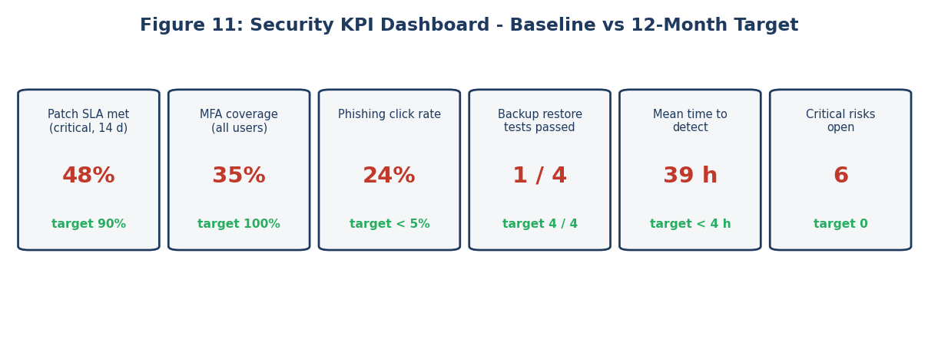
Figure 11: security KPI dashboard, baseline versus 12-month target

1.2 Three most urgent issues
1. No MFA on VPN and administrator accounts (A03). A single stolen password is enough to enter the network, the pattern behind the Colonial Pipeline incident.
2. Delayed patching and end-of-life systems (A06). Only 48% of critical patches meet the 14-day target; 23 systems run unsupported operating systems.
3. Untested, non-isolated backups (A10). Backups share the domain with production and only one of four restore tests was ever passed, so recovery from ransomware is uncertain.

1.3 Roadmap in one paragraph
The proposed roadmap has three horizons. In 0-3 months, quick wins: MFA everywhere, credential rotation, blocking legacy protocols, immutable backups and a patch sprint. In 3-12 months, build the capabilities that are missing: centralised monitoring, segmentation, vendor and incident-response programmes, and awareness training. In 12-24 months, mature the programme: formal ISMS aligned to ISO 27001, zero-trust access and certification readiness. The modelled cost for tooling and services is about USD 70,000 over two years (excluding internal staff time), which is a small fraction of the average cost of a single data breach.

2. Audit Scope, Criteria and Method

2.1 Objectives
- Assess the effectiveness of security measures across systems, networks and applications.
- Compare current practice with ISO/IEC 27001, NIST CSF 2.0 and CIS Controls.
- Identify gaps and rate the resulting risks.
- Provide a prioritised action plan and a strategic roadmap for the short and long term.

2.2 Scope
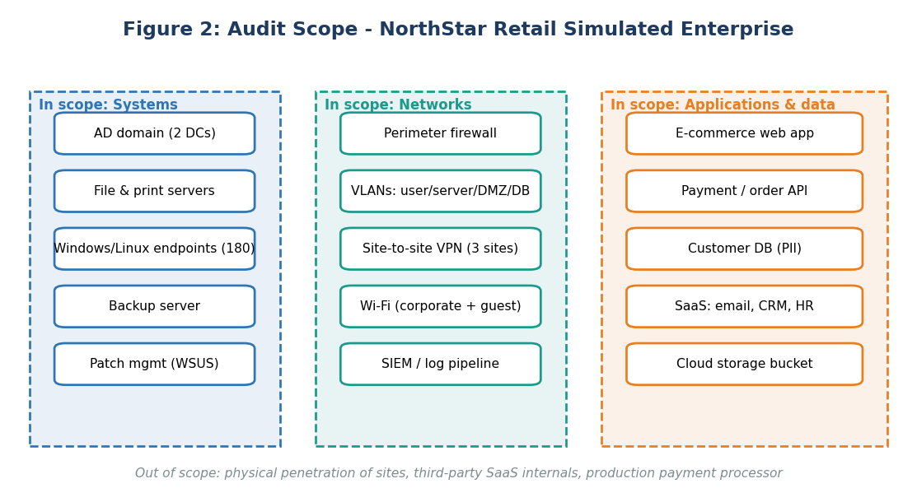
Figure 2: audit scope map

2.3 Audit process
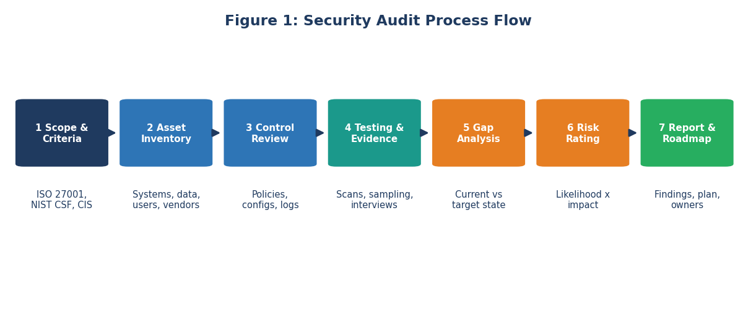
Figure 1: audit process flow
The audit followed the general approach of ISO 19011 (Guidelines for auditing management systems): plan, collect evidence, evaluate against criteria, report and follow up. It was risk-based: more time was spent on areas where failure would be most damaging, such as identity, backups and internet-facing systems.

2.4 Evidence types
Evidence type | Examples in this audit | Reliability
Documents | Security policy, network diagrams, asset list, backup schedule | Medium: shows intent, not practice
Interviews | IT manager, helpdesk lead, HR, finance user, developer | Medium: needs corroboration
Observation | Walk-through of server room, backup console, helpdesk process | High
Technical testing | Configuration exports, scans, log samples, policy settings | High
Re-performance | Restore a backup, attempt login without MFA on test account | Highest

2.5 Rating scales
Finding rating | Meaning | Expected action
Critical | Control missing or failed; probable serious compromise | Immediate (0-30 days)
High | Significant weakness | Within 90 days
Medium | Weakness that increases risk | Within 6 months
Low | Minor improvement | Within 12 months

Maturity level | Description
0 None | Control not present
1 Initial | Ad hoc, depends on individuals
2 Repeatable | Basic process exists, inconsistently applied
3 Defined | Documented, standard, communicated
4 Managed | Measured and monitored
5 Optimised | Continuously improved

2.6 Independence and limitations
In a real audit the auditor is independent of the area audited. In this exercise the author acts as the internal auditor of a simulated environment. Findings are limited to the sample of systems and records inspected and to the time of the audit.

3. Frameworks and Real-World Background

3.1 Frameworks used
Framework | What it is | How it was used
ISO/IEC 27001:2022 | International standard for an information security management system (ISMS); Annex A lists 93 controls in four themes: Organisational (37), People (8), Physical (14), Technological (34) | Compliance baseline and certification readiness
NIST CSF 2.0 (2024) | Outcome-based framework with six functions: Govern, Identify, Protect, Detect, Respond, Recover | Maturity assessment and executive reporting
CIS Controls v8 | 18 prioritised safeguards groups with Implementation Groups; IG1 is essential cyber hygiene | Technical gap analysis
CIS Benchmarks | Detailed secure configuration guides for operating systems and software | Configuration checks on servers and endpoints
NIST SP 800-30 / ISO 27005 | Risk assessment methods | Risk rating

3.2 Relationship between the frameworks
The frameworks complement each other. ISO 27001 says you need a management system and certifies it; NIST CSF provides a common language for outcomes and board communication; CIS Controls and Benchmarks give technical detail on what to configure. A mapping table (Section 7) shows how findings relate to each.

3.3 Real incidents that shaped the audit questions
Real-world case: SolarWinds, 2020
Attackers inserted malicious code into the build process of a widely used network-management product, and trojanised updates reached thousands of customers. Audit question: how are suppliers and software updates verified? (Finding A12.)

Real-world case: MGM Resorts, 2023
Attackers reportedly phoned the IT service desk, impersonated an employee and obtained a credential reset, then deployed ransomware that disrupted hotels and casinos for days. MGM later reported an impact of around USD 100 million. Audit question: how is identity verified before resets, and are privileged accounts protected by MFA? (A03, A05.)

Real-world case: Equifax, 2017
Failure to patch a known critical flaw in an internet-facing system, coupled with an incomplete asset inventory and expired certificates that blinded monitoring, led to the exposure of data on about 147 million people. Audit question: how complete is the asset inventory and how fast are patches applied? (A02, A06, A09.)

Real-world case: Colonial Pipeline, 2021
A legacy VPN account without MFA was used to enter the network. The company halted pipeline operations for several days. Audit question: is MFA enforced on all remote access? (A03.)

4. Environment and Asset Inventory

4.1 Company profile
Attribute | Detail
Business | Online and in-store retailer, 3 locations, e-commerce platform
Staff | About 200 (support 25, finance 12, marketing 20, operations 90, IT 6, others)
Data | Customer PII, order history, payment tokens (card data handled by payment processor), HR and finance records
Hosting | On-premises servers (24), cloud storage and SaaS (email, CRM, HR)
Compliance drivers | Customer privacy law (DPDP Act 2023 in India; GDPR for EU customers), PCI DSS scope reduction, contractual requirements

4.2 Asset inventory
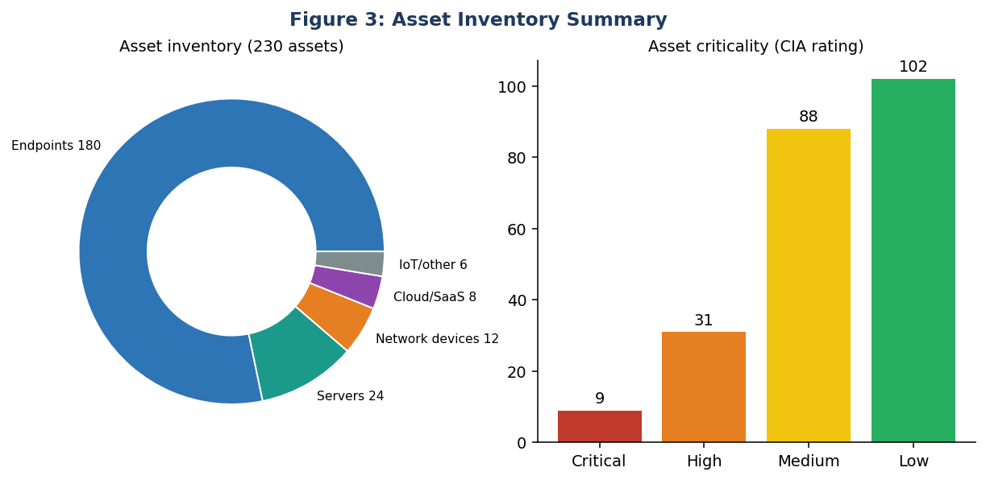
Figure 3: asset inventory summary
Category | Count | Examples | Criticality
Servers | 24 | AD domain controllers (2), file server, backup server, e-commerce web and database, WSUS | Critical/High
Endpoints | 180 | Windows 10/11 laptops and desktops, 14 Windows 7 machines in stores | Medium (High for admin and finance)
Network devices | 12 | Firewalls (3), switches, Wi-Fi controllers, VPN gateway | High
Cloud and SaaS | 8 | Email, CRM, HR, cloud storage | High
IoT / other | 6 | Cameras, badge readers, printers | Low/Medium

Finding about the inventory itself
The IT team's spreadsheet listed 164 of the 230 assets found during discovery (71%). Eight SaaS applications were known only from expense reports. An inventory is the first CIS Control because you cannot protect, patch or audit what you do not know about.

4.3 Defence-in-depth layers
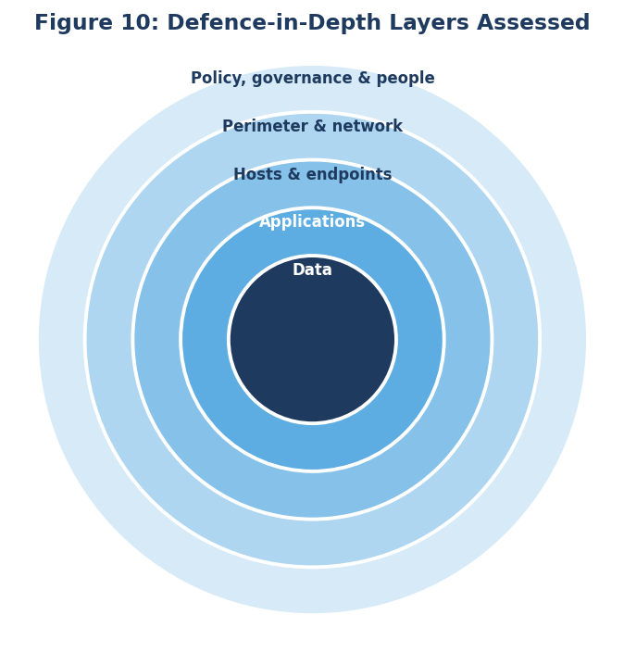
Figure 10: defence-in-depth layers assessed
The audit assessed each layer from the outside in: governance and people, network perimeter, hosts, applications and finally data. Weakness in an outer layer is acceptable only if the inner layers are strong; here several layers were weak at once.

5. Control Inventory and Testing
The first step of the evaluation was to list the controls that exist, who owns them and how they were tested. A control that exists on paper but is not tested was rated as partially effective at best.
Domain | Existing controls found | How tested | Effectiveness
Governance | Information security policy (3 years old); IT manager acts as security lead; no risk register | Document review, interview | Low
Asset management | Spreadsheet inventory | Network discovery compared with list | Low
Identity and access | Active Directory; MFA on email for 35% of users; 14 domain admins | AD export, policy review, login test | Low
Endpoint security | EDR on 90% of devices; rules in audit mode; BitLocker on 70% of laptops | Console review, sample of 20 devices | Medium
Patching | WSUS for Windows; no process for Linux or third-party software | Vulnerability scan, WSUS report | Low
Network security | Perimeter firewall; flat internal network; guest Wi-Fi separated | Rule review, connectivity tests | Medium
Logging and monitoring | Wazuh collects server logs; endpoints partly; no reviews | Log sampling, alert test | Low
Backup and recovery | Nightly backups to a domain-joined server; one restore test last year | Observation, restore re-performance | Low
Incident response | One-page contact list | Interview, scenario walk-through | Low
Vendor management | Contracts signed by procurement; no security assessment | Sample of 5 vendors | Low
Awareness | Annual slide deck; no phishing simulation | Records, simulated phish to 40 users (24% clicked) | Low
Physical security | Badge access, CCTV; server room log not reviewed | Walk-through | Medium
Cloud | Cloud storage with 6 containers; one public-read policy | Config review | Low

5.1 Audit procedure examples
Control | Audit step | Expected evidence | Result
MFA | List users in MFA groups; attempt VPN login with a test account without MFA | 100% of remote users | Login succeeded: fail
Passwords | Export default domain password policy | Min 12+, lockout enabled | Min 8, no lockout: fail
Admin accounts | Count Domain Admin members | Under 5, named, justified | 14 members: fail
Patching | Compare scan results to patch policy | Critical patched within 14 days | 48% compliant: fail
Backups | Restore 4 random servers to a test network | All restored within RTO | 1 of 4 restored: fail
Logging | Perform test attack and check for alert | Alert within 15 minutes | Not detected: fail
Encryption | Sample 20 laptops for disk encryption | All encrypted | 14 of 20: partial

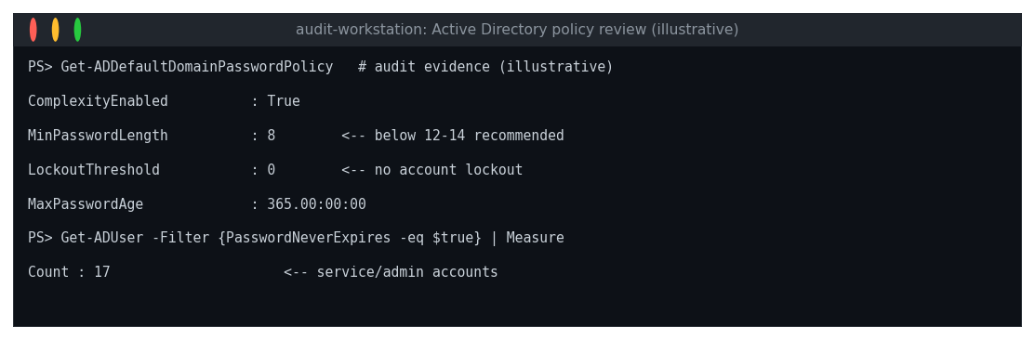
Figure 12: Active Directory password policy evidence (illustrative)

6. Audit Findings
ID | Finding | Domain | Severity
A03 | MFA absent for VPN and administrators | Identity | Critical
A06 | Late patching and unsupported operating systems | Vulnerability management | Critical
A10 | Backups untested, domain-joined and not immutable | Recovery | Critical
A01 | No ISMS, risk method or current policy set | Governance | High
A04 | Weak password policy, shared local admin password | Identity | High
A05 | Excessive privileged access (14 Domain Admins) | Identity | High
A07 | Flat network; no internal segmentation | Network | High
A09 | Logging gaps and no routine review | Monitoring | High
A11 | No tested incident response plan | Response | High
A14 | Cloud storage misconfiguration (public read policy) | Cloud | High
A15 | No data classification; PII on open file shares | Data | High
A02 | Incomplete asset inventory and unknown SaaS | Governance | Medium
A08 | No egress filtering | Network | Medium
A12 | No vendor risk management | Supply chain | Medium
A13 | Awareness training ineffective (24% click rate) | People | Medium
A16 | 30% of laptops not encrypted | Endpoint | Medium
A18 | Informal change management | Operations | Medium
A19 | No regular security testing (no pen test in 24 months) | Assurance | Medium
A17 | Server room access log not reviewed | Physical | Low

6.1 Critical and High Findings in Detail

A03 MFA absent for VPN and administrators (Critical)
Attribute | Detail
Criteria | ISO 27001 A.8.5 (secure authentication); CIS Control 6.3-6.5; NIST CSF PR.AA
Observation and evidence | The VPN accepted a test account with username and password only. MFA was configured for email on 70 of 200 users (35%). No administrator account used MFA.
Risk and impact | One phished or reused password gives remote access to the internal network and possibly domain admin rights. Related incidents: Colonial Pipeline, Uber, MGM.
Recommendation | Enforce MFA on VPN, email, admin consoles and cloud within 30 days, using authenticator apps or hardware keys (phishing-resistant for administrators). Remove legacy authentication.

A06 Late patching and unsupported systems (Critical)
Attribute | Detail
Criteria | ISO 27001 A.8.8 (technical vulnerabilities); CIS Control 7; NIST CSF ID.RA, PR.PS
Observation and evidence | A scan found 312 critical or high vulnerabilities; 48% of critical patches were applied within the 14-day target. 23 systems (14 store PCs on Windows 7, 9 servers on end-of-support versions) no longer receive security updates.
Risk and impact | Exploitation of known vulnerabilities, such as MS17-010 or Struts, is the most common route to compromise. Related: Equifax, WannaCry.
Recommendation | Patch sprint for critical items in 30 days; replace or isolate unsupported systems in 90 days; define patch SLAs (critical 14 days, high 30); add third-party software patching; monthly authenticated scans.

A10 Backups untested and not protected from ransomware (Critical)
Attribute | Detail
Criteria | ISO 27001 A.8.13 (information backup); CIS Control 11; NIST CSF PR.DS-11, RC.RP
Observation and evidence | The backup server is joined to the production domain, so domain credentials can delete backups. Only 1 of 4 sample restores succeeded; the failed ones were missing database transaction logs. No offline or immutable copy exists.
Risk and impact | Ransomware actors routinely delete backups first. A failed restore means prolonged downtime and potential payment. Related: Maersk's recovery depended on a single surviving domain controller.
Recommendation | Follow the 3-2-1-1-0 rule (3 copies, 2 media, 1 off-site, 1 offline or immutable, 0 errors after restore tests); remove backup server from the domain; test restores quarterly and record recovery time.

A01 No ISMS, risk method or current policy set (High)
Attribute | Detail
Criteria | ISO 27001 clauses 4-10 and A.5.1; NIST CSF GV
Observation and evidence | Policy last reviewed three years ago; no risk register; no security roles beyond the IT manager; no management review.
Risk and impact | Controls are bought and applied without priority; leadership cannot make risk-based decisions.
Recommendation | Appoint a security owner, adopt a risk method (ISO 27005 / NIST 800-30), build a risk register, update policies and report quarterly to management.

A04 Weak password policy and shared local admin password (High)
Attribute | Detail
Criteria | ISO 27001 A.5.17, A.8.5; CIS Control 5
Observation and evidence | Minimum length 8, lockout disabled, 17 accounts with non-expiring passwords. The same local administrator password is used on 180 endpoints and servers.
Risk and impact | One compromised machine allows lateral movement to all others.
Recommendation | Length 14 or passphrases, banned-password list, lockout, deploy Windows LAPS, rotate service account passwords, use managed service accounts.

A05 Excessive privileged access (High)
Attribute | Detail
Criteria | ISO 27001 A.8.2; CIS Control 5.4, 6.8
Observation and evidence | 14 members in Domain Admins for a team of 6 IT staff; admins use the same account for email and administration.
Risk and impact | Large attack surface; compromise of any admin leads to domain takeover.
Recommendation | Reduce to named, justified accounts; separate admin and daily-use accounts; privileged access management with approval and logging.

A07 Flat internal network (High)
Attribute | Detail
Criteria | ISO 27001 A.8.22; CIS Control 12; NIST CSF PR.IR
Observation and evidence | Workstations can reach file servers and the database directly; SMB is open between workstations; guest Wi-Fi is separate but store networks can reach HQ.
Risk and impact | Attackers can move freely after the first foothold. Related: Target 2013.
Recommendation | Segment into user, server, database, management and store zones; default-deny rules; block workstation-to-workstation SMB.

A09 Logging gaps and no routine review (High)
Attribute | Detail
Criteria | ISO 27001 A.8.15, A.8.16; CIS Control 8, 13
Observation and evidence | Servers send logs to the SIEM but only 40% of endpoints do; no alerting use cases; no named person reviews alerts. A simulated attack went undetected.
Risk and impact | Long dwell time; weak forensic evidence. IBM data show slow detection raises breach cost.
Recommendation | Forward all endpoint, firewall, DNS and cloud logs; implement 20 core detection use cases mapped to ATT&CK; define alert triage duties and escalation.

A11 No tested incident response plan (High)
Attribute | Detail
Criteria | ISO 27001 A.5.24-A.5.27; CIS Control 17; NIST CSF RS
Observation and evidence | One-page contact list exists; no roles, severity matrix, playbooks or exercise records.
Risk and impact | Delayed, disorganised response and avoidable damage.
Recommendation | Adopt a plan based on NIST SP 800-61 and run a tabletop exercise twice a year (see Week 2 report).

A14 Cloud storage misconfiguration (High)
Attribute | Detail
Criteria | ISO 27001 A.5.23, A.8.9; CIS Control 3, 4
Observation and evidence | One container had a public-read policy that was meant for marketing images but also listed other folders. No periodic cloud configuration review.
Risk and impact | Data exposure by accident. Related: numerous cloud storage leaks; Capital One cloud misconfiguration case.
Recommendation | Block public access at account level; review policies monthly using a cloud security posture tool or benchmark scripts.

A15 No data classification; PII on open shares (High)
Attribute | Detail
Criteria | ISO 27001 A.5.12, A.5.13; CIS Control 3
Observation and evidence | The HR share was readable by the 'Everyone' group in a sample of 6 shares; 3 contained personal data.
Risk and impact | Insider exposure and larger impact in any breach; compliance risk under privacy law.
Recommendation | Define classification levels, scan shares for PII, apply least privilege, add DLP for email and cloud uploads.

6.2 Medium and Low Findings in Detail
ID | Observation | Recommendation
A02 | Inventory covers 71% of assets; 8 SaaS applications unknown to IT | Automated discovery; SaaS discovery via expense and single-sign-on logs; assign owners
A08 | All outbound HTTPS allowed from servers and workstations | Egress allow-lists for servers; DNS filtering; alert on large uploads
A12 | Five sampled vendors had no security review or breach notification clause | Tiered vendor risk assessment; contract clauses; review SolarWinds-style software supply chain risks
A13 | Annual training; phishing simulation to 40 users resulted in 24% clicks and 3% reports | Short monthly training, simulation programme, easy reporting button
A16 | 30% of laptops without disk encryption | Enable BitLocker via policy; escrow recovery keys
A18 | Changes made without approval or rollback plan on 4 of 10 sampled changes | Simple change process with risk rating and emergency path
A19 | No penetration test in 24 months | Annual external and internal test; test after major changes
A17 | Server room log not reviewed; one visitor badge not returned | Monthly log review and visitor badge reconciliation

7. Gap Analysis
The gap analysis compares the current state with a defined target, here 90% implementation of CIS Controls and tier 3.8 of 5 for NIST CSF within 12 months, and compliance with the relevant ISO 27001 Annex A controls.

7.1 CIS Controls v8
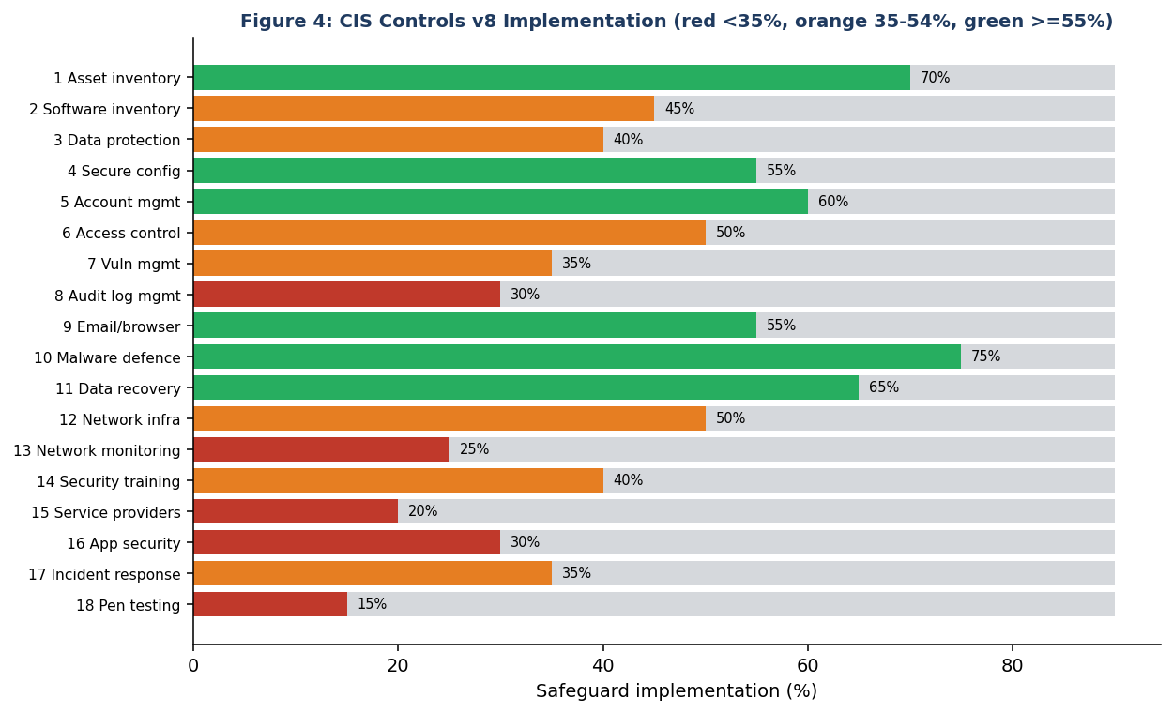
Figure 4: CIS Controls v8 implementation versus target
Average implementation is 44%. The widest gaps are in penetration testing (15%), service provider management (20%), network monitoring (25%), application software security (30%) and audit log management (30%). The strongest areas are malware defences (75%) and asset inventory (70%), although the latter is incomplete.

7.2 NIST CSF 2.0
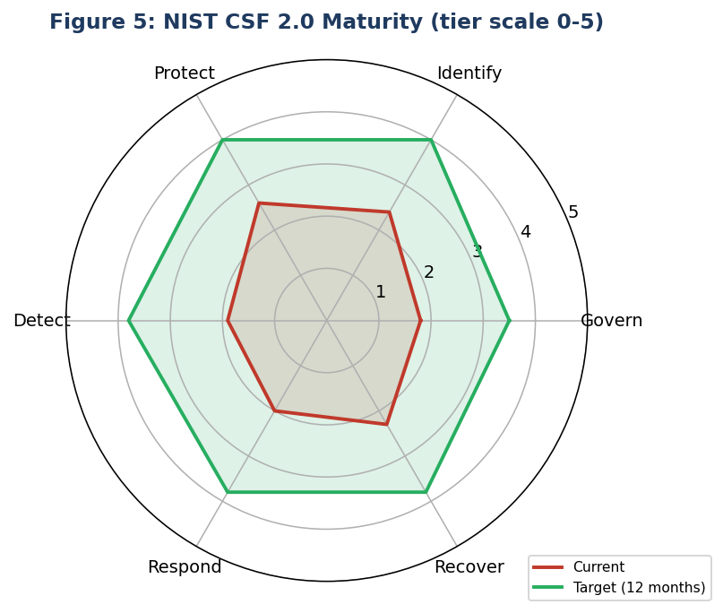
Figure 5: NIST CSF 2.0 maturity versus target
Function | Current | Target | Main gap
Govern | 1.8 | 3.5 | No risk strategy, roles or policy review
Identify | 2.4 | 4.0 | Incomplete assets; no risk register; vendor risk missing
Protect | 2.6 | 4.0 | MFA, patching, segmentation, encryption
Detect | 1.9 | 3.8 | Limited logging, no use cases, no triage
Respond | 2.0 | 3.8 | No tested plan or playbooks
Recover | 2.3 | 3.8 | Backups untested and exposed

7.3 ISO/IEC 27001:2022 Annex A
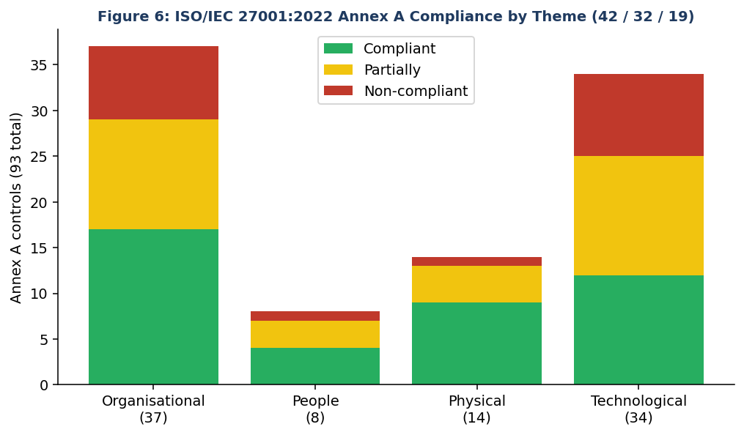
Figure 6: Annex A compliance by theme
Out of 93 controls, 42 are compliant, 32 partially compliant and 19 non-compliant. The technological theme has the most partial and non-compliant controls (22 of 34), reflecting the technical findings above. The organisational theme shows gaps in governance, supplier and incident management.

7.4 Mapping findings to frameworks
Finding | ISO 27001:2022 | NIST CSF 2.0 | CIS v8
A03 MFA | A.8.5 | PR.AA | 6
A06 Patching | A.8.8 | ID.RA, PR.PS | 7
A10 Backups | A.8.13 | PR.DS, RC.RP | 11
A07 Segmentation | A.8.22 | PR.IR | 12
A09 Logging | A.8.15, A.8.16 | DE.CM, DE.AE | 8, 13
A11 Incident response | A.5.24-A.5.27 | RS.MA, RS.CO | 17
A12 Vendors | A.5.19-A.5.22 | GV.SC | 15
A13 Awareness | A.6.3 | PR.AT | 14
A19 Testing | A.8.8, A.5.35 | ID.IM | 18

8. Risk Assessment and Prioritisation

8.1 Method
Each finding was decomposed into risk scenarios, for example 'ransomware encrypts the file server and backups are deleted'. Each scenario was rated for likelihood (considering threat activity, exposure and control strength) and impact (financial, operational, legal and reputational) on a five-point scale, and the product used to give Critical (17-25), High (10-16), Medium (5-9) or Low (1-4).

8.2 Top risk scenarios
Rank | Scenario | Findings | L | I | Score | Rating
1 | Ransomware encrypts servers and deletes backups; recovery takes weeks | A10, A06, A07 | 4 | 5 | 20 | Critical
2 | Stolen credentials used on VPN to access network and domain admin | A03, A04, A05 | 4 | 5 | 20 | Critical
3 | Exploitation of unpatched internet-facing or legacy system | A06, A02 | 4 | 5 | 20 | Critical
4 | Customer or HR personal data exposed via open shares or cloud container | A14, A15 | 4 | 4 | 16 | High
5 | Attack undetected for weeks due to missing logging | A09, A11 | 4 | 4 | 16 | High
6 | Lateral movement from store network to HQ | A07, A08 | 3 | 4 | 12 | High
7 | Supplier compromise passes malicious update | A12 | 2 | 5 | 10 | High
8 | Lost laptop with unencrypted data | A16 | 3 | 3 | 9 | Medium
9 | Unauthorised change breaks production | A18 | 3 | 3 | 9 | Medium

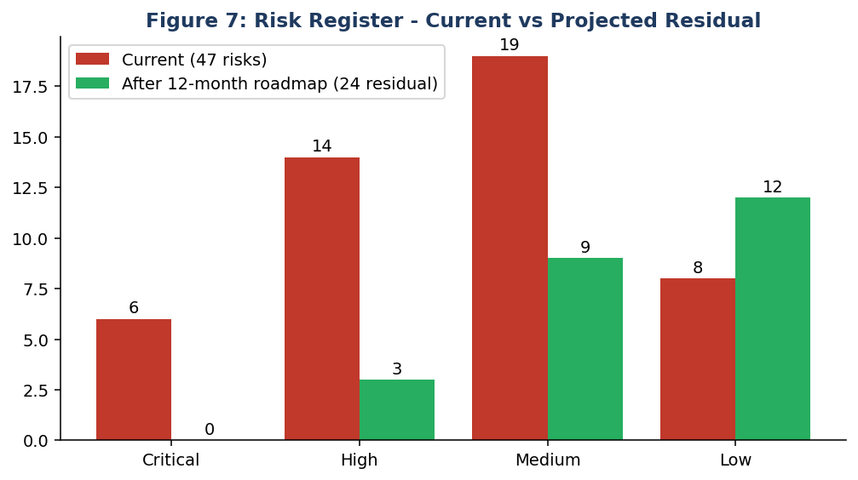
Figure 7: risk register current versus projected residual

8.3 Prioritisation logic
- Likelihood x impact gives the first order of priority.
- Effort and cost then rank equal risks: MFA and credential rotation are cheap and reduce several scenarios at once.
- Dependency: some controls enable others (inventory before patching, logging before detection).
- Compliance deadlines: privacy-law obligations and customer contracts advance data protection items.

9. Recommendations and Strategic Roadmap

9.1 Immediate remediation (0-30 days)
# | Action | Fixes | Owner | Cost
1 | Enforce MFA on VPN, admins, email and cloud | A03 | IT manager | Low
2 | Deploy LAPS; rotate shared and service passwords; fix password policy | A04 | Sysadmin | Low
3 | Reduce Domain Admins to named accounts; separate admin accounts | A05 | Sysadmin | Low
4 | Take backup server out of the domain; create one offline or immutable copy; test 4 restores | A10 | IT ops | Medium
5 | Patch sprint for all critical and high vulnerabilities | A06 | IT ops | Low
6 | Block public access on cloud storage; fix open shares | A14, A15 | Cloud admin | Low
7 | Move EDR macro and ransomware rules to block mode | A06, A07 | Security | Low
8 | Publish incident contact tree and first-hour checklist | A11 | CISO / IT manager | Low

9.2 Strategic roadmap (24 months)
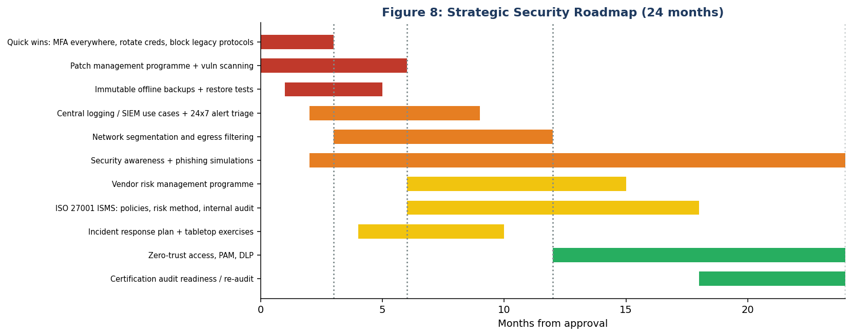
Figure 8: strategic roadmap
Horizon | Theme | Key deliverables | Success measure
0-3 months | Stop the bleeding | MFA, LAPS, backups, patch sprint, egress control for servers, cloud lockdown | All Critical findings closed
3-12 months | Build capability | SIEM use cases, 24x7 triage (managed service), segmentation, IR plan and exercises, vendor assessments, awareness programme, disk encryption | No High risks without plan; MTTD under 4 hours
12-24 months | Mature and certify | ISMS aligned to ISO 27001, zero-trust access, PAM, DLP, annual pen test, internal audit and certification readiness | Pass Stage 1 and 2 certification audit

9.3 Cost and benefit
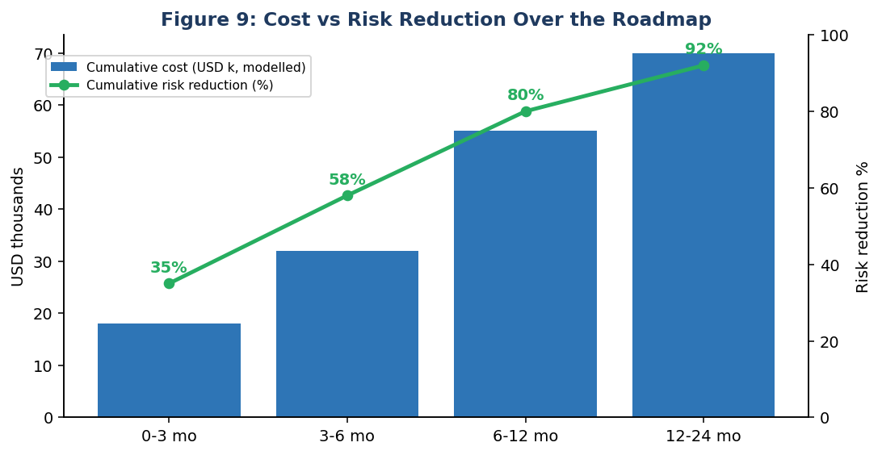
Figure 9: cumulative cost versus cumulative risk reduction (modelled)
Modelled spending is front-loaded because the early actions (MFA, backups, patching) remove the largest risks for the least money. About 58% of projected risk reduction is achieved within six months for about USD 32,000. By comparison IBM's 2024 Cost of a Data Breach report gave an average cost of USD 4.88 million per breach globally, so the roadmap pays for itself if it prevents even a small fraction of a single serious incident.

9.4 Key performance indicators
KPI | Baseline | Target (12 months) | Reported
Critical patches within 14 days | 48% | 90% | Monthly
MFA coverage (all users) | 35% | 100% | Monthly
Phishing click rate / report rate | 24% / 3% | Under 5% / over 50% | Quarterly
Backup restore tests passed | 1 of 4 | 4 of 4 | Quarterly
Mean time to detect (exercise) | 39 hours | Under 4 hours | Per exercise
Open Critical risks | 6 | 0 | Monthly
CIS Controls average implementation | 44% | 90% | Quarterly

9.5 Governance of the plan
- Appoint an executive sponsor and a security steering committee that meets monthly.
- Track every finding in a remediation register with owner, due date and evidence of closure.
- Re-audit Critical and High findings after 90 days; full re-audit after 12 months.
- Report KPIs to the board each quarter in plain language.

10. Conclusion, References and Appendices

10.1 Conclusion
NorthStar Retail does not have a technology problem so much as a consistency problem. Most of the necessary tools exist, but they are not configured, tested or governed to a level that matches the value of the data they protect. The risk is concentrated in a small number of weaknesses, identity, patching and recovery, that are inexpensive to fix compared with the harm they could cause. The recommended approach is to close those quickly, build detection and response capability next and formalise the programme into an ISMS so that improvement continues without depending on individual heroics.

10.2 Management response template
Finding | Agree / Disagree | Management action | Owner | Due date
A03 | [ ] | [ ] | [ ] | [ ]
A06 | [ ] | [ ] | [ ] | [ ]
A10 | [ ] | [ ] | [ ] | [ ]

10.3 Audit checklist excerpt (CIS-aligned)
Control | Question | Evidence | Status
1.1 | Is a complete asset inventory maintained? | Inventory vs discovery | Partial
4.1 | Is a secure configuration process established? | CIS Benchmark scan | Partial
5.2 | Are unique passwords used? | LAPS status | No
6.3 | Is MFA required for externally exposed applications? | Config review | No
7.3 | Are operating system patches automated? | WSUS report | Partial
8.2 | Are audit logs collected? | SIEM source list | Partial
11.2 | Are backups automated and tested? | Restore evidence | No
17.4 | Is an incident response process established? | Plan and exercises | No

10.4 References
- ISO/IEC 27001:2022, Information security management systems - Requirements; ISO/IEC 27002:2022 (control guidance).
- ISO 19011:2018, Guidelines for auditing management systems.
- NIST Cybersecurity Framework 2.0 (February 2024).
- Center for Internet Security, CIS Critical Security Controls v8 and CIS Benchmarks, cisecurity.org.
- NIST SP 800-30 Rev. 1, Guide for Conducting Risk Assessments; NIST SP 800-53 Rev. 5.
- IBM Security, Cost of a Data Breach Report 2024.
- CISA, SolarWinds supply-chain compromise advisories (2020-2021).
- US GAO (2018), Equifax data breach report; US Senate report on the Target breach (2014).
- MGM Resorts International, SEC filings on the September 2023 cyber incident.
- India: Digital Personal Data Protection Act, 2023; CERT-In directions of April 2022.

